Form to make a complaint about your health or disability care

This is a long document with lots of:
Before you start

- things for you to read

- pages for you to fill in.

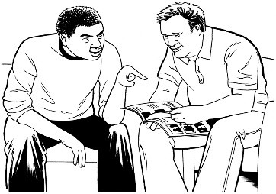
Some things you can do to make it easier to read are:

- read a few pages at a time

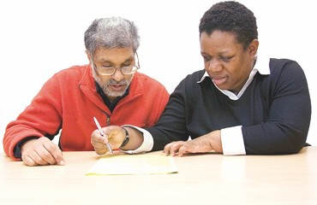
- fill out a few pages at a time

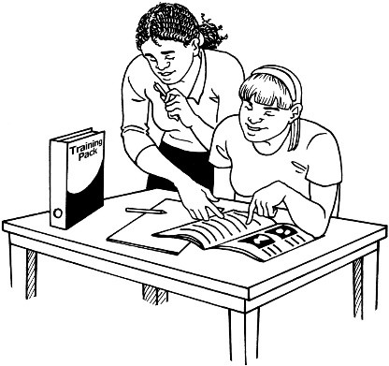
- have someone support you to fill it out like a:

  - family member

  - friend

  - support person.

Page number:
What you will find in here

What this document is about 4

When to fill out this form 8

What to do if you need assistance filling out this form 10
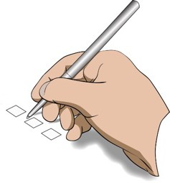 Before you start filling out this form 13
Tell us about you 18

Tell us how to contact you 32

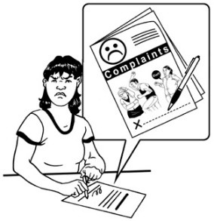
Page number:

Tell us about your complaint 34
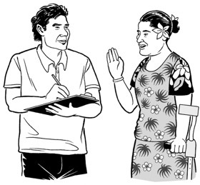
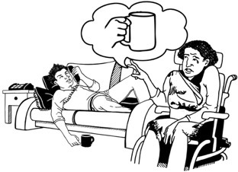 Tell us what happened 41
Is there anything else you need to
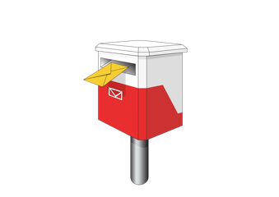
tell us about your complaint? 44

How to send this form to us 52

Where to find more information 55

This Easy Read document is from the Health and Disability Commissioner.
What this document is about

The Health and Disability Commissioner is also called the HDC.

HDC looks after the rights of people who use:

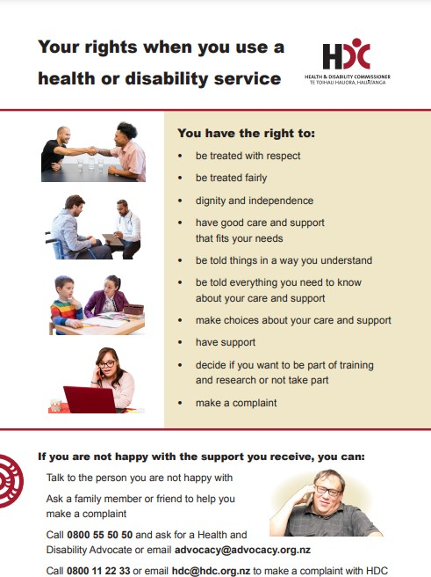
- health services

- disability services.

HDC protects the rights people have under the Code of Health and Disability Services Consumers’ Rights.

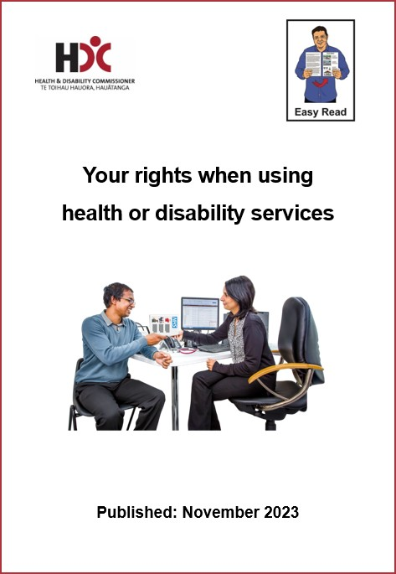
To find more information about your rights there is an Easy Read document called:

Your rights when using health or disability services

Your rights when using health or disability services

You can find this Easy Read document on the HDC website:

www.hdc.org.nz/your-rights

This Easy Read document is a form that you can use if you want to make a complaint to HDC about a health or disability service.

A complaint is when you tell someone that you did not like a service that you used.

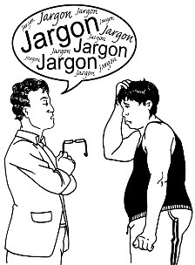
You might make a complaint if:

- something bad happened

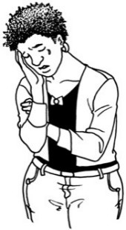
- something upset you

- a service was not good enough

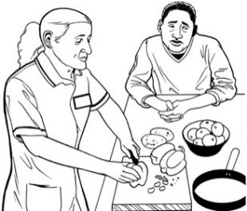
- you did not like how the service was given to you.

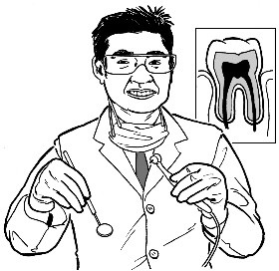
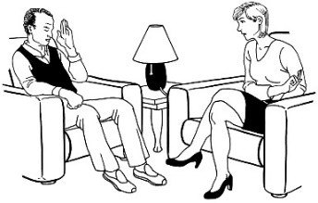
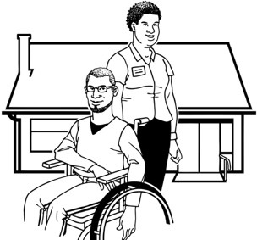
Before you complain to HDC you might want to make a complaint to:

- the provider

- someone else.
A provider is a person or organisation that offers health or
disability services like:
•
doctors
•
dentists
•
massage therapists
•
counsellors
•
support workers.

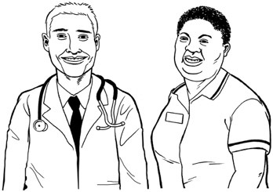
You can fill out this form when you have a complaint about a:
When to fill out this form

- health service provider

- disability service provider.

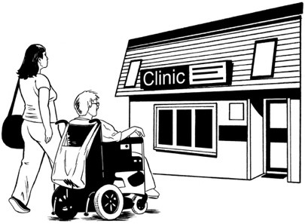
You can make a complaint about a service:

- you were given

- someone you know was given

- you saw someone else getting.

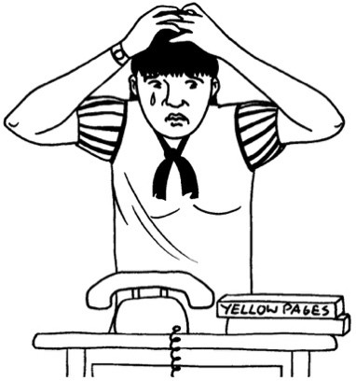
You can use this form to make a complaint if you:

- are not comfortable making a complaint directly to the provider

- tried making a complaint to a provider but you were not happy with what they did with your complaint.

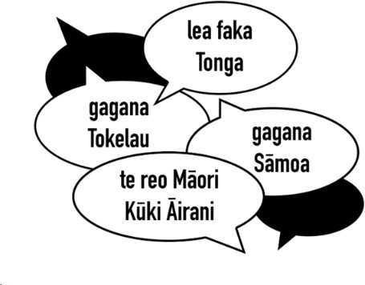
You can fill out this form in any language.
What to do if you need assistance filling out this form

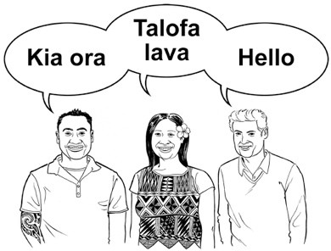
We will have what you write translated so we can understand it.

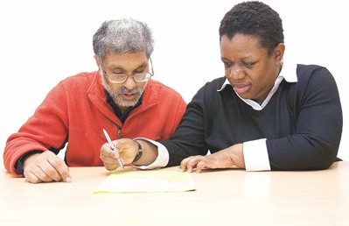
You can get an advocate to help you to:

- fill out this form

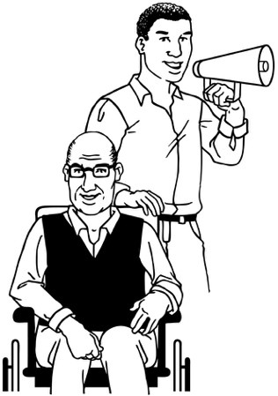
- make a complaint to the service you have a problem with.

An advocate is someone who supports you to have your say.

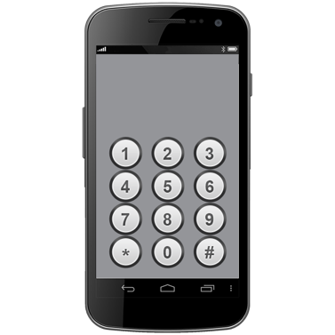
If you need an advocate you can phone us on:

0800 555 050

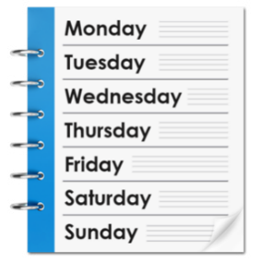
This number is open:

- Monday to Friday

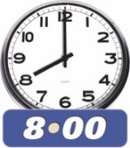
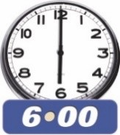
- 8 o’clock in the morning to 6 o’clock in the evening.

You do not need to pay any money to phone this number.

If you find it hard to use the phone, the New Zealand Relay service is for people who are:

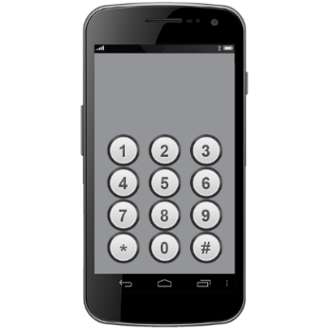
- Deaf / hard of hearing

- deafblind

- speech impaired / find it hard to talk.

You can find out more about the New Zealand Relay service at:

www.nzrelay.co.nz

You can write on this form.
Before you start filling out this form

Write on dotted lines like this:

..........................................................

When asked to choose answers please tick boxes like this:

□

If you see a * before a question then you must answer it.

If there is no * then you can choose if you want to answer it.

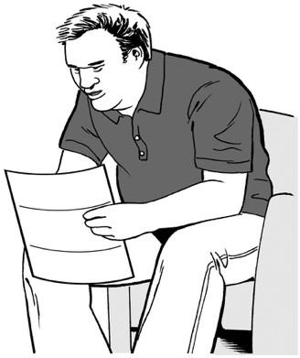
You can send HDC other things with this form like:

- documents

- letters

- emails

- photos.

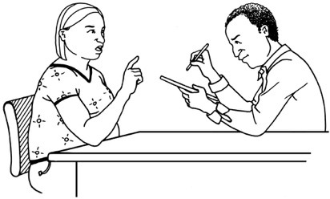
We might need to talk about your complaint with the person / provider your complaint is about.

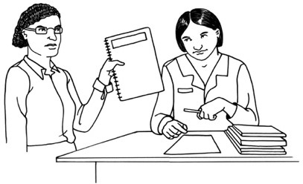
To do this we may need to send them:

- a copy of your complaint form

- your health records.

This is so that they know enough to be able to answer our questions.

You can learn more about how we respect your privacy on this website:

www.hdc.org.nz/privacy-statement/

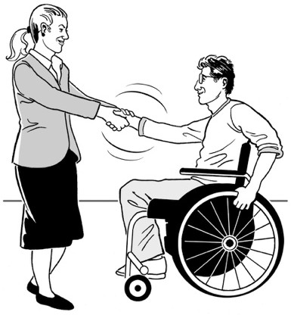
We treat all complaints with:

- fairness

- respect.

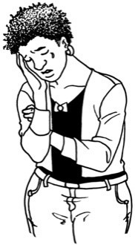
We know that if you have a complaint to make then you may be feeling:

- upset

- angry.

When talking to our staff please stay:

- calm

- polite.

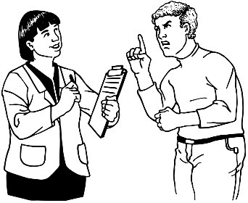
Please do not:

- yell at HDC staff

- be rude to HDC staff.

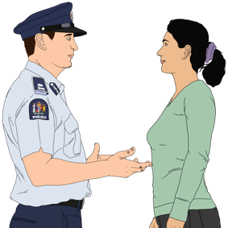
If you do not treat our staff well we may need to:

- give you a warning

- talk to the Police

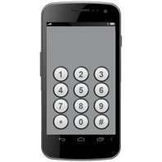
- change how you can contact our staff.

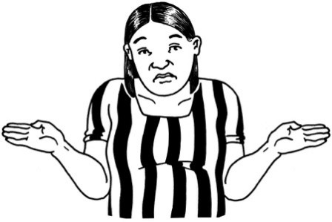
All of these things would make it more difficult for us to assist you well with your complaint.

We need to know some things about you so we can understand what you need.
Tell us about you

Please tell us the following:

* My title is:

..........................................................

Title means what goes before your name like Mr / Mrs / Miss / Ms / Mx / Dr.

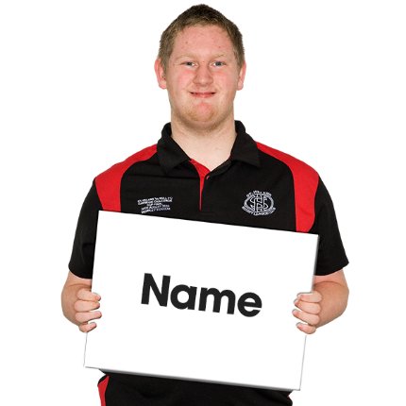
My first name is:

..........................................................

My last name is:

..........................................................

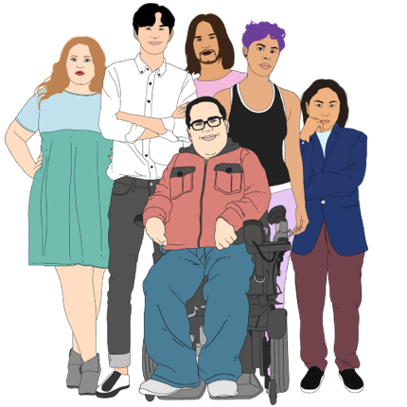
My gender is:

- Male
- Female
- Other (please write what it is):
..........................................................

- I do not want to answer
- I do not know.

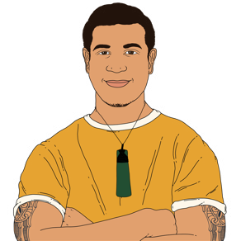
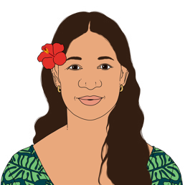
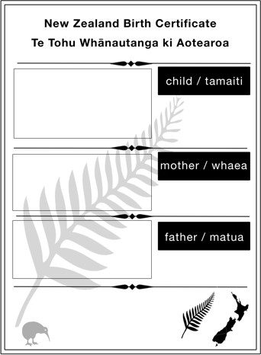

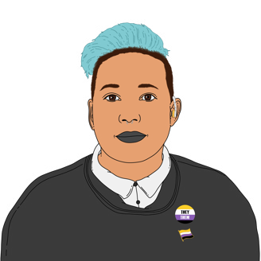
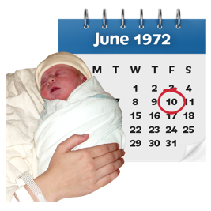
My date of birth is:
Gender means the type of person
you are which might be:
•
the same as what you were
called at birth
•
different from what you were
called at birth.
There are many genders including:
•
female
•
male
•
takatāpui
•
nonbinary
•
gender fluid.

..........................................................

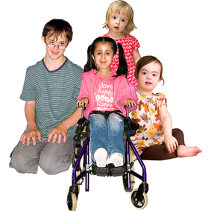
My age is in this group:

- Less than 15 years
□ 15 to 17 years old
- 18 to 24 years old
- 25 to 34 years old
- 35 to 49 years old
- 50 to 64 years old
- 65 to 74 years old
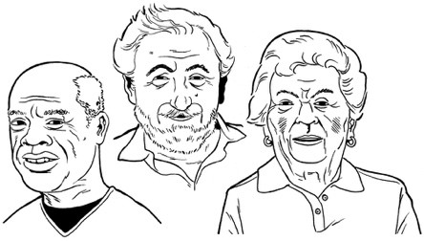
- 75 to 84 years old
- 85 years old or older.

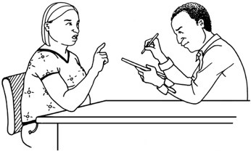
If you prefer you can choose 1 of these answers if you want to:

- I do not want to tell you my age

- I do not know how old I am.

The ethnic group I am from is:

Tick all the ethnic groups you are a part of on this page / the next page.

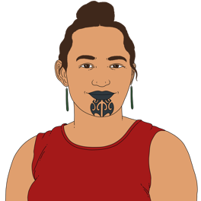
- NZ European / Pākehā
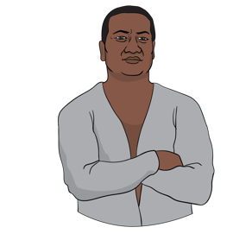
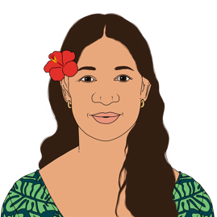
- Māori
- Samoan
- Cook Islands Māori
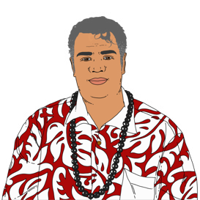
- Tongan
- Niuean
- Chinese
- Indian.

- I do not know my ethnic group
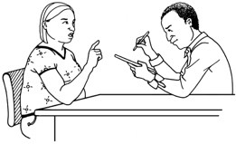
- I do not want to answer
- I am from this other ethnic group which I will write here:

..........................................................

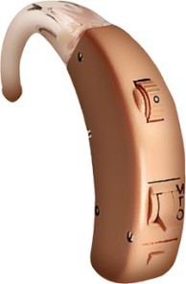
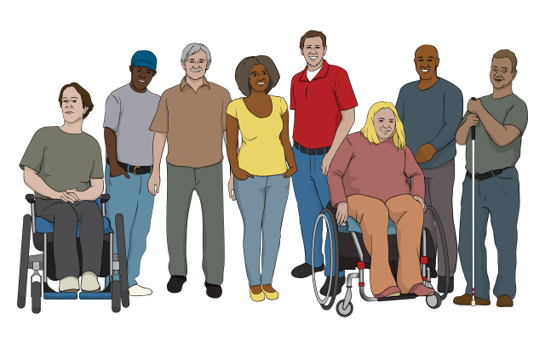
Do you have a disability?

- Yes
- No
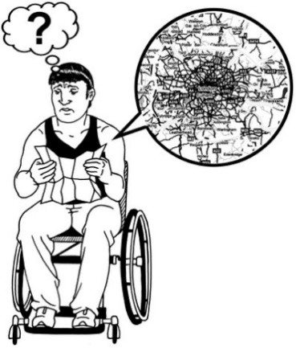
- I do not want to answer.
A disability is a condition you have that makes it more difficult for you to do some things than other people
who do not have that condition.
Disabilities can affect your:
•
body
•
senses such as vision / hearing
•
mind
•
ways of learning.

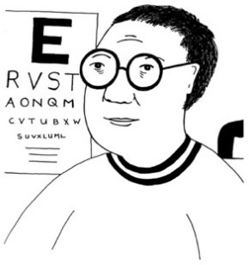
Do you need assistance with any of these?

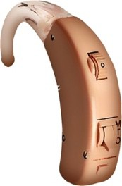
- Seeing things including wearing glasses

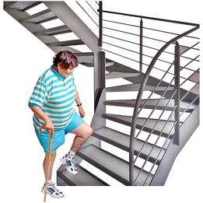
- Hearing things including using a hearing aid

- Walking / climbing steps
- Thinking such as remembering / concentrating

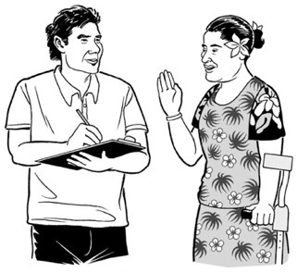
- Looking after your body like keeping yourself clean

- Talking to people in your own language / being understood
by others when talking.

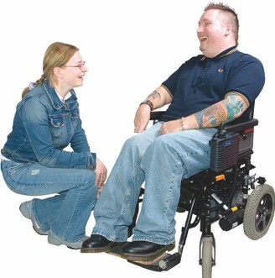
Or you might like to choose one of these options:

- I do not need assistance with any of these things

- I do not want to answer this question

- I need assistance with this other thing I will tell you about
here:

...................................................................................................

...................................................................................................

...................................................................................................

...................................................................................................

...................................................................................................

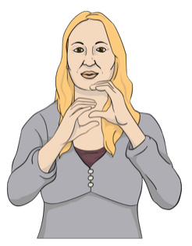
Do you have any accessibility needs?
Accessibility needs are things you need to be able to use something
well for example:
•
I need large print documents
•
I need a New Zealand Sign
Language interpreter
•
I need to talk to people in a room with low glare lighting that is not
too bright for me.

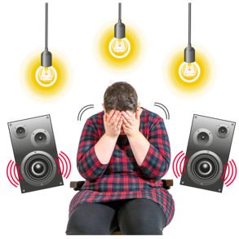
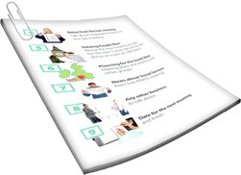
Please tick your accessibility needs on the next page.

- No I do not have accessibility needs like this

- Yes I have accessibility needs that I will tell you about here:

...................................................................................................

...................................................................................................

...................................................................................................

Do you know your National Health Index number?

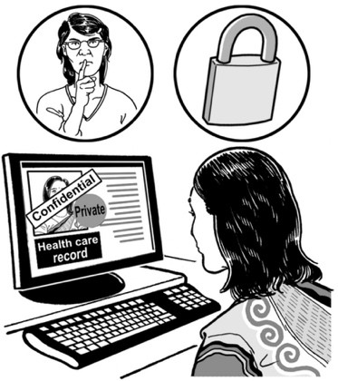
Your National Health Index number is used by health / disability services to make sure that you are who they
think you are.
It is also called an NHI number.

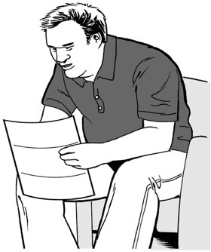
You can find your NHI number on:

- a letter from your doctor

- a medicine prescription form

- the label of your medicine.

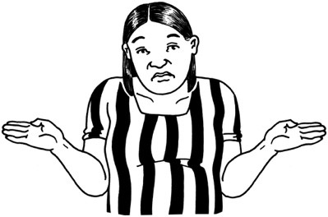
It is okay if you cannot find your NHI number because we can find it for you.

- No I do not know my NHI number

- Yes I know my NHI number
and it is:

..........................................................

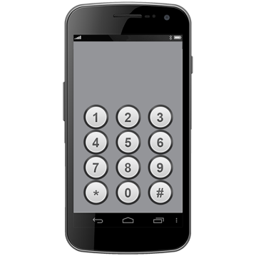
Please fill out this part of the form so that we know how to contact you.
Tell us how to contact you

I want to be contacted by:

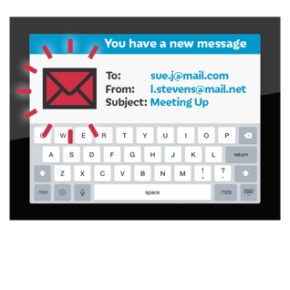
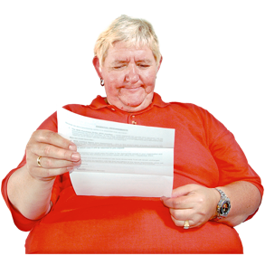
- Phone
- Email
- A letter sent to me in the post
- NZ Relay Service
- In this way I will tell you about:
...................................................................................................

...................................................................................................

My email address is:

..........................................................

My phone number is:

..........................................................

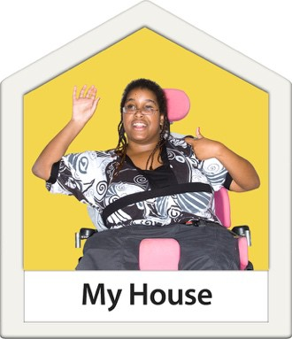
* My home address is:

House / apartment number: ..............

Street: ...............................................

Suburb: .............................................

Town / city:........................................

Postcode:..........................................

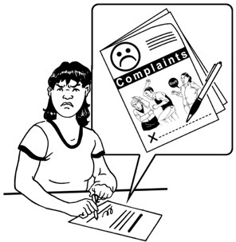
In this section you can tell us about your complaint.
Tell us about your complaint

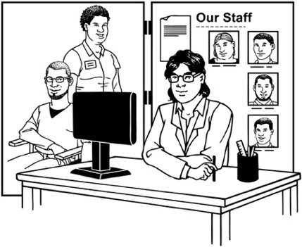
Please tell us about the health / disability service providers you have a complaint about.

If you have lots of providers to tell us about there is a place to write more on page 40.

* How many providers do you want to tell us about?
..........................................................

* The name of the health / disability service provider my complaint is about is:

...................................................................................................

...................................................................................................

What type of health / disability service provider are they?
□ Doctor
- Nurse
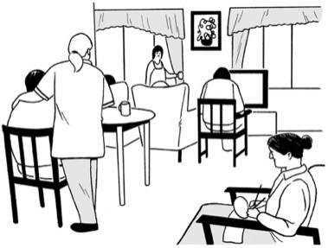 □ Care home
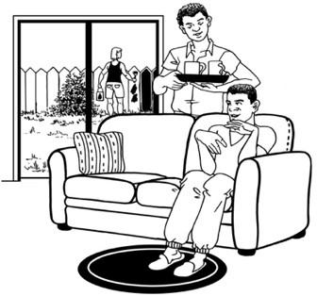
- Support worker
- Residential disability service

There are more options on the next page.

Or the provider could be one of these:

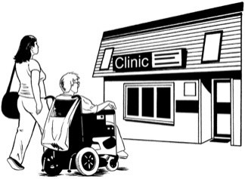
- Counsellor
- Medical centre
- Midwife
- Hospital
- Another type of provider which I will tell you about here:

...................................................................................................

...................................................................................................

...................................................................................................

...................................................................................................

...................................................................................................

Please tell us about how you spent time with the provider.

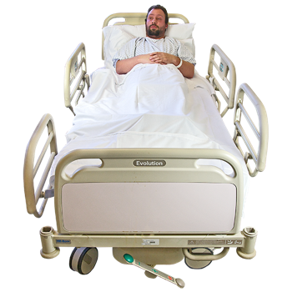
* Are / were you their:

- Patient / someone who got services from them

- Employer / boss
- Employee / staff member
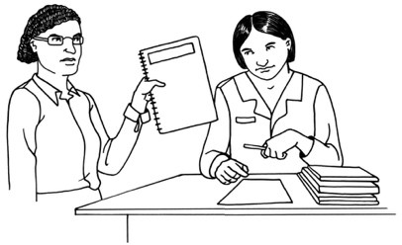
- Volunteer which means you worked for them for free

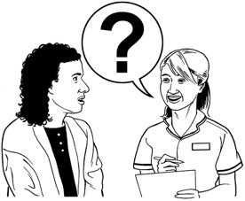
- Contractor / someone who did work for them

- Tangata whaiora / service user.

You might like to give us more information here:

- I spent time with the provider
in this other way I will tell you about here:

...................................................................................................

...................................................................................................

...................................................................................................

...................................................................................................

...................................................................................................

...................................................................................................

...................................................................................................

...................................................................................................

* Please tell us the address of the health / disability service provider:

Building / unit number: ......................

Street: ...............................................

Suburb: .............................................

Town / city:........................................

Postcode:..........................................

If you have other providers you want to make a complaint about please tell us their names here:

...................................................................................................

...................................................................................................

...................................................................................................

...................................................................................................

...................................................................................................

...................................................................................................

...................................................................................................

...................................................................................................

...................................................................................................

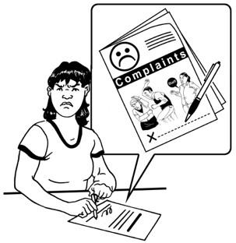
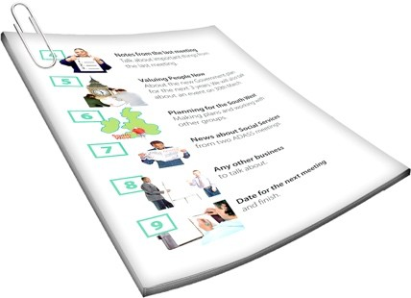
In this part of the form you can tell us more about what you want to make a complaint about.
Tell us what happened

You can also attach other documents to this form for us to look at.

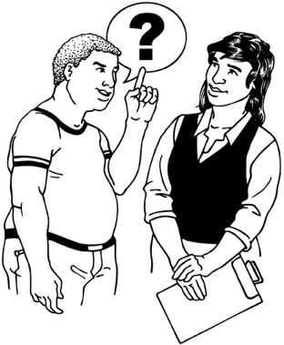
* Please tell us about what happened with as many details as you can:

What happened?

...................................................................................................

...................................................................................................

...................................................................................................

...................................................................................................

Who did it happen to?

...................................................................................................

...................................................................................................

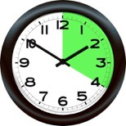
When did it happen including date / time?
...................................................................................................

...................................................................................................

Where did it happen?
...................................................................................................

...................................................................................................

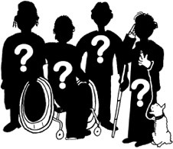 Who did it?
...................................................................................................

...................................................................................................

...................................................................................................

Did it happen more than 2 years ago?
□ Yes
- No

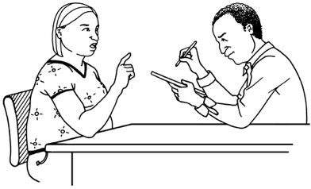
If it happened more than 2 years ago please tell us why you could not complain straight away:

...................................................................................................

...................................................................................................

...................................................................................................

...................................................................................................

...................................................................................................

...................................................................................................

...................................................................................................

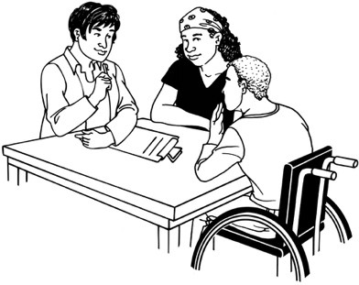
In this section you can tell us more information about your complaint.
Is there anything else you need to tell us about your complaint?

Are there other people who we can ask questions about:

- what happened

- you

- the health / disability service provider?

- Yes
- No

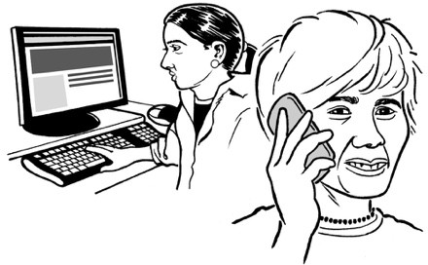
If there are other people we can ask please tell us:

- their names

- how to contact them such as a phone number / email address.

Name:

...................................................................................................

Contact:

...................................................................................................

Name:

...................................................................................................

Contact:

...................................................................................................

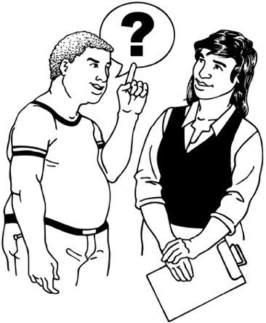
Please tell us about why you are making the complaint including:

- how you want this complaint to make things better for you

- what you want to see happen after making this complaint.

...................................................................................................

...................................................................................................

...................................................................................................

...................................................................................................

...................................................................................................

...................................................................................................

...................................................................................................

...................................................................................................

...................................................................................................

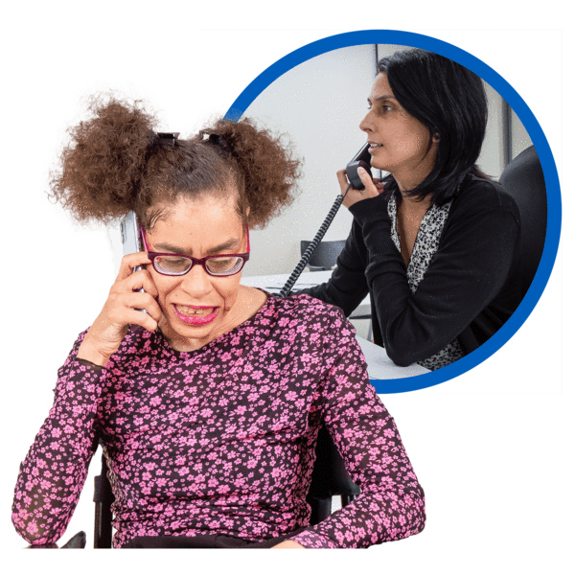
Have you talked to the health / disability service provider to make this complaint to them?

- Yes
- No

If you have please tell us what happened:

...................................................................................................

...................................................................................................

...................................................................................................

...................................................................................................

...................................................................................................

...................................................................................................

...................................................................................................

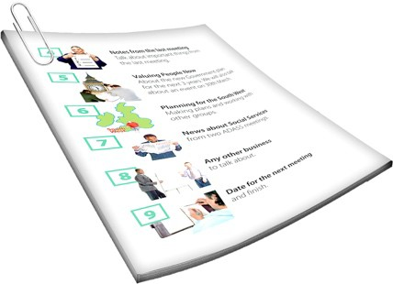
If you have any documents from when you made the complaint to the provider you can attach them to this form.

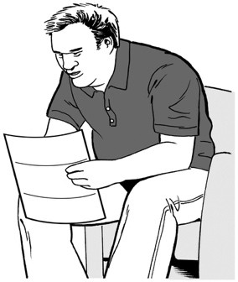
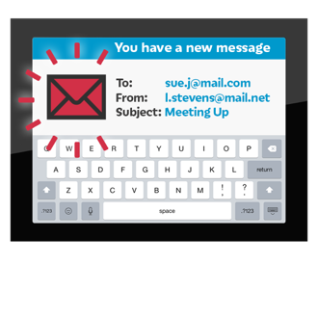
These documents could be:

- emails

- letters

- meeting notes.

If you have not made the complaint to them please tell us why not:

...................................................................................................

...................................................................................................

...................................................................................................

...................................................................................................

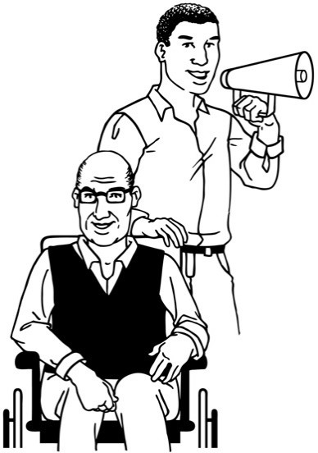
Have you asked the Nationwide Health and Disability Advocacy Service to assist you with this complaint?

- Yes
- No

If you have please tell us what happened:

...................................................................................................

...................................................................................................

...................................................................................................

...................................................................................................

...................................................................................................

...................................................................................................

...................................................................................................

If you have any documents from when the Advocacy Service assisted you please attach them to this form.

These documents could be:

- emails

- letters

- meeting notes.

If you have not asked the Advocacy Service for assistance please tell us why not:

...................................................................................................

...................................................................................................

...................................................................................................

...................................................................................................

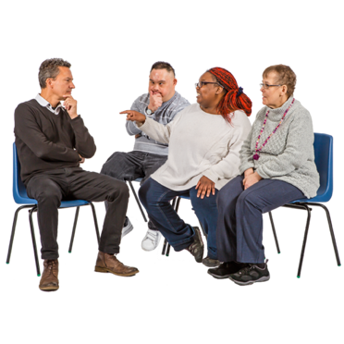
Have you made this complaint to another place such as:

- ACC

- the Human Rights Commission

- the Privacy Commissioner

- the Police?

- Yes
- No

If you have please tell us what happened:

...................................................................................................

...................................................................................................

...................................................................................................

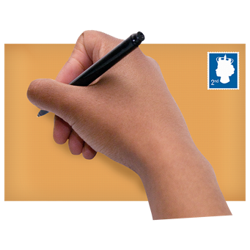
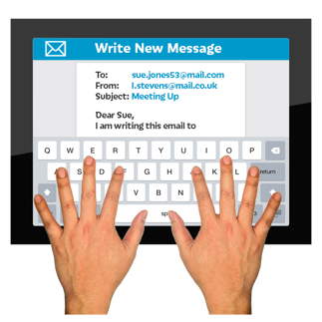
You can send this form to us:
How to send this form to us

- in an envelope in the post

- as an electronic document by email.

Our postal address is:

Health & Disability Commissioner PO Box 1791
Auckland 1140

Our email address is:

hdc@hdc.org.nz

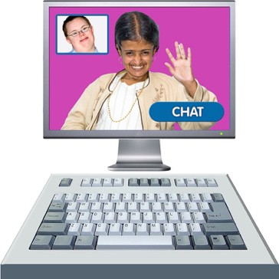
If you use New Zealand Sign Language which is also called NZSL you can send in your complaint by video.

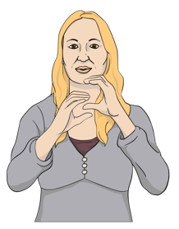
You can record an NZSL video and email it to us.

We will get your video translated.

Please email the video to this email address:

hdc@hdc.org.nz

You can also use the Seeflow
service to contact us.

You can learn more about Seeflow at this website:

www.seeflow.co.nz

You can find more information about the HDC on our website:
Where to find more information

www.hdc.org.nz

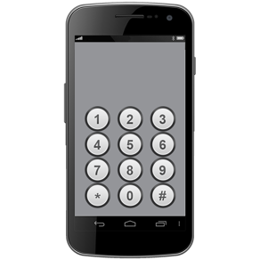
If you have any questions you can
phone us on:

0800 11 22 33

This phone number is open:

- Monday to Friday

- 8 o’clock in the morning to 6 o’clock in the evening.

If you find it hard to use the phone the New Zealand Relay service is for people who are:

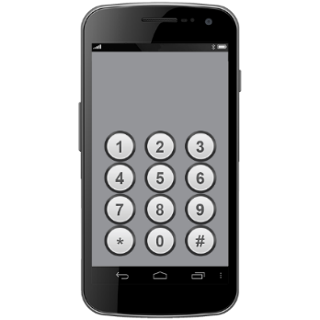
- Deaf / hard of hearing

- deafblind

- speech impaired / find it hard to talk.

You can find out more about the New Zealand Relay service at:

www.nzrelay.co.nz

This information has been written by the Health & Disability Commissioner.

It has been translated into Easy Read by the Make it Easy Kia Māmā Mai service of People First New Zealand Ngā Tāngata Tuatahi.

All images used in this Easy Read document are subject to copyright rules and cannot be used without permission.

Published: December 2023

