Your rights when using health or disability services

This is a long document.
Before you start

It can be hard to read a document this long.

Some things you can do to make it easier are:

- read it a few pages at a time

- set aside some quiet time to look at it

- have someone read it with you to support you to understand it.

Page number:
What you will find in here
What is this document about? 5
Protecting your rights 6

About your rights 8

Right 1: Respect 8

Right 2: Fair treatment 10

Right 3: Dignity and independence 14

Right 4: Appropriate standards 15

Page number:

Right 5: Effective communication 17

Right 6: Information 19

Right 7: Choice and consent 22

Right 8: Support 30

Right 9: Teaching and research 30

Right 10: Complaints taken seriously 31

Assisted dying 34

Page number:

If you think your rights have
not been met 37

How to contact us 41

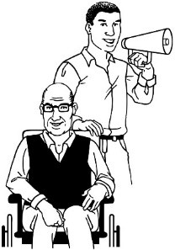
How to contact an
advocacy service 44

This Easy Read document is from the Health and Disability Commissioner.
What is this document about?

The Health and Disability Commissioner is also called the HDC.

HDC looks after the rights of people who use:

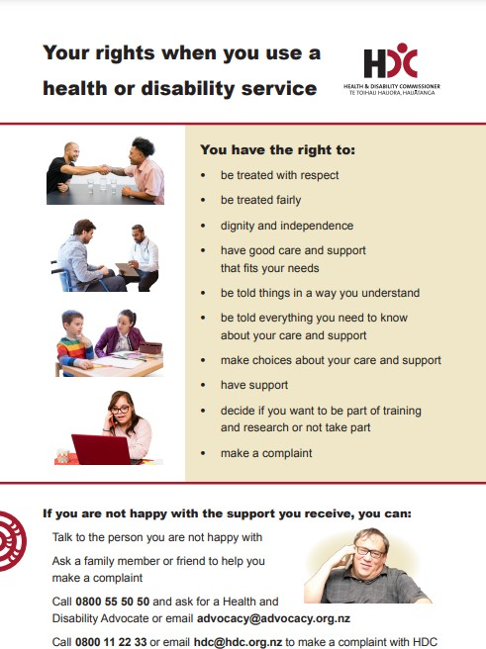
- health services

- disability services.

HDC protects the rights people have under the Code of Health and Disability Services Consumers’ Rights.

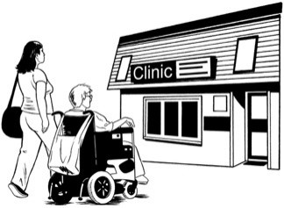

Everyone who uses a health or disability service has their rights protected under New Zealand law.
Protecting your rights

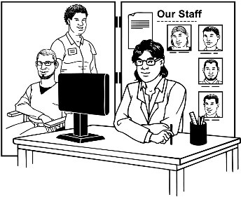
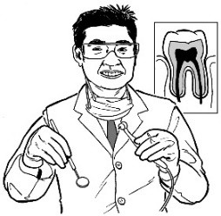
Every provider of a health or disability service has things they must do to make sure their service respects your rights.
A provider is a person or organisation that offers health or
disability services like:
•
doctors
•
dentists
•
counsellors
•
medical centres.

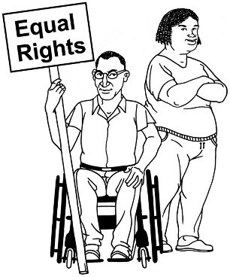
Providers need to:
To respect you means that someone
else:
•
treats you fairly
•
is kind to you
•
knows your rights
•
does not ignore your rights.

- tell you about your rights

- let you use your rights.

You have 10 rights under
About your rights
New Zealand law when using a health or disability service.

This part of the document will explain what your rights are.

Right 1: Respect

Providers need to:

- treat you with respect

- make sure that you have

privacy.

Privacy means not sharing information about you with other people without your permission.

Providers need to consider your:

- social needs like friendships

- religious needs like going to church

- cultural needs like being able to talk to someone in your language

- ethnic needs like traditions.

Right 2: Fair treatment

How well your treatment is done should not change based on:

- your age

- your gender

- your race

- if you are working or not

- if you are in a relationship

- who is in your family.

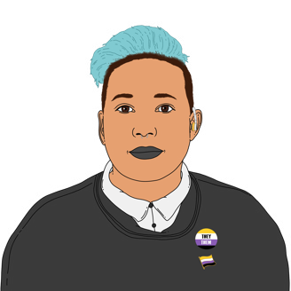
Gender means the type of person
you are which might be:
•
the same as what you were
called at birth
•
different from what you were
called at birth.
There are many genders including:
•
female
•
male
•
takatāpui
•
nonbinary
•
gender fluid.

How well your treatment is done should also not change based on:

- your beliefs

- your disabilities

- your sexual orientation.
Sexual orientation can mean:
•
gay / lesbian
•
straight / heterosexual
•
bisexual / pansexual
•
asexual.

You should be able to use services without being:

- made to do something you do not want to do

- threatened like someone saying they will hurt you if you do not do something

- harassed.
Someone harassing you is when someone keeps doing something hurtful when you have asked them to
stop.
Harassment can happen in lots of
ways like:
•
calling someone names
•
hitting someone
•
sending mean emails.

Right 3: Dignity and independence

Services providers must respect your:

- dignity

- independence.

Dignity means the respect you have for yourself.

Independence means making choices for yourself.

Right 4: Appropriate standards

Appropriate standards means that services should be done:

- with a good quality of care

- by someone who knows what they are doing

- in a way that supports you to live the best life you can

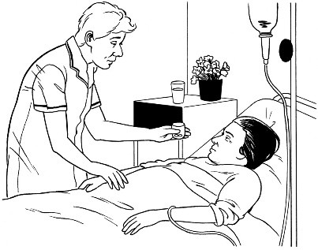
- in a way that makes sure any treatment that might be painful is not any more painful than it should be.

Services should:

- follow the law

- make sure their staff do their jobs well

- make sure they offer good care

- be ethical.
Ethical means doing things like:
•
being honest
•
making choices that are fair
•
treating people well.

Right 5: Effective communication

You should be given information in a way that you can understand.

You should be able to ask for an

interpreter if:

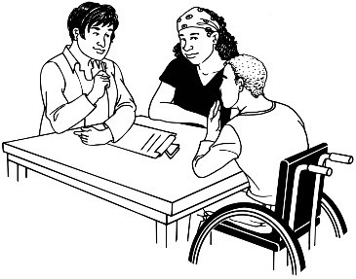
- you need one

- it is possible to get one.

An interpreter is someone who can explain what someone else is saying in a language you understand.

Communication should be:

- held in a safe place

- done in a way that:

  - is easy to understand

  - works well for everyone

  - is honest.
Communication being honest
means:
- telling the truth
- telling someone why you think
something
- not keeping information from people when they need to know
that information.

Right 6: Information

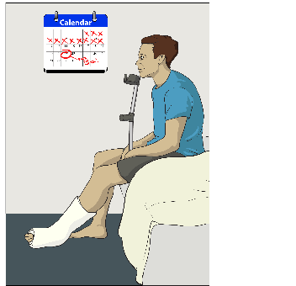
You should always be told:

- about any health conditions you have

- how long a provider thinks it might be before you can use a service

- any information you might need to make a choice

- what providers find out as part of any:

  - tests they do

  - treatments you have.

You should also be told if you might be part of any:

- teaching

research.
Research is when people find out a lot about something.

You should be told everything about the choices you can make like any:

- things that could go wrong

- good things that could happen

- money you might have to pay

side effects.

Side effects are things like a headache or feeling sick because of medicine or treatment.

You should be given answers to any questions you have about services like:

- who the provider of the service is

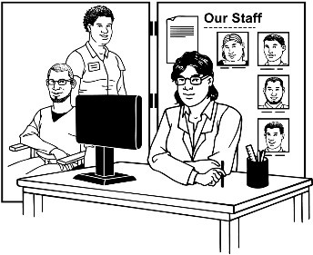
- what training the provider has had

- what your provider thinks you should do

- how to ask what a different provider thinks

- what has been found out because of research you were part of.

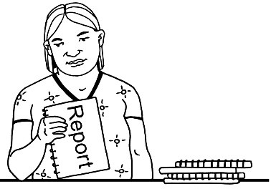
You have the right to ask to have any information you need written down for you.

Right 7: Choice and consent

You should be given a service only once you have:

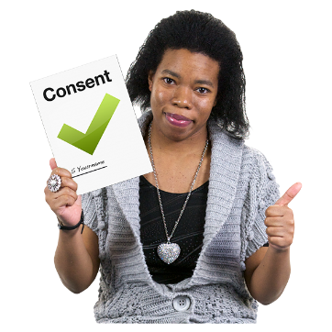
- made an informed choice

- given your informed consent.
An informed choice means that you:
•
have been told any information
you need or want to know about the service
•
understand what this information
means
•
have chosen if you want to use
the service or not.

Providers should think that you are competent unless they have a good reason not to.
Informed consent also means that
you:
•
have enough information to make
a decision
•
agree to use the service
•
understand what:
- using the service means
- could happen if you use the
service.

Some people are not competent to make informed choices.
Competent means that you can:
•
understand information
•
think about what choice is best
for you
•
ask questions about things you
are not sure about.

If you are not competent to make an informed choice then you should still be allowed to:

- make the choices that you understand

- choose to give consent to things you understand.

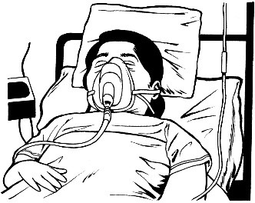
Sometimes people cannot give their consent when it is needed like if they are unconscious.
Unconscious means that you are
not:
•
aware of what is happening
around you
•
able to communicate / talk.
Being unconscious is like being in a
very deep sleep that is hard to wake up from.

If a service is needed when you cannot give your consent then providers need to:

- do what is best for you

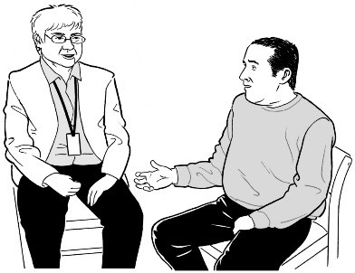
- try and find out if you would usually consent to the service

- talk with people who know you to find out what you might think.

You will need to consent in writing if you agree to:

- be part of some research

- use a general anaesthetic

- use an experimental procedure.

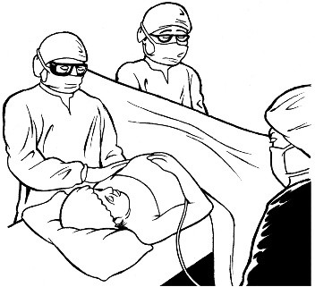
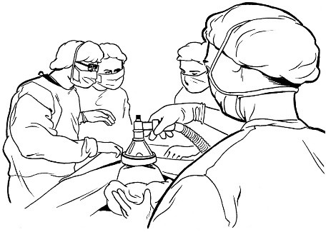
A general anaesthetic is a medicine
that is used to make you:
•
sleep during an operation
•
not remember the operation
happening
•
not feel any pain during the
operation.

An experimental procedure is a treatment that is still being tested.

If something might have very bad side effects then you need to say in writing that you understand what these side effects are.

You have the right to:

- not agree to a service

- change your mind about using a service at any time

- ask to change providers if it is possible

- make a choice about most future treatments.

Some treatments cannot have choices made about them before they are needed.

You have the right to choose:

- what happens to any parts of your body that might be removed as part of a treatment

- what happens to your bodily substances like your blood

- if any of your body parts can be:

  - used

  - stored.

Right 8: Support

You may bring a support person with you as long as it:

- is safe to do so

- does not go against the rights of other people.

Right 9: Teaching and research

You also have all these rights if you are part of:

- teaching

- research.

Right 10: Complaints taken seriously

You can make a complaint about a provider in a way that works for you.

Providers must try to work out your complaint with you:

- fairly

- quickly.

You should be told how making a complaint to your provider works.

Your provider should tell you:

- what is happening as they work on your complaint

- what happens because of your complaint.

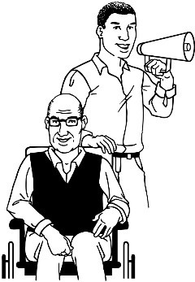
You should be told about who can support you with your complaint like:

- health advocates

- disability advocates

- the HDC.

You can find the full Code of Rights on the HDC website at:

www.hdc.org.nz/your-rights

Sometimes providers might not be able to meet all your rights.

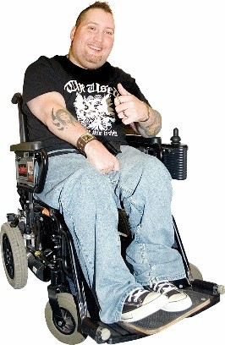
Providers must always do their best for you even if they cannot meet all your rights.

Some rights work differently for
Assisted dying
assisted dying services.

Assisted dying is end of life care that supports people who would like medical support to die when they choose.

Under Right 6: Information means a health practitioner can tell you about assisted dying only if you ask them.

You will need to show that you are competent to make an informed choice about assisted dying.

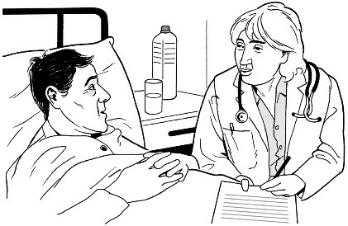
You cannot make an advance directive for assisted dying.
An advance directive is a plan you write to tell your doctor what services
you want in the future.
An advance directive is used if you
cannot tell your provider what you want.

Your doctor does not have to perform assisted dying services for you.

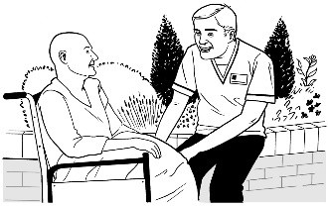
Your doctor must still make sure you are cared for if they do not perform assisted dying services.

You can find out more about your rights and assisted dying on the HDC website at:

https://tinyurl.com/yr35nk6w

Sometimes you might feel:
If you think your rights have not been met

- unhappy with a service

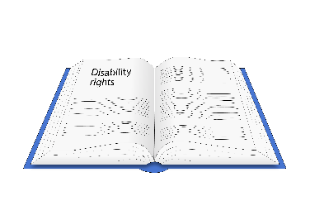
- that your rights have not been met.

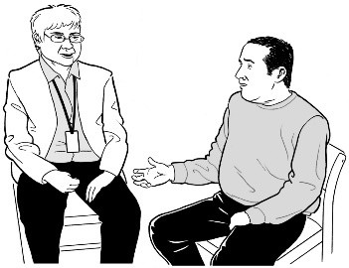
To make sure that the problem is fixed quickly you need to first:

- talk to the person who provided the service

or

- talk to the person in charge of the service.

You can ask other people for support in talking to the provider like:

- your whānau / family

- friends

- an advocate from the Nationwide Health & Disability Advocacy Service.

You can find out more about the Nationwide Health & Disability Advocacy Service on page 44.

You should not have anything bad happen from:

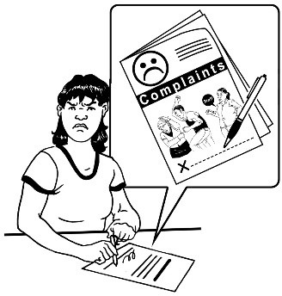
- talking to the provider about something that worries you

- making a complaint.

If you feel that you are still not getting your rights met by a health or disability service you can make a complaint to the HDC.

A complaint sent to the HDC is dealt with in a way that:

- is fair

- works well.

HDC will work on your complaint as quickly as possible.

You can find an Easy Read guide to making a complaint in the document:

Form to make a complaint about your health or disability care

Form to make a complaint about your health or disability care

You can find this document on the HDC website at:

https://www.hdc.org.nz/making-a-complaint/make-a-complaint-to-hdc/

You can contact the Health and Disability Commissioner by:
How to contact us

- phone: 0800 11 22 33

- email: hdc@hdc.org.nz

We are open:

- Monday to Friday

- 8 o’clock in the morning to 6 o’clock in the evening.

You can find out more about the Health and Disability Commissioner on our website at:

www.hdc.org.nz

If you find it hard to use the phone the New Zealand Relay service is for people who are:

- Deaf / hard of hearing

- deafblind

- speech impaired / find it hard to talk.

You can find out more about the New Zealand Relay service at:

www.nzrelay.co.nz

You can also use Seeflow to record a video to send to us.

To use Seeflow go to their website at:

https://www.seeflow.co.nz/direct

If you need more support to fix a problem you have had with a health or disability service you can contact the Nationwide Health & Disability Advocacy Service.
The Nationwide Health & Disability Advocacy Service can support you when you have had a problem with a
health or disability service by:
•
talking with you about what you
can do
•
telling you about your rights
•
answering your questions
•
supporting you in making a
complaint.
How to contact an advocacy service

You can contact the Nationwide Health & Disability Advocacy Service by:

- phone: 0800 555 050

- email:

advocacy@advocacy.org.nz

They are open:

- Monday to Friday

- 8 o’clock in the morning to 6 o’clock in the evening.

You can find out more about them on their website at:

www.advocacy.org.nz

This information has been written by the Health and Disability Commissioner.

It has been translated into Easy Read by the Make it Easy Kia Māmā Mai service of People First New Zealand Ngā Tāngata Tuatahi.

All images used in this Easy Read document are subject to copyright rules and cannot be used without permission.

Published: December 2023

