What happens when the
Health and Disability Commissioner
investigates your complaint?

Easy
Read

Your investigation

If you want to talk about your investigation, contact your investigator.

The name of your investigator is:

_______________________

You can call your investigator
on this number:

_______________________

You can send your investigator
an email at this address:

_______________________

You have rights

You have rights when you use a health or disability service in New Zealand.

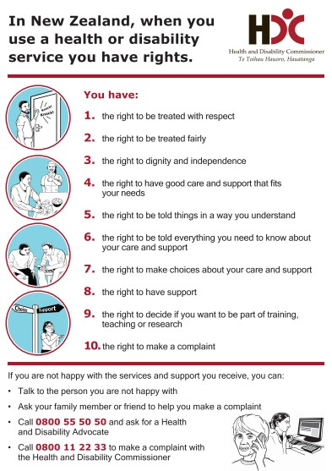
These rights are called the Code of Health and Disability Services Consumers’ Rights.

Some people also call them the Code of Rights.

Sometimes people do not get good health or disability services.

If this happens you can:

- tell someone you are not happy

- make a complaint to the Health and Disability Commissioner.

In this booklet the Health and Disability Commissioner is sometimes called the Commissioner.

The Health and Disability Commissioner makes sure you:
- get your rights
- are treated in a good way when you use health or disability services.
What is in this booklet?

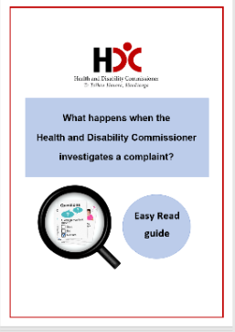
In this booklet you can find out about:

- the Health and Disability Commissioner

- how an investigation works

- how to contact the Health and Disability Commissioner.

Investigations

The Health and Disability Commissioner may decide to investigate your complaint.

This happens only with a small number of complaints.

If the Health and Disability Commissioner decides to investigate your complaint, that means he will look into whether or not you got your rights.

If your complaint is to be investigated, the Health and Disability Commissioner will give your complaint to an investigator to work on.

An investigator is a person who:

- works for the Health and Disability Commissioner

- takes over from your Complaints Assessor

- talks to you about your complaint

- collects more information about your complaint.

If an investigator is working on your complaint, this means that it is being investigated.

The investigator will be impartial.

This means that the investigator will treat you and the health or disability service providers the same.

A health or disability service provider can also be called a service.

The investigator is not on:

- your side

- the side of the service.
The process — what needs to happen?

The investigator will get in contact with the service your complaint is about.

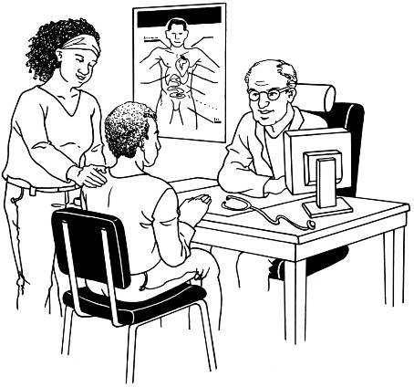
The investigator will let the service know about:

- your complaint

- the investigation.

The investigator may ask your service some questions.

The investigator will ask your service what it thinks about your complaint.

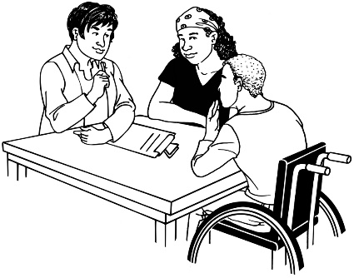
During the investigation, the investigator may also ask for more information from:

- you or your advocate

- your service

- other people.

The investigator may also talk to other people who were there when the thing you are complaining about happened.

These people are known as witnesses.

The investigator may also talk to people who know a lot about the service you were using.

These people are known as experts.

Fixing your complaint

The Health and Disability Commissioner may try other ways to fix your complaint.

The Health and Disability Commissioner may send your complaint to:
- the Advocacy service

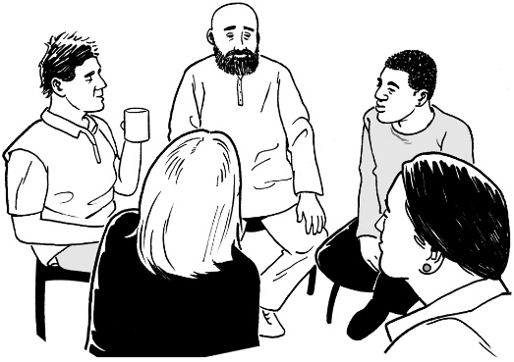
or

- formal mediation.

Formal mediation means bringing you and your service together to:

- talk about the complaint

- work out how to fix the problem.

If you want to try this way of fixing your complaint, ask your investigator to make it happen.

What happens next?

When your investigation is finished, the Health and Disability Commissioner will send a draft report to:

- you

- the service you made a complaint about.

A draft report:

- means a report that is not finished
- tells you about the information that has been collected during the investigation.

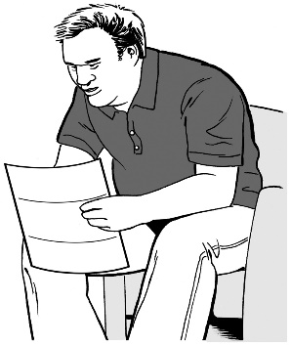
You will have a chance to:

- read the draft report

- say what you think about the draft report

- give the investigator more information.

The Commissioner will listen to what you say.

The Commissioner will also listen to what your service says.

The Commissioner may then make changes to the draft report.

The Commissioner will then make a final report on your complaint.

A final report means a report that is finished.

This report will be sent to:
- you

- the service you made the complaint about.

The final report will tell you about:

- your complaint

- the investigation

- all the information that has been collected during the investigation
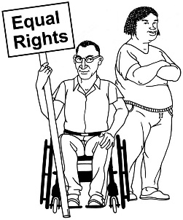
- whether you got your rights

- any action your service should take.

An action is something that needs to be done.

The Health and Disability Commissioner may want your service to take some actions.

These actions could be things like:

- saying sorry to you
- changing how it does things.

The report may also be sent to:

- the Ministry of Health
- registration authorities

- a District Inspector
- somebody else.

The Health and Disability Commissioner will let you know where the report will be sent.

Director of Proceedings

Sometimes, your investigation may also be sent to someone called the Director of Proceedings.

This does not happen very often.

It happens if you:
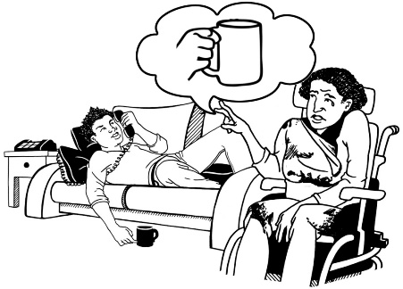
- did not get your rights

- were treated in a very bad way.

If this happens, you will be given information about what:

- this means

- you need to do

- could happen.

Questions

How long will the investigation take?

Some investigations take around 6 months to finish.

Some investigations take around 18 months to finish.

This is because it may take
a while to get information.

Your investigator will contact you every 2 months.

Your investigator will update you on how the investigation is going.
Will an investigation mean I get some money?

The Health and Disability Commissioner cannot tell a service to give you:

- compensation

- a refund.

Compensation is when you get money for something that has gone wrong.

A refund is when you pay for something and then get your money back.

What if I am not happy with the Health and Disability Commissioner’s decision?

You cannot change the final decision made by the Commissioner.

You can contact The Office of the Ombudsman.

An Ombudsman can look at the way the investigation was done.

An Ombudsman will check that it was done in a fair and legal way.

You can get in touch with The Office of the Ombudsman by:
- Phone: 0800 802 602

It is free to call this number.

- Fax: 04 471 2254

- Email:
info@ombudsman.parliament.nz
- Posting a letter:

The Office of the Ombudsman
P.O. Box 10152
Wellington 6143

- Website:
www.ombudsman.parliament.nz
How to contact the
Health and Disability Commissioner

If you want to talk about your investigation, contact your investigator.

Contact the Health and Disability Commissioner if you:

- would like to learn more about your rights

- are worried you have not been treated in a good way by a service.

To contact the Health and Disability Commissioner, please:

phone us on:
(09) 373 1060
or
0800 11 22 33 — it is free to call this number

or write to us at:

The Health and Disability Commissioner
P.O. Box 1791
Auckland
or look at our website:
www.hdc.org.nz

This information has been translated into Easy Read
by People First New Zealand Inc. Ngā Tāngata Tuatahi

