What happens after you make a complaint to the Health and Disability Commissioner?

Easy Read

You have rights

You have rights when you use a health or disability service in New Zealand.

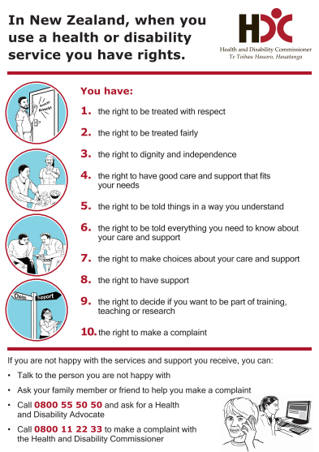
These rights are called the Code of Health and Disability Services Consumers’ Rights.

Some people also call them the Code of Rights.

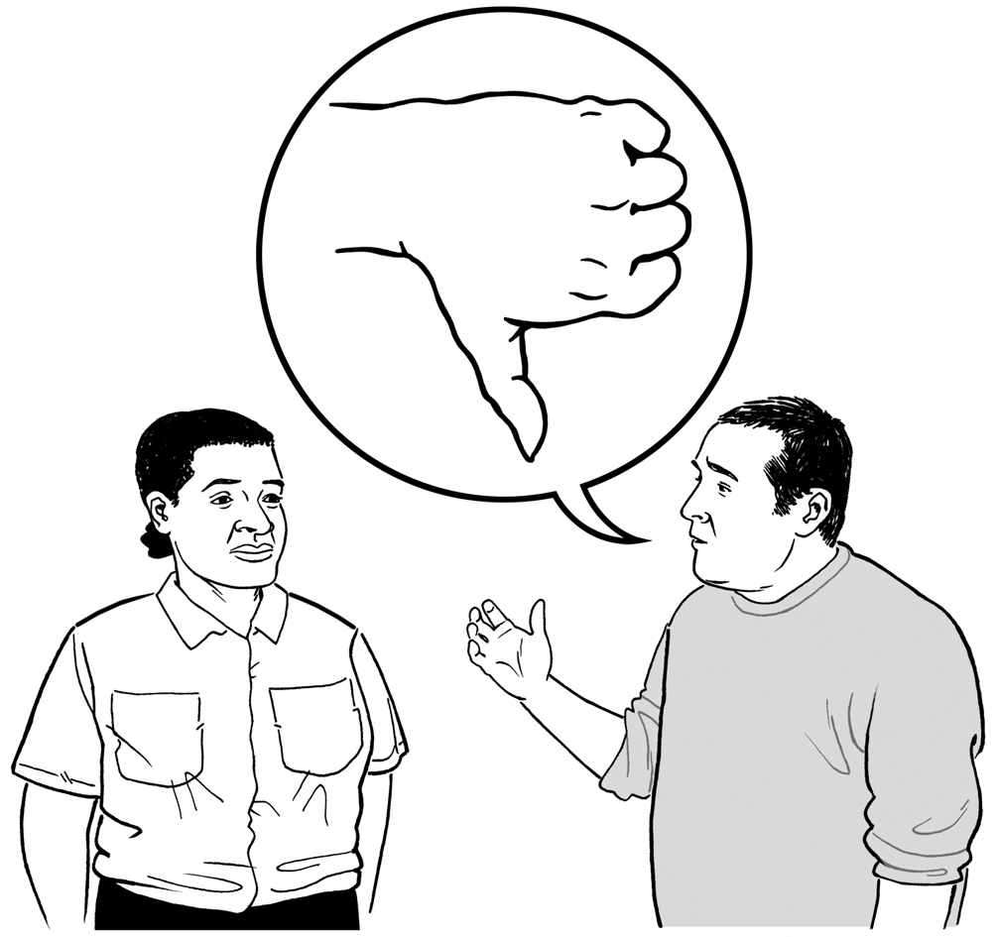
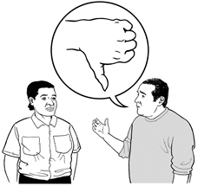
Sometimes people do not get good health or disability services.

If this happens you can:

- tell someone you are not happy

- make a complaint to the Health and Disability Commissioner.

The Health and Disability Commissioner makes sure you:

- get your rights

- are treated in a good way when you use health or disability services.

Who looks after your complaint?

When you make a complaint to the Health and Disability Commissioner it will be given to a Complaints Assessor.

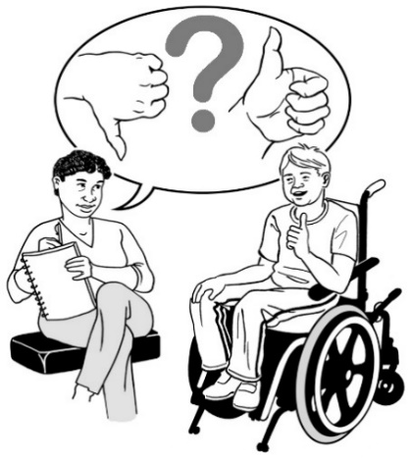
A Complaints Assessor is someone who looks after your complaint.

The Health and Disability Commissioner will write and tell you:
- the name of your Complaints Assessor
- how to contact your Complaints Assessor.

You can contact your Complaints Assessor to:

- give your Complaints Assessor more information about your complaint

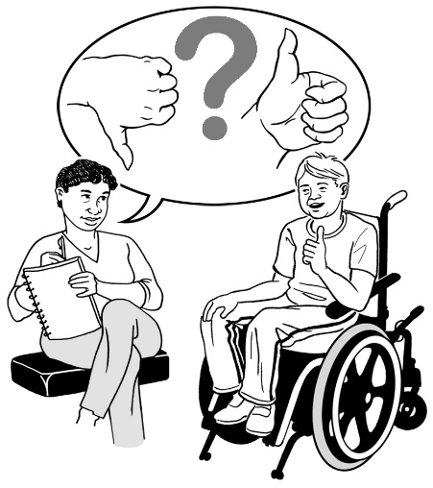
- talk about getting help from an Advocate from the Nationwide Health and Disability Advocacy Service
- ask questions about your complaint

- get an update.

Other people who work with the Health and Disability Commissioner may also contact you about your complaint, like:

- another Complaints Assessor
- a Complaints Assessment Administrator

- other people from the Health and Disability Commissioner.

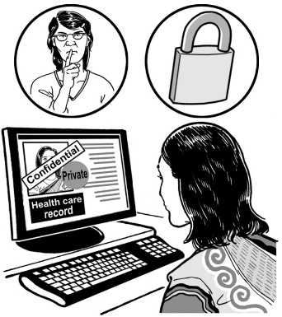
A Complaints Assessment Administrator makes sure information about your complaint is looked after and easy to find.

The final decision about your complaint will be made by:
- the Health and Disability Commissioner

or

- 1 of the Deputy Commissioners.

The complaints assessment process

The Health and Disability Commissioner looks at your complaint.

The Health and Disability Commissioner will use the complaints assessment process to:

- find out more about your complaint

- decide what to do next.

The Health and Disability Commissioner makes sure your complaint is something the law says the Health and Disability Commissioner is allowed to look into.
In the complaints assessment process the Complaints Assessor may:
- send a copy of your complaint to the health or disability services provider you are complaining about

- ask for more information from the health or disability services provider you are complaining about

- ask you for more information about your complaint

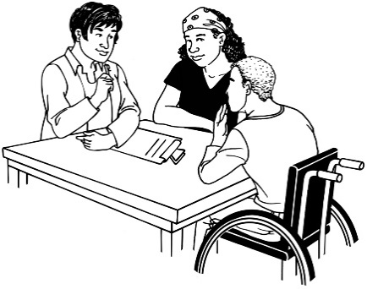
- ask other people for more information about your complaint

- ask someone who knows a lot about health or disability services some questions about the services you got.

Usually it takes up to 6 months for the complaints assessment process to finish.

Your Complaints Assessor will:
- let you know what is happening with your complaint
- contact you every 2 months with an update.

Things that could happen with your complaint

The Health and Disability Commissioner may:

- send your complaint to an Advocate from the Nationwide Health and Disability Advocacy Service so the Advocate can help you

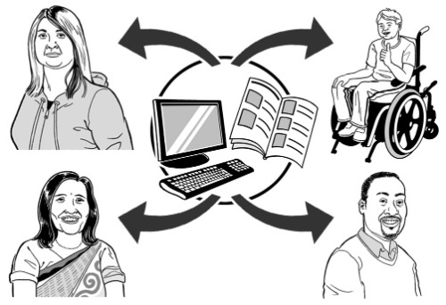
- send your complaint to the health or disability services provider it is about so the provider can:

  - try to fix the problem
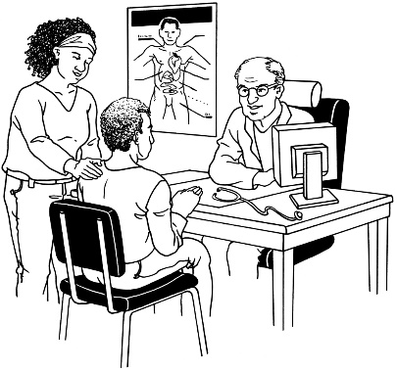
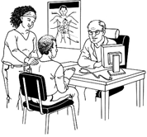
  - say sorry to you.

The Health and Disability Commissioner may also:
- investigate your complaint

see page 15 to read what investigate means

- not do anything further if:

  - the health or disability services provider has looked at your complaint and has already sorted it
  - it happened a long time ago

  - someone else could deal with your complaint better
  - there is another reason. The Health and Disability Commissioner will write and tell you the reason.

The Health and Disability Commissioner may also:

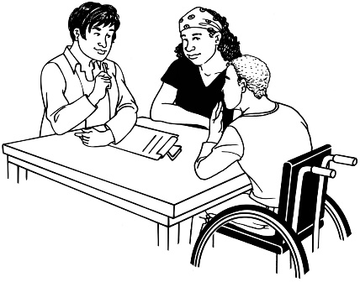
- tell the health or disability services provider to:

  - change the way they do things

  - say sorry to you

- tell you about places where you can get help.

The Health and Disability Commissioner may send your complaint to:
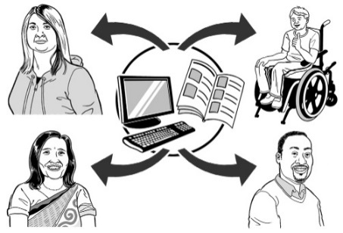
- the Ministry of Health
- a registration authority
- the Privacy Commissioner
- a District Inspector

- or someone else.

The Health and Disability Commissioner will write and tell you what will be done.

Investigations

The Health and Disability Commissioner may decide to investigate your complaint.

This happens with only a small number of complaints.

If the Health and Disability Commissioner decides to investigate your complaint that means the Health and Disability Commissioner will look into whether or not you got your rights.
If your complaint is to be investigated the Health and Disability Commissioner will give your complaint to an Investigator.

An Investigator is a person who:
- takes over from your Complaints Assessor

- asks more questions about your complaint

- collects even more information about your complaint
- talks to you about your complaint
- talks to the health or disability services provider you complained about.

If an investigator is looking at your complaint that means it is under investigation.

When your investigation is finished, the Health and Disability Commissioner will tell you what they found out about:
- your complaint

- your rights.

Some investigations take around 6 months to finish.

Some investigations take around 18 months to finish.

Money

Compensation is when you get money for something that has gone wrong.

A refund is when you pay for something and then get your money back.
The Health and Disability Commissioner cannot help you get compensation or a refund.
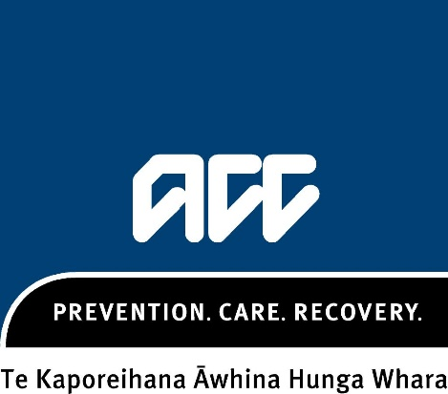
Sometimes people who get hurt can get money from ACC. You should talk to ACC if you think you got hurt by a health or disability services provider.

How to contact the Health and Disability Commissioner

You can contact the Health and Disability Commissioner:

- to get more information
- if you are worried.

You can call the Health and Disability Commissioner on 0800 11 22 33.

It is free to call this number.

You can email the Health and Disability Commissioner at:
hdc@hdc.org.nz
You can post a letter to:
Health and Disability Commissioner
PO Box 1791
Auckland 1140
You can fax the Health and Disability Commissioner on (09) 373 1061.

The Health and Disability Commissioner’s website is:
www.hdc.org.nz

This information has been translated into Easy Read
by People First New Zealand Inc. Ngā Tāngata Tuatahi

