Amplifying the voices of older people across Aotearoa New Zealand
1

Report by the Aged Care Commissioner March 2024

Amplifying the voices of older people across Aotearoa New Zealand 2024
Report authored and issued by the Health and Disability Commissioner | Te Toihau Hauora, Hauātanga.
©COPYRIGHT (2024) Health and Disability Commissioner | Te Toihau Hauora, Hauātanga.
This copyright material is licensed for re-use under the Creative Commons Attribution 4.0 International Licence. This means that you have the right to copy, distribute and adapt the material as long as you attribute it to the Health and Disability Commissioner | Te Toihau Hauora, Hauātanga and adhere to other licence requirements. View the full licence at: https://creativecommons.org/licenses/by/4.0/ legalcode.
ISBN: 978-0-473-70797-2
The Health and Disability Commissioner | Te Toihau Hauora, Hauātanga promotes and protects the rights of people using health and disability services as set out in the Code of Health and Disability Services Consumers’ Rights (the Code). This includes resolving complaints in a fair, simple, speedy, and efficient way.
The Health and Disability Commissioner | Te Toihau Hauora, Hauātanga is an independent watchdog for the rights of consumers, providing people using health and disability services with a voice, resolving complaints, and holding providers to account for improving their practice at an individual and system-wide level.

The Health and Disability Commissioner | Te Toihau Hauora, Hauātanga is independent of government policy, allowing it to be an effective guardian for the promotion and protection of consumers’ rights.
For more information visit our website www.hdc.org.nz or find us on LinkedIn.

Liability:
All reasonable care and diligence has been used in processing, analysing, and extracting data and information in this publication. However, the Health and Disability Commissioner | Te Toihau Hauora, Hauātanga does not guarantee, and accepts no legal liability whatsoever arising from or connected to, the accuracy, reliability, currency, or completeness of any material contained in this publication, including in any third-party linked websites. The Health and Disability Commissioner | Te Toihau Hauora, Hauātanga recommends that users exercise their own skill and care with respect to their use of this publication, and that users carefully evaluate the accuracy, completeness, and relevance of the information in this publication for their purposes.

Printing:
This report is printed on 70% PEFC certified paper. Chain of Custody Code: SAI-PEFC-1614569.
Health and Disability Commissioner | Te Toihau Hauora, Hauātanga and PO Box 1791, Auckland 1140.

Ngā kaupapa | Contents

- He karere nā te Toihau Tautiaki Kaumātua | Foreword, page 5
- He ahanoa tuatahi | Infographic: Our ageing, increasingly diverse population, page 10
- He whakarāpopototanga matua | Executive summary, page 14
- He kupu arataki | Introduction, page 24
- Ki te whaiao | Voices of older people, insights and recommendations, page 35
- Te tirohanga ake | Next steps and future focus, page 84
- Tikina he āwhina | Where to get support, page 87
- Kupu āpiti | Endnotes, page 89
- Ngā tohutoro | References, page 104
- Kuputaka | Glossary, page 117
- He mihi whakawhetai | Acknowledgements, page 122

He karere nā te Toihau Tautiaki Kaumātua | Foreword
He hōnore, he korōria ki te Atua, he maungārongo ki te mata o te whenua. Whaakaro pai ki ngā tāngata katoa. Arohaina ngā tēina me ngā tūākana i roto i te whakaaro tahi.
Ki ngā tini mate o te tau, haere, haere, haere atu rā. Haere atu koutou ki tua o te ārai ki ngā huihuinga o ngā tini whetū e pīata mai rā, ki te pūtahitanga nui o Rēhua.
Tihei mauri ora ki a tātou, ngā mahuetanga o rātou mā.
Me mihi ka tika ki ngā whakaruruhau kia koutou ko ngā kaumātua hei tiaki hei arahi ki a mātou ngā tae tupuranga o te wā. Tēnā koutou katoa.
The role of Aged Care Commissioner was created as a focal point to drive quality improvement and provide advocacy for better health and disability services for older people in Aotearoa New Zealand. The Aged Care Commissioner has a wide-ranging role that focuses on all health and disability care delivered to older people nationwide, not just ‘aged care’ services. The focus on older people is not limited to those aged 65 years and over, but covers all people affected by ageing-related health conditions regardless of their age.
I commenced my role as Aged Care Commissioner in March 2022. As someone who has worked in the health industry for over 40 years, in both Aotearoa New Zealand and Australia, I bring my health sector knowledge to this role, together with my lived experience as a daughter and niece involved in the care of older whānau | family.

My first year in the role has focused on setting up a team within the Office of the Health and Disability Commissioner | Te Toihau Hauora, Hauātanga, and connecting with older people across Aotearoa New Zealand, their whānau | family, carers, providers, and the agencies who work with them. It has been a privilege to initiate connection and collaboration hui | meetings to hear directly from older people about their experiences with the health system. These hui | meetings will be ongoing, and I plan to continue building relationships with people based on meaningful connections — not one-off engagement.
Supporting equity of health outcomes for Māori is an important aspect of my role. I am committed to working with our Kaitohu Mātāmua Māori | Director Māori and his team to engage closely with kaumātua, whānau, hapū, and iwi to ensure that their voices, health needs, and aspirations are embedded in my monitoring work.
This report is informed by the voices of older people and is the start of a journey to improve the visibility and monitoring of health and disability services provided to older people across Aotearoa New Zealand. Since commencing the role of Aged Care Commissioner, I have observed, and heard about, significant challenges in the provision of quality health and disability services for older people.
Critically, there is a lack of dedicated strategy and planning for the health needs of an ageing population. Older people are high users of the health and disability system and, while we have many strategies relevant to ageing well, we are not seeing a clearly coordinated strategy and action plan to manage the health and disability needs of what will be around 20% of the population within the next decade.
Innovative models of care need to be considered to meet the changing needs of people as they age.

During our connection and collaboration hui | meetings, older people expressed their concerns around access to and continuity of services and lack of culturally appropriate care. Our older people deserve to receive coordinated, integrated health and disability services to enable them to live well (ideally in their homes) with support, if required, from primary and community providers.
Over the past year, I have heard many personal stories about older people being in public hospitals much longer than was clinically required due to a lack of access to appropriate supports in the community. This includes a timely return home from acute care with support, if needed, or moving to aged residential care, if required. The impacts on the wellbeing of those involved are considerable and include de-conditioning and loneliness for the older person and potentially their partner, carer, and whānau | family. Not providing the right care in the right place and at the right time for older people can also place significant pressure on other areas of the health system, including the provision of emergency and planned care. The lack of a clear continuum of care across all aspects of the health system designed to meet the needs of older people is concerning.
While I was pleased to see discussion, and announcements, around ensuring that there is a sustainable health workforce, more visibility on the strategy and action to achieve this in respect of the aged-care workforce is required. A particular focus is needed on non-hospital sectors, especially primary care, community care, and aged residential care to ensure that there is a sustainable workforce to support older people to receive the care they need from the right providers and as close to home as possible.
Three key critical themes were identified as significant issues in our hui | meetings. These were: the issues for older people and whānau | family living with dementia mate wareware; a lack of options to meet kaumātua health aspirations and needs; and timely access to primary

care, aged residential care, and home and community support, including respite care and carers’ relief.
Our discussions with older people and their whānau | family, including carers, on these issues have provided valuable insights that I hope will influence future improvements in the sector. I am committed to working with leaders in the health and disability sector to collectively address the issues outlined in the report and will continue to advocate for better services for older people.
I would like to thank the numerous people who contributed their lived experience, knowledge, and insights as we developed this report. This includes the many older people and whānau | family who attended connection and collaboration hui | meetings, general meetings, as well as those working in the sector.
Finally, I would like to thank Health and Disability Commissioner Morag McDowell, the aged care team, the HDC cultural team, and the HDC communications team for their support and guidance, and wider HDC colleagues for their commitment to the work of the Aged Care Commissioner.

Carolyn Cooper
Aged Care Commissioner

He ahanoa tuatahi | Infographic: our ageing and increasingly diverse population1

The number of people aged 65 and older in Aotearoa New Zealand is growing rapidly:A
The population of people over 65 is projected to grow to:
- 20% in 2028
- 21-25% in 2048
- 24-32% in 2073
The number of people over 65 is projected to reach:
- 1.3 million by 2040
- 1.5 million by 2050
Life expectancy (years) is set to increase:
- Males: 80.8 in 2023 to 87 in 2073
- Females: 84.1 in 2023 to 89.7 in 2073
The oldest 10% of the population will rise:
- 72+ in 2022
- 75-79 in 2033
- 77-79 in 2048

The fastest growing age group in our population are those aged 85 plus
By 2073, there could be nearly half a million New Zealanders aged 85 plus

Our population, including people aged 65 plus, will increase in ethnic diversity:B
The percentage of people aged 65 plus from ethnic groups in 2043 will be:
- 75% Pākehā (New Zealand European) 11% Māori
- 15% Asian
- 5% Pacific
- 1% Middle Eastern, Latin American, and African

The number of disabled older people will increase as the population ages:C
- Around 25% of New Zealand’s population identifies as disabledD
- 35% of disabled people are more than 65 years old That’s 370,000 peopleE

According to the New Zealand Disability Survey 2013
(which will be updated and released in 2024): For those aged 65 plus:
- 59% were disabled across the general population
- Half of Asian people identified as disabled
- There were more disabled Māori men (66%) than women (51%)
- Around 60% of Pacific people identified as disabled

Regional data for the general population aged 65 plus shows higher percentages of disabled people in regions outside the biggest cities of Tāmaki Makaurau Auckland and Te Whanganui a-Tara Wellington.F
- Taranaki, Otago and the Bay of Plenty had the biggest proportions of disabled older people aged 65 plus.
- Other regions where 6 in 10 people aged 65 plus were disabled include: Waikato, Southland and the rest of the South Island, closely followed by Canterbury (59%) and Wellington (57%).G

Infographic footnotes:
- www.stats.govt.nz/information-releases/national- population-projections-2022
- www.stats.govt.nz/information-releases/national- ethnic-population-projections-2018
- www.odi.govt.nz/home/about-key-facts- about-disability-in-new-zealand
- Physical, sensory, learning, mental health or other disability.
- New Zealand Disability Survey 2013.
- Note the estimates below only include people living in households (private dwellings); people living in residential facilities are excluded.
- As older people are overrepresented among disabled people, it is likely that the numbers and proportion of disabled older people will rise as the number of people aged 85+ are the fastest growing age group in the population of Aotearoa.

He whakarāpopototanga matua | Executive summary
This report draws on the voices of thousands of older people, their whānau | family including carers, and service providers to outline some core issues in health and disability services for older people. I have chosen to focus on the need for an integrated continuum of care that concentrates on prevention and the support required to enable older people to navigate services easily. The insights in this report consider the importance of:
  - The need for better transitions of care for older people from hospital to home and community support services (HCSS) and aged residential care (ARC);
  - Investing in innovative primary and community care models, including assisting older people to navigate health and disability services;
  - Preventative interventions for dementia mate wareware; and
  - Ensuring that people can access reliable, quality HCSS services to age well at home.
As Aged Care Commissioner, an important part of advocating for quality care for older people includes profiling improvements in the health and disability system. This report highlights just some of the quality improvements happening throughout the country. Some of the most innovative work in our system is driven by the lived experiences of older people, balancing quality of care and quality of life.
It is encouraging to see that currently Te Whatu Ora | Health NZ is undertaking an aged-care funding and service models review with the aim of improving the sustainability of services and ensuring equity of access and outcomes. I hope the insights and recommendations within this report will prove useful to Te Whatu Ora | Health NZ as this review progresses.
I will monitor the recommendations in this report, summarised below, in future reporting:
- There is a need for a targeted strategy to ensure quality health and disability services for older people. There is no dedicated strategy and planning for the health and disability needs of an ageing population. Despite strategies and action plans relevant to ageing well, there is no coordinated strategy focused on our ageing and increasingly diverse population, including rising numbers of people with chronic conditions and high health needs.
- Better discharge planning by hospitals to support transitions of care for older people from hospital to homes and communities or aged residential care. There would be value in nationally replicating and upscaling existing roles in Te Whatu Ora | Health NZ that support older people to be discharged safely from hospital. A good example is hospital social workers specialising in older people’s health, especially those with dementia mate wareware and complex needs requiring enduring powers of attorney (EPOAs) to enter ARC. On page 19, this report profiles such a specialist social worker role in Te Tai Tokerau Northland, which currently is supported by a charitable trust co-founded by a social worker formerly in that role. Other existing roles, eg, clinical nurse specialists in gerontology, should also be resourced adequately and replicated for consistent service delivery to older people, especially those with dementia mate wareware, across all localities/regions.

- Supporting person-centred, culturally safe communication for older people that involves whānau | family, including carers, by continuing to resource and train existing pou tikanga and kaitakawaenga | cultural advisors and interpreters in hospitals. These crucial roles should be available when needed, especially by kaumātua, Pacific matua, and all older people needing culturally safe services. They should be accessible consistently across Aotearoa New Zealand.
- I am pleased to see that Te Whatu Ora | Health NZ is undertaking an aged-care funding and service models review — this is an important step towards older people being able to access the community and residential support options they need and avoid unnecessary or prolonged hospital admissions. Home and community support services (HCSS) and aged residential care (ARC) must be valued as integral parts of the health and disability system and supported to provide high quality accessible care.
- Any focus on workforce in the aged-care funding and service models review and in future Te Whatu Ora | Health NZ workforce plans should have a focus on actions that contribute to a sustainable aged- care workforce, including a focus on the training and retention of aged-care nurses, healthcare assistants (HCAs), geriatricians and psycho-geriatricians/psychiatrists, pou tikanga, and kaitakawaenga | cultural advisors specialising in the health of older people.
- Shortages in psychogeriatric care beds across the country must be addressed urgently. I understand that Te Whatu Ora | Health NZ’s funding and service models review of aged-care services is prioritising the sustainability of psychogeriatric services. This needs to include an analysis of service gaps across the country, ensuring that planning and funding support geographically equitable access to acute and long-term psychogeriatric care. The review should develop culturally safe models of care that support both acute and long-term care delivered in the community wherever possible.
- The aged care funding and services review must also address the significant gap in the provision of kaupapa Māori aged-care services, particularly for people with dementia mate wareware and psychogeriatric care needs.
- Primary and community care, especially general practitioner (GP) clinics, should be valued as critical partners with priority investment in changing models of primary and community care. I am pleased to see that Te Whatu Ora | Health NZ is undertaking a primary health funding review, and I support its intention to create comprehensive community care teams. These teams have the potential to reduce hospital admissions, improve continuity of care, and lift people’s access to preventative and integrated care. These multidisciplinary care teams should include roles with an enhanced or dedicated focus on the health of older people.
- Older people have expressed the importance of enduring relationships and having a single point of contact for primary care. A health worker and/or social care worker focused on older people’s health could have an important navigator role to support people with complex conditions and their whānau to access and transition between services. Such roles could also support priority populations, including kaumātua, Pacific matua, and tāngata whaikaha | disabled people aged 50 plus.
- Investing in innovation, especially models of care that can keep older people safer and well for longer in communities, is important, and I hope that such innovation becomes a focus of the aged care funding and service models review. Supporting GP practices to become integrated comprehensive community care teams can assist in keeping older people at home for longer. Whilst currently there are some positive examples of these models of care across Aotearoa New Zealand, this is not consistent.
- I am supportive of initiatives such as the 24-hour rural telehealth line recently established to ensure more equitable access to primary care services in rural areas. Innovation that assists wider access for those in rural areas to access scarce resources, such as specialist services, is welcomed. The focus should be on areas needing immediate relief, such as GP clinics, health hubs, and HCSS, especially doctors, nurses, and HCAs.
- Regular training and development of primary and community care providers and staff on the health and wellbeing of older people and ageing- related health and disability conditions could be supported by modelling professional networks based on successes of clinical networks by Te Whatu Ora | Health NZ, and lessons from the ‘community connector’ role at MSD.
- Preventative actions to reduce dementia mate wareware include increasing hearing-aid subsidies and public health interventions fostering social connection and age-friendly environments. The subsidy for hearing aids has not been increased for many years, and cost may be a barrier for some older people, including those from communities with rising rates of dementia mate wareware. The New Zealand hearing aid subsidy should be increased to cover the cost of hearing aids, assessment and fitting, and the hearing aid funding scheme should be extended to cover the cost of fitting and assessing hearing aids. There is also a need to increase funding by the Accident Compensation Corporation (ACC), which applies to people for whom more than 6% of hearing loss is due to an injury.2 Other avenues are also available for people to have their hearing aids funded, eg, by Veterans’ Affairs if they are veterans who have hearing damage or who developed tinnitus while serving in the New Zealand Defence Forces. The cost of providing hearing aids to those who need them is far outweighed by the benefits and cost savings from preventing, diagnosing, and treating dementia mate wareware.
- I support the public health actions to prevent dementia mate wareware, as outlined in the Dementia Mate Wareware Action Plan, and I will continue to monitor how these actions are delivered and their effects on the health of older people. These actions include addressing loneliness by investing in locally led, kaupapa Māori/kaupapa kaumātua, community-driven social connection programmes for older people and their whānau | family. Some of these programmes are profiled in this report. Successful projects funded under the Action Plan will require ongoing sustainable funding if they take a preventative approach to delaying onset and symptoms of dementia mate wareware.
- Home and Community Support Services (HCSS) has a significant role to play in keeping people well in their communities for longer and in reducing demand on ARC and emergency and specialist services. It is important that the government and Te Whatu Ora | Health NZ value home care and community support services as an integral part of the health and disability system and adequately support HCSS to provide high quality accessible care.
- It is hoped that the aged-care funding and service models review by Te Whatu Ora | Health NZ considers aspects of home and community support services to improve the sustainability of services and to ensure equity. Older people require greater access and choice on community support options, and I am pleased to see that this review includes HCSS. I will be monitoring the outcomes of this review closely. In my view, it will be important that the review considers:
  - The increasingly complex needs of older people using HCSS;
  - The overlap between disability and ageing and the inadequacies of using ‘age’ to demarcate access to services;
  - Implementation of long-term nationally consistent flexible funding models across the country;
  - Models of care and funding that support access and choice in HCSS for rural and Māori communities;
  - Exploration of digital technology and tools that can be used to extend the reach of services; and
  - Investment in innovative models of care to address current gaps in the continuum of care, for example developing consistently available community-based acute models of care.
- While providing care in a person’s home is an integral part of keeping people well in their communities for longer, I hold concerns about the lack of transparency over the care provided by HCSS. I support Te Whatu Ora | Health NZ and the Ministry of Health (MoH)’s implementation of the monitoring framework to oversee the quality, safety, and equity of the HCSS system. Assessing consumer experience must be a central feature of such a framework (including consumer experience of the reliability of support).
- Tracking shortages of care and support workers, nurses, and other HCSS workers by Te Whatu Ora | Health NZ would allow the sector to map gaps in services for people who are reliant on this support. It may be that HCSS providers could report shortages of care and support workers and nurses, like the ‘section 31’ notifications of registered nurse (RN) shortages by ARC providers to HealthCERT at MoH. Like reporting by ARC providers to HealthCERT at MoH, HCSS providers could both report staff shortages and mitigations to deliver services despite these shortages.
- A comprehensive national HCSS workforce dataset collated, shared, and regularly updated by Te Whatu Ora | Health NZ could help prioritise this workforce in any future workforce planning undertaken by Te Whatu Ora | Health NZ and others.
- We also need accurate data on current and projected demand for HCSS by Te Whatu Ora | Health NZ, especially for older people with high health needs. An HCSS demand planner, like the Te Whatu Ora | Health NZ ARC demand planner that tracks current and projected demand for beds in ARC, could help capture current and future demand for HCSS across different regions and assist in ensuring equity of access across the country.

He kupu arataki | Introduction

About this report
This report is a scene setter to monitor and advocate for better health and disability services for older people and their whānau | family. It has been informed by the voices of older people, their whānau | family including carers, and communities.
The report will help to provide a higher profile to quality and safety issues faced by older people when accessing health and disability services. I am committed to working with leaders and agencies across the sector to collectively address the issues outlined in the report.
As a Deputy Commissioner to the Health and Disability Commissioner, I am a statutory decision-maker on complaints (including formal investigations) about care provided to older people, and whether their rights have been breached under the Code of Health and Disability Services Consumers’ Rights (the Code).
While managing complaints about the quality of health and disability services accessed by older people is integral to my work, the role of the Aged Care Commissioner is broader than complaints. A significant part of my role is to amplify the voices of older people and their whānau | family about their experiences of care and to advocate for better services and drive quality improvement.

My role is focused on the quality of health and disability services provided to older people. While determinants of health — such as housing, income, family violence (including violence against older people) — are not within the scope of my role, I acknowledge that these factors are significant influences on the health of older people.

As an advocate for better services and upholding the rights of older people, as outlined in the Code, I hope to shift deficit stereotypes and discourses on ageing and older people to the use of a strengths-based approach that affirms older people as highly valued members of society.
A te ao Māori | Māori worldview venerates its elders and has remained steadfast in upholding kaumātua as cultural community anchors.3 Kaumātua are often turned to for guidance and responsibilities such as upholding and maintaining the integrity of kawa and tikanga | traditional cultural protocols and practices, and they have an active role in supporting the functions of the marae and attending to the needs of whānau, hapū, iwi, and communities.
Taking a public health approach to ageing well or healthy ageing is about enabling older people to realise their full potential as they age and to acknowledge their contributions to our shared wellbeing. A World Health Organization (WHO) age-friendly approach maximises functional capacity and capabilities as people age and promotes age-friendly environments with intergenerational social connections, digital equity, and strong public services.4

What health and disability services are covered by the Aged Care Commissioner’s mandate?
The scope of the Aged Care Commissioner covers health and disability services delivered to older people across Aotearoa New Zealand, including medical centres and other primary care settings; public and private hospitals; home and community support services (HCSS); and aged residential care (ARC). This scope aligns with the jurisdiction of HDC.
I acknowledge that whānau | family, carers, hapū, iwi, and communities also play crucial roles in the delivery of health and disability services to older people.
An ageing and increasingly diverse population will mean rising rates of disability, increasing complexity of health concerns, and a need to address inequities that prevent people from ageing well.
Older people are high users of the health system, noting, for example, their higher rates of falls, heart disease, diabetes, dementia mate wareware, and other chronic conditions. Use of primary and hospital services, including emergency departments (EDs) will likely rise as our population ages.5
As discussed below, seeing services as an integrated continuum of care (from preventative primary and community-based care, including HCSS and ARC, to hospital services and palliative/end-of-life care) is vital to the health of older people. Older people are more likely to have ageing-related health conditions that require ongoing rather than episodic care, including GP care, HCSS, or ARC.

What do we mean by ‘older people’?
‘In this report, reference to kaumātua, Pacific matua, and tāngata whaikaha | disabled people includes those aged 50 plus.’
There is no single definition of ‘older people’, although 65 years and above is the age threshold often used for measuring health, disability, and other data on older people.
However, academic research and government policies on the wellbeing of older people (eg, the Better Later Life Strategy by the Office for Seniors | Te Tari Kaumātua) increasingly cover people aged 50 years and older.6 Many factors influence experiences of ageing, including life expectancy rates; health and disability inequities; people doing (paid and unpaid) work later in life; declining home ownership; socio-economic status; cultural conceptions of ageing; and gender and sexuality.

Where this report discusses kaumātua, Pacific matua, and tāngata whaikaha | disabled people, it refers to people aged 50 plus in these communities, drawing on discrepancies in life expectancy as seen over the page. There is a need to reduce the gaps in overall and health-adjusted life expectancy (years in good health) and potentially avoidable deaths, as indicated over the page.

Average overall and health-adjusted life expectancy (years in good health after the age of 65)7

General population
- Men 83 years
- Women 83.5 years

Māori
- Men 73.4 years
- Past the age of 65: Māori men have 5.5 years on average without disability or long-term illness (versus 10.6 years for non-Māori men) and the highest proportion of remaining time with disability requiring support (64%).8
- Women 77.1 years
- Past the age of 65: Māori women have around 9.4 years on average without disability or long-term illness (lower than 10.7 years for non-Māori women).9

Pacific peoples
- Men 75.4 years
- Women 79 years
- The proportion of all deaths considered potentially avoidable is twice as high for Pacific versus non-Māori, non-Pacific populations.10 Chronic conditions like cardiovascular diseases, cancer, and diabetes contribute significantly to the gap between Pacific and non-Māori, non-Pacific peoples.11

What do we mean by ‘aged care’?
I use the definitions below of aged residential care (ARC) and home and community support services (HCSS):
ARC is an option for older people with ongoing health and personal care needs that may be better supported in a residential care home, rather than in the community. ARC takes a person-centered approach so that older people are the focus of care planning and delivery. There are four levels of care available (in different homes/facilities depending on a person’s health needs):
- Rest-home-level care: for people who need some additional support with their daily life activities, but do not need 24-hour nursing care.
- Hospital-level care: for people needing 24-hour nursing care.
- Dementia mate wareware-level care: for people who are living with symptoms of dementia mate wareware and require personalised support and a secure environment.
- Specialist dementia mate wareware/psychogeriatric services: for people with late onset psychiatric conditions/advanced brain disease who are in the late stages of their illness with behavioural and psychological symptoms of cognitive impairment and need intensive 24-hour nursing care in a secure environment.
HCSS: personal and household cares for a person in their home and/or wider community. These services support people to live safely and independently in their homes and communities, and care can be provided by health and disability support workers and/or by whānau | family carers.

The importance of kaumātua in te ao Māori
Kaumātua have special status in te ao Māori | Māori way of being. Kaumātua are kaitiaki | protectors of kawa | tradition who speak on behalf of whānau | family, provide spiritual leadership, resolve disputes, and protect, mentor, and care for rangatahi | youth and tamariki mokopuna | children.12 Kaumātua told me that their hauora is intrinsically connected to the hauora of their mokopuna | grandchildren. Connection to whānau | family and whenua | land is also of central importance. Positive ageing for kaumātua means freedom to exercise their mana motuhake and to live in ways aligned with a te ao Māori worldview.
Kaumātua health knowledge is an important resource for the whānau | family. Approaches that are ‘for kaumātua, by kaumātua’ can help to reshape our delivery models to better meet care needs and improve health outcomes.
These approaches to delivering health and disability services recognise kaumātua as kaitiaki | guardians of tikanga | customs and acknowledge the importance of kaumātua having decision-making, oversight, and input into new models of care that better reflect the importance of intergenerational relationships as key tools for positive
aging. Several initiatives, for example the project Kaumātua Mana Motuhake Poi,13 are to be welcomed and enhanced across Aotearoa New Zealand in partnership with local iwi.
Such approaches see kaumātua hauora | wellbeing encompassing te whare tapa whā,14 which comprises the following four elements: taha hinengaro | mental and emotional; taha tinana | physical; taha wairua | spiritual; and taha whānau | family and social. Measures that can help reflect these four interdependent elements of hauora include: self-reported health; mental/physical health-related quality of life; spiritual wellbeing; loneliness; perceived and desired social support; and cultural connection.15
I support the recommendations outlined in research commissioned by Te Tāhū Hauora | the Health Quality & Safety Commission (HQSC), which affirms a need to support and adequately resource the development of
kaumātua-led ARC and kaupapa Māori care models that deliver services for people with similar clinical care needs. Tikanga Māori, including te reo Māori | the Māori language and Māori values, must underpin care models by involving and resourcing appropriate expertise. Accompanying these proposed initiatives are recommended reforms in:16
- Policy: ensuring a pro equity policy in ARC settings and monitoring ARC access and quality outcomes for Māori
- Workforce: developing an ARC workforce to deliver culturally safe care to kaumātua that is equitably resourced and where both cultural and clinical skills are valued and remunerated appropriately
- Commissioning and funding: ensuring flexibility in contracting ARC services so that ARC accommodates more than just clinical needs
Public health promotion and education: increasing socialisation across the life course, of the concept of ARC for Māori. The education is not just for consumers but funders and providers too. We must all recognise that the diversity of Māori means that appropriate models of care will vary for different regions, whānau | family, and individuals, and this is likely to change as different cohorts of Māori age.

Aged Care Commissioner updates from my appointment into the role
So far in the role I have:
- Built supportive and cooperative relationships through whakawhanaungatanga | the process of connecting and relating well to others, when hosting initial ‘connection and collaboration hui | meetings’ in person and online in the first half of 2023, to help prepare this report. Many other engagements with older people have also contributed to this report. I plan to continue having hui | meetings with older people, whānau | family, and communities as I focus on monitoring health and disability services for older people.
- Appointed a team, including principal advisors focused on clinical/operational and policy aspects of aged care and the health and wellbeing of older people; additional nurse advisors with aged-care expertise; and navigators — a new clinical role designed to assist people in understanding their care and the clinical information provided in the HDC complaint management process. This role has since been replicated across HDC.
- Invested in Māori leadership to support process changes that improve cultural safety. I work with the Kaitohu Mātāmua Māori | Director Māori to better understand how the health system and health and disability services can provide quality services to meet the needs of kaumātua and their hauora, and to enact and reflect on the application of Te Tiriti o Waitangi in my role. I supported the appointment of two senior advisors with expertise in te ao Māori me ngā mātauranga Māori | Māori worldviews and knowledge with a focus on kaumātua hauora | wellbeing and aged care/older people.
- Made decisions on complaints and investigations in relation to the care provided to older people receiving health and disability services, as well as other complaints and investigations for health and disability service consumers generally. I support the Health and Disability Commissioner on process improvement to address the rise in complaints to HDC.
- Supported the appointment of increased resource for HDC with a focus on older people, including two senior investigator roles, two complaints assessor roles, and senior communications and data roles.
- Built collaborative relationships with health agencies relevant to the care of older people.
I will share this report with the Minister of Health, Minister for Seniors, and Associate Ministers of Health. I will also work with funders, planners, and providers of health and disability services for older people to drive quality improvement. I hope that the insights and recommendations in this report will contribute to the aged-care funding and service models review in the endeavour of improving services for older people and whānau | family, and reduce pressure on other parts of the health and disability system.
My most important source of information remains older people and their whānau | family. I welcome comments from people reading this report on how best to reflect the voices, concerns, and contributions of older people (email agedcare@hdc.org.nz).

Ki te whaiao | Voices, insights, and recommendations

Older people need coordinated services, including timely access to home and community support services (HCSS) and aged residential care (ARC) and better discharge planning to support transitions of care

Voices of older people:

Voices from attendees at connection and collaboration hui | meetings hosted by the Aged Care Commissioner
‘A Māori rest home will always have visitors. In a Māori rest home, your visitors — your relations, are my relations. They will always stop to acknowledge you, mihi [pay tribute] to you and then you can have kōrero about old times e.g., I remember your nanny when … Aye, the ahuatanga is pai … [They] need to have people who understand tikanga and Māori and tikanga based practices and who are actually passionate about their mahi and caring for others. Not just [doing] a job to be paid.’
Participant at a hui | meeting with kaumātua affiliated with Waikato iwi.

‘Without a (language/cultural specific) navigator, there is no channel for communication and no awareness of the existing system.’
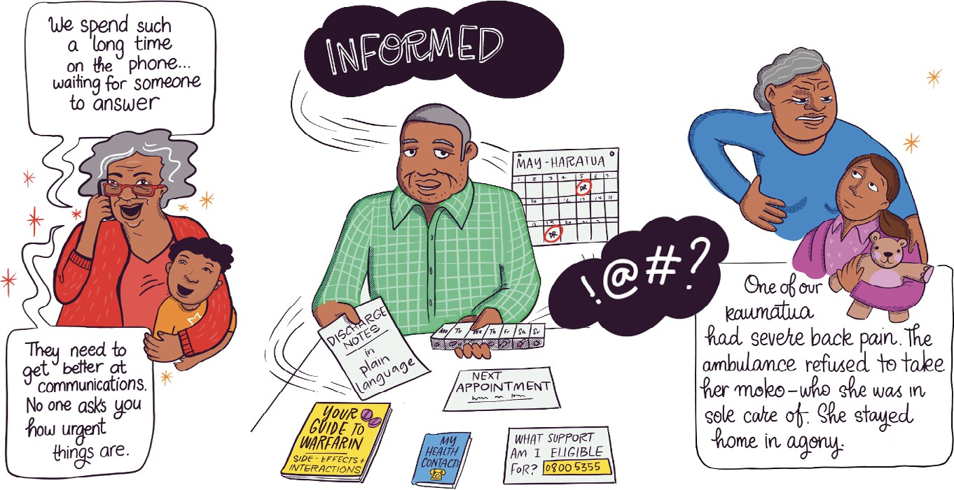
Participant at hui | meeting hosted by CNSST (formerly the Chinese New Settlers Services Trust) Foundation focused on the health and wellbeing of older Asian Aucklanders.

This section features live illustrations from a hui with kaumātua affiliated with Rauawaawa Kaumātua Charitable Trust, by the League of Live Illustrators.
Reproduced in this report with thanks to Rauawaawa Kaumātua Charitable Trust.

Insights

Older people, wherever they live, need to be discharged safely from hospital to adequately staffed, sustainable, quality care delivered by the HCSS and ARC sectors
Older people who cannot be discharged from hospitals due to a lack of community care options risk ‘pyjama paralysis’ and worsened health outcomes as they wait for discharge.17 Older people face prolonged and unnecessary hospital stays because they cannot access either HCSS or an ARC home to safely exit hospital.18 Initial data shared with HDC by Te Whatu Ora | Health NZ in March 2023 (not reproduced as it needs standardisation across regions) indicates that this is a concern for older people. Older people in different regions are waiting too long for ARC beds to be available,19 and this has a negative impact on their health and wellbeing. The lack of a sustainable continuum of care that ensures that older people can access HCSS or ARC when they need it also places additional capacity constraints on the hospital care system, directly contributing to delays in emergency and specialist care services.
Avoidable or ‘ambulatory sensitive’ hospital (ASH) admissions show that people cannot always get primary care when they need it. Closures of after-hours primary care services in some regions also means that people are more likely to visit hospitals.
It is promising to see that the interim Government Policy Statement (iGPS) on Health, valid to 2024, considers measuring ASH admissions for people aged 65 and older. Te Whatu Ora | Health NZ already tracks ASH admission rates for those aged 45–64 years, in its National Performance Metrics (NPMs) measuring the performance of Te Whatu Ora | Health NZ services.20

The available data shows that Pacific people aged 45–64 years experience around double the rate of ASH admissions than the general population in that age group, closely followed by high avoidable hospital admissions for Māori.
Reducing ASH admissions for Māori and Pacific peoples should be an urgent priority.
The data also shows regional disparities in ASH admisions with some regions having comparatively higher rates than others for people aged 45–64 years. The avoidable hospital admission rate for this age group increased by more than 10% in three districts (Lakes, Nelson Marlborough, and South Canterbury) between the year to March 2022 and the year to March 2023.21
ARC has a rising shortage of beds, especially at the highest levels of care. The Aged Care Association (ACA) states that the financial performance of its members (most of the ARC sector) has fallen exponentially due to COVID-19, rising wages, inflation, and clinical workforce shortages, while subsidies and other revenue sources have declined. The average reported EBITDA (Earnings before Interest, Taxation, Depreciation and Amortisation) per occupied bed day has fallen from $23.82 to $3.94 in just five years. More than half of ACA members made a net loss in 2022/23 (around $4.24 per operating bed day).22
The ARC sector has decreased its provision of hospital- level care, especially much-needed specialist dementia mate wareware (psychogeriatric) care, which provides enhanced services for people with advanced dementia mate wareware. From January 2022 to June 2023, the ACA reported that around 66 specialist dementia mate wareware or psychogeriatric care beds had closed among its members (who represent most ARC providers).23

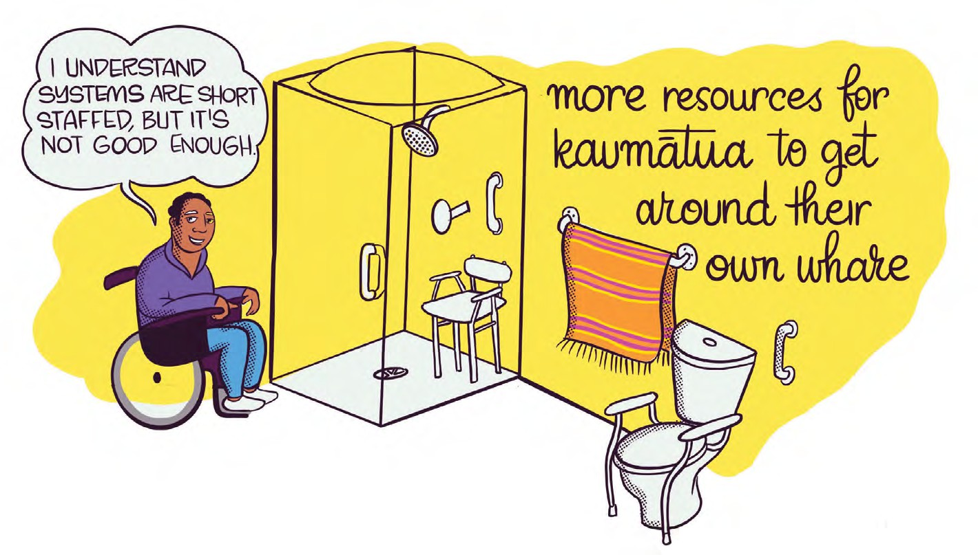
There are significant geographical inequities across the country in relation to psychogeriatric service provision, and significant patient and whānau | family harm is caused by the lack of access to appropriate care for people living with dementia mate wareware and other cognitive and mental health conditions. To the best of our knowledge, no provider in the private sector is currently including a psychogeriatric level of care when building new facilities. This is a concerning prospect for the growing ageing population, particularly as we will see an increased number of people living longer with dementia mate wareware and other conditions over the next decade.
While people who live in rural regions will need to travel to access specialist residential care, harm can also be caused by separation of couples and whānau where consumers must seek care in another region a long distance from their home. There are significant negative impacts on the wellbeing of older people associated with living a long distance away from their spouse/partner and whānau | family.
Training and retaining registered nurses is critical to the sustainability of the ARC sector. The aged-care workforce is under significant pressure. People are entering ARC facilities with higher acuity and complexity of need.
One of the common issues seen on assessment of the more serious complaints HDC receives about ARC facilities is that the skills mix of staff does not always reflect this growing complexity and acuity. In my view, the sustainability of the aged-care workforce is one of the most important challenges currently facing the aged-care sector and has serious ramifications for the quality of care provided to older people.
The retention of registered nurses is critical to ensuring the sustainability of the workforce. Many issues affect the retention of nurses in the aged-care sector — including a lack of pay parity with other sectors, higher pay internationally, and an ageing workforce. When ARC nurses leave their job, around 50% find work in hospitals, 8% go overseas, 5% get another healthcare job, 5% retire, and 4% leave health for another sector. Only 14% of ARC nurses leaving their job remain in the ARC sector.24
Notifications of registered nurse shortages in ARC are self-reported by providers to HealthCERT at MoH.25 In the year to September 2023, HealthCERT received a monthly average of 400 ‘section 31’ notifications of a shortage of registered nurses in an ARC home. This means that there were around 400 instances each month in which ARC homes did not have enough registered nurses to care
for older people. ARC homes also notify HealthCERT of difficulties in recruiting staff — an average of 90% of ARC providers noted this difficulty nationwide.
The Te Whatu Ora | Health NZ Health Workforce Plan (the Workforce Plan) notes that our ageing population will have greater acuity (more unwellness and complex conditions) and higher demand for health and disability services.

Chronic conditions (eg, cancer, ischaemic heart disease, and cerebrovascular illnesses) will be a major cause of health loss for older people as our health workforce ages alongside their patients. Stop-gap measures to address the lack of registered nurses reported to HealthCERT, like rostering senior healthcare assistants instead, potentially puts quality care at risk. Actions in the Workforce Plan need to have an increased focus on non-hospital sectors, especially HCSS and ARC.
We need to train, recruit (domestically and internationally), and retain our aged-care workforce, especially nurses in ARC (at least one-quarter of the roughly 4,800 nurse positions (around 1,200) are vacant in ARC according to the Aged Care Association).26 The aged-care workforce must be prioritised in future workforce planning. We need to grow our aged-care workforce, including doctors (geriatricians, GPs, psychogeriatricians), nurses (including nurse practitioners), pharmacists, social workers and allied health workers.
Patients receiving HCSS and in ARC are among our oldest people and often have complex health needs. The average length of stay in ARC is 18 months, reflecting the high acuity of residents. This means that when people enter ARC they are likely to have complex care needs that necessitate adequate staffing and resources to provide quality care that maximises their quality of life.
International resident assessment instrument (interRAI) data assesses some of our most unwell people discharged from public hospitals needing HCSS or ARC. Many people assessed in ARC homes had some level of dementia mate wareware — underscoring the importance of providing sustainable, appropriately funded psychogeriatric care models. By contrast, interRAI identified around one-quarter of people in ARC with depression (27%); coronary heart disease (24%); and stroke or CVA (cerebrovascular accident/brain injury) (22%). In HCSS, dementia mate wareware (including Alzheimer’s disease) was the diagnosis for 29% of home-care assessments, closely followed by: heart disease (27%); diabetes (22%); stroke/CVA (17%), and cancer (17%).27
Kaumātua need culturally safe ARC.28 Culturally safe ARC must be available for those who need it, especially communities facing rising rates of dementia mate wareware.
Residential care is not the preferred option for many older people and communities to receive care, including kaumātua and their whānau | family. We need Kaupapa Māori-led options for care, including the kaupapa kaumātua- led options for care outlined earlier in the section on kaumātua hauora | wellbeing. Coupled with factors such as increased prevalence and late diagnoses of dementia mate ware ware and other ageing-related conditions, barriers to accessing care, and accessibility of safe home environments, culturally safe ARC homes are needed now more than ever.

Recommendations
- There is a need for a targeted strategy to ensure quality health and disability services for older people. There is no dedicated strategy and planning for the health and disability needs of an ageing population. Despite strategies and action plans relevant to ageing well, there is no coordinated strategy focused on our ageing and increasingly diverse population, including rising numbers of people with chronic conditions and high health needs.
- Better discharge planning by hospitals to support transitions of care for older people from hospital to homes and communities or aged residential care. There would be value in nationally replicating and upscaling existing roles in Te Whatu Ora | Health NZ that support older people to be discharged safely from hospital. A good example is hospital social workers specialising in older people’s health, especially those with dementia mate wareware and complex needs requiring enduring powers of attorney (EPOAs) to enter ARC. This report profiles such a specialist social worker role in Te Tai Tokerau Northland on page 19, which currently is supported by a charitable trust co-founded by a social worker formerly in that role. Other existing roles, eg, clinical nurse specialists in gerontology, should also be resourced adequately and replicated for consistent service delivery to older people, especially those with dementia mate wareware, across all localities/regions.
- Supporting person-centred, culturally safe communication for older people that involves whānau | family, including carers, by continuing to resource and train existing pou tikanga and kaitakawaenga | cultural advisors and interpreters in hospitals. These crucial roles should be available when needed, especially by Māori kaumātua, Pacific matua, and all older people needing culturally safe services. They should be accessible consistently across Aotearoa New Zealand.
- I am pleased to see that Te Whatu Ora | Health NZ is undertaking an aged-care funding and service models review. This is an important step towards older people being able to access the community and residential support options they need and avoid unnecessary or prolonged hospital admissions. HCSS and ARC must be valued as integral parts of the health and disability system and supported to provide high-quality accessible care.
- Any reviews of workforce funding and services in the aged-care sector and future Te Whatu Ora | Health NZ workforce plans should have a focus on actions that contribute to a sustainable aged-care workforce, including a focus on the training and retention of aged- care nurses, healthcare assistants, geriatricians and psycho-geriatricians/psychiatrists, pou tikanga and kaitakawaenga | cultural advisors and interpreters specialising in the health of older people.
- Shortages in psychogeriatric care beds across the country must be addressed urgently. I understand Te Whatu Ora | Health NZ’s funding and service models review of aged care is prioritising the sustainability of psychogeriatric services. This needs to include an analysis of service gaps across the country, ensuring that planning and funding supports geographically equitable access to acute and long-term psychogeriatric care, and developing culturally appropriate models of care that support both acute and long-term care provision in the community wherever possible.
- The funding review must also address the significant gap in the provision of kaupapa Māori aged-care services, particularly for people with dementia mate wareware and psychogeriatric care needs.

Quality improvement: Supporting older people with Enduring Powers of Attorney (EPOAs) in Te Tai Tokerau Northland
Seniors ASAP (Advice, Support, Action, Protection) Trust, based in Whangārei, is a charitable trust born out of an identified need for community-based intervention for older people surviving violence and neglect. The organisation provides advice, support, and intervention options to protect older people at risk, often in hospital settings at points of crisis and transition.
Many older people, their whānau | family and networks are unaware of, or struggle to access, intervention against abuse of older persons. Many private healthcare practices in Whangārei have identified a need for the type of services offered by ASAP Trust.
Issues stemming from violence against older persons could range from physical assaults to theft or inappropriate activation of EPOAs. ASAP Trust aims to empower older people by providing information and options around individual needs and risks face to face or via phone or video calls. Services include helping an older person or their whānau | family to develop safety or care plans; providing social work services so that the older person can be safe at home; and helping to connect to available services or providing access to refuge or safety. ASAP Trust can also coordinate intervention options for older people with affected decision-making capacity, supporting people with no EPOA to transition into aged residential care.

In addition to directly serving older people, their whānau | family and other concerned people, ASAP Trust wants to improve awareness in the community of intervention options for vulnerable older people. Improved community knowledge, including for GPs and other professionals and residential facilities and services, will help more people understand how to access interventions before a crisis emerges. The work has the potential to decrease the prevalence of abuse and neglect for older people, save on hospital costs and ED admissions, and empower older people and whānau | family.
There is potential for growth of the service to become a nationwide adult protective service with social workers and health providers working in partnership with older people to support their health and wellbeing.

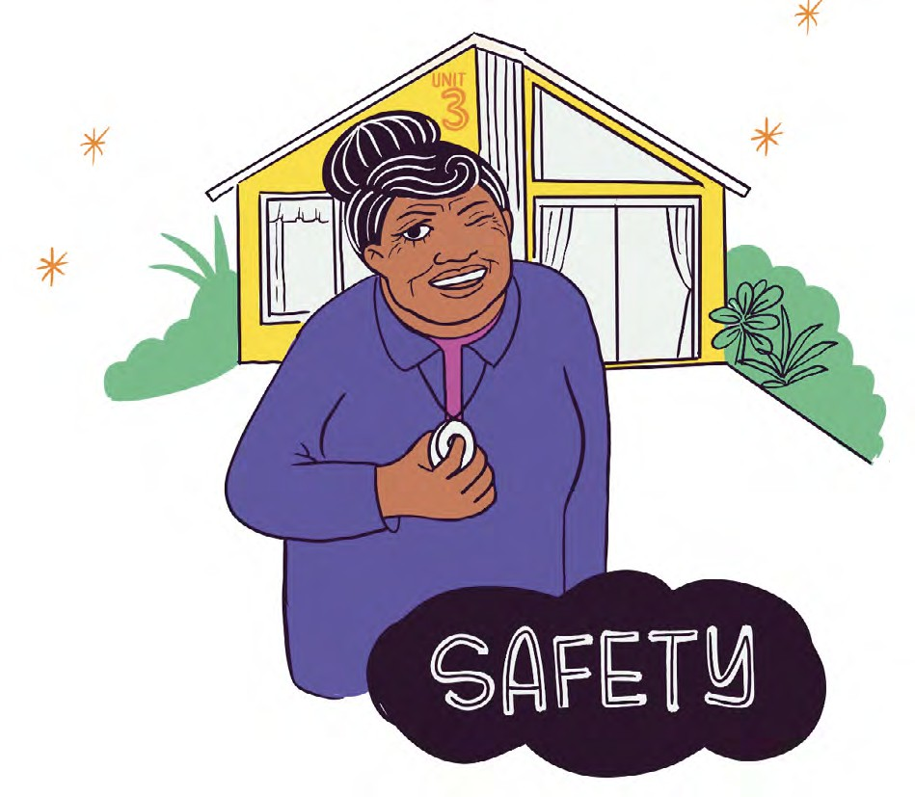

Quality improvement: Digital equity for people with dementia mate wareware — the University of Auckland collaborating with Te Aka Mauri Rotorua Library
A project between the University of Auckland and Te Aka Mauri Rotorua Library (with funding from Internet New Zealand) improved digital capacity in people living with dementia mate wareware. The project — the first of its kind in Aotearoa New Zealand — was led by University of Auckland researchers, and was co-designed with members of the community. Library employees, upskilled as digital mentors, used tablets, apps, and the internet to pass on their digital capability to people in the community living with dementia mate wareware.

Quality improvement: Maintaining connection in aged residential care (ARC) through WeChat
During COVID-19 lockdowns, restrictions were placed on visitors to many care homes, increasing the risk of social isolation for residents. In addition to levels of social isolation faced by older people in the general population, older Chinese people may face additional challenges due to language and cultural barriers. A research study that looked at how information and communication technologies might enhance and maintain social connections between families and older Chinese people in aged residential care found that WeChat (a social media messaging app) was effective for maintaining social connections.29 This was particularly true when usage was facilitated by staff in the facility.

We need transformative models of primary and community care so that older people can access care when they need it, including navigation/social care roles and preventative action on dementia mate wareware and other ageing-related health conditions

Voices of older people

Voices from attendees at connection and collaboration hui | meetings hosted by the Aged Care Commissioner
‘Why can’t clinical support come into the home, rather than take the person from their home just for clinical support. Bring this one thing into the house, rather than take the person out … [The clinical support staff] could come into groups of 8 or 10 houses.’
Participant at a hui | meeting with kaumātua affiliated with Waikato iwi.
‘GP shortages reduce access and time in appointments. This diminishes the potential for meaningful relationships to be formed with healthcare providers.’
Participant group at hui | meeting co-hosted by the Aged Care Commissioner and Alzheimers New Zealand.

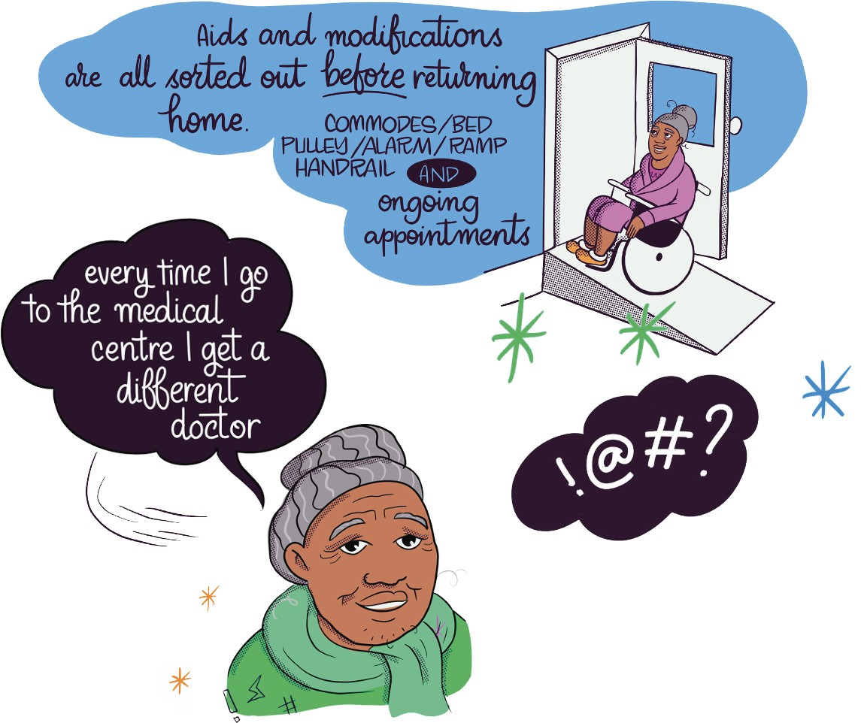

Insights

A need for transformative investment in primary and community care, especially lifting numbers of GPs, better use of nurses and pharmacists, and new models of care and technology.
Older people are concerned about waits to access GP care. In my engagement with older people, they consistently raised difficulties in being able to see a GP as a real concern. Te Tāhū Hauora | HQSC consumer experience insights show that some people do not get primary care when they need it, with inequitable access more pronounced for Māori and Pacific people aged 45–64 years.30 The inequity in demand for GP care for Māori adults has increased steadily each year. The prevalence of being unable to get an appointment has also risen year-on-year for Māori and Pacific adults.31
Older women are more likely to wait more than a week for an appointment than older men.32, 33 Women can face compounding barriers to seeing a GP, especially disabled women (60% of women aged 65 plus are disabled);34 carers (women are 63% of unpaid carers, who are an
ageing, unpaid workforce);35 and those with responsibility for childcare or other family duties. Other barriers to accessing primary care can include commuting distance from GPs and opening hours of clinics versus hours of paid and unpaid work (people cannot see their GP due to caring and other responsibilities).
While barriers to accessing GPs are less likely to be about cost for older people, analysis of 2016/17 Health Survey data found significant inequities. Eleven percent of Māori aged 65 and older reported cost as a barrier to seeing a GP, compared to 6.5% of non-Māori.36 Survey data for 2022/23 confirms that Māori, tāngata whaikaha | disabled people, and people living in more socio-economically deprived areas were more likely to face cost as a barrier to seeing a GP.37
The numbers in GP workforce in New Zealand is declining — we need to grow the rural GP workforce and ensure a strong and equitable domestic workforce pipeline. GPs are an ageing workforce — more than half intend to retire in the next decade, and over a third in the

next five years. GPs serve an ageing population, especially in rural areas,38 with people aged 65 plus being the age group most likely to live rurally, especially kaumātua aged 65 and older (34% of whom live rurally).39
I am pleased to see that the primary care and medical workforce has been prioritised in the Te Whatu Ora | Health NZ Workforce Plan. Initiatives such as the $9,100 accommodation allowance for GP trainees living within 30 km of their rural GP practice are welcomed.40 The Pae Ora Rural Health Strategy also recognises the acute shortages and ageing workforce of GPs as a priority.41 I look forward to seeing actions to train and support more GPs in rural areas, including capability-building on older people’s health to ensure a strong and equitable domestic workforce. The
Workforce Plan intends to increase international recruitment by around 300 FTEs a year with a focus on GPs and senior medical officers (SMOs).42
There are also very few Māori (4%) and Pacific (1.7%) GPs in Aotearoa New Zealand, reflecting an inequitable workforce pipeline.43 The Workforce Plan commits to increasing the number of specialist GPs trained each year to 300 by 2026, with a focus on growing Māori and Pacific GPs. These measures could focus on GPs specialising in older people’s health, including Māori GPs in rural areas to serve kaumātua, and Pacific GPs focused on urban health to serve Pacific matua. The LiLACS study (Living in Advanced Age Cohort Study — Te Puāwaitanga O Ngā
Tapuwae Kia Ora Tonu) found that of older adults in primary care, Māori in advanced age (aged 80–90 years) were less

likely to report that their doctor was excellent or very good at putting them at ease during a physical examination than non-Māori (aged 85 years and older).44
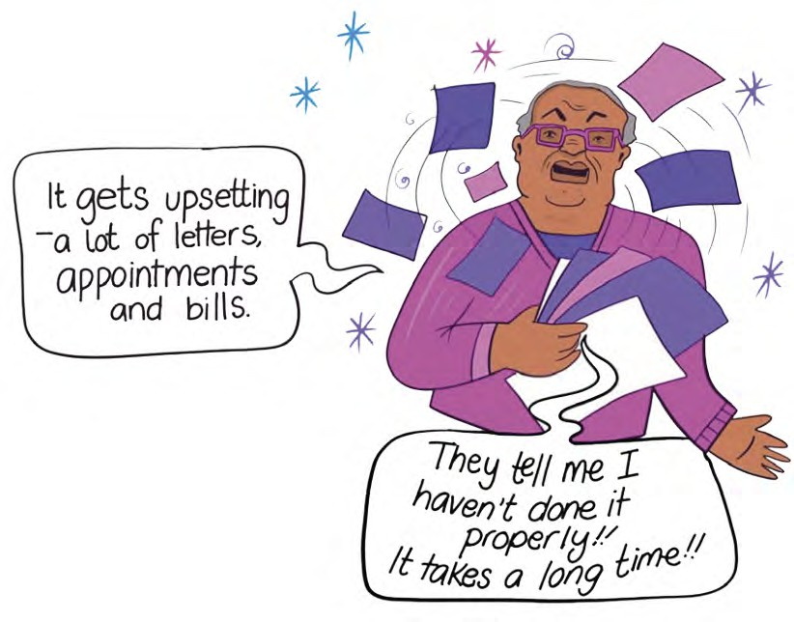
Long wait times to see GPs may be driven by current numbers of GPs. As seen below, we have a relatively low and reducing supply of GPs for our population. In 2021, New Zealand had 74 GPs per 100,000 people, compared to Australia with 116 and Canada with 124 GPs per 100,000 people. This is projected to drop to 70 GPs per 100,000 people in Aotearoa New Zealand by 2031.45

Multidisciplinary primary care teams with an increased focus on nursing and allied health workforces can improve care for older people, who prefer having a consistent contact/relationship in primary care.

I have been pleased to see a focus in the current workforce plan on shifting care closer to people’s homes by expanding the primary and community workforce and developing models of care where people work together across disciplinary lines in cross-disciplinary teams. The development of multi-disciplinary, comprehensive primary care teams has the potential to improve care to older people, particularly in respect of ensuring continuity of care (especially a primary relationship with a healthcare professional) and access to preventative care.
With phone and other telehealth (eg, app-based, virtual) services on the rise, it is important that older people know their options and have support to get quality health and disability care. Older people may need digital literacy training and financial support (eg, subsidised phones and internet) to access services. In rural areas where internet connectivity is an issue, more phone consults and appropriate telehealth tools could be used. This could include sites where older people visit to access IT to connect to virtual appointments and other care, including public libraries, community centres, faith-based spaces, and other places.
I would encourage innovations that see models of care where, for example, more practice nurses who are community based provide services to support those with chronic conditions. Increasing the proportion of people aged 85 plus seeing a practice nurse regularly could reduce hospital admissions and increase consumer engagement (and potentially generate cost savings). New Zealand research shows positive results on ‘rebalancing’ the use of practice nurses by people aged 85 plus. This group, who currently has the most health vulnerabilities and acute bed days in hospital, had a significant decrease (25.5%) in public hospital admissions.46 There are good examples where this is working currently, but we need a consistent approach.

Older people and whānau | family consistently voiced their preference for meaningful relationships with primary care professionals. Another study shows that older people in rural areas often saw nurses as reliable contacts given long wait times, inadequate continuity of care, and difficulties accessing specialist care.47 Likewise the LiLACS study of people in advanced age found that pharmacists were the primary healthcare professionals seen by most people alongside GPs.48 A ‘connector’ social care role specialising in older people’s health and disability services could provide the relational aspect of ongoing care that is valued by older people, especially those with high health needs, while reducing pressure on workforces operating at capacity.
It is positive to see that Te Whatu Ora | Health NZ has acknowledged the shortage of pharmacists and has identified them as a high-risk workforce. Pharmacists’ involvement in multidisciplinary teams can also promote and support medication reviews to enable safe reduction of medications by GPs, alongside support for GP awareness and knowledge, and better communication between multiple prescribers.49 Older people, especially those aged 85 plus and Pacific people, face high rates of problematic polypharmacy.50, 51

Public health interventions in primary and community care can help prevent dementia mate wareware by increasing subsidies for hearing aids and ear health care and improving social connections.
Research published in The Lancet in April 2023 estimates that the attributable risk of dementia mate wareware from hearing loss is 29.1%. Access to support for prevention of hearing loss, such as hearing tests and subsidised/funding options for those needing hearing aids reduces the risk of developing dementia mate wareware by up to 8%.52 Hearing loss affects up to 90% of older adults living with dementia mate wareware and is more prevalent in people with dementia mate wareware than for their peers who do not experience cognitive decline. Hearing loss and declined cognition can diminish people’s quality of life and increase social isolation and dependency on others.53 The risk of dementia mate wareware is likely to be higher for Māori and Pacific people, due in part to prevalence of untreated hearing loss.54
Hearing aid subsidies have not risen in Aotearoa New Zealand in some years. Every citizen and permanent resident aged 16 years and older can get a government subsidy of $1022.22 towards a pair of hearing aids (or up to $511.11 for a single hearing aid) every six years.55 This is different to other jurisdictions, eg, the United Kingdom, where hearing aids are provided either free by the National Health Service (NHS) or paid for privately. Around 85% of hearing aids in the UK are obtained for free via the NHS.
The WHO recently declared loneliness a global health concern and announced a Commission on Social Connection 2024–2026, reflective of global data showing that one in four older adults experience loneliness.56 Many quality improvements in this report show how social connection programmes can alleviate loneliness. A UK study in 2020 (before the COVID-19 pandemic) showed that perceived loneliness (but not social isolation) predicts the development of all-cause dementia mate wareware, especially Alzheimer’s type, in older people. People with supportive social relationships with relatives and carers may be protected from cognitive decline, with the quality of connections more important than how often people met in person.57
While loneliness is not synonymous with isolation, it may have overlaps with physical and social isolation, especially since the COVID-19 pandemic. New Zealand research shows that for kaumātua, living in culturally centered, age-friendly communities lowers social isolation.58 Physical isolation, including ‘touch deprivation’, and the consequences of the pandemic have exacerbated loneliness, especially for residents in ARC homes during restrictions where whānau | family were unable to visit older people. New Zealand Europeans | Pākehā living in ARC homes were more likely to have higher rates of severe depressive symptoms versus lower rates of loneliness among kaumātua.59 With dementia mate wareware the most common interRAI diagnosis, and depression the fourth most common diagnosis in ARC, it is important to prioritise social connection interventions to both prevent and intervene in addressing dementia mate wareware among people in ARC in particular.

Recommendations
- Primary and community care, especially GP clinics, should be valued as critical partners with priority investment in changing models of primary and community care. I am pleased to see that Te Whatu Ora | Health NZ is undertaking a primary health funding review, and I support its intention to create comprehensive community care teams. These teams have the potential to reduce hospital admissions, improve continuity of care, and lift older people’s access to preventative and integrated care. These multidisciplinary care teams should include roles with an enhanced or dedicated focus on the health of older people.
- Older people have expressed the importance of enduring relationships and having a single point of contact for primary care. A health worker and/or social care worker focused on older people’s health could have an important navigator role to support people and whānau | families with complex conditions to access and transition between services. Such roles could also support priority populations, including kaumātua, Pacific matua, and tāngata whaikaha | disabled people aged 50 plus.
- Investing in innovation, especially models of care to keep older people safer and well for longer in communities, is important, and I hope such innovation becomes a focus of the aged-care funding and service models review. Supporting GP practices to become integrated comprehensive community care teams can assist in keeping older people at home for longer. Whilst currently there are some positive examples of these models of care across Aotearoa New Zealand, this is not consistent.
- I am supportive of initiatives such as the 24-hour rural telehealth line recently established to ensure more equitable access to primary care services in rural areas. Innovations that assist wider access for those in rural areas to access scarce resources, such as specialist services, are welcomed. The focus should be on areas needing immediate relief, such as GP clinics and health hubs, and HCSS, especially doctors, nurses, and healthcare assistants.
- Regular training and development of primary and community care providers and staff on the health and wellbeing of older people, and ageing-related health and disability conditions could be supported by modelling professional networks based on successes of clinical networks by Te Whatu Ora | Health NZ, and lessons from the ‘community connector’ role at MSD.
- Preventative actions to reduce dementia mate wareware include increasing hearing aid subsidies. The subsidy for hearing aids has not been increased for many years, and cost may be a barrier for some older people, including those from communities with rising rates of dementia mate wareware. The New Zealand hearing aid subsidy should be increased to cover the cost of hearing aids, including assessment and fitting, and the hearing aid funding scheme should be extended to cover the cost of fitting and assessing hearing aids. There is also a need to increase funding by ACC, which applies to people for whom more than 6% of hearing loss is due to an injury.60 Other avenues are also available for people to have their hearing aids funded, eg, by Veterans’ Affairs if they are veterans who have hearing damage or who developed tinnitus while serving in the New Zealand Defence Forces. The cost of providing hearing aids to those who need them is far outweighed by the benefits and cost savings from preventing, diagnosing, and treating dementia mate wareware.
- I support the public health actions to prevent dementia mate wareware as outlined in the Dementia Mate Wareware Action Plan, and I will continue to monitor how these actions are delivered and their effects on the health of older people. These actions include addressing loneliness by investing in locally led, kaupapa Māori/kaupapa kaumātua, community-driven social connection programmes for older people and their whānau | family, some of which are profiled in this report. Successful projects funded under the Action Plan will require ongoing sustainable funding if they take a preventative approach to delaying onset and symptoms of dementia mate wareware.

Quality improvement: Cognitive stimulation therapy (CST) for kaumātua living with dementia mate wareware
The number of Māori living with dementia mate wareware is projected to increase to around 4.5k in 2026. Based on research, there is a need to increase culturally appropriate community support for kaumātua and whānau | family living with dementia mate wareware in the community.
Haumanu Whakaohooho Whakāro — Māori is the first type of cognitive stimulation therapy (CST) specifically adapted for Māori kaumātua living with moderate to mild stages of dementia mate wareware. CST was first developed in the United Kingdom and has been shown to improve cognitive function and quality of life for people living with mild to moderate dementia mate wareware. The Haumanu Whakaohooho Whakāro — Māori programme was adapted for use with Māori by Dr Makarena Dudley (Te Rarawa, Ngāti Kahu), a clinical neuropsychologist and researcher at the Centre for Brain Research at Waipapa Taumata Rau University of Auckland, with support from Alzheimers New Zealand. Collaborators include Dr Tai Kake (Ngāpuhi, clinical neuropsychologist), Dr Kathy Peri (Director of the Dementia Learning Centre, Alzheimers New Zealand) and Dr Gary Cheung (Associate Professor, School of Medicine, University of Auckland).
To be effective, CST interventions need to fit within the cultural context of the person receiving the therapy.
Haumanu Whakaohooho Whakāro — Māori has been embedded in tikanga Māori | customary practices and te ao Māori | Māori worldview. Feedback from kaumātua living with dementia mate wareware showed that certain activities were helpful — for example, being active on the marae, speaking and listening to te reo Māori | the Māori language, singing waiata | song, and reciting karakia | blessing.
Haumanu Whakaohooho Whakāro — Māori is based on concepts of Reality Orientation, Validation Therapy, Reminiscence Therapy, and cognitive stimulation, and is underpinned by 18 principles that encompass all that is required to keep the person’s mana intact, to support them and to provide them with quality experiences. The programme contains 15 activity-based sessions delivered over seven weeks in groups of up to eight people. Each session has a different focus and can include topics such as sounds, orientation, childhood, food, physical games, and current affairs — all designed to help trigger memories and challenge and extend cognitive abilities. Customised programmes will be delivered by Māori CST facilitators in te reo Māori. In future, its founders hope to adapt this tool to meet the diverse cultural needs of Aotearoa New Zealand.

Quality improvement: Lived experience of dementia mate wareware — My Life’s Journey on an app
My Life’s Journey app creator Alister Roberston is living with dementia mate wareware and created the app using Reminiscence Therapy, an important tool for people living with dementia mate wareware. Reminiscence Therapy is based on recounting and capturing past memories. Through the app, people can weave together and record their life story to share with others. This could include carers, who can use the tool to prompt conversations and get to know the person with dementia mate wareware better. The
app has been designed to be intuitive and features ten categories that provide a means to prompt and stimulate memories.
The My Life’s Journey app was funded by a grant from the Ministry of Social Development (MSD) and is provided on a secure platform to enable privacy.

Quality improvement: Empowering kaumātua to prevent falls — Taurite Tū
Taurite Tū is a falls prevention and wellness programme designed around the needs of kaumātua. The name combines the words taurite | balance and tū | to stand.
This refers to standing strong as the elements of wellbeing are balanced (a holistic approach), and of course balanced standing. Taurite Tū combines best practice from both mātauranga Māori | body of wisdom, knowledge, understandings and from falls prevention rehabilitation and science.
In older people, falls are a common cause of injury and even death. Research has shown that strength and balance- based exercises for older people can significantly reduce the risk of falls. Accredited strength and balance-based mainstream falls prevention programmes are widely offered in the community but are not well attended by Māori.
However, Māori have higher rates of mortality and risk of hospitalisations than non-Māori from unintentional injuries, including falls.
Taurite Tū is the only kaupapa Māori, evidence-based approach that meets all the criteria for an effective falls- prevention community-based programme. The programme is led by Māori and designed by kaumātua to improve physical strength and help prevent falls.

An initial pilot research programme developed by physiotherapist Katrina Pōtiki Bryant and Te Rūnanga o Ōtākou funded by the Health Research Council (HRC) found that Taurite Tū not only reduced falls for Māori participants but had an 85% attendance rate. It also delivered other wellness benefits, such as increased awareness of body posture, enhanced whanaungatanga | socialisation and a sense of connection with the Māori community.
A longitudinal study started in 2021 (funded by HRC, ACC, and the Ageing Well Science challenge) to deliver the programme in Ōtākou takiwā. The study is also assessing the replicability of Taurite Tū with rohe | regions outside of Ōtākou and it is hoped that these insights will enable Taurite Tū to be easily replicated for kaumātua throughout Aotearoa New Zealand.
Findings from the Taurite Tū research could improve equity for Māori in the health system by reducing injuries and improving access to ACC services. Taurite Tū has the potential to develop into a wraparound service providing follow-up care and connecting kaumātua with a range of service providers.
Taurite Tū is led by the Te Rūnanga o Ōtākou Taurite Tū Research team. See: www.ageingwellchallenge.co.nz.

Older people need access to reliable, quality care to age well at home
Voices of older people

Voices from attendees at connection and collaboration hui | meetings hosted by the Aged Care Commissioner

‘Relying on carers (with) no relief options (creates) unrelenting pressures and presents health and safety risks both to the carer and older person.’
- Participant group at hui | meeting co-hosted with Alzheimers New Zealand.

‘Care is disconnected. Collective action between organisations [is required] to dissolve the obstacles and seniors need to be asked what they want and need to understand their individual health and welfare needs.’
- Participant group.

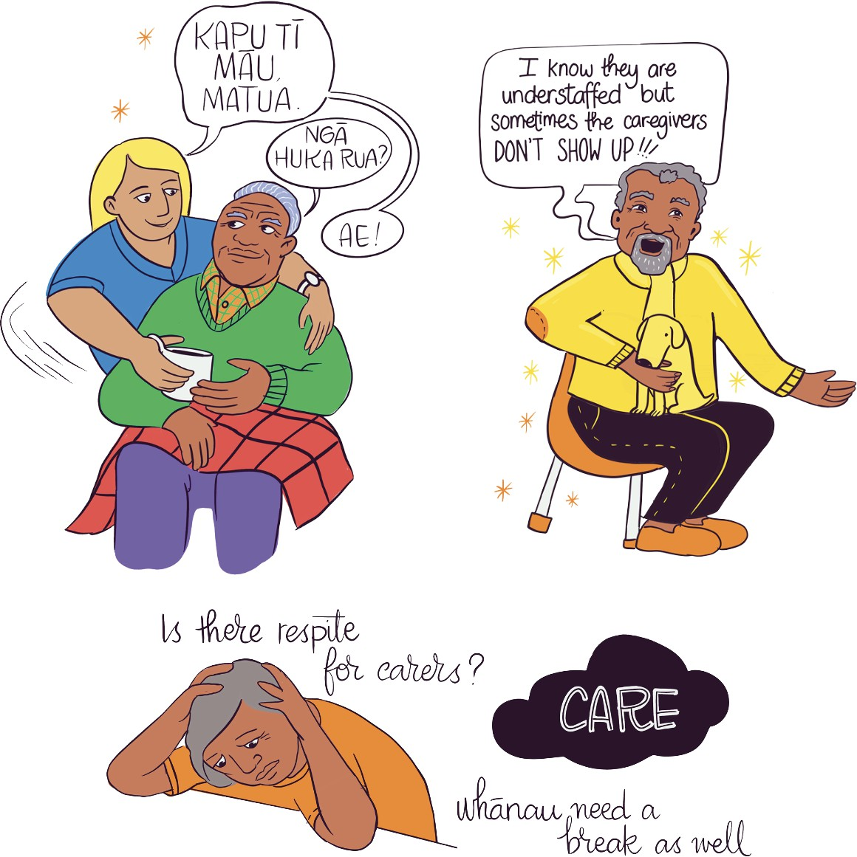

Insights

On the potential of Home and Community Support Services (HCSS) to support older people to age safely at home with whānau and communities, especially those with high health needs and complex conditions
There is a need for more comprehensive and transparent monitoring for HCSS to ensure that consistent care is provided nationally. I have been concerned by the number of complaints I receive from older people and their whānau | family about the capacity and capability of home care and community services to meet their needs. These complaints highlight the detrimental physical and psychological impacts on older people and their whānau | family caused by inconsistencies in availability of care and unexpected and unwarranted reductions in the level of care provided.
The national data available on ‘missed’ and inadequate care is at odds with insights shared with me by older people and their whānau | family. There is a need for greater transparency over the care provided by home and community-based services — noting that the care is provided in people’s homes by a largely unregulated workforce. It is positive to see that there will be a comprehensive monitoring framework to oversee the quality, safety, and equity of the HCSS system. It is hoped that such a framework will include regular assessment of consumer and whānau experience.
HCSS has complex funding arrangements that influence service expectations and access for older people, especially those with dementia mate wareware and cognitive conditions.61 A rigid age-demarcation between a disabled and older person at the age of 65 years has several equity implications. HCSS, like ARC, is a mix of private/for-profit and non-profit providers who are funded mainly by Te Whatu Ora | Health NZ and ACC, with some funding from Manatū Hauora | the Ministry of Health and Whaikaha | the Ministry of Disabled People, Te Aka Whai Ora | the Māori Health Authority, and Te Manatū Whakahiato Ora | the Ministry of Social Development (MSD) depending on health need.
More than 70% of people provided services by the HCSS sector are aged 65 plus. Many have chronic conditions, with the Home and Community Health Association (HCHA), a peak body of 34 providers (including 11 kaupapa Māori agencies) serving 100,000 people, noting rising rates of dementia mate wareware.62 Navigating HCSS can be difficult for older people, with recent research finding poor lines of communication and fragmentation of services, affecting quality and equity of care. Complex funding arrangements can also make the system difficult to navigate.63
Complex funding arrangements have implications for consumers, especially kaumātua, Pacific matua, and tāngata whaikaha | disabled people aged 50–64 years who are predisposed to ageing-related conditions but who may not qualify for funding for these conditions until they reach the age of 65. Tāngata whaikaha | disabled people can also lose access to funding for disability-specific services at the age of 65, as they are now considered an ‘older person’.
Older tāngata whaikaha | disabled people with whom I met reported being subsumed into mainstream older people’s health services that are not designed to accommodate their lived experiences.64 The age-based demarcation between a disabled and older person is clearly too rigid, and the current funding model does not provide appropriately for variable needs, lived experiences, life expectancies, and rates of ageing and morbidity across different population groups.
The challenge to sustainability of HCSS is of concern to older people with complex needs and who may be admitted to hospital due to inadequate access to care. These challenges for sustainability of HCSS pose risks for people with cognitive impairment and/or other conditions requiring complex care. Around 25% of people served by the HCSS sector have moderate or severe cognitive impairment.65 Dementia mate wareware, including Alzheimer’s disease, is the most common diagnosis in interRAI assessments in the HCSS and ARC sectors.66 The shortage of dementia mate wareware and psychogeriatric care beds67 means that the availability and capability of HCSS is even more important, particularly in respect of its ability to provide appropriate care for people with more complex or acute needs.
Other common diagnoses for people using HCSS include heart disease (27%), diabetes (22%), stroke/CVA (17%), and cancer (17%), the majority of which are for people older than 65 years. A review of 36,000 interRAI home care assessments in 2022/23 showed that 56% of older people are at high risk of future ED use in the coming six months.68 Avoiding admission to EDs for people with these and other conditions requiring HCSS keeps them safe at home and reduces strain on already overburdened emergency and hospital services.
Variable funding arrangements mean that there are geographical inconsistencies in access and quality of care. Currently, funding for HCSS across the country is a mix of bulk funding and fee-for-service models.
Inconsistencies in funding arrangements are not reflective of costs, which are generally consistent nationwide. Fee-for- service models ensure that providers are paid for the inputs they have for individual consumers they serve. Providers who are bulk funded may be able to tailor their services as people’s needs change. Flexible budgets, decision-makers sharing the same goals, and deciding service mix at a local level could help achieve better funding for the sector and improved health outcomes for older people receiving HCSS.
A Productivity Commission case study on HCSS in New Zealand in its inquiry into social services recommended a focus on client choice to guide the HCSS sector (including on funding models). It was also recommended that this be accompanied by systems providing guidance and information for older people exercising choice and that guard against violence.69 The Commission recommended a client-directed service model for HCSS for older people (and for respite and drug and alcohol rehabilitation services). This shift would need ‘significant change in mindset for many officials and providers’, with time and resources for new ways of working.70
There are declining levels of HCSS available, especially in rural areas. Between 2015 and 2019, 20 HCSS providers left the market and most of the remaining providers were in urban centres.71 It is likely that since 2019, with the onset of the pandemic, rising costs, and inconsistent funding models, more HCSS providers have closed or reduced services.72
We need to better track the demand for home and community-based care now and in the future. While there is a Te Whatu Ora | Health NZ demand planner for ARC beds, there is no analogous tool to track current and future demand for HCSS. HCSS is a crucial service in managing demand for ARC, hospital, and specialist services. Tracking current and future demand for HCSS would allow for more robust whole-of-sector planning, while also ensuring that the needs of an increasingly complex population can be met.
We need to focus on the recruitment and retention of the HCSS workforce, in particular skilled healthcare assistants, to ensure the sustainability of HCSS. There are around 18,500 care and support workers supported by 750 nurses and allied health staff, including physiotherapists, clinical coordinators, and managers.
The average age of the HCSS workforce is 55 years old, reflective of an ageing workforce that is primarily women (93%) and Pākehā (82%).73 A 2019 survey estimated that around 11% of community support workers were Māori.74
There is a need to grow and diversify the HCSS workforce to meet the needs of our increasingly diverse and ageing population. There are an estimated 1,300 vacancies in HCSS with reported shortages and high turnover in all roles.75
Opportunities to value the HCSS workforce are about more than pay and include access to sufficient hours of work. The pay equity settlements of 2017 have delivered access to fewer working hours for care and support workers (level 3 and 4 in the New Zealand Qualifications Authority framework).76 A 2019 survey of the aged-care workforce found that 61.5% of home and community support workers would like to have more hours of work.77 Fewer hours available to care and support workers has resulted in quality of care being diminished in some cases, as well as increased workloads.78 A coherent workforce development strategy is needed for this workforce, with no actions to build or retain this workforce in the Te Whatu Ora | Health NZ Workforce Plan.
We need to invest in education and technology to upskill care and support workers and provide person- centered digital tools that help them deliver care, and to support whānau, especially carers who are filling care gaps.79 Adapting to new communication, services, and social supports has been challenging for older people since the onset of the COVID-19 pandemic, with new needs for technology and digital literacy skills.80 The Office for Seniors | Te Tari Kaumātua has a Digital Inclusion Action Group that provides digital literacy skills to older people nationwide to help them to access health and disability services, which increasingly are delivered online.81 More consumer experience data is needed to see how older people receive digital care, eg, nurse telehealth consults as part of HCSS, especially in rural areas or cities with shortages of older people’s health services, ARC beds, practice nurses, etc.
Connectivity in rural areas and the affordability of internet and phone services are equity considerations.
In Aotearoa New Zealand there are trials of predictive technology and digital tools to better plan care needs of older residents in ARC with chronic conditions. In South Canterbury, a pilot for at-risk older people living in the community had them wear coin-sized wearable devices that monitored clinical parameters like heart rate, sleep, activity, gait analysis, body position, fall detection, and activity level. An app created by a person with lived experience of dementia mate wareware, My Life’s Journey, is profiled in this report on page 64 as an example of person-centered innovation and hopefully is the first of many resources based on lived experiences of older people.
Whānau | family carers are filling care gaps and need support for their own wellbeing and for their caring relationships with older people in their lives. Whānau| family carers have been filling care ‘gaps’, with growing calls for health leaders, ARC, and HCSS service providers to recognise and acknowledge the unique benefits of this supplementary caregiving support at times of crisis such as the pandemic, when households were socially isolated.
The Australian Royal Commission of Inquiry into Aged Care recommended quality respite for carers earlier and more often for their own wellbeing and to sustain the caring relationship, and for quality respite to be better available.82 In Aotearoa New Zealand the Mahi Aroha Carers’ Strategy and Action Plan 2019–2023 calls for better funding systems to ensure that carers of older people can access government-provided carer support that is meaningful to them. Recent New Zealand research on experiences from the pandemic focuses on carer wellbeing for Māori, Pacific, and rural carers as priority groups.83 Further work is needed for better carer support and respite relief, including investigation of issues being raised by carers and those working with the most vulnerable older people, like violence against older people, hoarding, poverty, and other social determinants of health and wellbeing.

Recommendations
- HCSS has a significant role to play in keeping people well in their communities for longer and in reducing demand on ARC and emergency and specialist services. It is important that the government and Te Whatu Ora | Health NZ value HCSS as an integral part of the health and disability system and adequately support them to provide high quality accessible care.
- Currently, Te Whatu Ora | Health NZ is undertaking an aged-care funding and service models review that aims to improve the sustainability of services and to ensure equity of access and outcomes. To support equity, older people require greater access and choice on community support options, and I am pleased to see that this review includes HCSS. I will be monitoring the outcomes of this review closely. In my view, it will be important that the review considers:
  - The increasingly complex needs of people using HCSS;
  - The overlap between disability and ageing and the inadequacies of using ‘age’ to demarcate access to services;
  - Implementation of long-term nationally consistent flexible funding models across the country;
  - Models of care and funding that support access and choice in HCSS for rural and Māori communities;
  - Exploration of digital technology and tools that can be used to extend the reach of services; and

  - Investing in innovative models of care to address current gaps in the continuum of care, for example developing consistently available community-based acute models of care.
- While providing care in a person’s home is an integral part of keeping people well in their communities for longer, I hold concerns about the lack of transparency over the care provided by HCSS. I support Te Whatu Ora | Health NZ and the Ministry of Health (MoH)’s implementation of the monitoring framework to oversee the quality, safety, and equity of the HCSS system. Assessing consumer experience must be a central feature of such a framework (including consumer experience of the reliability of support).
- Tracking shortages of care and support workers, nurses, and other HCSS workers by Te Whatu Ora | Health NZ would allow the sector to map gaps in services for people who are reliant on this support. It may be that HCSS providers could report shortages of care and support workers and nurses like the ‘section 31’ notifications of registered nurse shortages by ARC providers to HealthCERT at MoH. Like reporting by ARC providers to HealthCERT at MoH, HCSS providers could report both staff shortages and mitigations to deliver services despite these shortages.
- A comprehensive national HCSS workforce dataset collated, shared, and regularly updated by Te Whatu Ora | Health NZ could help prioritise this workforce in any future workforce planning undertaken by Te Whatu Ora | Health NZ and others.
- We also need accurate data on current and projected demand for HCSS by Te Whatu Ora | Health NZ, especially for older people with high health needs. An HCSS demand planner, like the Te Whatu Ora | Health NZ ARC demand planner that tracks current and projected demand for beds in ARC, could help capture current and future demand for HCSS across different regions and assist in ensuring equity of access across the country.

Quality improvement: Caring for South Asian older people in Auckland with holistic health and intergenerational programmes
Bhartiya Samaj Charitable Trust is one of the largest multi- ethnic South Asian groups in Auckland and has more than 1,200 older members. The organisation brings together diverse people from different nationalities, religions, ethnic and cultural backgrounds, and age groups. For older people, opportunities for support, care, learning and contributing to the community are provided through regular meetings (held in Central and South Auckland). Holistic programmes, offered free of charge, are designed around the social, cultural, and emotional needs of older people, and include workshops on health and fitness, digital technology, and English language classes. Festivals and celebrations organised by Bhartiya Samaj are important intergenerational events linking older people to their communities.

Quality improvement: Promoting health of older people through a television show
In response to COVID-19 lockdowns, former district health boards (now Te Whatu Ora | Health NZ) around Aotearoa New Zealand recognised a clinical risk for older people around the loss of functional ability and independence. A multidisciplinary team drawn from universities, government, and non-government organisations developed a free-to- view national television programme for older people called ‘Healthy for Life’. The 30-minute show comprised Super7 (a strength and balance exercise programme) as well as tips on nutrition, safety, sleep, brain health, and social connection. The show, broadcast on weekends nationwide and available through streaming, had an audience of more than 100,000 people. Following the show, focus groups with older people across New Zealand showed that there is a need for more television content aimed at supporting older people.

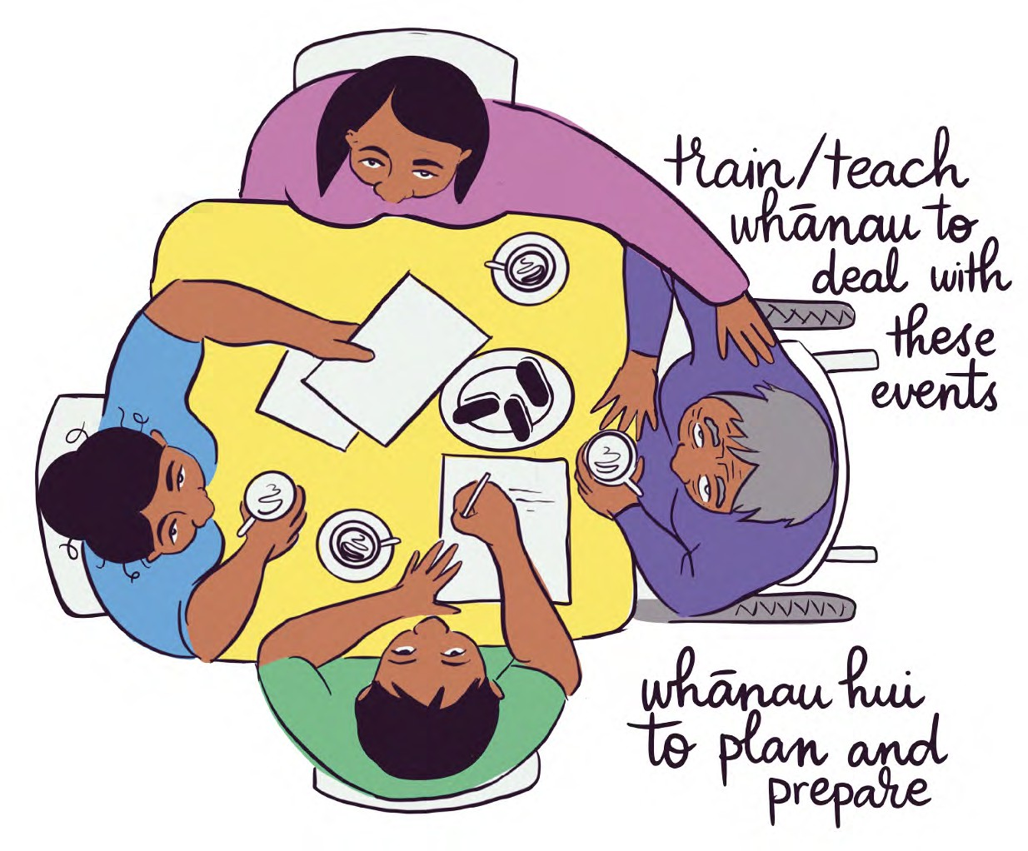

Quality improvement: Providing culturally appropriate care for Asian older people living with dementia mate wareware
A lack of culturally and linguistically appropriate services and resources can create a significant barrier for older people’s access to health and disability services. According to the Dementia Economic Impact Report 2020, Asian people access dementia mate wareware services the least of all ethnic groups, yet the number of Asian people living with dementia mate wareware in Aotearoa New Zealand is projected to triple to 17.9k by 2040.
The Caring for People with Dementia Together (CPT) 護 腦同行 aims to improve services for Chinese older people living with dementia mate wareware and their whānau | family. A 2022 study showed that Chinese New Zealanders lack understanding of the condition prior to diagnosis.
Using insights from this study, the CPT project is working to improve awareness of, and reduce stigma towards, dementia mate wareware for Chinese people. The project aims to improve access to person-centred interventions and provide strategies for healthy ageing for those living with dementia mate wareware, as well as support and education for families providing care.
Age Concern Auckland provides culturally and linguistically appropriate support for Asian older people through their Asian Service, which caters to Mandarin, Cantonese, Korean and Japanese-speaking communities. The support is offered face to face in Auckland and online (including WeChat and Kakao) across Aotearoa. Age Concern provides individual support and group education sessions around issues faced by older Asian people, including violence and neglect. The service runs culturally and linguistically appropriate health promotion activities and workshops in several cities across New Zealand, and an accredited visitor service for those experiencing social isolation. In partnership with the Auckland Chinese Alliance Christian Church, and as part of CPT, Age Concern Auckland also supports the Chinese Healthy Brains Hub 長者健腦俱樂部, which focuses on brain-supporting activities and social connection for Cantonese-speaking older people living in East Auckland.
Quality improvement: Providing community transport helps older residents of social housing stay connected in Tāmaki Makaurau Auckland
The Selwyn Foundation runs a community transport service for Haumaru Housing tenants across Tāmaki Makaurau Auckland. There are several Haumaru Housing communities spread across Tāmaki Makaurau Auckland, but without the means to get around, older residents can become socially isolated. The community transport service uses three age-friendly vans that can accommodate wheelchairs.
By providing a reasonably priced and accessible form of transport, the service enables older people to remain independent and attend community activities and events.
Haumaru Housing provides affordable housing for older people and is a partnership between the Selwyn Foundation and Auckland Council.

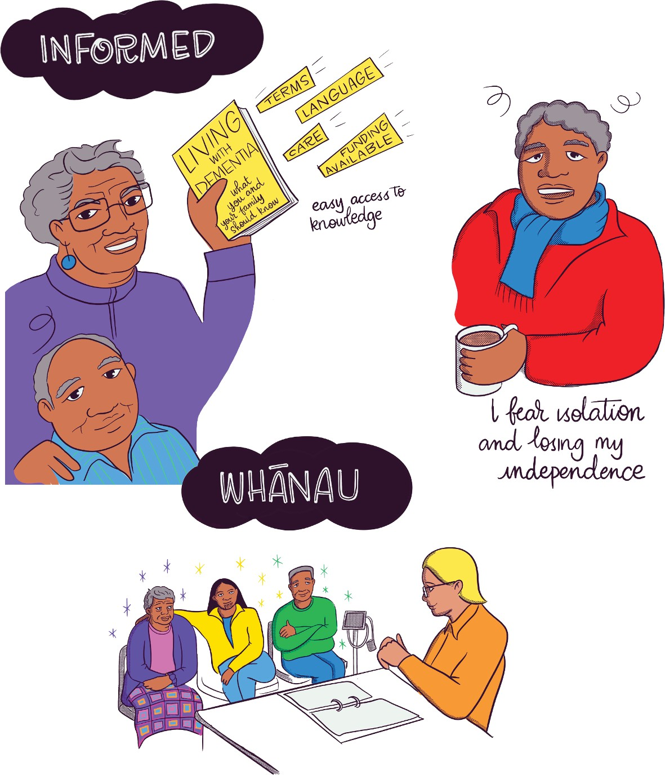

Te tirohanga ake | Next steps and future focus
I will continue to advocate for quality health and disability services for older people across Aotearoa New Zealand. I will also track issues and improvements in health and disability care for older people, including:
- Preventing and treating dementia mate wareware with culturally safe, innovative models of care;
- Ensuring the sustainability of HCSS and ARC, including through the introduction of innovative models of care that are person-centered, use digital technologies and tools, and enable options and choice for older people, including in rural areas and communities under- represented in HCSS and ARC; and
- Supporting kaupapa Māori/kaupapa kaumātua- led approaches to hauora | health and wellbeing of kaumātua and whānau | family in ways that honour Te Tiriti o Waitangi.
A literature review for this report, which will be published on our website, highlighted some other areas to explore in my future work programme as Aged Care Commissioner. I hope these issues will also help guide the delivery of existing government commitments for older people to age well and safely, especially in homes and communities, and will be considered in upcoming iterations of Te Pae Tata | the Interim New Zealand Health Plan, the Government Policy Statement (GPS) on Health, and workforce plans. They include:

Serving older people from different communities
Equity in accessing services for Māori kaumātua, Pacific matua and people of all culturally and linguistically diverse (CALD) backgrounds
- Support for older people from Rainbow and takatāpui communities
- Care for older people living in detention, including those with cognitive and mental health conditions
- Stronger awareness and support for people living in our communities with life-limiting conditions, including cognitive and/or physical impairment, and culturally safe assessment tools for diagnosis

Changing how we deliver care
- Better carer support and quality respite relief
- The role of relationships and delivery of person- centered care
- Using digital technology and tools mindfully, including tracking consumer insights on their effectiveness

Focus on areas of health care for older people
- Oral hygiene care and its role in preventing cognitive and physical impairment
- Mental health and suicide prevention services for older people

Changing how the system supports older people to age well
- Using strengths-based language to consider health and disability needs of older people
- Addressing stigma, bias, and barriers to older people seeking support or using services, especially by providing coordinated, accessible information on available services to reach those in isolated and rural communities
- Strategies and interventions to end the stigma of loneliness and promote social connection
- Considering links between housing, transport, and socio-economic resources to older people’s health and wellbeing
- Addressing violence against older persons as a determinant of health that requires particular attention, including aspects that are especially prevalent in instances of violence against older people as a family violence issue, eg, financial exploitation and abuse, self-neglect by older people, hoarding, etc.

Tikina he āwhina | Where do I get support?

Where to get support for yourself or older people you know
Accessing health and disability care for older people can be challenging, especially for those with complex conditions.
Below is a non-exhaustive list of services that offer support and information for older people and whānau | family.
  - Health and Disability Commissioner (HDC): (freephone 0800 11 22 33). If you are unhappy about a health or disability service you or someone else, including a whānau | family member, received, you have the right to complain to HDC. Visit www.hdc.org.nz.
  - Health and Disability Advocacy Service: (freephone 0800 555 050 or visit www.advocacy.org.nz). The Nationwide Health and Disability Advocacy Service offers free, independent, confidential advice and support to help you resolve issues with health and disability services and talk through your options for making a complaint.
  - Healthline: (freephone 0800 611 116) provides advice from registered nurses.
  - Mental health support: contact the free national helpline at any time (text or call 1737).

  - The Office for Seniors | Te Tari Kaumātua: (phone +64 4 916 3300 or visit: www.officeforseniors.govt.nz). The Office for Seniors is the lead advisor in government on the issues affecting older people. It is located in the Ministry of Social Development.
  - Age Concern: (freephone 0800 65 2 105) offers services including social connection and support, and preventing and addressing elder abuse. Visit https://www. ageconcern.org.nz/.
  - Seniorline: (freephone 0800 725 463) is a national information service to help older people and their whānau
| family navigate the health system. Visit https://www. seniorline.org.nz/.
  - Carers New Zealand: (freephone 0800 777 797) is an independent organisation and national peak body run by and for family carers. Visit https://carers.net.nz/.
  - Alzheimers New Zealand: (freephone 0800 004 001) represents people living with dementia mate wareware by raising awareness, providing information and resources, advocating for services, and promoting research. Visit https://alzheimers.org.nz/.
  - Dementia New Zealand: (freephone 0800 444 776) supports the dementia mate wareware community through awareness and knowledge. Visit https://dementia.nz/.
  - Te Whatu Ora | Health NZ services for older people. Visit https://info.health.nz/services-support/older-people/.

Kupu āpiti | Endnotes
- Note that the pie chart adds to more than 100 as people may identify with more than one ethnic group.
- ACC may cover some portion of hearing aids if hearing loss is due to an injury, including an occupational noise exposure, eg, working around loud sound, or an accident. The amount of funding depends on the cause and degree of hearing loss and how much is due to injury.
- Hokowhitu, B., Oetzel, J. G., Simpson, M., Nock, S., et al. (2020). Kaumātua Mana Motuhake Pōi: a study protocol for enhancing wellbeing, social connectedness and cultural identity for Māori elders. BMC Geriatrics, 20(1). https://doi.org/10.1186/s12877-020-01740-3 [Kaumātua Mana Motuhake Pōi].
- World Health Organization. (2023). National programmes for age-friendly cities and communities: a guide. Geneva. Available at: https://www.who.int/ teams/social-determinants-of-health/demographic- change-and-healthy-ageing/age-friendly- environments.
- Ibid.
- The Better Later Life Strategy, overseen by the Office for Seniors | Te Tari Kaumātua covers people aged 50 years and older as they will be 65 years old at the end of the Strategy’s duration in 2034 (and were 50 years old when it was adopted in 2019). The Older Workers’ Employment Action Plan 2022, also overseen by the Office for Seniors, covers workers aged 50 years and over.
- Stats NZ. (20 April 2021). Growth in life expectancy slows. Available at: https://www.stats.govt.nz/news/ growth-in-life-expectancy-slows#:~:text=Life%20 expectancy%20at%20birth%20was,to%20live%20 to%2084.4%20years. And 2016 analysis from the Healthy Ageing Strategy cited in paper by Dr Joanna Hikaka for the Aged Care Commissioner (2022) (Dr Joanna Hikaka paper for Aged Care Commissioner).
- Hikaka, J. (February 2022). The Health of Older Māori: a background paper prepared for the Aged Care Commissioner. Available on request from the Office of the Health and Disability Commissioner.
- Dr Joanna Hikaka report for the Aged Care Commissioner.
- Walsh, M. & Grey, C. (2019). The contribution of avoidable mortality to the life expectancy gap in Māori and Pacific populations in New Zealand — a decomposition analysis. New Zealand Medical Journal, 132(1492), 46–60.
- Ryan, D., Grey, C. & Mischewski, B. (2019). Tofa Saili: A review of evidence about health equity for Pacific Peoples in New Zealand. Wellington: Pacific Perspectives Ltd. Available at: https://www.nzdoctor. co.nz/sites/default/files/2019-09/Tofa%20Saili-%20 A%20review%20of%20evidence%20about%20 health%20equity%20for%20Pacific%20Peoples%20 in%20New%20Zealand.pdf.
- Durie, M. (1999). ‘Kaumātuatanga. Reciprocity: Māori elderly and whānau’. New Zealand Journal of Psychology 28(2), 102.
- Kaumātua Mana Motuhake Pōi.
- Durie, M. (1998). Whaiora: Māori Health Development. Oxford University Press, Auckland NZ.Pp. 69-74.
- Kaumātua Mana Motuhake Pōi.
- Hikaka, J. & Kerse, N. (2021). Aged residential care in Aotearoa. Available at: https://www.hqsc.govt.nz/ assets/Our-work/Improved-service-delivery/Aged- residential-care/Publications-resources/Older_ Maori_and_ARC_report_Dec2021_final.pdf.
- (Former) Nelson and Marlborough District Health Board. (2018). Ending PJ Paralysis for patients. Available at: https://www.nmdhb.govt.nz/quicklinks/ publications-and-notices/our-people-our-stories/ ending-pj-paralysis-for-patients/.
- Te Tāhū Hauora | Health Quality & Safety Commission. (2021). ‘Applying an algorithm to predict patients at risk of end-of-stay delays to discharge’. Available at: https://www.hqsc.govt.nz/assets/Our-work/ Leadership-and-capability/Building-leadership-and- capability/Publications-resources/Algorithm-poster.pdf.
- Hill, R. (May 2023). Shortage of rest home beds putting pressure on health system, providers say. Available at: https://www.rnz.co.nz/news/national/489023/ shortage-of-rest-home-beds-putting-pressure-on- health-system-providers-say.
- Minister of Health. (2022). Interim Government Policy Statement on Health. Available at: https://www.health. govt.nz/system/files/documents/publications/ hp8132-igps-v28.pdf.
- Te Whatu Ora | Health NZ. (August 2023). Clinical Performance Metrics Report. Available at: https:// www.tewhatuora.govt.nz/publications/clinical- performance-report/.
- Ansell Strategic. (September 2023). New Zealand Aged Residential Care Financial Performance Study.
- Aged Care Association. (December 2023). Supplied.
- Aged Care Association. (November 2022). Aged Residential Care in New Zealand: a snapshot.
- Regulator based at Te Whatu Ora | Health NZ, which regulates ARC facilities (called ‘section 31 notifications’; these are self-reported by ARC facilities to HealthCERT, with the onus on providers to notify authorities of all registered nurse shortages).
- Jones, N. (4 October 2022). Aged Care crisis: Elderly languishing in hospitals as 1200 nurses sought, 940 beds closed. Available at: https://www.nzherald. co.nz/nz/aged-care-crisis-elderly-languishing-in- hospitals-as-1200-nurses-sought-940-beds-closed/ LGTFAWC37KZMUVX5V6HPKAIC7E/.
- interRAI New Zealand. (8 December 2023). Data visualisation. Available at: https://www.interrai.co.nz/ data.
- Pacific matua and aiga | kāinga | ngutuaretangata | famili | magafaoa | kaiga | vuvale | kaaiga and tāngata whaikaha and their whānau | family are also populations of concern for the Aged Care Commissioner, and they require culturally safe care. It is likely that more peer-reviewed research is needed on cultural safety for older people from these communities as well as Asian, MELAA, Rainbow, and takatāpui communities.
- Zhang, D., Cheung, G., Cullum, S. & Ng, L. (2022). Navigating WeChat in COVID Times as a Chinese Care Home Resident. Journal of Long-Term Care. Available at: https://doi.org/10.31389/jltc.153.
- The May 2023 Patient Experience Survey of Adults in Primary Care (mostly GP visits) shows that of people aged 45–64, around one-quarter (25.1%) had a time they needed health care and did not get it. This rose to 27.1% for Pacific women and 29.5% for wāhine Māori aged 45–64 years. While this is a snapshot insight,it would be useful to see in-depth and longitudinal consumer insights on people aged 50 plus unable to get primary care — especially GP care — when needed.
- Royal New Zeland College of General Practitioners (RNZCGP). (2024). Our voice: data and statistics. Available at: https://www.rnzcgp.org.nz/our-voice/ data-and-statistics/.
- The May 2023 Te Tāhū Hauora | HQSC Patient Experience Survey of adults in primary care shows that around a quarter of wāhine Māori (24%) and Pacific women (26%) aged 65–74 waited longer than a week for their last appointment. HQSC (May 2023), Adult Primary Care Patient Experience Explorer.
- Ibid
- Minister of Health. (2023). Women’s Health Strategy. Available at: https://www.health.govt.nz/publication/ womens-health-strategy
- Ibid.

- Te Tāhū Hauora | Health, Quality & Safety Commission. (2019). He Matapihi Ki te Kounga o Ngā Manaakitanga Ā-Hauora o Aotearoa 2019. A Window on the Quality of Aotearoa’s Health Care 2019. A View on Māori Health equity. Wellington: Health Quality & Safety Commission. Available at: https://www.hqsc.govt.nz/assets/Our- data/Publications-resources/Window_2019_web_ final-v2.pdf.
- Manatū Hauora | Ministry of Health. (2023). New Zealand Health Survey results. Available at: https:// www.health.govt.nz/nz-health-statistics/surveys/ new-zealand-health-survey#:~:text=New%20 Zealand%20Health%20Survey%20 2022%2F23&text=The%20Annual%20Data%20 Explorer%20presents,and%20level%20of%20n- eighbourhood%20deprivation.
- Allen & Clarke. (2023). Te Rangahau Ohu Mahi The Workforce Survey Overview Report 2022. Available at: https://www.rnzcgp.org.nz/resources/data-and-statistics/2022-workforce-survey/ (RNZCGP Survey 2022).
- Minister of Health. (2023). Rural Health Strategy. Available at: https://www.health.govt.nz/publication/ rural-health-strategy.
- Te Whatu Ora | Health NZ. (2023). Health Workforce Plan. Available at: https://www.tewhatuora.govt.nz/ publications/health-workforce-plan-202324/ [Health Workforce Plan.
- Minister of Health. (2023). New Zealand Health Strategy. Available at: https://www.health.govt.nz/ system/files/documents/publications/rural-health- strategy-oct23-v2.pdf.
- Te Whatu Ora | Health NZ. (2023). Health Workforce Plan 2023/24. Available at: https://www.tewhatuora. govt.nz/publications/health-workforce-plan-202324/.
- Allen & Clarke. (2022). 2021 Future GP Workforce Requirements Report. Available at: https:// www.rnzcgp.org.nz/gpdocs/new-website/ publications/2021-GP-future-workforce-report- FINAL.pdf.
- Kerse, N. (2015). Primary care in advanced age: Findings from LiLACS NZ. University of Auckland. Available at: https://www.fmhs.auckland.ac.nz/ assets/fmhs/faculty/lilacs/docs/Primary%20 Care%20in%20advanced%20age%20Findings%20 from%20LiLACS%20NZ.pdf [LiLACS study].
- Above n40.
- Lay-Yee, R., Pearson, J., von Randow, M., Kerse, N., Brown, L. & Davis, P. (2016). Rebalancing health service use for older people: simulating policy- relevant scenarios under demographic ageing. New Zealand Medical Journal, 129(1442), 25–35. Available at: https://assets-global.website-files. com/5e332a62c703f653182faf47/5e332a62c703 f6bc5c2fd0d9_Lay-Yee%20FINAL.pdf.
- Neville, S., Napier, S., Adams, J. & Shannon, K. (2020). Accessing rural health services: Results from a qualitative narrative gerontological study. Australasian journal on ageing, 39(1), e55–e61. Available at: https:// doi.org/10.1111/ajag.12694.
- LiLACs study.
- Ailabouni, N. J., Nishtala, P. S., Mangin, D. & Tordoff, J.
M. (2016). Challenges and Enablers of Deprescribing: A General Practitioner Perspective. PLOS ONE, 11(4), e0151066. Available at:
https://doi.org/10.1371/journal.pone.0151066.
- Defined by HQSC as, ‘prescribing of many medicines inappropriately (five or more medicines is often quoted) or adding an inappropriate medicine to an existing regime’.
- Aronson, J. (2004). ‘In defence of polypharmacy’. British Journal of Clinical Pharmacology 57(2): 119–20.
- Jiang, F., Mishra, S. R., Shrestha, N., Ozaki, A., Virani, S. S., Bright, T., Kuper, H., Zhou, C. & Zhu, D. (2023). Association between hearing aid use and all-cause and cause-specific dementia: an analysis of the UK Biobank cohort. The Lancet. Public health, 8(5), e329– e338. Available at: https://doi.org/10.1016/S2468- 2667(23)00048-8 (Retraction published Lancet Public Health. 2024 Jan;9(1):e10).
- Hooper, E., Brown, L. J. E., Cross, H., Dawes, P., Leroi, I. & Armitage, C. J. (2022). Systematic Review of Factors associated with Hearing aid use in people living in the community with Dementia and Age- Related Hearing Loss. Journal of the American Medical Directors Association, 23(10), 1669–1675.e16. https:// doi.org/10.1016/j.jamda.2022.07.011.
- Ma’u, E., Cullum, S., Cheung, G., Livingston, G. & Mukadam, N. (2021). Differences in the potential for dementia prevention between major ethnic groups within one country: A cross sectional analysis of population attributable fraction of potentially modifiable risk factors in New Zealand. The Lancet Regional Health — Western Pacific, 13, 100191. Available at: https://doi.org/10.1016/j.lanwpc.2021.100191.
- There is some funding also available via ACC for people whose type of work has taken a toll on their hearing, and Veterans’ Affairs for returned veterans.
- World Health Organization. (15 November 2023). WHO launches commission to foster social connection. Available at: https://www.who.int/news/item/15-11- 2023-who-launches-commission-to-foster-social- connection.
- Sundström, A., Adolfsson, A. N., Nordin, M. & Adolfsson, R. (2019). Loneliness increases the risk of All-Cause dementia and Alzheimer’s disease. The Journals of Gerontology: Series B, 75(5), 919–926. Available at: https://doi.org/10.1093/geronb/gbz139.
- Brydon, A., Bhar, S., Doyle, C., Batchelor, F., et al. (2022). National Survey on the Impact of COVID-19 on the Mental Health of Australian Residential Aged Care Residents and Staff. Clinical Gerontologist, 45(1), 58–70. Available at: https://doi.org/10.1080/07317115.20 21.1985671; Cheung G., Bala S., Lyndon M., Ma’u E., Rivera Rodriguez C., Waters, D. L. & Walker, X. (2022).Impact of the first wave of COVID-19 on the health and psychosocial well-being of Māori, Pacific Peoples and New Zealand Europeans living in aged residential care. Australasian Journal on Ageing, 41(2), 293–300. [Cheung et al, 2022]; Sweeney, M., Boilson, A., White, C., Nevin, M., Casey, B., Boylan, P. & Staines, A. (2022). Experiences of residents, family members and staff in residential care settings for older people during COVID-19: A mixed methods study. Journal of Nursing Management 30 (4), 872–882. Available at: https://doi. org/10.1111/jonm.13574.
- Cheung et al, 2022.
- ACC may cover some portion of hearing aids if hearing loss is due to an injury, including an occupational noise exposure, eg, working around loud sound, or an accident. The amount of funding depends on the cause and degree of hearing loss and how much is due to injury.
- Hughes, F. A., Blackwell, A., Bish, T., Chalmers, C., Foulkes, K., Irvine, L., Robinson, G., Sherriff, R. & Sisson, V. (2021). The coming of age: Aged residential care nursing in Aotearoa New Zealand in the times of COVID-19. Nursing Praxis in Aotearoa New Zealand, 37(3), 25–29. Available at: https:// doi.org.10.36951/27034542.2021.030; Aged Care Association (2022). Aged Residential Care (ARC) Industry Profile 2021–22. Available at: https:// nzaca.org.nz/advocacy-and-policy/arc-industry- profile-2021-22/.
Aged Care Association. (2022). Supporting equitable and timely access to aged residential care. Available at: https://nzaca.org.nz/wp-content/uploads/2022/06/ Supporting-equitable-and-timely-access-to-ARC.pdf.
- Home and Community Healthcare Association. (November 2023). Briefing to the Incoming Ministers, supplied to the Aged Care Commissioner.
- Miskelly, P., Kerse, N., & Wiles, J. (2020). Joining-the- dots: caring for patients in advanced age. Quality in Ageing and Older Adults, 21(1), 15–27. Available at: https://doi.org/10.1108/qaoa-08-2019-0042.
- Hunt, R. (25 August 2023). Riding the silver tsunami as a disabled New Zealander. Available at: https:// thespinoff.co.nz/society/25-08-2023/riding-the- silver-tsunami-as-a-disabled-new-zealander.
- Ibid.
- interRAI is part of Te Whatu Ora | Health NZ. In New Zealand, interRAI is used under licence from interRAI, an international collaborative organisation committed to improving the quality of life for vulnerable people through a seamless comprehensive clinical assessment system. The organisation is made up of a collaborative network of clinicians and researchers in over 35 countries, including New Zealand.
- Radio New Zealand. (16 October 2022). Staff shortages mean 30,000 dementia patients missing vital care — advocate. Available at: https://www.rnz.co.nz/news/ national/476773/staff-shortages-mean-30-000- dementia-patients-missing-vital-care-advocate.
- Home and Community Health Association. (2023). Briefing to the Incoming Ministers November 2023. Supplied.
- Productivity Commission. (August 2015). Social Services Summary Report. Available at: https://www. productivity.govt.nz/assets/Documents/6e7cb6e142/ social-services-final-report-summary.pdf.
- Ibid.
- EY. (November 2019). Recognising the Contribution of the Home and Community Support Sector to New Zealand. Available at: https://hcha.org.nz/ publications/ey-report. [EY HCHA Report].
- Meeting with HCHA board members in December 2023.
- EY HCHA Report.
- Ravenswood, K., Nicholson, A., Hurd, F. et al. (2019). The Wellbeing of Community Support Workers During the Covid-19 Pandemic. Available at: https://etu.nz/ wp-content/uploads/2022/09/The-wellbeing-of- community-support-workers-during-the-Covid-19- pandemic-1.pdf.
- Ibid.
- EY HCHA Report.
- Ravenswood, K., Douglas, J. & Ewertowska, T. (2021). The New Zealand Care Workforce Survey 2019 Report. Auckland. Available at: https://workresearch.aut. ac.nz/ data/assets/pdf_file/0003/504093/Care- Workforce-Survey-2019-Report-edited.pdf.
- EY HCHA Report.
- Home and Community Healthcare Association. (February 2023). Briefing to the Incoming Ministers. Available at: https://hcha.org.nz/assets/ Uploads/2023-02-HCHA-BIM-for-web-v2.pdf.
- Saravanakumar, P., Garrett, N., Van Wissen, K., Montayre, J. & McBride-Henry, K. (2021). Social connectedness and self-perceived health of older adults in New Zealand. Available at: https://openaccess. wgtn.ac.nz/articles/journal_contribution/Social_ connectedness_and_self-perceived_health_of_ older_adults_in_New_Zealand/15025881.
- Office for Seniors. (2022). Digital Inclusion Action Group for Older People. Available at: https:// officeforseniors.govt.nz/our-work/digital-inclusion/ digital-inclusion-action-group-for-older-people/.
- Australian Royal Commission into Aged Care Quality and Safety. (2021). Final Report Volume 1. Available at: https://apo.org.au/sites/default/files/resource- files/2021-03/apo-nid311218_8.pdf.
- Burholt, V., Balmer, D., Frey, R., Meha, P., Parsons, J. et al. (2022). Health equity and wellbeing among older people’s caregivers in New Zealand during COVID-19: Protocol for a qualitative study. PLOS ONE 17(7): e0271114. Available at: https://doi.org/10.1371/ journal.pone.0271114.

Ngā Tohutoro | References
(Former) Nelson and Marlborough District Health Board. (2018). Ending PJ Paralysis for patients.
Available at: https://www.nmdhb.govt.nz/quicklinks/ publications-and-notices/our-people-our-stories/ ending-pj-paralysis-for-patients/.
Allen & Clarke. (2022). 2021 Future GP Workforce Requirements Report. Available at: https:// www.rnzcgp.org.nz/gpdocs/new-website/ publications/2021-GP-future-workforce-report- FINAL.pdf.
Allen & Clarke. (2023). Te Rangahau Ohu Mahi The Workforce Survey Overview Report 2022. Available at: https://www.rnzcgp.org.nz/resources/data-and- statistics/2022-workforce-survey/.
Ansell Strategic. (September 2023). New Zealand Aged Residential Care Financial Performance Study.
Aged Care Association. (December 2023). Supplied.
Aged Care Association. (November 2022). Aged Residential Care in New Zealand: a snapshot.
Aged Care Association. (2022). Aged Residential Care (ARC) Industry Profile 2021-22. Available at: https:// nzaca.org.nz/advocacy-and-policy/arc-industry- profile-2021-22/.
Aged Care Association. (2022). Supporting equitable and timely access to aged residential care. Available at: https://nzaca.org.nz/wp-content/uploads/2022/06/ Supporting-equitable-and-timely-access-to-ARC. pdf.
Ailabouni, N. J., Nishtala, P. S., Mangin, D. & Tordoff, J. M. (2016). Challenges and Enablers of Deprescribing: A General Practitioner Perspective. PLOS ONE, 11(4), e0151066. Available at: https://doi.org/10.1371/ journal.pone.0151066.
Aronson, J. (2004). ‘In defence of polypharmacy’. British Journal of Clinical Pharmacology 57(2): 119–20.
Australian Royal Commission into Aged Care Quality and Safety. (2021). Final Report Volume 1. Available at: https://apo.org.au/sites/default/files/resource- files/2021-03/apo-nid311218_8.pdf.
Brydon, A., Bhar, S., Doyle, C., Batchelor, F. et al. (2022).
National Survey on the Impact of COVID-19 on the Mental Health of Australian Residential Aged Care Residents and Staff. Clinical Gerontologist, 45(1), 58–70. https://doi.org/10.1080/07317115.2021.1985671.
Burholt, V., Balmer, D., Frey, R., Meha, P., Parsons, J., Roberts, M., et al. (2022). Health equity and wellbeing among older people’s caregivers in New Zealand during COVID-19: Protocol for a qualitative study. PLOS ONE 17(7): e0271114. Available at: https://doi.org/10.1371/ journal.pone.0271114.
Cheung, G., Bala, S., Lyndon, M., Ma’u, E., Rivera Rodriguez, C., Waters, D. L. & Walker, X. (2022). Impact of the first wave of COVID-19 on the health and psychosocial well-being of Māori, Pacific Peoples and New Zealand Europeans living in aged residential care. Australasian Journal on Ageing, 41(2), 293–300.
Durie, M. (1999). ‘Kaumātuatanga. Reciprocity: Māori elderly and whānau’. New Zealand Journal of Psychology 28(2), 102.
Durie, M. (1998). Whaioa: Māori Health Development.
Oxford University Press, Auckland NZ.
EY. (November 2019). Recognising the Contribution of the Home and Community Support Sector to New Zealand. Available at: https://hcha.org.nz/publications/ey- report.
Hikaka, J. (February 2022). The Health of Older Māori: a background paper prepared for the Aged Care
Commissioner. Available on request from the Office of the Health and Disability Commissioner.
Hikaka J. & Kerse, N. (2021). Older Māori and aged residential care in Aotearoa. Available at: https:// www.hqsc.govt.nz/assets/Our-work/Improved- service-delivery/Aged-residential-care/Publications- resources/Older_Maori_and_ARC_report_Dec2021_ final.pdf.

Hill, R. (May 2023). Shortage of rest home beds putting pressure on health system, providers say. Available at: https://www.rnz.co.nz/news/national/489023/ shortage-of-rest-home-beds-putting-pressure-on- health-system-providers-say.
Hokowhitu, B., Oetzel, J. G., Simpson, M.L. et al. (2020). Kaumātua Mana Motuhake Pōi: A study protocol for enhancing wellbeing, social connectedness and cultural identity for Māori elders, 20(377). Available at: https:// doi.org/10.1186/s12877-020-01740-3.
Home and Community Healthcare Association. (February 2023). Briefing to the Incoming Ministers. Available at: https://hcha.org.nz/assets/Uploads/2023-02-HCHA- BIM-for-web-v2.pdf.

Home and Community Healthcare Association. (November 2023). Briefing to the Incoming Ministers, supplied to the Aged Care Commissioner.
Hughes, F. A., Blackwell, A., Bish, T., Chalmers, C., Foulkes, K., Irvine, L., Robinson, G., Sherriff, R. & Sisson, V. (2021). The coming of age: Aged
residential care nursing in Aotearoa New Zealand in the times of COVID-19. Nursing Praxis in Aotearoa New Zealand, 37(3), 25–29. Available at: https://doi. org.10.36951/27034542.2021.030.
Hunt, R. (25 August 2023). Riding the silver tsunami as a disabled New Zealander. Available at: https:// thespinoff.co.nz/society/25-08-2023/riding-the- silver-tsunami-as-a-disabled-new-zealander.
interRAI New Zealand. (8 December 2023). Data visualisation. Available at: https://www.interrai.co.nz/ data.
Jiang, F., Mishra, S. R., Shrestha, N., Ozaki, A., Virani, S. S., Bright, T., Kuper, H., Zhou, C. & Zhu, D. (2023).
Association between hearing aid use and all-cause and cause-specific dementia: an analysis of the UK Biobank cohort. The Lancet. Public health, 8(5), e329– e338. Available at: https://doi.org/10.1016/S2468- 2667(23)00048-8 (Retraction published Lancet Public Health. 2024 Jan;9(1):e10).
Jones, N. (4 October 2022). Aged Care crisis: Elderly languishing in hospitals as 1200 nurses sought, 940 beds closed. Available at: https://www.nzherald. co.nz/nz/aged-care-crisis-elderly-languishing-in- hospitals-as-1200-nurses-sought-940-beds-closed/ LGTFAWC37KZMUVX5V6HPKAIC7E/.
Kerse, N. (2015). Primary care in advanced age: Findings from LiLACS NZ. University of Auckland. Available at: https://www.fmhs.auckland.ac.nz/assets/fmhs/ faculty/lilacs/docs/Primary%20Care%20in%20 advanced%20age%20Findings%20from%20 LiLACS%20NZ.pdf.
Lay-Yee, R., Pearson, J., von Randow, M., Kerse, N., Brown, L. & Davis, P. (2016). Rebalancing health service use for older people: simulating policy- relevant scenarios under demographic ageing.
New Zealand Medical Journal, 129(1442), 25–35. Available at: https://assets-global.website-files. com/5e332a62c703f653182faf47/5e332a62c703f6bc 5c2fd0d9_Lay-Yee%20FINAL.pdf.
Manatū Hauora | Ministry of Health (November 2022).
New Zealand Health Survey — Annual Data Explorer. Available at: https://www.health.govt.nz/ nz-health-statistics/surveys/new-zealand-health- survey#:~:text=New%20Zealand%20Health%20 Survey%202022%2F23&text=The%20Annual%20 Data%20Explorer%20presents,and%20level%20 of%20neighbourhood%20deprivation.
Manatū Hauora | Ministry of Health. (2020). Treaty of Waitangi principles. Wellington: Ministry of Health.
Ma’u, E., Cullum, S., Cheung, G., Livingston, G. & Mukadam, N. (2021). Differences in the potential for dementia prevention between major ethnic groups within one country: A cross sectional analysis of population attributable fraction of potentially modifiable risk factors in New Zealand. The Lancet Regional Health — Western Pacific, 13, 100191. Available at: https://doi.org/10.1016/j.lanwpc.2021.100191.
Minister of Health. (2022). Interim Government Policy Statement on Health. Available at: https://www.health. govt.nz/system/files/documents/publications/ hp8132-igps-v28.pdf.

Minister of Health. (2023). New Zealand Health Strategy. Wellington: Ministry of Health. Available at: https:// www.health.govt.nz/system/files/documents/ publications/new-zealand-health-strategy-jul23.pdf.
Minister of Health. (2023). Pae Tū: Hauora Māori Strategy.
Available at: https://www.health.govt.nz/system/ files/documents/publications/pae-tu-hauora-maori- strategy-july2023.pdf.
Minister of Health. (2023). Rural Health Strategy. Wellington: Ministry of Health. Available at: https://www.health. govt.nz/system/files/documents/publications/rural- health-strategy-jul2023.pdf.
Minister of Health. (2023). Te Mana Ola: The Pacific Health Strategy. Wellington: Ministry of Health. Available at: https://www.health.govt.nz/publication/te-mana-ola- pacific-health-strategy.
Minister of Health. (2023). Women’s Health Strategy.
Available at: https://www.health.govt.nz/publication/ womens-health-strategy.
Ministry of Social Development. (2016). Attitudes towards ageing report. Wellington, New Zealand: New Zealand Government. Available at: https://officeforseniors. govt.nz/documents/attitudes-towards-ageing- research/attitudes-toward-ageing-summary- report-2016.pdf.
Miskelly, P., Kerse, N. & Wiles, J. (2020). Joining-the-dots: caring for patients in advanced age. Quality in Ageing and Older Adults. ahead-of-print. 10.1108/QAOA-08- 2019-0042.
Neville, S., Napier, S., Adams, J. & Shannon, K. (2020).
Accessing rural health services: Results from a qualitative narrative gerontological study. Australasian Journal on Ageing, 39(1), e55–e61. Available at: https://doi.org/10.1111/ajag.12694.
Office for Seniors. (2022). Digital Inclusion Action Group for Older People. Available at: https://officeforseniors. govt.nz/our-work/digital-inclusion/digital-inclusion- action-group-for-older-people/.
Productivity Commission. (August 2015). Social Services Summary Report. Available at: https://www. productivity.govt.nz/assets/Documents/6e7cb6e142/ social-services-final-report-summary.pdf.
Radio New Zealand. (16 October 2022). Staff shortages mean 30,000 dementia patients missing vital care — advocate. Available at: https://www.rnz.co.nz/news/ national/476773/staff-shortages-mean-30-000- dementia-patients-missing-vital-care-advocate.
Ravenswood, K., Douglas, J. & Ewertowska, T. (2021). The New Zealand Care Workforce Survey 2019 Report.
Auckland. Available at: https://workresearch.aut. ac.nz/ data/assets/pdf_file/0003/504093/Care- Workforce-Survey-2019-Report-edited.pdf.
Ravenswood, K., Nicholson, A., Hurd, F. et al. (2019). The Wellbeing of Community Support Workers During
the Covid-19 Pandemic. Available at: https://etu.nz/ wp-content/uploads/2022/09/The-wellbeing-of- community-support-workers-during-the-Covid-19- pandemic-1.pdf.
Rose, K., Kozlowski, D. & Hostmanshof, L. (2023). ‘Experiences of ageing in place in Australia and New Zealand: A scoping review’. Journal of Community & Applied Social Psychology, 33(3), 623–645: https://doi. org/10.1002/casp.2669.
Royal New Zeland College of General Practitioners (RNZCGP). (2024). Our voice: data and statistics. Available at: https://www.rnzcgp.org.nz/our-voice/ data-and-statistics/.
Ryan, D., Grey, C. & Mischewski, B. (2019). Tofa Saili: A review of evidence about health equity for Pacific Peoples in New Zealand. Wellington: Pacific
Perspectives Ltd. Available at: https://www.nzdoctor. co.nz/sites/default/files/2019-09/Tofa%20Saili-%20 A%20review%20of%20evidence%20about%20 health%20equity%20for%20Pacific%20Peoples%20 in%20New%20Zealand.pdf.
Saravanakumar, P., Garrett, N., Van Wissen, K., Montayre,
J. & McBride-Henry, K. (2021). Social connectedness and self-perceived health of older adults in New Zealand. Available at: https://openaccess.wgtn. ac.nz/articles/journal_contribution/Social_connectedness_and_self-perceived_health_of_ older_adults_in_New_Zealand/15025881.
Social Wellbeing Agency (2023). Older people experiencing vulnerability and multiple disadvantage: A report on
the needs of older people (65+) in health, housing, finance, social connections, and access. Wellington, New Zealand. Available at: https://www.swa.govt.nz/ assets/Document-Library/5849e6cff8/Older-people- vulnerability-and-multiple-disadvantage.pdf.
Stats NZ. (20 April 2021). Growth in life expectancy slows.
Available at: https://www.stats.govt.nz/news/ growth-in-life-expectancy-slows#:~:text=Life%20 expectancy%20at%20birth%20was,to%20live%20 to%2084.4%20years.

Stephens, C. & Breheny, M. (2022). Diverse experiences among older adults in Aotearoa/New Zealand during COVID-19 lockdown: A qualitative study. Australasian Journal on Ageing, 41(1), e23–e31.
Sundström, A., Adolfsson, A. N., Nordin, M. & Adolfsson, R. (2019). Loneliness increases the risk of
All-Cause dementia and Alzheimer’s disease. The Journals of Gerontology: Series B, 75(5), 919–926. Available at: https://doi.org/10.1093/geronb/gbz139.
Sweeney, M., Boilson, A., White, C., Nevin, M., Casey, B., Boylan, P. & Staines, A. (2022). Experiences of residents, family members and staff in residential care settings for older people during COVID-19: A mixed methods study. Journal of Nursing Management 30 (4), 872–882. Available at: https://doi.org/10.1111/ jonm.13574.
Te Ara Ahunga Ora | Retirement Commission. (2022).
Review of Retirement Income Policies. Available at: https://assets.retirement.govt.nz/public/Uploads/ Retirement-Income-Policy-Review/2022-RRIP/ RRIP_2022.pdf.
Te Tāhū Hauora | Health Quality & Safety Commission. (2021). ‘Applying an algorithm to predict patients at risk of end-of-stay delays to discharge’. Available at: https://www.hqsc.govt.nz/assets/Our-work/

Leadership-and-capability/Building-leadership-and- capability/Publications-resources/Algorithm-poster. pdf.
Te Tāhū Hauora | Health, Quality & Safety Commission. (2019). He Matapihi Ki te Kounga o Ngā Manaakitanga Ā-Hauora o Aotearoa 2019. A Window on the Quality of Aotearoa’s Health Care 2019. A View on Māori Health equity. Wellington: Health Quality & Safety Commission. Available at: https://www.hqsc.govt.nz/assets/Our- data/Publications-resources/Window_2019_web_ final-v2.pdf.
Te Tāhū Hauora | Health Quality & Safety Commission. (December 2021). The health care experience of disabled people during COVID-19: Summary of findings from the COVID-19 patient experience survey. Available at: https://www.hqsc.govt.nz/assets/Our-data/

Publications-resources/COVID-disability-report_ final-for-website_161221.pdf.
Te Tāhū Hauora | Health Quality & Safety Commission. (February 2023). Patient Experience Survey for Adults in Primary Care. Available at: https://www.hqsc.govt. nz/our-data/patient-reported-measures/patient- experience/survey-results/.
Te Tāhū Hauora | Health Quality & Safety Commission. (May 2023). Patient Experience Surveys in Hospitals. Available at: https://www.hqsc.govt.nz/our-data/ patient-reported-measures/patient-experience/ survey-results/.
Te Whatu Ora | Health NZ. (August 2023). Clinical Performance Metrics Report. Available at: https:// www.tewhatuora.govt.nz/publications/clinical- performance-report/.
Te Whatu Ora | Health NZ. (2023). Health Workforce Plan 2023/24. Available at: https://www.tewhatuora.govt. nz/publications/health-workforce-plan-202324/.
Te Whatu Ora | Health NZ. (2020). Mortality Web Tool.
Available at: https://www.tewhatuora.govt.nz/our- health-system/data-and-statistics/mortality-web- tool/.
Te Whatu Ora | Health NZ. (2023). National Performance Metrics. Available at: https://www.tewhatuora.govt. nz/publications/national-performance-reporting- metrics/.

Te Whatu Ora | Health NZ. (2022). Planned Care Taskforce: Reset and Restore Plan. Available at: https://www. tewhatuora.govt.nz/publications/health-workforce- plan-202324/.
Walsh, M. & Grey, C. (2019). The contribution of avoidable mortality to the life expectancy gap in Māori and Pacific populations in New Zealand — a decomposition analysis. New Zealand Medical Journal, 132(1492), 46–60.
World Health Organization. (2023). National programmes for age-friendly cities and communities: a guide. Geneva.
Available at: https://www.who.int/teams/social- determinants-of-health/demographic-change-and- healthy-ageing/age-friendly-environments.
World Health Organization. (15 November 2023). WHO launches commission to foster social connection.
Available at: https://www.who.int/news/item/15-11- 2023-who-launches-commission-to-foster-social- connection.
Yates, S. (24 March 2023). Makarena Dudley: Bringing te ao Māori to dementia. Available at: https://e-tangata. co.nz/comment-and-analysis/makarena-dudley- bringing-te-ao-maori-to-dementia/.
Zhang, D., Cheung, G., Cullum, S. & Ng, L. (2022).
Navigating WeChat in COVID Times as a Chinese Care Home Resident. Journal of Long-Term Care. Available at: https://doi.org/10.31389/jltc.153.

Kuputaka | Glossary
The te reo Māori words defined below are non-exhaustive and address how the essence of these words are used in this report, in the context of health and disability care for kaumātua and all older people in Aotearoa New Zealand. Some of the Māori words have no parallel meaning in English, and therefore cannot be translated aptly. Words may have several meanings and the definitions below are suggestions only.
Hapū — related family groups (whānau) from the same area with a common ancestor. The hapū is usually named after their common ancestor or from an important event in the group’s history. In traditional Māori society the hapū was the primary political unit that had the authority to make decisions within te ao Māori (the Māori world).
Hauora — Māori view of health and wellbeing.
He Ara Oranga | Pathways to Wellness — the report of the government inquiry into mental health and addiction.
Hui — gathering, meeting.
Iwi — extended kinship group, tribe, nation, people, nationality, race — often refers to a large group of people descended from a common ancestor and associated with a distinct territory.
Kaumātua — elder (male or female) — a person of status within the whānau, hapū or iwi.
Kaupapa Māori — connected to Māori philosophy and principles, privileging the validity and legitimacy of Māori, and the importance of identity, language and culture. An analytical approach concerned with the
struggle for autonomy over their own cultural wellbeing, which involves thinking critically, including developing
a critique of Pākehā (non-Māori) constructions and definitions of Māori and affirming the importance of Māori self-definitions and self-valuations.
Kawanatanga — governance, oversight.
Kōrero — speech, narrative, story, news, account, discussion, conversation, discourse, statement, information.
Koroua — grandfather, older male.
Kuia — grandmother, older female.
Mahi — (verb) to work, do, perform, make; (noun) work, job, employment, practice, exercise.
Mana — prestige, authority, control, power, influence, status, spiritual power, charisma.
Mana Motuhake — self-determination, independence, sovereignty, authority.
Manatū Hauora — the Ministry of Health.
Marae — a complex that consists of carved meeting houses and grounds that belong to a particular hapū within an iwi. The marae is a focal meeting point of Māori communities who see their marae as their tūrangawaewae (their place to stand and belong).
Mātauranga — body of knowledge, wisdom, education, understandings.
Mate wareware — dementia.
Motu — land, island, ‘Aotearoa New Zealand’, ‘the nation’.
Pae Ora | Healthy futures — the government’s vision for Māori health; also an Act to provide the public funding and services to protect, promote and improve the health of all New Zealanders and achieve equity in health outcomes.
Pōrangi — confused, troubled or mentally ill in a way that affects decision-making.
Rangatira — high ranking chief, leader of a hapū, iwi.
Rohe — boundary, district, region, territory, area, border (of land).
Tangata whaikaha — disabled people, using the ‘social model’ and not the ‘medical model’ or definition of disability, where disability is caused by ableism and lack of accessibility in society.
Tangata whenua — indigenous people of the land.
Te Aka Whai Ora — Māori Health Authority.
Te Whatu Ora — Health New Zealand.
Te Tiriti o Waitangi — The Treaty of Waitangi is a legally binding document. It is an agreement that was made between Māori hapū (through their Rangatira) and the British Crown on 6 February 1840. There are two versions: Te Tiriti o Waitangi written in the Māori language and the treaty known as the Crown’s English language version. There are significant differences between the two versions in the terms used to refer
to matters of governorship and sovereignty in Articles 1 and 2, which have resulted in longstanding issues of partnership, and ongoing breaches of Te Tiriti. A Waitangi Tribunal was established in 1975 to begin redressing the impact of Crown actions that have breached the promises made in Te Tiriti o Waitangi.
Te Toihau Hauora, Hauātanga — Office of the Health and Disability Commissioner.
Te Whare Tapa Whā — A Māori wellbeing model describing health and wellbeing as a house with four walls. These walls represent taha wairua (spiritual wellbeing), taha hinengaro (mental and emotional wellbeing), taha tinana (physical wellbeing) and taha whānau (family and social wellbeing).
Wairangi — suffering from mental illness.
Whaikaha — The Ministry of Disabled Peoples.
Whānau — family group, extended family or a family- like group.
Whānau Ora — healthy families, conceptually to support Māori families to achieve their maximum health and wellbeing.

Ngā mihi whakawhetai | Acknowledgements
This report, published by HDC, could not have been achieved without the support of many people and groups who contributed to my understanding of the barriers and challenges our older people face in the health and disability system, as well as their gifts and contributions to our society.
My thanks go to the following groups and their leaders and members for being part of specific connection and collaboration hui for this report:
Partners for Tāmaki Makaurau Tauawhi Kaumātua, the Age-friendly Auckland Action Plan; CNSST Foundation and members of Chinese, Indian, and Korean communities; Malia Hamani and TOA Pacific; Haumaru Housing; Age
Concern Auckland and Canterbury (including frontline staff); Alzheimers New Zealand, which co-hosted a workshop in Te Whanganui-a-Tara Wellington; kaumātua affiliated with Waikato iwi and Rauawaawa Kaumātua Charitable Trust; the Multiple Sclerosis (MS) Society of New Zealand; and Rural Women New Zealand.
The Consumer Advisory Group of the Health and Disability Commissioner | Te Toihau Hauora Hauātanga (HDC) and many other groups of older people and their advocates and supporters, including Greypower, Age Concern, Carers NZ, and others whose views and insights inform this report.
Colleagues at: Manatū Hauora | Ministry of Health; Te Whatu Ora | Health New Zealand; Te Aka Whai Ora
| Māori Health Authority; Office for Seniors | Te Tari Kaumātua; Social Wellbeing Agency | Toi Hau Tāngata; Tatauranga Aotearoa | Stats NZ; Te Manatū Whakahiato Ora | Ministry of Social Development; Whaikaha | Ministry of Disabled People; Te Tāhū Hauora | Health Quality & Safety Commission; Hato Hone | St John; Wellington Free Ambulance; and Te Hiringa Mahara | Mental Health and Wellbeing Commission.

