Some research involves adults who
are not able to say if they want to
take part or not.
The Health and Disability
Commissioner asked people
what they thought about this.
This booklet summarises his views.
Easy Read August 2019

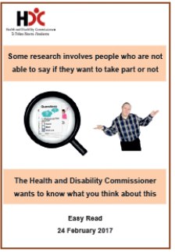
This booklet should be read after reading the questions booklet.

The Health and Disability Commissioner wanted to know what people thought about doing research on adults who cannot give informed consent to research.

We did not ask what people thought about doing research on children.

You can find the questions booklet on this website:
www.hdc.org.nz/media/5116/easy-read-hdc-informed-consent- consulation-28-feb-2017.pdf
1

Sometimes health and disability service providers want to do research to better understand the needs of people.
Health or disability research means trying to find answers to questions about health or disability treatment and services.
When health and disability service providers do research they must make sure people have the rights in the Code of Health and Disability Services Consumers’ Rights.
This is also known as the
Code of Rights.
2

The Code of Rights says

Some research can be done with adults who cannot give informed consent if the research meets the best interests rule.
Informed consent is when you:
- are told about the research
- understand what the research is about

- are able to say if you want to take part or not.

3

The best interests rule means that it is better for a person to take part in the research than not.

If someone else is allowed to give informed consent for the person, the research must still be in the best interests of the person who is taking part in the research.
4

Why change things?

Some people are unhappy with the best interests rule because it means that some research that may help some people cannot happen.
The Health and Disability Commissioner has:
- looked into this rule
- asked people what they thought about this rule.
5
What questions the Health and
Disability Commissioner asked
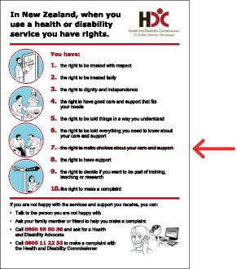 | 1. Should the Code of Rights be changed so that other research can happen even when people cannot give informed consent?
2. Should the best interests rule apply or do we need a different rule?
3. What do we need to protect adults who cannot give informed consent?
4. Who will decide what research is OK?
5. Are there other rules or laws that need to change?
6

Who answered?

Many people answered the questions like:
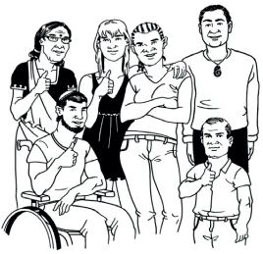
- general public
- disability groups
- patients
- doctors.

7

What did people say?

People said a lot of different things such as:
- if people cannot give informed consent it is never OK to include them in research
- some research is OK if it will improve treatment and services
- some research is OK if you can protect the person from harm and abuse
- if such research is allowed there needs to be more protection for people who cannot give informed consent
8
What the Health and Disability
Commissioner thinks
The Health and Disability Commissioner thought a lot about what people said.

The Health and Disability
Commissioner thinks:
- some research should be allowed
so that it improves treatment and services
and services

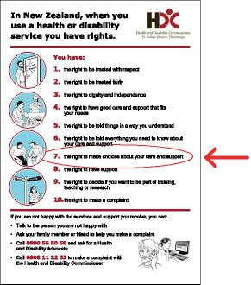 | - the Code of Rights needs to be changed so that some research can happen as long as people are safe

9

- research should happen only when the chance of a person being harmed is small
- we need extra rules to protect people

- there should be a special ethics committee to decide if research involving adults who cannot give informed consent is OK.
10

An ethics committee:
- is a group of people who listen to what the researcher wants to do
- decides if the research is OK.

Before an ethics committee can say that the research is OK it has to:
- decide if the research could happen with adults who can give informed consent
- decide if the research will be good for everyone
11
What happens next?

The Health and Disability Commissioner thinks it is a good idea if:
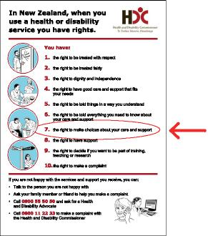
- the Code of Rights is changed so that some health and disability research can happen that is not allowed now
- we make sure that adults who cannot give informed consent are protected from harm
- there is a special ethics committee to decide if the research is OK or will be good for everyone.
Before any changes happen to the Code the Health and Disability Commissioner wants other changes made. Then he will ask more questions.
12

Health and Disability Commissioner
Po Box 1791
Auckland 1140

Level 10
Tower Centre
45 Queen Street
Auckland 1010

Ph: 09 373 1060
Fax:09 373 1061
Toll Free Ph: 0800 11 22 33
www.hdc.org.nz

