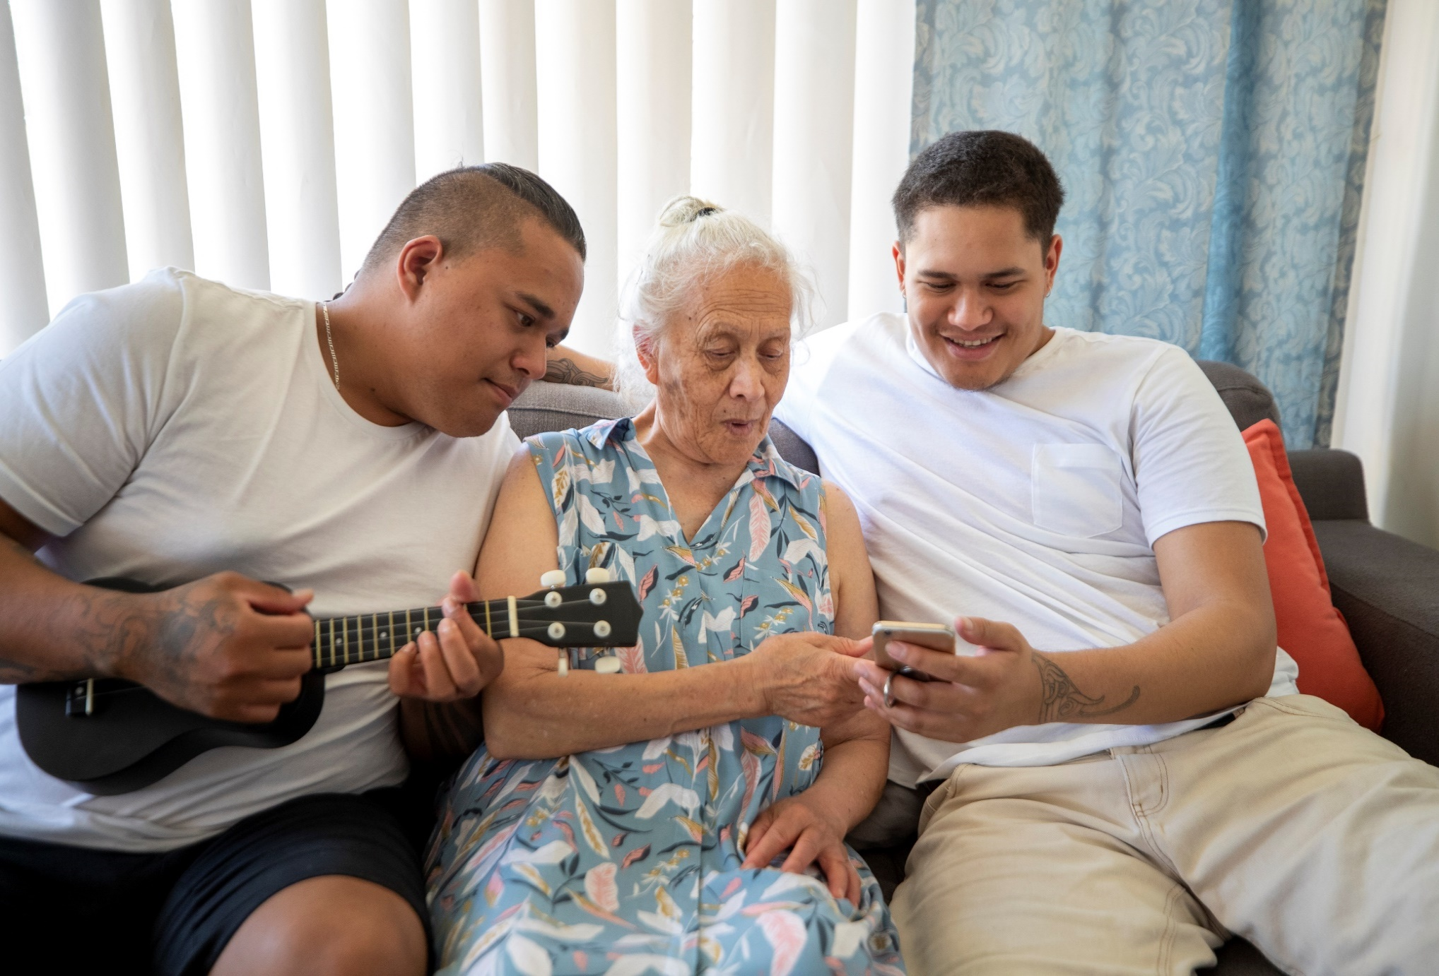

**Whakarāpopoto Matua | Executive Summary**

**Ko te arotakenga o Te Ture Toihau Hauora, Hauātanga 1994 me to Tikanga o**

**ngā Mōtika Kiritaki mō ngā Ratonga Hauora, Hauātanga |**

**Review of the Health and Disability Commissioner Act 1994 and the**

**Code of Health and Disability Services Consumers’ Rights**

**Poutū-te-rangi 2025 | March 2025**

# He kupu whakataki

Ko Te Toihau Hauora, Hauātanga (HDC) he hinonga karauna ko tāna he whakatairanga, he tiaki hoki i ngā motika o ngā tāngata katoa i Aotearoa nei e whakamahi ana i ngā ratonga hauora, ratonga hauātanga. He kawenga tō mātou kia auau te arotakenga i te Ture Health and Disability Commissioner 1994 (Te Ture) me te Code of Health and Disability Services Consumers’ Rights (Te Tikanga) ka tuku whakaaro ki te Minita take Hauora. Kei te Minita me te Kāwanatanga te mana kia kōkiri rānei ērā panonitanga.

He whai wāhi ēnei arotakenga kia mauritau tonu Te Ture me Te Tikanga hei tiaki, hei whakatairanga ake hoki i ngā mōtika o ngā tāngata e whakamahi ana i ngā ratonga hauora, ratonga hauātanga. Ka āwhina hoki ngā arotakenga i a mātou hei whakapai ake i ngā mahi i HDC me te tautohu panoni hei whakapai ake i te pūnaha hauora, hauātanga.

Ko tā mātou arotakenga whakamutunga i meatia ai i te whakamanatanga o te Ture Pae Ora me te arotahi mai ki Te Ture me Te Tikanga e pai ake ai te whakatutuki i ngā hiahia o ngāi kiwi katoa. Ka puta tēnei arotakenga i tētahi wā e kahapanoni, tētahi wā nui te wero ki te rāngai hauora, hauātanga me te kaha hiahia ki ngā ratonga o HDC.

I te wā ka rapu whakaaro mō tēnei arotakenga ko te aronga matua he hiahia whakarongo ki ngā hapori e wheako haere ana pea i tētahi āhua taurite-kore i te wā ka tauwhirotia me te korenga e tuku āwangawanga, tae atu ki te Māori me ngā tāngata whaikaha.

Tūturu, te nuinga o ngā tāngata me ngā rōpū e tautoko mai ana i ngā take i kōrerotia me ngā mātāpono o tā mātou whakaaro mō te panoni. Ā, te nuinga hoki o ngā tāngata me ngā rōpū i whakaae mai kia tika, kia whai wāhi atu, kia urupare hoki Te Ture me Te Tikanga, ā, kia noho ko te tangata te pūtahi o ngā whakataunga amuamu kia tere hoki te whakatau.

Ko tā tēnei tuhinga he whakarāpopoto taiea o te Pūrongo *He Tuhinga Taunaki. Review of the Health and Disability Commissioner Act 1994 and the Code of Health and Disability Services Consumers’ Rights*’*.* Kei review.hdc.org.nz te pūrongo matua.

# Te Tukanga

Nā te hui tuatahi me ngā kaitautoko ka tino whakaae mai rātou ki ngā whakaarotau mō te arotakenga. E rima ngā wāhi hei aronga:

* Kia pai ake, kia tōkeke hoki te whakatau amuamu;
* Kia mauritau Te Ture me Te Tikanga hei urupare atu ki ngā matea o te iwi Māori;
* Kia pai ake Te Ture me Te Tikanga mō ngā tāngata whaikaha;
* Kia whakaarohia ngā kōwhiringa mōtika hei tono pīra i ngā whakatau a HDC;
* Kia paku whakapai ake ētahi mea me ngā mea hangarau.

Hei tā mātou kia taea e te tangata e pīrangi ana te tuku whakaaro ki tēnei arotakenga. I whai mātou i ētahi tukanga rapu whakaaro e arotahi atu ana kia rongo whakaaro mai i ngā taupori whakaarotau i rārangihia mai i te Ture Pae Ora — tae atu ki te iwi Māori, ngā tāngata whaikaha me ngāi pasifika. I whakaritea hoki kia whaimana te Māori, ngā tāngata whaikaha me ngāi pasifika ki te tātari me te whakamārama o te whakahokinga kōrero.

Nā ngā ārai rerekē e wero ana i ngā tāngata whaikaha, i aro atu mātou ki ngā rōpū rerekē o te hapori hauā, tae atu ki te hunga turi, me ērā e noho pāmamae ā-hinengaro ana.

He mea o runga rawa ngā tāpaetanga kōrero (e 259) i riro mai i a mātou i te wā whiriwhiri tūmatanui, ā, i hui tahi hoki mātou me te tini tangata, te tini rōpū i te wā o te arotakenga.

# Ngā whakataunga kōrero

Hui katoa nei, i kitea e mātou e āhua pai ana te mahi a Te Ture me Te Tikanga me te aha ko ngā panoninga e hiahiatia e te tangata kia tirohia ko ērā o te taha whakahaere. Heoi anō, ko ētahi panoninga o Te Ture me Te Tikanga me whakahāngai ki ngā kawatau o āianei, kia neke te mahi o te rāngai me te whakapai ake i ngā mahi whakahaere a HDC.

**Kia tere te urupare o Te Ture me Te Tikanga ki te Māori me ngā tāngata whaikaha**

Ahakoa he ngāwari Te Tikanga hei huri ki tā te horopaki, i kitea e mātou ētahi paku panoninga e mārama ake ai ngā mōtika o te tangata kia kauawhi Te Tikanga i ngā hapori katoa.

Mō te Māori ia me ngā tāngata whaikaha, ko te tikanga kia āta whakamārama atu i ngā kawenga a ngā kaiwhakarato hei tirotiro ki ngā ārai toronaha kia noho mai ko te haumaru ahurea. Kei roto i ā mātou whakataunga kōrero ko te panoni reo o Te Tikanga hei whakakaha ake i te whai wāhi mai me te tautoko kauawhi; kia whakaurua te mōtika kia whakaarohia te tikanga ina whakaratohia te manaakitanga ki a rātou.

Mā ēnei panoninga ka taunaki ake ngā kawatau mahi o āianei kia kitea e te tangata Te Tikanga hei mea whakaata i ō rātou matea me ō rātou uara. Ko ētahi o ēnei panoninga me tautoko mā te ārahi mō te rāngai.

I whakaaro ngā kaitautoko kia noho ki Te Ture te āhua o te kaitātaki nō roto mai o HDC he mea tino nui e āhei ai a HDC ki te tiaki me te whakatairanga ake i ngā mōtika o ngā hapori katoa. I rongohia e mātou he mea nui tēnei mō te āhei o HDC kia mārama, kia whakatinana me te whai i te tikanga e mārama ai, e hāpai ai hoki i ngā mōtika o ngā tāngata whaikaha. Nā reira ko tā mātou whakataunga kōrero he whakauru paearu mahi hei kopou i ngā Kaikōmihana Tuarua ki Te Ture. Ko ngā pūkenga o roto o te whakaaro nei ko te mātauranga ki te ao māori, ki ngā tikanga me te reo hoki; ā, he māramatanga hoki ki ngā mōtika o ngā tāngata whaikaha me te taha whakahaere o te rāngai tautoko hauātanga.

He tino nui te tautoko kia āta whakaritea he kōrero ki Te Ture kia whakamana i Te Tiriti o Waitangi, ā, i te hiahia hoki ngā tāngata kia kitea ngā whakaritenga whānui me ngā whakaritenga whāiti i roto i Te Ture. Ahakoa i kīia mai ko te kaitātaki tika o roto o HDC tētahi panoninga nui i te hiahia hoki ngā tāngata kia kitea i Te Ture te mahi tahi pono me te Māori, te mea ai hoki, mō ngā arotakenga o Te Ture me Te Tikanga me ngā aratohu kōkiri, me te kawenga kia mahi tahi me ngā māngai mātauranga Māori. He hiahia anō nō ngā tāngata kia whakatairanga ake me te tiaki i te tikanga o roto o te taha whakahaere amuamu, tae atu ki te whakarite hui ā-whānau[1] me nga hui Hohou rongo[2].

Kei te whakaae mātou ki tētahi huarahi mō Te Ture kia whakamana i Te Tiriti o Waitangi, me te aha, he whakataunga kōrero nā mātou kia uru ki Te Ture ngā whakaritenga whānui me ngā whakaritenga tauwhāiti ki tā ngā tāpaetanga o ngā hui i riro mai. Ka tautoko i ngā whakaaro o ngā kaitautoko mā konei ka whaihua ai ngā tāngata katoa o Aotearoa.

**Ko te tangata te pūtahi o ngā whakataunga amuamu**

E whakaae mai ana ngā tāngata ko tētahi pūnaha tuku amuamu he tino huarahi hei hāpai i ngā take kounga, ngā take haumaru me te whakapai ake i te wheako o ngā tūroro. Heoi anō, i rongo hoki mātou nā te mataku kei rerekē te āwhina kei whakakorehia rānei te whai wāhi mai ki ngā ratonga e kore pea te tangata e kōrero, ā, nā te uaua o te tukanga hei tuku amuamu, ka mutu, i ētahi wā ka nui atu te pēhi kino o ngā tāngata e rapu whakatau ana, ahakoa kiritaki, whānau, kaiwhakarato rānei. Mō te tokomaha o ngā hapori kāhore ngā tukanga o āianei e tino hāngai ana ki tā rātou e whai nei hei whakatau take, hei hohou rongo rānei.

Ko tēnei whakahokinga kōrero ka taunaki i te hiahia kia noho ko te tangata te pūtahi o ngā whakataunga amuamu— tērā ka tere, ka whai wāhi, ka whai aroha, ka haumaru hoki te tangata. Ko tā mātou e whakatau nei kia panoni i Te Ture kia whakangāwari ake ai i te mahi a HDC hei urupare atu ki ngā amuamu e tutuki ai ngā matea o ngā tāngata katoa, tae atu ki te whakamahi i ngā tukanga hohou rongo, tukanga ahurea e tika ana, ā, kia panoni i ngā mātāpono matua o te whakataunga amuamu kia noho ko te tangata te pūtahi. Kei te meatia hoki e mātou te whakahokinga kōrero mō ngā tukanga a HDC kia whakapaitia ai.

Ka whakatau panoni hoki mātou ki Te Tikanga hei taunaki i ngā mōtika o ngā tāngata kia tiakina mehemea ka rautupuria rātou mō te tuku amuamu noa iho. Kāore tēnei whakatau e waihanga kawenga hou engari rā ka āta tohua te tautoko o ngā tāngata kia haumaru te tuku amuamu.

Ahakoa ka āta whakaarohia te tiakina o ngā mōtika o ngā tangata hei takitahi, kua kī mai ngā tāngata kei te hiahia kia kaha ake te whakamana i te mahi a ngā whānau e tautoko ana i ētahi atu hei hāpai i ō rātou mōtika. He mea nui tēnei mō ngā tāngata e hiahia āwhina ana hei whakawhiti kōrero, hei whiriwhiri, hei hapai, hei whakatau take hoki. Ko tā mātou he whakatau kia panoni i Te Tikanga hei taunaki i te mōtika kia tautoko i te tangata hei whiriwhiri; kia noho ētahi kaitautoko ahakoa tē taea te noho ā-tinana mai; ā, ka whai mōtika ngā tāngata ki te tautoko i te tuku amuamu.

Mō te mahi a ngā kaitautoko e tautoko ana i ngā tāngata kia mārama ki ō rātou mōtika me te whakatau i ō rātou āwangawanga, kei te whakaaro te Tumu Whakarae o Ngā Kaitautoko me HDC kia tirohia ngā whakahokinga kōrero hei tautuhi i ngā huarahi ki te urupare o roto mai i ngā mahi o āianei. Tae atu ki tētahi aronga hei whakarite whanaungatanga ki ngā rōpū hapori o te kāinga kia nui atu te mahi tahi me ngā hapori kanorau.

**Te mātātaki ki ā HDC whakatau**

I kī atu ki a HDC kia whakaarohia ngā kōwhiringa hei tono pīra i ngā whakatau a HDC nō muri mai i tētahi petihana ki te Komiti Hauora. Ko ngā panoninga e rua o Te Ture i uiuia rā kia nui atu te mātātaki ki ngā whakatau a HDC ko te whakauru mai o tētahi wāhanga ā ture nei mō HDC ki te arotake i ōna ake whakatau, me te whakaheke i te paepae kia whai wāhi ki Te Taraipiunara Mana Tangata(HRRT)[3]. Ahakoa te tautoko mō te whakaaro o ngā panoninga pēnei, he whānui ngā whakaaro mō te āhua o tēnei panoninga hei mahi.

I te whakaaro ki ngā kōwhiringa mō te tuku pīra ka kitea e ngā tāngata te hua o te tōkeke me te whai wāhi atu ki te ture, te whakarongo ki te tangata me te kounga o ngā mahi whakatau a HDC. Heoi anō, ka āwangawanga mai hoki ngā tāngata ki te āhua o te takaroa, o te utu, o te pēhi kino me te tautika-kore. Tokomaha ka whakaaro atu ki ngā panoninga ki ngā tukanga tuku amuamu o āianei a HDC ka tino rerekē.

Ko te kōwhiringa kia uru mai he kawenga ā-ture mō HDC ki te arotake whakatau te kōwhiringa i tino tautokona mai, me te tino hiahia o ngā tāngata mō te tukanga arotakenga kia whai wāhi atu, kia puata, kia mōhio ki te whētuki, kia tū motuhake i ngā kaiwhakatau o mua, kia ōrite te huarahi atu o ngā kaiwhakarato me ngā kiritaki. Kāore e whakaae te katoa ki te kōwhiringa kia heke te whai wāhi mai ki te HRRT, ko te nuinga e tautoko mai i tēnei kōwhiringa i te tautoko kia paku heke te paepae – kia oti kē i a HDC tētahi tirotiro. Tokomaha i whakaaro ina whakahekea te paepae me arotake hoki te āhei o ngā whakatau kia arotakengia.

Ko tā mātou whakatau kia whakaurua he kawenga ā-ture mō HDC ki Te Ture hei arotake whakatau, me tētahi wā tepe, ētahi paearu hoki kia whāiti te mātai me ngā āhuatanga o te arotakenga kia oti pai. Nā te iti o ngā tāpaetanga mō tēnei take, kāore anō mātou kia whakaaro ina heke rānei te paepae whai wāhi ki te HRRT. He tino tautohe mō ngā taha e rua o tēnei kōwhiringa nā konei kei te whakaaro mātou he take tēnei mā te Manatū hauora me te whiriwhiri a ētahi atu. Heoi anō, ki te whakatau kia heke te paepae whai wāhi, kāore mātou e tautoko kia heke hei hao mai ngā maumau katoa ki a HDC.

**Ngā panoninga paku, panoninga hangarau**

I whiriwhiri tahi a HDC me te tuku whakatau mō ētahi panoninga paku, panoninga hangarau me te whakatau:

* Ko tā Te Ture hiahia mō te arotakenga o Te Ture me Te Tikanga kia hāngai me ngā wā arotake ka kīia ka mahia ‘i ia te tekau tau’;
* Ko te whaina nui i raro i Te Ture ka piki ake kia $10,000;
* Ko te kīanga ‘tangata auhi’ ka whakakapia ki te kīanga *‘ko te kaiwhakapae (mēnā tētahi) te tangata auhi rānei (ehara i te kaiwhakapae)’* ki ngā wāhanga hāngai mai i a s52 o Te Ture (Ka rapua pea he rongoā) haere atu; ā
* Ko te kīanga ‘i raro i te ira l rehu’ i roto i a Mōtika 7(6)(c) o Te Tikanga ka whakakapia ki te ‘*he hoatu rongoā hei whakarerekē i tō rātou tūoho, aroā, maumahara rānei, hei whai i te tukanga’*.

I whakatau hoki a HDC ko ngā panoninga e rua i tonoa ai e ētahi atu i ngā huinga ka kauneke i te Manatū Hauora me ētahi atu:

* Me whakamārama mō ngā Mōtika o Te Tikanga ka rere ki tua o te matenga i ētahi wā Mōtika; ā
* Kia panonitia ngā kupu o wāhanga 72 o Te Ture (Taunaha o te Kaitukumahi me te tangata) kia mārama te taunaha, kia tōkeke kia hāngai ki te mahi o āianei.

# Whakakapinga

Ko ngā panoninga ki Te Tikanga ka aro atu kia whakanekehia te mahi puta noa i te rāngai, hei whakakaha ake hei whakapai ake i te aronga ko te tangata te pūtahi o te tauwhirotanga e urupare atu ana ki ngā matea matatini o ō tātou hapori me te tautoko i ngā take kia tere te whakatau. Ko ngā panoninga ki Te Ture e tonoa e mātou kua hoahoa ki tā HDC e mahi nei. E aro ana kia ngāwari ake ngā tukanga, ā, he mana tō mātou me te āheinga kia mahia tā mātou mahi hei painga mō te katoa.

Ko te pūtake o ēnei whakataunga ko te whanaungatanga — i waenga i ngā kiritaki me ngā kaiwhakarato, i waenga i ngā kaiwhakarato me te pūnaha whānui, ā, i waenga hoki i a HDC me ngā hapori ka whakaratohia e mātou.

Puta noa i te arotakenga kua āta whakaarohia e mātou te pūtahi o tā mātou arotakenga me ērā atu o ētahi atu ture, arā, te Ture Health Practitioners’ Competence Assurance me te ture Oranga Hinengaro, te arotakenga a Te Aka Matua o te Ture i te ture āheinga o te pakeke ki te whiriwhiri me te urupare a te Kāwanatanga ki Te Pakirehua a Te Kōmihana Roera o te Takakino i te Tauwhiro Kāwanatanga. Kei tā mātou ko ngā panoninga o Te Ture me haere tahi me tēnei arotakenga kia ōrite, kia honohono hoki, ā, kia whakaotia ngā panoninga ki Te Tikanga kia mārama te ahunga o te kaupapa here.

Ahakoa ka whakaae mātou me panoni Te Ture me Te Tikanga mā ngā panoninga ki ā HDC mahi me ngā tukanga, mā te ārahi ā-rāngai, mā te mātauranga me te whakatairanga ka whakatauria ngā take nui tonu ka hāpaingia e ngā tāngata. Kua tautohu tēnei arotakenga ngā mahi matua hei whakapai ake te mahi o roto i ō HDC rauemi o āianei.

I miramira hoki te arotakenga i ētahi wāhi me tirotiro kia pai ake te hāpai o ngā mōtika o te tangata. Tāpiri atu i ngā whakatau whāiti ki ētahi atu e hāngai ana ki ēnei take, ka mahi tahi mātou me te rāngai kia tuari ngā akoranga o tēnei arotakenga, tae atu ki ngā take i waho atu i te tirohanga a HDC i hāpaingia ake e ngā tāngata.

1. He tukanga ā-tikanga kia noho ko te whānau (tae atu ki te kiritaki) te hunga mātau ko tō rātou ake wheako, ā, mā rātou anō me te tautoko e whiriwhiri i te āhua o te whakatau ki tā rātou e pai ai.
2. Ko Hohou te rongo he whakaahua tukanga mō te whakatau tautohe mā te whai mātāpono, whai uara hoki o te ao). Mā Hohou te rongo te nawe i wheakohia e te whānau ka whakaae mai ngā kaiwhakarato, ka mutu, ka rapu rangimārie te whānau o roto mai o te wheako i tētahi taiao tika a haumaru ahurea nei.
3. Mo te ahua ki ngā wāwāhinga i tēnei wā, me whaiuru e HDC ki a HRRT.