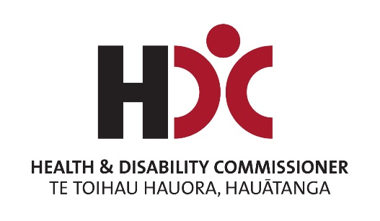



Review of the Health and Disability Commissioner Act and Code

Published: May 2024

Before you start


This document has a lot of information in it.


It can be hard for some people to read a document with lots of information.


Some things you can do to make it easier are:
read it a few pages at a time
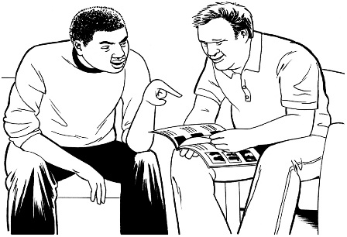
set aside some quiet time to look at it
have someone read it with you to support you to understand it.

What is in this document


Page number:

What is this document about? 4
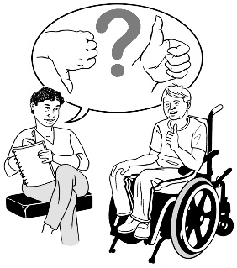

How to tell the HDC what you
think 10

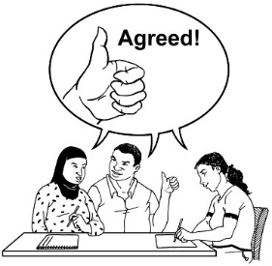
Topic 1: Making complaint
resolution better 14


Topic 2: Making things work better
for Māori 27


Topic 3: Making things work better
for disabled people 33

Page number:


Topic 4: Options for a right of
appeal 40


Topic 5: Other issues and
improvements 45



Topic 6: Technology 51

Where to get more information 53

What is this document about?


This document is a summary of the Review of the Health and Disability Commissioner Act and Code.


A summary is:
- shorter than the main document
- tells you the main ideas.


In this document the Health and Disability Commissioner will be called HDC.

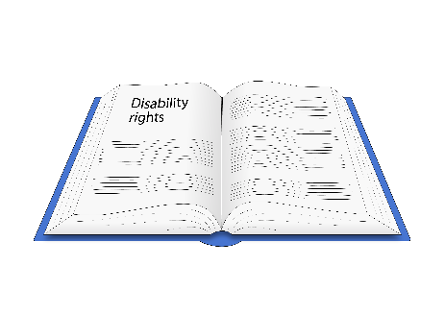
HDC looks after the rights of people using:
- health services
- disability services.


HDC is making a review of:
- the Health and Disability Commissioner Act 1994

- the Code of Health and Disability Services Consumers’ Rights.


A review is checking something carefully to find out if any changes can be made to make it better.

In this document the Health and Disability Commissioner Act 1994 will be called the Act.


The Act is a law that tells HDC:
- what HDC can do
- how to deal with complaints made to HDC.


In this document the Code of Health and Disability Services Consumers’ Rights will be called the Code.

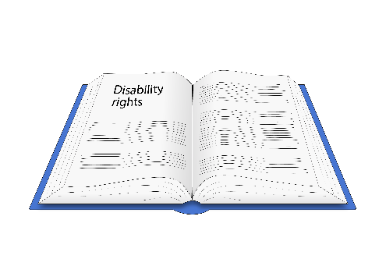
The Code is the 10 rights people have under Aotearoa New Zealand law when using:
- health services
- disability services.

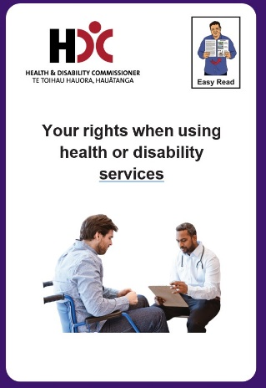
The Easy Read document of the Code can be found at this website:

hdc.org.nz/disability/easy-read-resources/

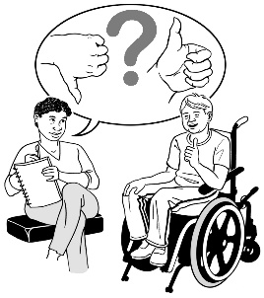
HDC wants to hear what you think about the review.


This document has:
- the important topics of the review
- suggestions HDC wants you to think about

- questions for you to think about
- information on how to tell HDC what you think.

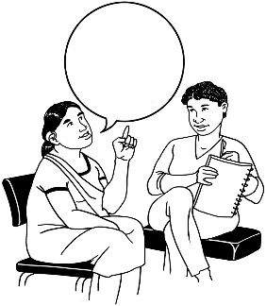
Here topic means an issue that is being talked about.


Suggestion means an idea to think about.


You can find the full review document at this website:

review.hdc.org.nz


This website is not in Easy Read.

How to tell HDC what you think


HDC wants to hear what you think.

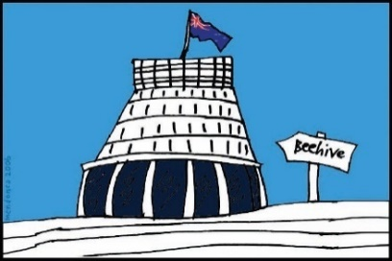
HDC will use what you tell them to make a report to the Minister of Health about making the Act and the Code better.

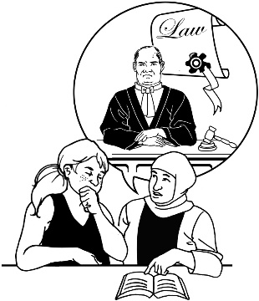
HDC asks questions in this document about making the Act and the Code better.

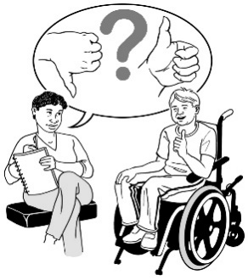
After you have read about the review in this document you can tell HDC what you think.


You can answer:
- all of the questions
- just the questions you want to.

You can answer the questions by doing a survey on this website:

review.hdc.org.nz


This website is not in Easy Read.


A survey is where you answer questions on a topic.


You can email your answers to HDC at:

review@hdc.org.nz


You can post your answers to:

The Health and Disability Commissioner
PO Box 1791
Auckland
1140.


If you cannot answer the questions in these ways please get in touch with HDC.

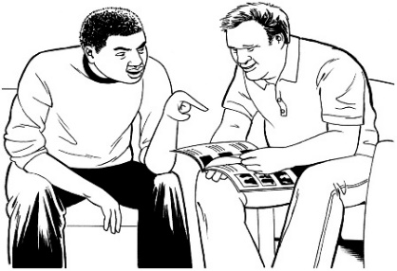
You might want a person to support you to:
- understand the questions
- answer the questions

- fill out the survey on the website
- save the survey to your computer
- send your answers to HDC.



The closing date to tell HDC what you think is:

5 pm on Wednesday 31 July 2024.

Topic 1: Making complaint resolution better


HDC is looking at how complaint resolution can be:
- better
- equitable.

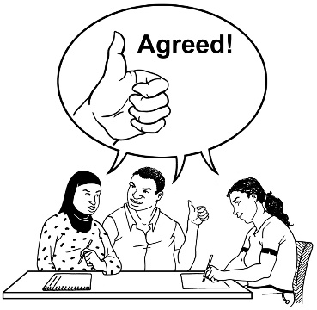
Resolution means:
- coming to an agreement
- making a decision.

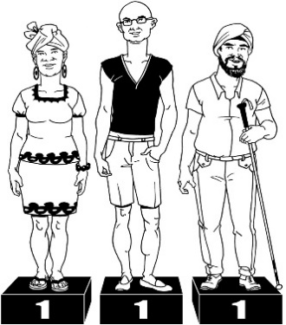
Equitable means doing things in ways that are fair for everyone.


Issues

HDC has heard:

- there are things that stop people from making complaints to them
- the principles used for dealing with complaints are not being used as well as they could be

- there could be more focus on people in the way complaints are sorted out.


Principles are a set of ideas that guide how something is done.


Another issue is to make the Code clearer so that people of all cultures:
- can understand it
- feel included.


Culture is a way of:
- thinking that a group shares
- doing things as a group.

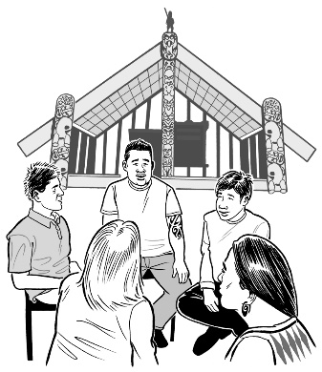
What HDC is doing already

HDC has started:
- doing hui ā-whānau

- using hohou te rongo
- using navigators who are people who show other people the way through the complaints process

- doing surveys of:
- people making complaints
- service providers.


Hui-ā-whānau are gatherings using
te ao Māori / Māori worldview.


Whānau means:
- family
- people with close relationships.


Hohou te rongo is a way of finding a solution using te ao Māori / Māori worldview.


HDC has also started making changes to how they look at complaints.

Suggestions
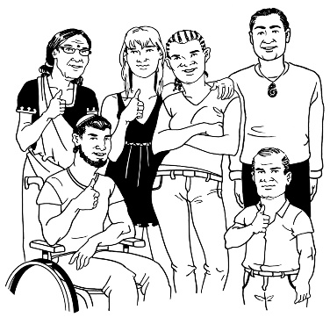

1.

Change the purpose statement of the Act to include:

- words that put people at the centre of everything that is done
- the idea of mana.

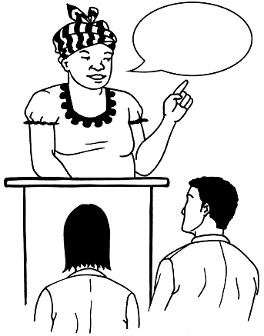
A purpose statement is a sentence that tells you what is important for an organisation to:
- do
- be.



Mana is the spiritual life force found in:
- all people
- the environment.


Having mana means a person feels in control to make their own decisions.

2.

Change the words of
Right 1 – Respect to:
- include all people

- respond better to what different groups of people need like:
- Māori

- disabled people
- LGBTTQIA+ people.


LGBTTQIA+ stands for people who are:
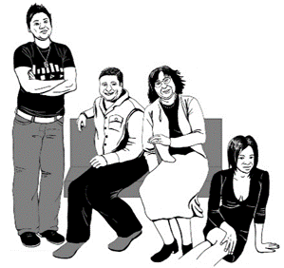
- lesbian
- gay
- bisexual

- transgender
- takatāpui

- queer
- intersex

- asexual
- + is for other people who fit in similar groups.

3.


Change things about how whānau are included like:
- using the word autonomy.

- supporting whānau to be involved when a person wants them to be
- supporting complaints to be made by a support person.


Autonomy means people being able to do the things they want with the support of others.


4.

Change the Code to use
words that include people of all genders.


Gender is if you are:
- a man
- a woman
- another gender like nonbinary.

5.

Make a change to the Code to include a way to stop retaliation.


Here retaliation means someone treating another person badly because they made a complaint.




This change could be made so people feel safe to make a complaint.

6.

Make a change to the Code so service providers know exactly what to do when making a complaint.


7.

HDC wants to find out how they could make the Nationwide Health and Disability Advocacy Service better.


The Nationwide Health and Disability Advocacy Service:
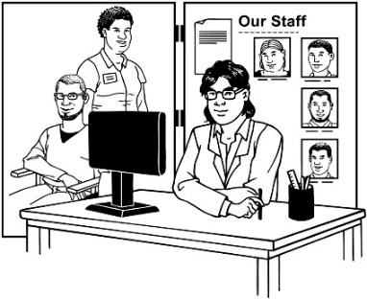
- tells people about the Code
- supports them when they have problems with a service provider.

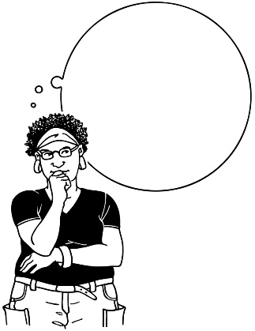
8.

HDC wants to find out what people think about changing some words in the Act to do with sorting out complaints.


Questions for you to think about

Does HDC cover the main issues about making complaint resolution better?


What do you think of the suggestions from HDC to make complaint resolution better?


What other changes should HDC think about to make complaint resolution better?

Topic 2: Making things work better
for Māori


HDC has heard that Māori are not getting the support they need from:
- the Act
- the Code.


Issues

HDC says Māori use HDC less than expected.

HDC hears that Māori:

- think te Tiriti o Waitangi / the Treaty of Waitangi is not in:
- the Act
- the Code


- are not getting information about the Code.
- feel the Code is not always right for them

- think te ao Māori / Māori worldview is not seen in:
- how complaints are done
- how rights are thought about.

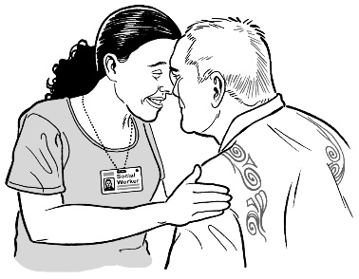
Te Tiriti o Waitangi / the Treaty of Waitangi is an important agreement between:

- Māori
- the Government.


What HDC is doing already
Leader

HDC has made:
- a leadership role called Director Māori
Team
- a team to work with this director.


This will support HDC to work on things for Māori.


Suggestions

1.

Put tikanga into the Code.


Tikanga is ways of doing things that come from Māori:

- knowledge
- beliefs
- values.

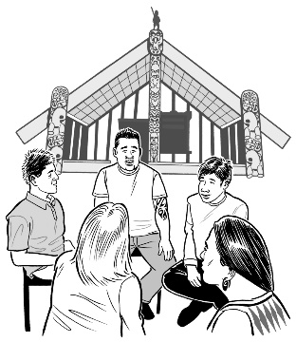
Values are things that are important to a group of people.


2.

Put things into the Act so that HDC must respect te Tiriti o Waitangi / the Treaty of Waitangi including by:
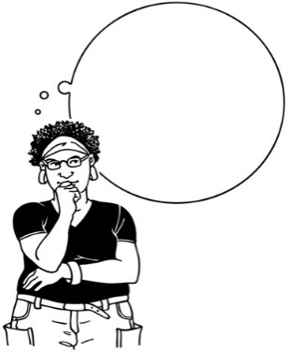

- working more with Māori
- having Māori leadership
- using te ao Māori / Māori worldview

- making sure things work for Māori.



Questions for you to think about

Does HDC cover the main issues about making things work better for Māori?

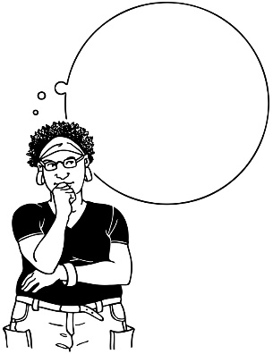

What do you think of the suggestions to make things work better for Māori?


What other changes should HDC think about to make things work better for Māori?

Topic 3: Making things work better for disabled people

Issues

HDC says there have been changes to the rights of disabled people since the start of:
- the Act
- the Code.

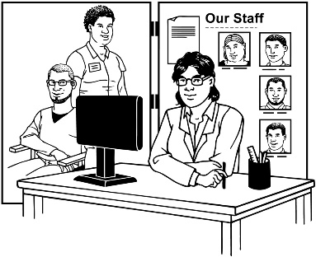
There have also been changes to:
- disability support
- disability services.

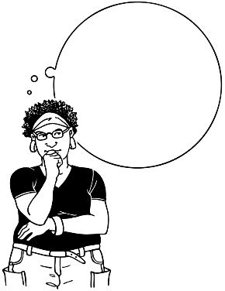
HDC wants people to tell them what they think about recommendations from a review on unconsented research.


Unconsented research is when research is done without asking someone for consent.

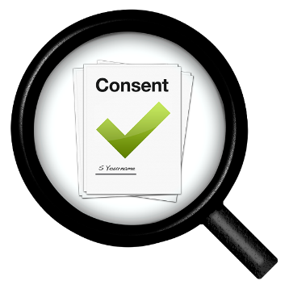
Consent is if you agree to do something.

It is your choice if you give consent.

The review on unconsented research looked at:

- if adults who cannot consent should be able to take part in research
- how they should be kept safe if they do.


What HDC is doing already

HDC is:
- improving how they do reports on disability issues
- watching how disabled people use the complaints process so they can make it better


- looking at things that are happening a lot with complaints
- making their information up to date.

Suggestions


1.

Add a role in HDC where a person works on disability issues.


This would:
- support how complaints by disabled people are handled
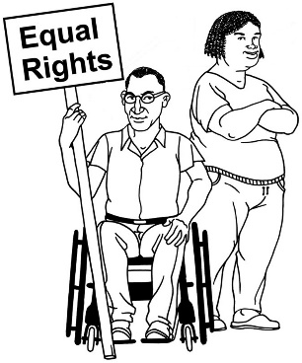
- let HDC focus more on the rights of disabled people
- support people to trust HDC.


2.

Make the meanings of words to do with disability in the Act more up to date.

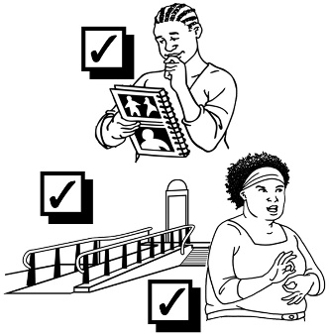
3.

Make changes in the Code to support accessibility.

4.

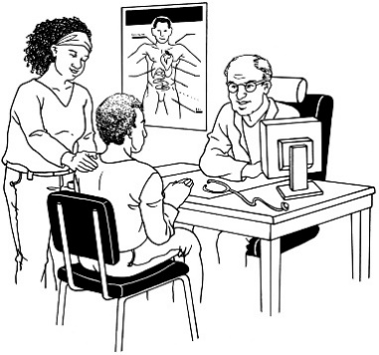
Make it clear in the Code that a person has the right to have support when making decisions about their:
- healthcare
- disability support.

5.


Have people tell HDC what they think about the recommendations on unconsented research.


An Easy Read version of the report from HDC about unconsented research can be found at this website:

tinyurl.com/unconsented-research


Questions for you to think about

Does HDC cover the main issues about making things work better for disabled people?



What do you think of the suggestions to make things work better for disabled people?

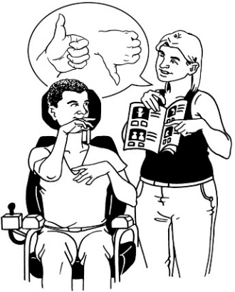
What other changes should HDC think about to make things work better for disabled people?

Topic 4: Options for a right of appeal


Issues

A petition to the Health Select Committee said there were not many ways to appeal HDC decisions.


A petition is a written document that asks people in charge to do something important.

A petition is signed by many people.


An appeal is asking someone to:
- take another look at a decision
- think about changing the decision.


The petition also said letting people make an appeal would protect the rights of people using:
- health services
- disability services.

What HDC is doing already

HDC has:
- taken a good look at how they review the things they do

- made it easier for people to know how HDC makes decisions.

Suggestions


1.

Make changes to the Act to say there must be reviews of decisions.


Some things that could be done are:
- make sure the person who made the decision is not part of the review

- involve other people in HDC in the review
- get a group of people from outside HDC to do the review.

2.
Make it easier for people to make a complaint to the Human Rights Review Tribunal about a breach of the Code.


The Human Rights Review Tribunal looks at breaches of the Code.

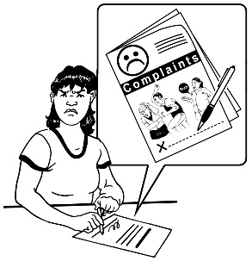
Before making a complaint to the Human Rights Review Tribunal a complaint must be:
- made to HDC
- a breach must be found.


Here a breach means breaking the rules of the Code.


Questions for you to think about

Does HDC cover the main issues about how people could appeal HDC decisions?


What do you think about the suggestions for how people could appeal HDC decisions?

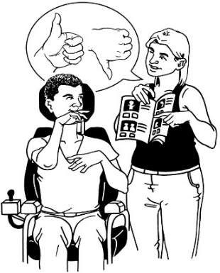
What other things should the HDC think about for how people could appeal HDC decisions?

Topic 5: Other issues and improvements


The review lets HDC look for other small things that could be changed in:

- the Act
- the Code.

Suggestions

1.


Change how reviews are done of:
- the Act
- the Code.

2.

Make the fines bigger for breaching the Act.


A fine is money someone pays as a punishment when they have done something wrong.

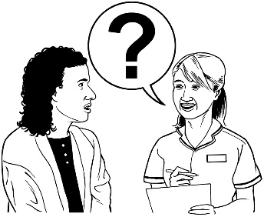
3.

Give the Director of Proceedings the power to get information.


The Director of Proceedings is a lawyer who works for HDC.


When a breach of the Act has happened the Director of Proceedings will:
- do a review of the case
- decide if anything else needs to be done.

4.


Put in a meaning for the term aggrieved person.

An aggrieved person is someone who has been harmed by a legal decision.


5.

Give HDC another way to deliver a legal document to a person when the person cannot be found.

6.
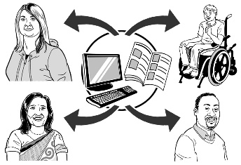
Give HDC ways to withhold information for a short time to support an investigation to run well.


7.

Make more rules for written consent for sedation.

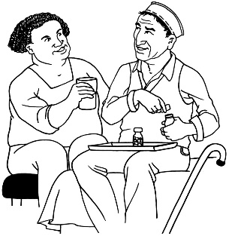
Sedation is when someone is given medication to make them feel more relaxed.

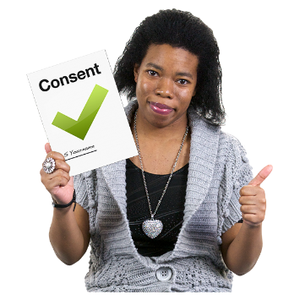
8.

Make it clear that written consent is needed when there is a big risk of bad things happening.

9.


In the Code fix the meanings of these words:
- teaching
- research.


Questions for you to think about

What do you think of the suggestions for these other things HDC wants to do better?

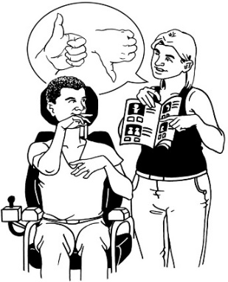
What other things do you think HDC could do better?

Topic 6: Technology


HDC wants to know what you think about how new technology might be a part of people getting:
- health services
- disability services.


AI
The technology includes artificial intelligence / AI.

Artificial intelligence / AI is a way computers can learn to do things.


Artificial intelligence / AI can:
- do some things people can do
- solve problems.



Questions for you to think about

What are your main concerns about the use of new technology?

What are your main concerns about how new technology could change the rights of people getting:
- health services
- disability services?

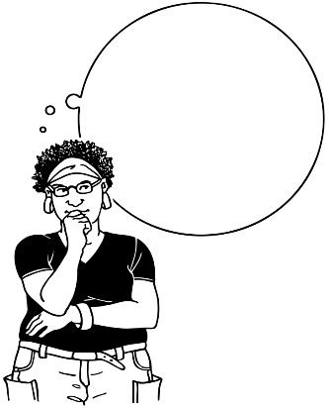
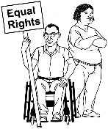
What changes should HDC think about to protect rights even if technology changes?

Where to get more information


You can learn more about the review at this website:

review.hdc.org.nz


You can ask questions by email:

review@hdc.org.nz


You can call or text:

027 283 2219


To make a time for the review team to call you back phone:

0800 11 22 33

The New Zealand Relay service number for HDC is:

6448975955


If you find it hard to use the phone the New Zealand Relay service is for people who are:
- Deaf / hard of hearing

- deafblind
- speech impaired / find it hard to talk.


You can find out more about the New Zealand Relay service at:

www.nzrelay.co.nz

This information has been written by the Health and Disability Commissioner.


It has been translated into Easy Read by the Make it Easy Kia Māmā Mai service of People First New Zealand Ngā Tāngata Tuatahi.


The ideas in this document are not the ideas of People First New Zealand Ngā Tāngata Tuatahi.

Make it Easy uses images from:


- Changepeople.org


            - Photosymbols.com

- SGC Image Works
- Huriana Kopeke-Te Aho

- T. Wood.

All images used in this Easy Read document are subject to copyright rules and cannot be used without permission.

