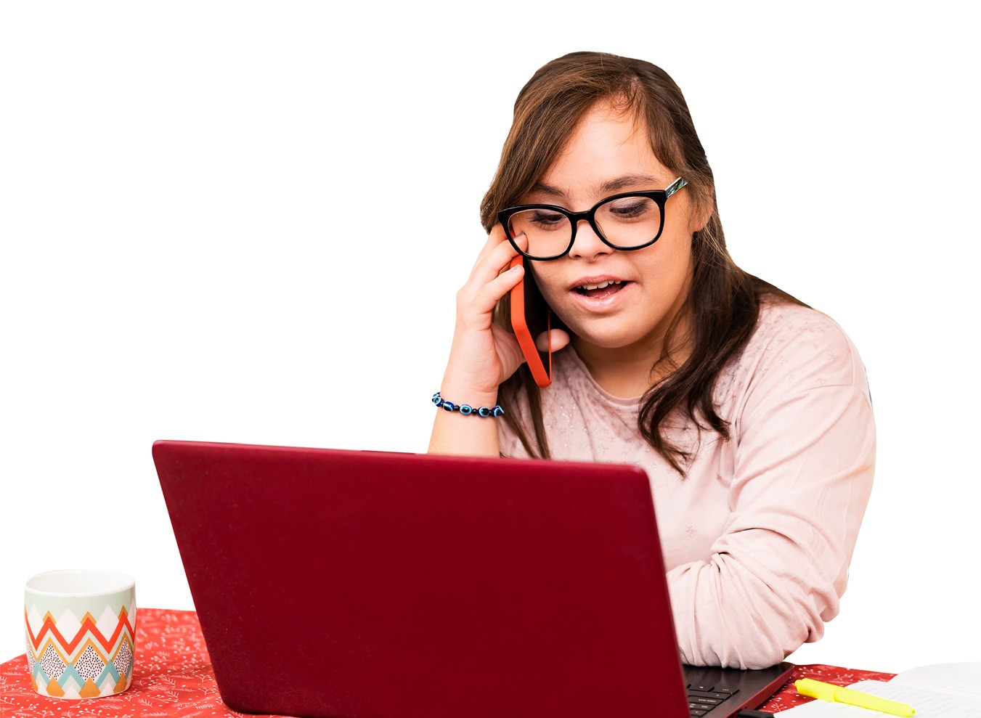
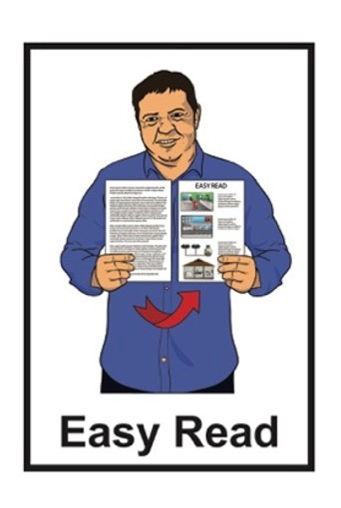

My Health Passport

Please ensure I take
My Health Passport with me when I leave

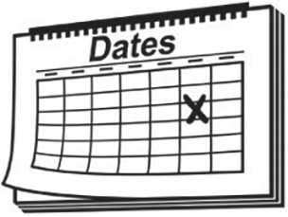
Date when this My Health Passport was filled in:

of
20

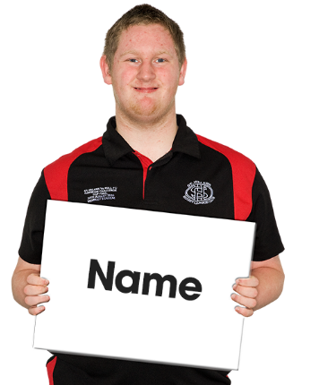
My name is:

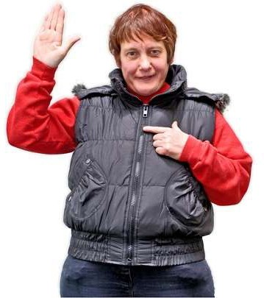
I like to be known as:

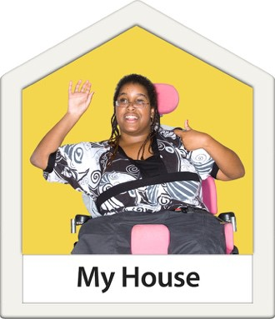
My address is:

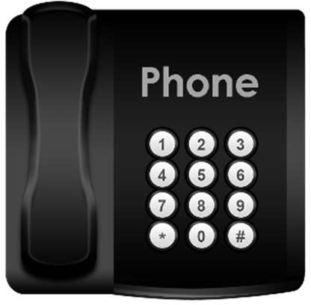
My telephone number is:

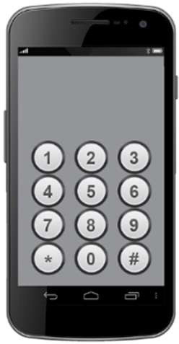
My mobile number is:

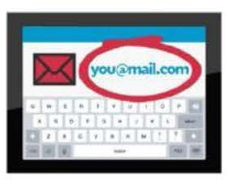
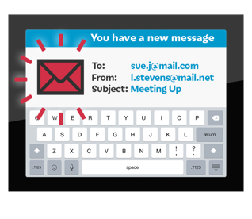
My email is:

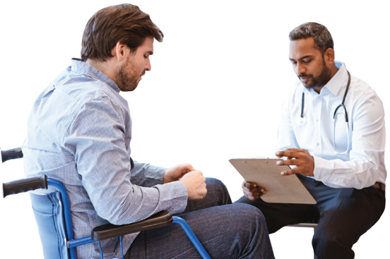
My Doctors name is:

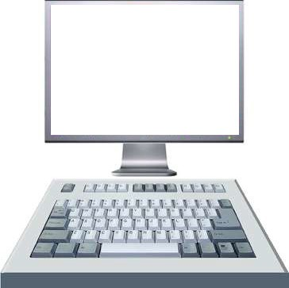
My National Health Index (NHI) number is:
NHI: ABC1234

If you do not know your NHI number you can leave this section blank.

- My disability is:
What you need to know

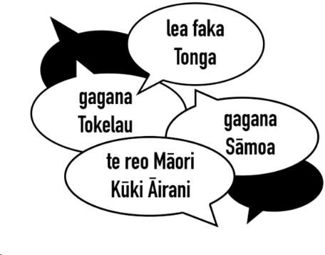
- The language I use is:

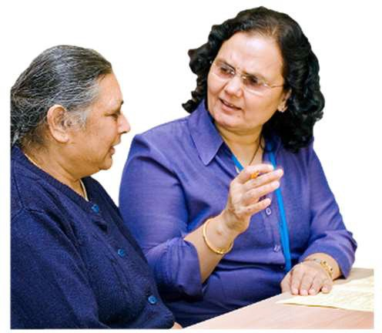
- I need an interpreter:

Please tick YES or NO

- I communicate with people by:

( as many as you like)

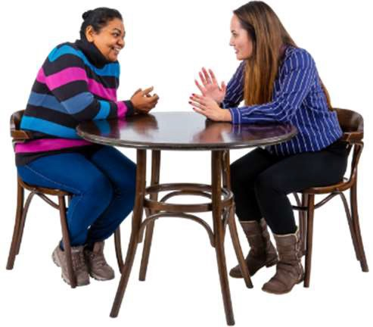
Talking

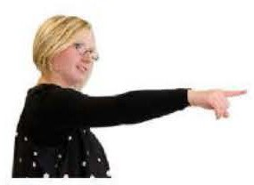
Gestures like nodding head or pointing

New Zealand Sign Language

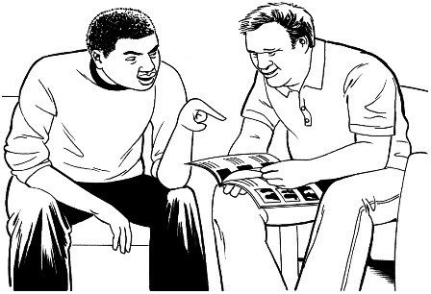
Pictures

Mobile phone / texting

Other:

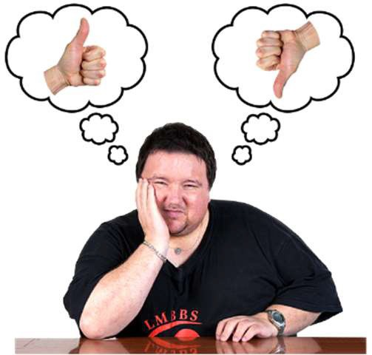
- I can / would like to make my own decisions.

Please tick

- I have a legal representative.
YES or NO

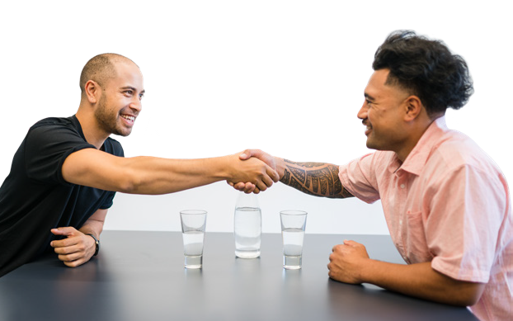

A legal representative is someone who has been given the role of making decisions for you in your best interest.

Please tick YES or NO

The name of my legal representative is:

- My contact person:

Full name:

Relationship to me: Telephone number:

Mobile number:

Email address:

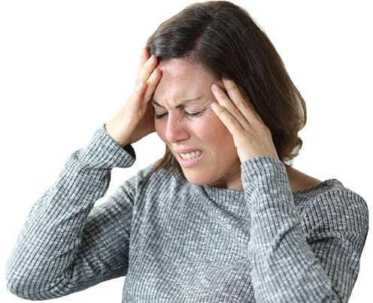
- I am in pain when:
Things to know when I use services

( as many as you like)

I tell you

I make a certain sound

I cover an area or part of my body

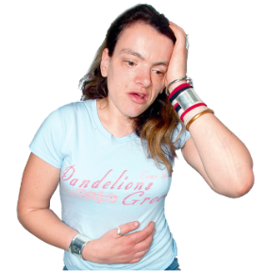
I hold an area or part of my body

Other / more information:

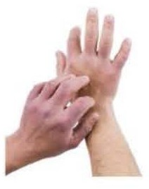
- I am allergic to:

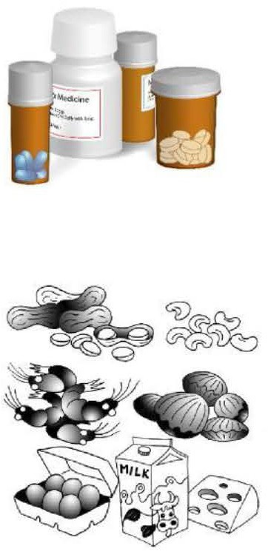
Allergies are when a person’s body has a bad reaction to something they
have:
•
taken like some medicine
•
eaten like nuts or fish
•
been around like pollen or
perfume.

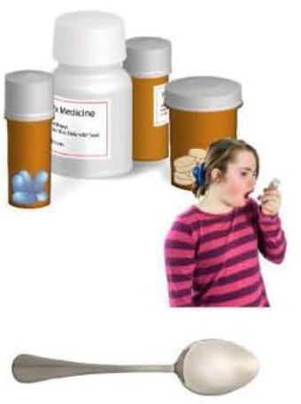
- When giving me medicine please:

( as many as you like)

Put pills on a spoon

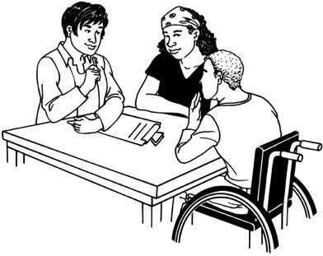
Tell me how I might feel when I take this medicine

Stay with me to make sure I take my medicine

Other:

- When you are looking at things on my body please:

( as many as you like)

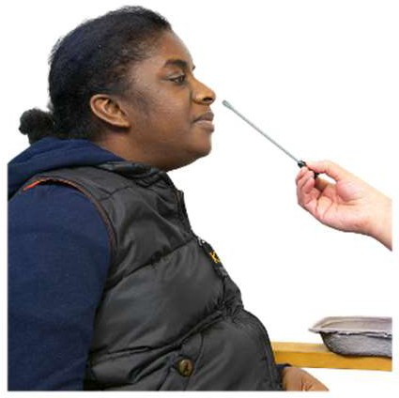
Tell me what you are doing

Be aware of my catheter bag

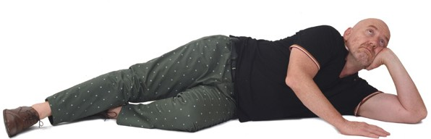
Lie me on my left side only

Other:

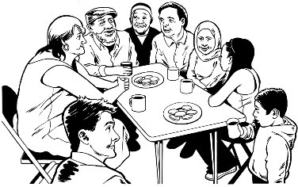
- My cultural needs are:

( as many as you like)

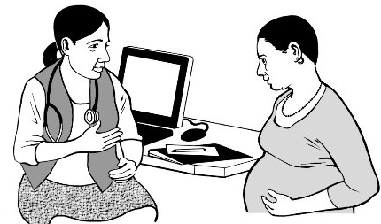
I need my doctor to be a woman

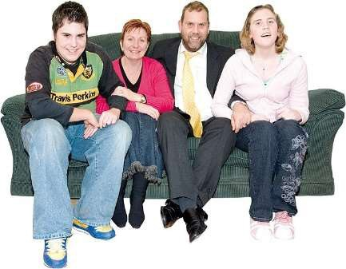
I need my family to be with me at all times where possible

Other:

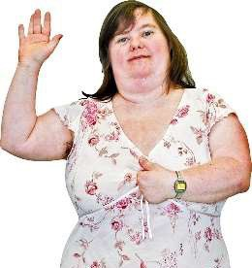
- Other information you need to know when giving me health services:

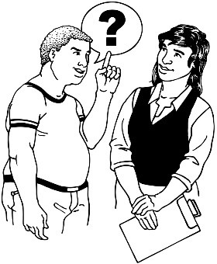
- Things that may upset me or make me anxious are:
Other helpful things to know about me

( as many as you like)

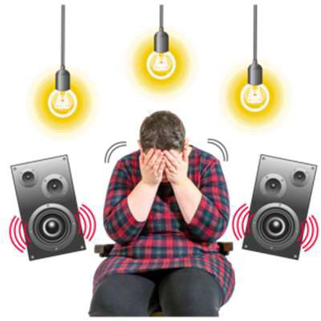
Bright lights

Loud noise

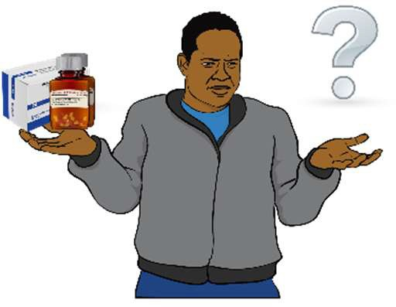
Lack of information

Other:

- If I get upset I might:

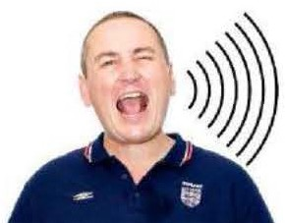
( as many as you like)

Become cross / loud

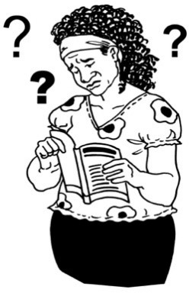
Not look people in the eye

Rock backwards and forwards

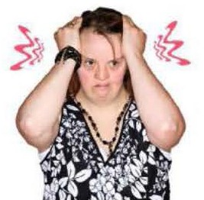
Mumble

Other:

- Things you can do to help me feel less upset:

( as many as you like)

Talk to me

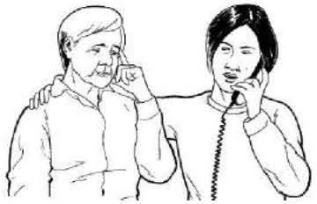
Give me some alone time

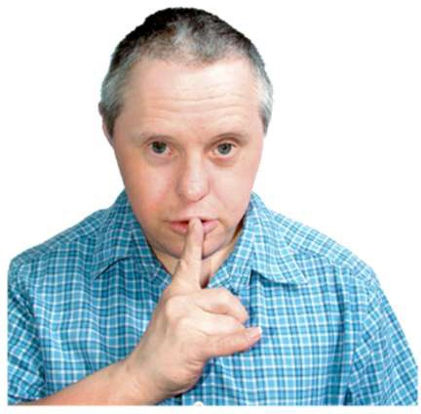
Call my contact person

Take me to a quiet place

Other:

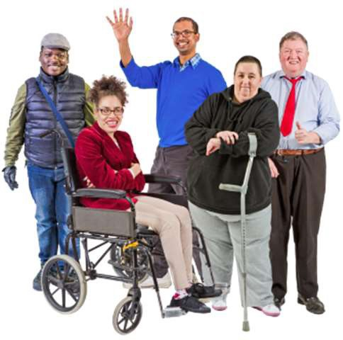
- I need support to move around:

Please tick YES or NO

If YES write more information here:

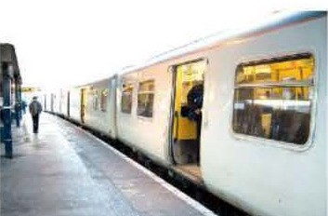
- I need support to travel:

Please tick YES or NO

If YES write more information here:

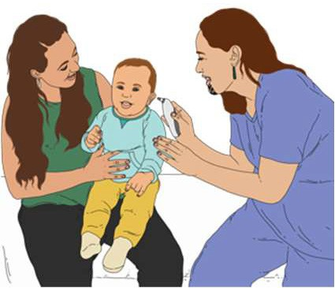
- I care and support other people

This could be:

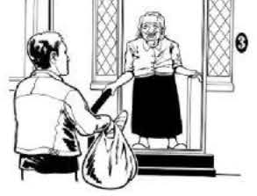
  - children under the age of 18 years old

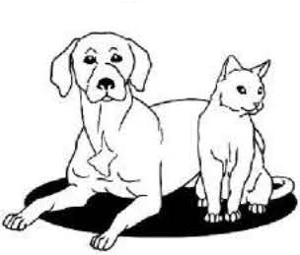
  - family members

  - your pets

Please tick YES or NO

I care for:

Acknowledgements:
My Health Passport is based on This is my Hospital Passport by Wandsworth Community Disability Team, United Kingdom.
Thank you to everyone involved in developing New Zealand’s My Health Passport.

Disclaimer:
The Health and Disability Commissioner makes the My Health Passport template available as a guide only and accepts no responsibility for the accuracy of the completed information.

All images used in this Easy Read translation are subject to copyright rules and cannot be used without permission.

HDC 2023
19

