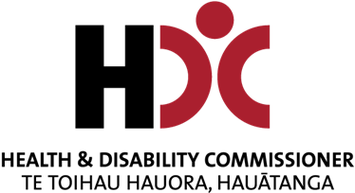
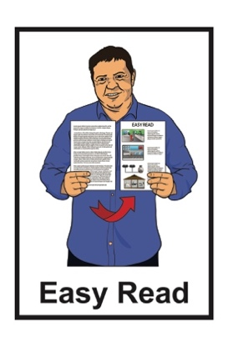


Report: Review of the
Health and Disability Commissioner Act and the Code

Published: March 2025

Before you start
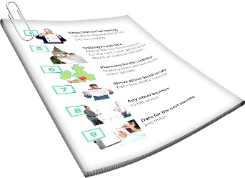

This is a long document.


It can be hard for some people to read a document this long.


Some things you can do to make it easier are:
read it a few pages at a time
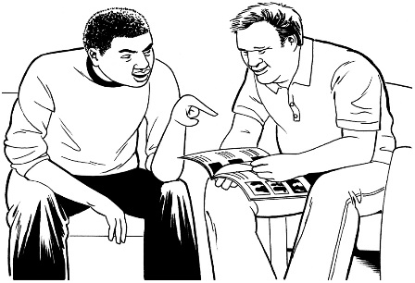
set aside some quiet time to look at it
have someone read it with you to support you to understand it.

What is in this document

Page number:

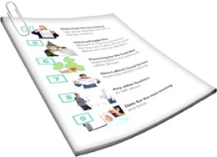
About this document 4

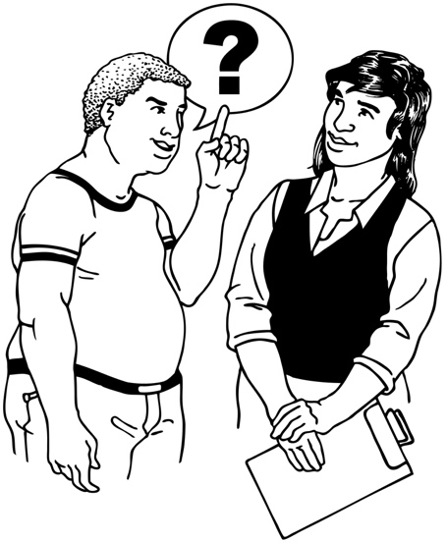
About the review 11

The main things we found out
by doing our review 16
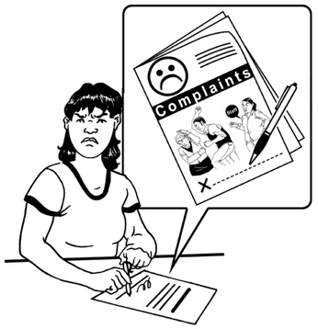

Making the complaints process
work better for everyone 20


Making the Code and the Act
work better for Māori 25

Page number:
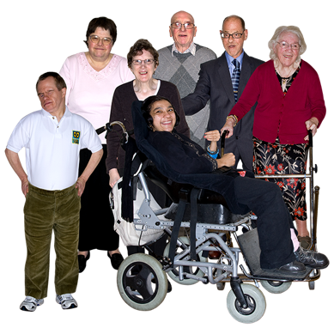

Making the Code and the Act
work better for tāngata whaikaha / disabled people 29


Being able to challenge decisions
made by the HDC 32

What we can do better now 36


More information 39

About this document
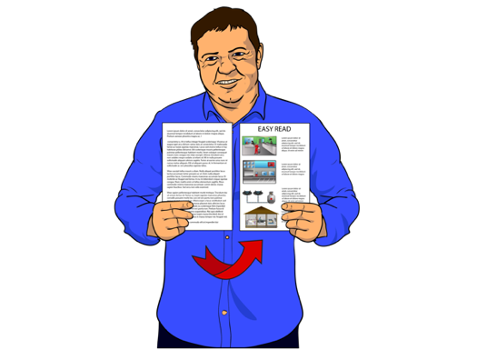

This is an Easy Read document by the Health and Disability Commissioner.

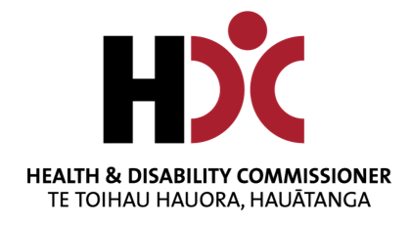
The Health and Disability Commissioner looks after the rights of people using:
- health services
- disability services.

In this document the Health and Disability Commissioner is called HDC for short.
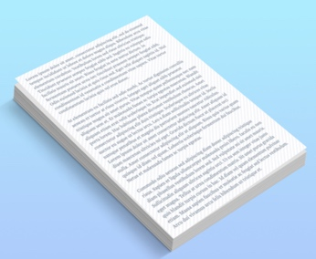

Where it says we / our / us in this document it means HDC.

This document is a summary of a report we made.


A summary:
- is shorter than the main document
- tells you the main ideas.
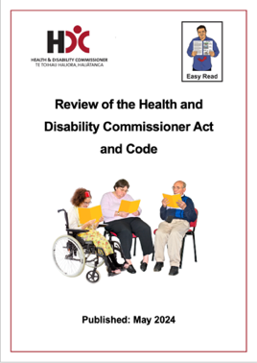

The report is about what we found out in our Review of the Health and Disability Commissioner Act and Code.


A review is checking something carefully to find out if any changes can be made to make it better.

Every 5 years the HDC reviews the:
- Health and Disability Commissioner Act 1994
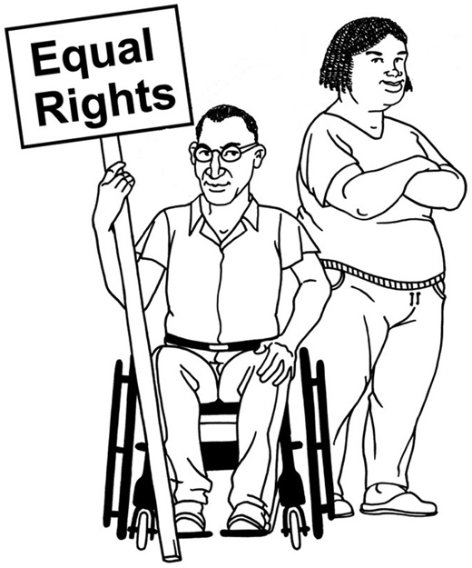
- Code of Health and Disability Services Consumers’ Rights.


The Health and Disability Commissioner Act 1994 is a law that tells HDC:
- what HDC can do
- how to deal with complaints made to HDC.
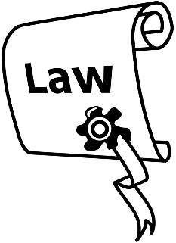

This law will be called the Act in this document.

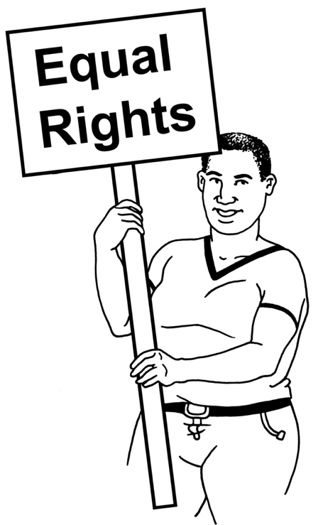
The Code of Health and Disability Services Consumers’ Rights is the 10 rights people have under Aotearoa New Zealand law when using:
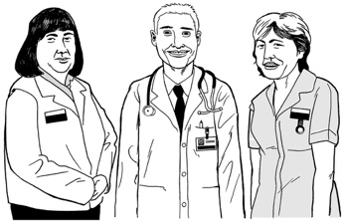
- health services
- disability services.

In this document the Code of Health and Disability Services Consumers’ Rights will be called the Code.
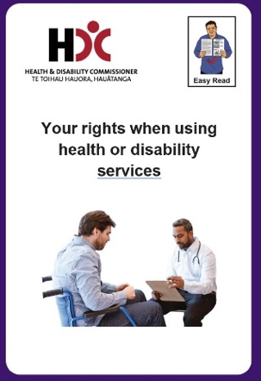

The Easy Read document of the Code can be found at this website:

hdc.org.nz/disability/easy-read-resources/

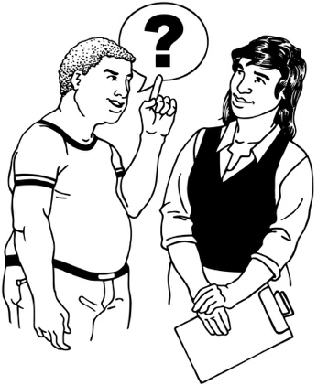
We wanted to find out what people think about the Act and the Code in the review.

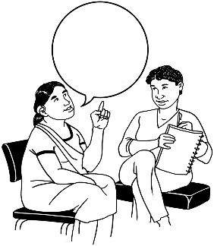
To find out what people think we:
asked people
held meetings about the review.


This report tells you about:
what we found out when we did our review

our recommendations to make:
- the Act better
- the Code better.


Recommendations means saying what things should be done to make something work better.

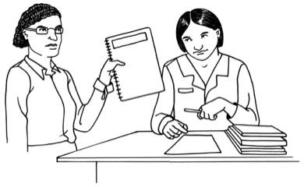
The report will be given to the Minister of Health.

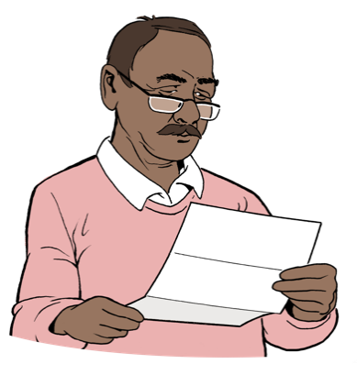
The Minister of Health will:
read the report
and

decide if changes will be made to:
- the Act
- the Code.


You can find the full report document at this website:

review.hdc.org.nz
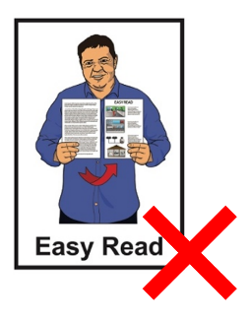

This website is not in Easy Read.


Contact HDC if you have any questions about the review at this email address:

review@hdc.org.nz

About the review

The review was done to find out how to make:
the Code better
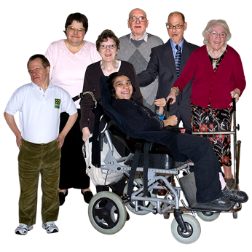
the Act better.

It is important these 2 things work for everyone.


We asked people what was:
working

not working.

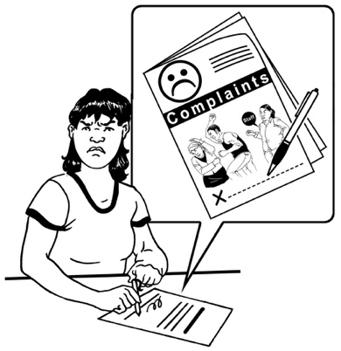
People told us to make:
the process better for people when they make a complaint
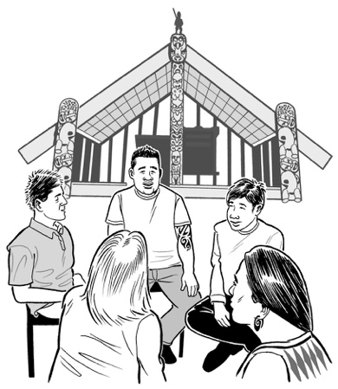
the Act and the Code work better for:
- Māori
- tāngata whaikaha /
disabled people.


Here process means the:
steps a person has to take to make a complaint

things HDC does when it gets a complaint
things a health or disability service provider does when it gets a complaint.

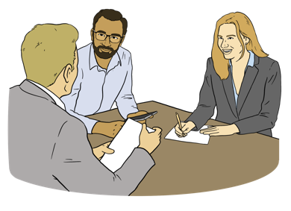
The Health Select Committee asked us to talk to people about what happens if a person does not agree with a decision HDC has made.

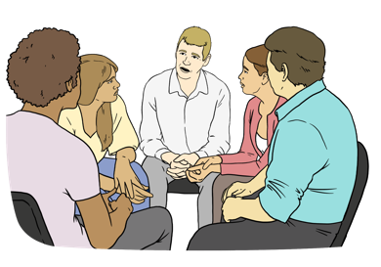
The Health Select Committee is a group of people from the Government who:
work together
and
make decisions about making health services better.

We heard from a lot of different people when we did our review.

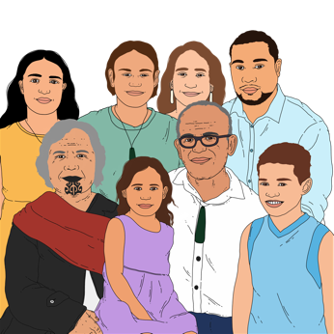
We heard from:
Māori
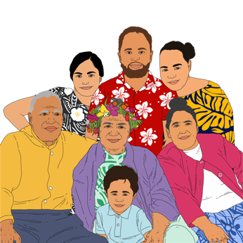
tāngata whaikaha /
disabled people
Pacific peoples.


During the review we:
got 259 written answers from people

held 60 meetings:
- online
- in person.

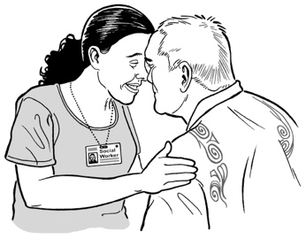
During the review we also held
7 workshops with:
Māori
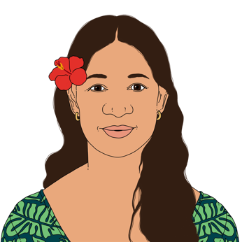
tāngata whaikaha /
disabled people
Pacific peoples.

The main things we found out
by doing our review


We found out that the Act and the Code are mostly working well.

People agree that small changes would make the Act and the Code better for everyone.

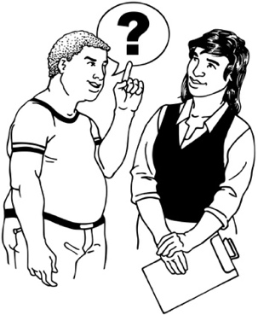
These changes should happen at the same time as changes to other laws about:
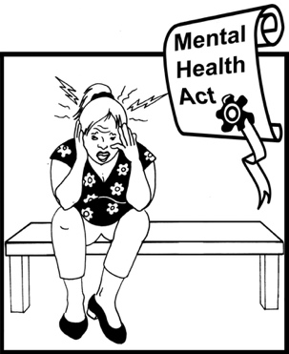
adult decision making
mental health.

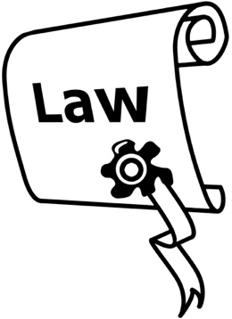

There are lots of ways to:
make things better
and

not have to change the laws.

More money will be needed to make some of these changes.


The Government can make the health and disability system better for everyone.

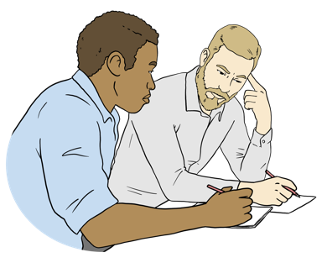
The Government can make sure people understand supported decision making.

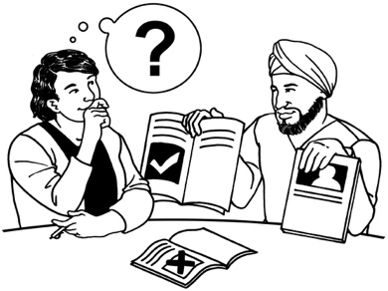
Supported decision making is when a person is supported to make decisions / choices about their own life.

The Government can also make sure new technology is:
safe
accessible.

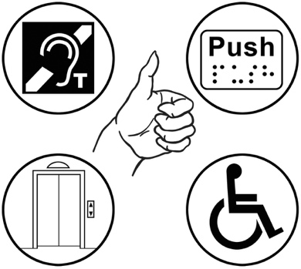
Here accessible means something can be used by everyone including disabled people.

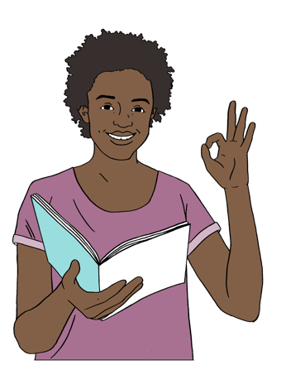
The Government can make disability support better by:
giving clear information about disability support services to:
- disabled people
- whānau / families.

The Government can also make disability support better by making it easy to:

make a complaint about disability support services
give feedback about disability support services.

Making the complaints process
work better for everyone

What people told us

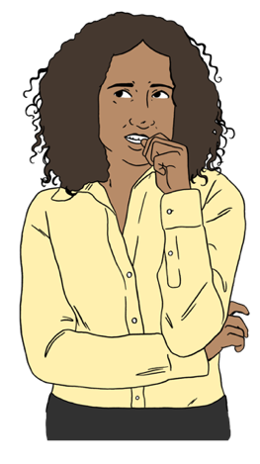
People told us it should be easy for people to:
say they are worried about something
make a complaint.



People told us why they do not:
speak up
or
make complaints.

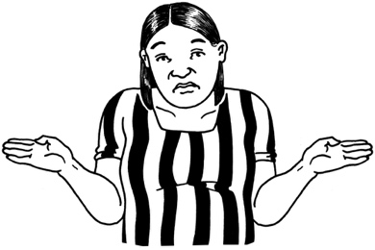
People told us they do not know:
they can speak up
how to speak up.

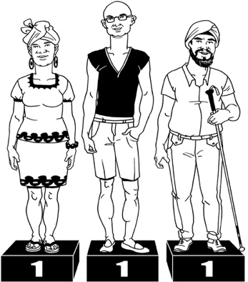

People also told us the reasons they do not speak up or make a complaint are that they:

do not think they will be treated fairly
are scared they will be treated badly by health and disability services

do not think things will get better
can find it very hard to do this.


People said the culture of a person should be respected when they make a complaint.

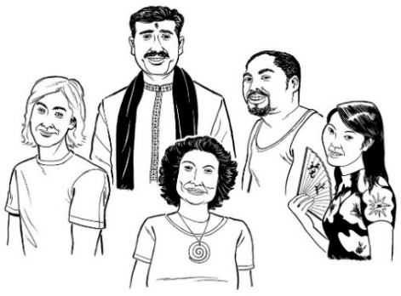
Culture is a way of:
thinking that a group shares
doing things as a group.

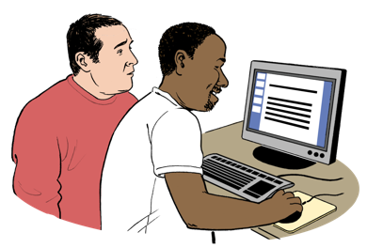
People also told us there should be more support for a person if they decide to make a complaint to:
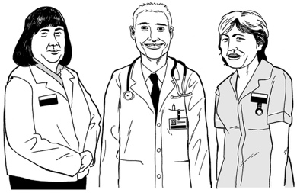
HDC

health and disability service providers.

Everyone agrees complaints should be sorted out quickly.


The main law changes we asked the Minister to make

We asked the Minister to make the complaints process work better for everyone.

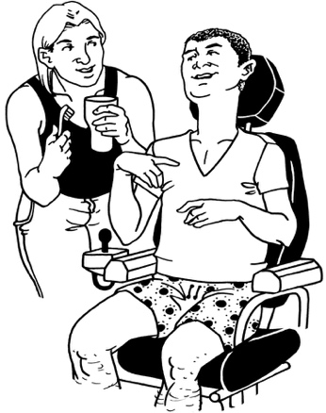
We asked the Minister to change the way complaints are handled by:
HDC
health and disability service providers.


1 way is to make the process for making complaints more accessible.

We also asked the Minister to give people the right to:
have support to make complaints

have support to say if they are worried about something
be treated fairly if they make a complaint.


We also asked the Minister to give us more ways to sort out complaints like ways that work better for:
Māori
tāngata whaikaha /
disabled people.

Making the Act and the Code
work better for Māori

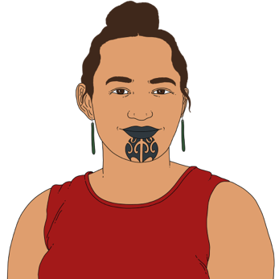

What people told us

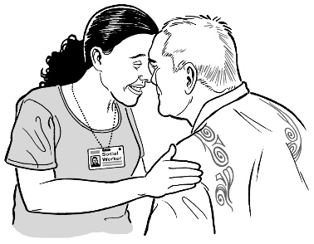
People told us it is important the Act and the Code respect te Tiriti o Waitangi / the Treaty of Waitangi.

Te Tiriti o Waitangi / the Treaty of Waitangi is an important agreement between:
- Māori
- the Government.


Doing this will make it better for everyone.

It is important the Code protects what is important to Māori.

To make the Act and the Code work for Māori we need to:
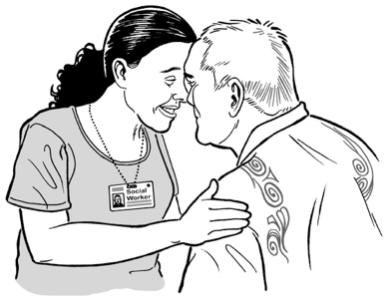
work with Māori
make sure some HDC leaders are expert in te ao Māori.

Te ao Māori is the Māori world view.
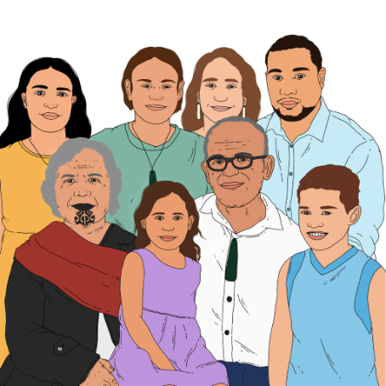

We will need to work with health and disability service providers so they understand what the Code means for Māori.

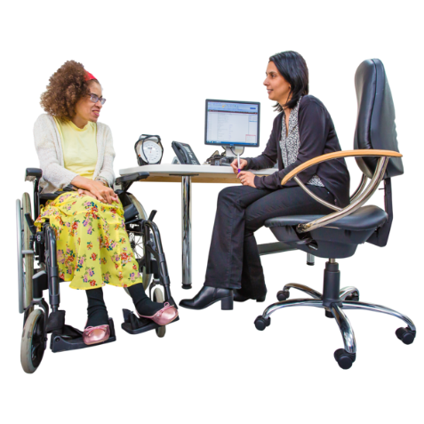
The main law changes we asked the Minister to make

We asked the Minister to give people the right to health and disability services that respect tikanga.

Tikanga is the way of doing things that come from Māori:
- knowledge
- beliefs
- values.

Here values are the important things that guide how we:
behave
and
act.
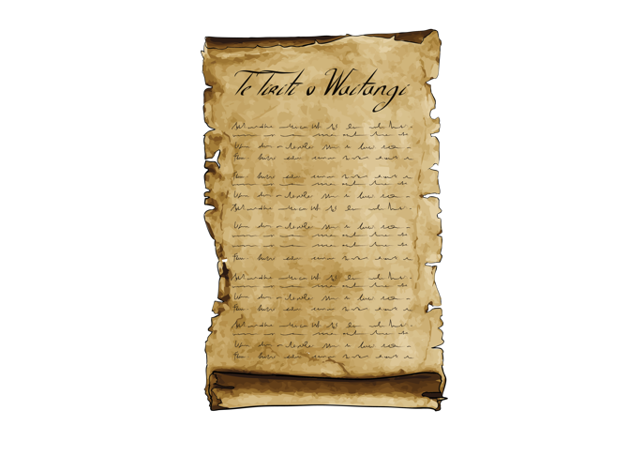
We asked the Minister to say in the Act how HDC will follow what
te Tiriti o Waitangi says.

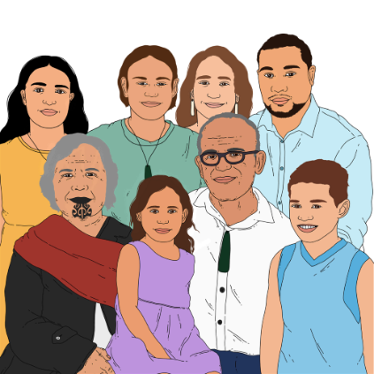
1 way is to make HDC talk to Māori when doing the review of the Act and
the Code.

It is important some of the HDC leaders are experts in:
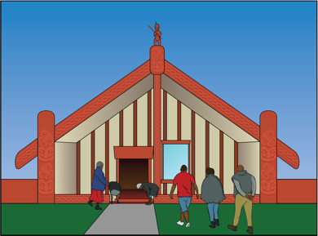
te ao Māori
and
te Tiriti o Waitangi.
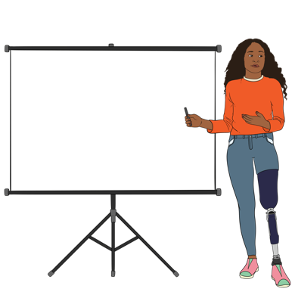
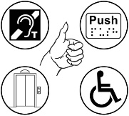

Experts are people that know a lot of information about something like
te Tiriti o Waitangi.

Making the Act and the Code work better for tāngata whaikaha / disabled people

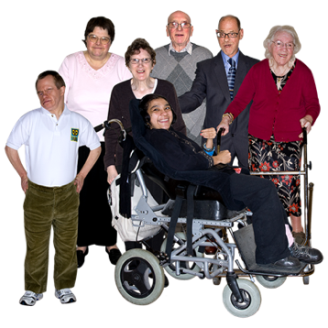

What people told us

People told us:
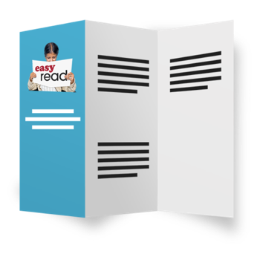
information about health and disability services should be more accessible
people should get support to make decisions
they want HDC to have more of a focus on disability
tāngata whaikaha /
disabled people want to know which services HDC can hear complaints about.

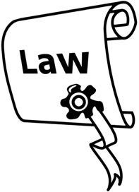
The main law changes we asked the Minister to make


We asked the Minister to make it clear people have the right to:
make their own decisions
have support to make decisions
have support to communicate.

Communicate means the way to share information like by:
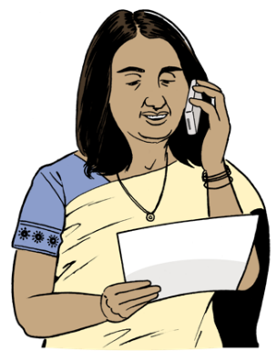
talking
writing
signing.

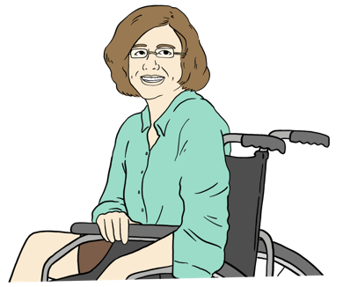
We also asked the Minister to make sure some of the HDC leaders are experts in disability rights.

Being able to challenge
decisions made by HDC
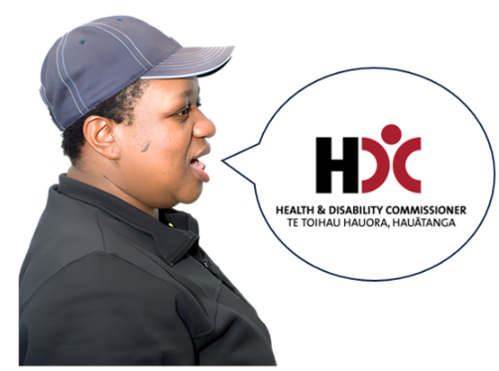

Here challenge means when you do not agree with a decision HDC has made you can tell us:
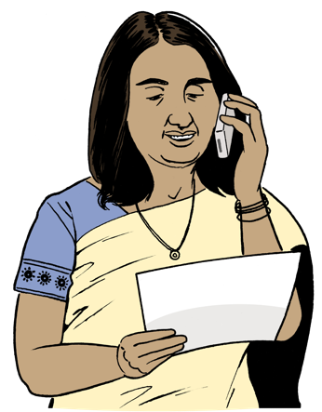
why you are unhappy with the decision
what you would like to happen.


What people told us

People told us:
they want to be able to challenge an HDC decision if they are not happy with it
it should be easy to challenge an HDC decision.

People also told us they should feel safe if they challenge an HDC decision.


Sometimes people are unhappy with a decision made by 1 person at HDC.

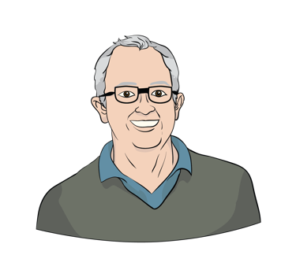
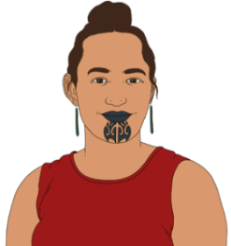
If this happens they would like a different person at HDC to:
look at their complaint
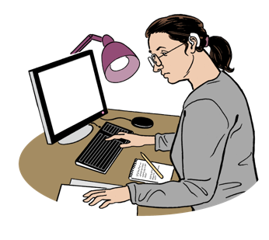
check to see if they think the decision is fair.

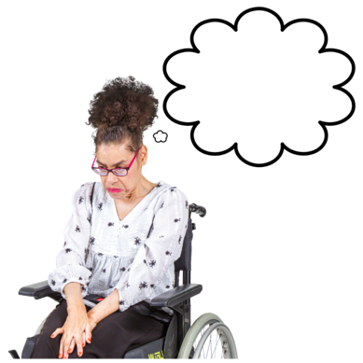
Most people did not think it was a good idea to get a different organisation to check if an HDC decision is:
fair
or
not fair.


Some people were worried that challenging HDC decisions would:
slow down sorting out the complaint
make it unfair for some people.
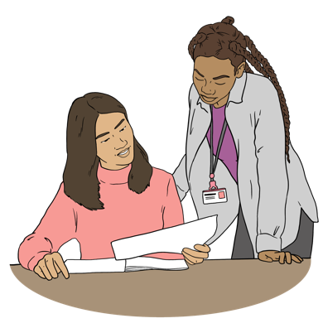

Some people told us it would be better to change how HDC does things.

The main law changes we asked the Minister to make


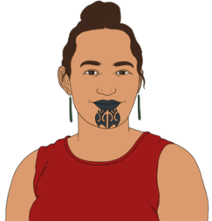
We asked the Minister to let people who are unhappy with a decision made by 1 person at HDC ask a different person at HDC to:
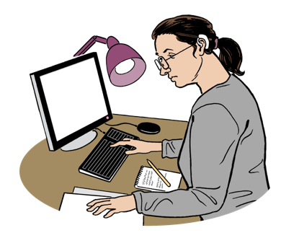
look at their complaint
check to see if they think the decision is fair.

What we can do better now

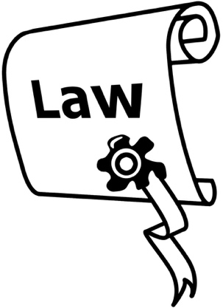
There are things we can do now without changing the law.

Some of these things are:
making the way we communicate with people better
being more accessible
working more closely with advocacy services.

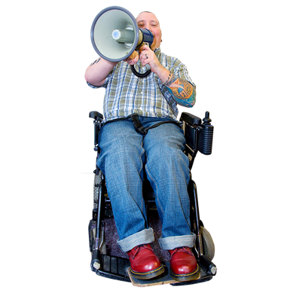
Advocacy services can support you when you have had a problem with a health or a disability service by:

talking with you about what you can do
telling you about your rights
answering your questions
supporting you to make a complaint


Other changes we can make are:
making sure we work well for everyone

talking to different communities about their rights
hearing from different communities about their experiences.
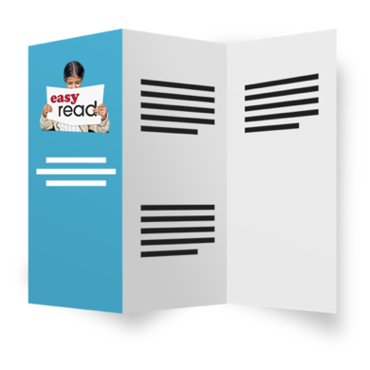
Other changes we can make are to support people / service providers to:
get more information about the rights of people to:
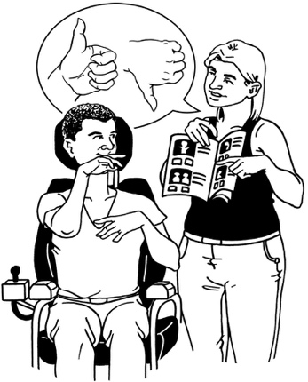
- make their own decisions
- have support to make decisions
- make complaints
understand different groups of people so these people get their rights
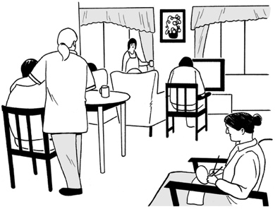
know which disability services HDC can hear complaints about.

We are already making some of these changes.

More information


You can learn more about the review at this website:

review.hdc.org.nz


You can ask questions about the review by sending an email to:

review@hdc.org.nz

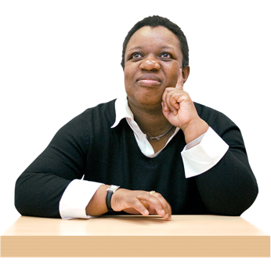
If you have a problem with a health or disability service you can contact the Health and Disability Commissioner by:


calling:
0800 11 22 33
emailing:
hdc@hdc.org.nz


You can find out more about us by visiting our website at:

www.hdc.org.nz

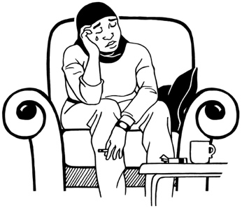
Contact the Nationwide Health & Disability Advocacy Service if you need more support to fix a problem you have had with a health or disability service by:
calling:
0800 555 050
emailing:
advocacy@advocacy.org.nz

You can find out more about them by visiting their website at:

www.advocacy.org.nz

This information has been written by the Health and Disability Commissioner.

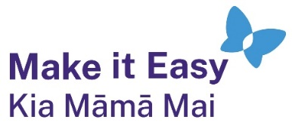
It has been translated into Easy Read by the Make it Easy Kia Māmā Mai service of People First New Zealand Ngā Tāngata Tuatahi.

The ideas in this document are not the ideas of People First New Zealand Ngā Tāngata Tuatahi.

All images used in this Easy Read document are subject to copyright rules and cannot be used without permission.


Make it Easy uses images from:


- Photosymbols

- Change Images


- Huriana Kopeke-Te Aho

- SGC Image Works

- T Wood


- Studio Rebeko

- Inga Kramer.

