
HEALTH & DISABILITY COMMISSIONER
TE TOIHAU HAUORA, HAUᾹTANGA

Using Healthcare Services
in the community
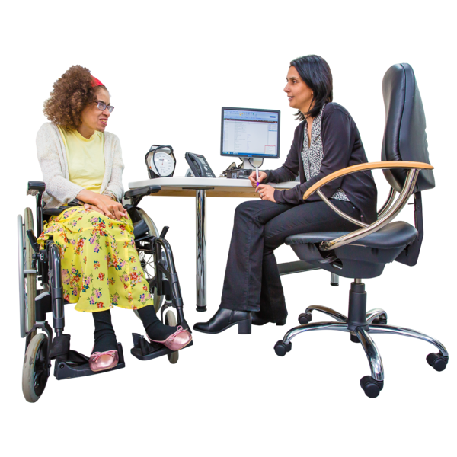

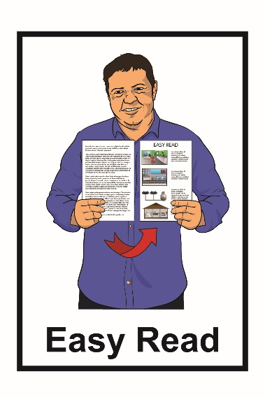

May 2021

What you will find in this booklet

Page number:
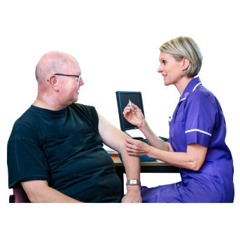

Community healthcare 3


Consent 6

Costs 10
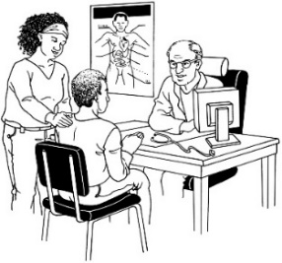

Support needs 13


COVID-19 15

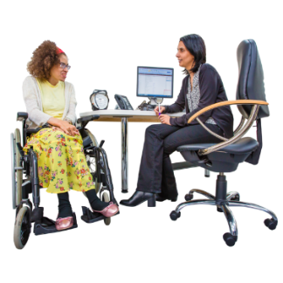
General practice 17

Appointments………………………..22


Page number:

Using technology 26
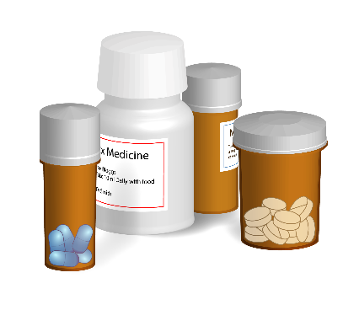

Pharmacies 28

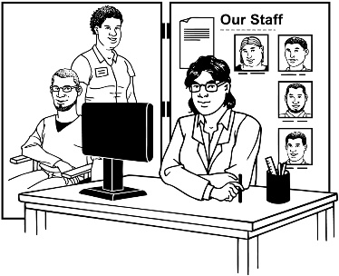
Other services in the community 34

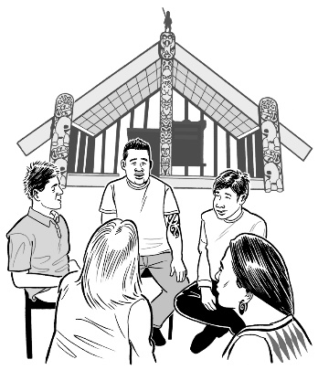
What to do………..………………….47

Te reo Māori words…………………52


Information about your rights………54

Community healthcare

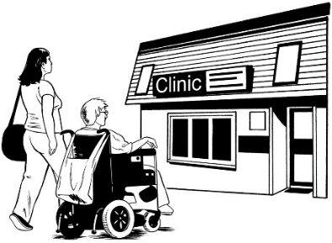
Community healthcare is care or treatment that is not in a hospital.
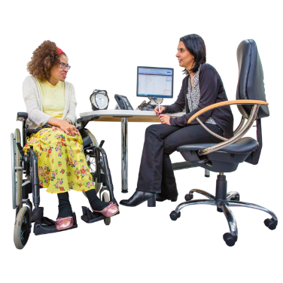

Different people in the community can support you to feel better.

They are people like:

            - your doctor

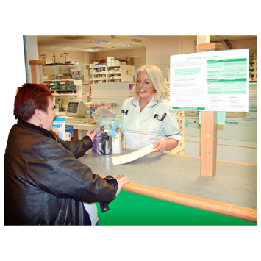
            - a nurse

            - a pharmacist

            - a physiotherapist.

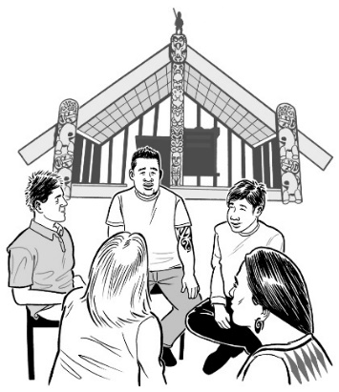
You can also see a Māori health service.

Māori health services will work with you in a Māori cultural way.

This Easy Read booklet has information about
- the people who are part of community healthcare
- what can happen when you see them.

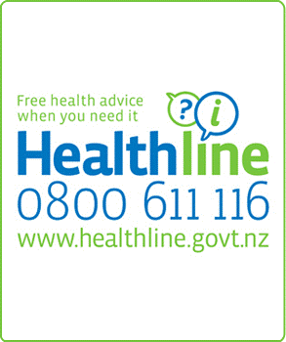
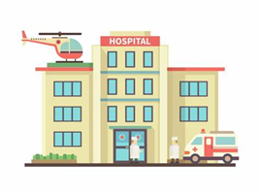
Remember if it is an emergency you should go to the hospital.

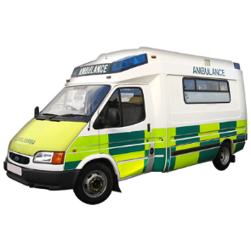
An emergency is when you need medical help quickly.

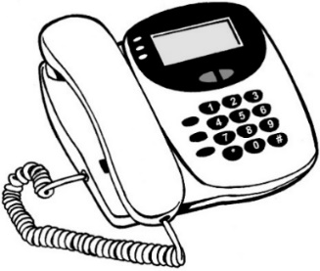
If it is an emergency and you need help quickly call:

111.

If you have questions about your health you can call Healthline for free on:

0800 611 116.

Consent

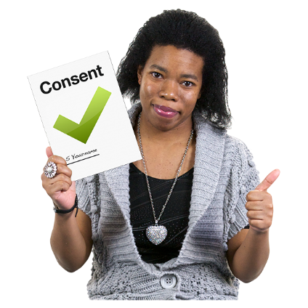
Giving consent means you say yes to care and treatment.

To give your consent you need to be told all the information in a way that you can understand.
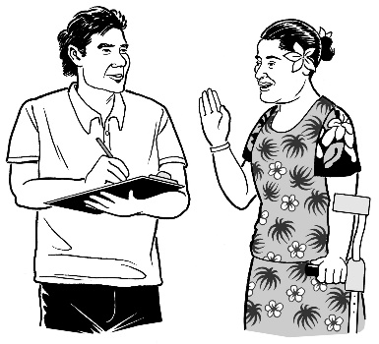

You can give consent by:
- talking
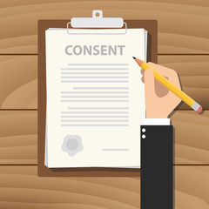
- writing
- your actions.


You can change your mind at any time.

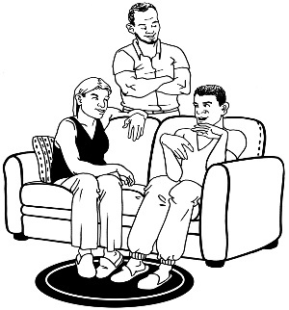
You can have support to:

- make decisions

- give consent.

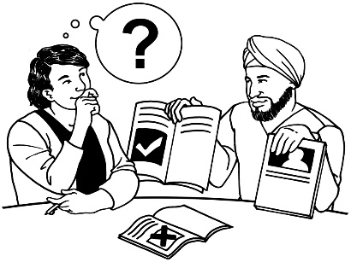
This is called
supported decision-making.

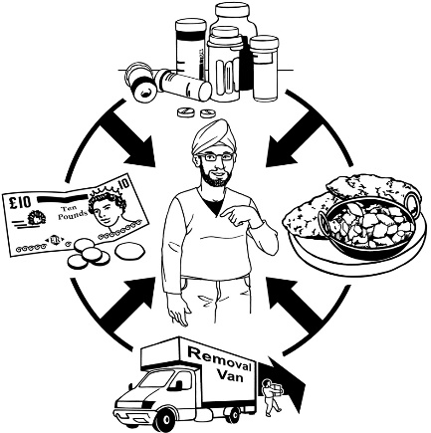
Supported decision-making means the person making the decision is:

- in charge of their life

- at the centre of all decisions that are to do with them.


You can find more information about supported decision making on the People First New Zealand website:

https://www.peoplefirst.org.nz/download/3304/

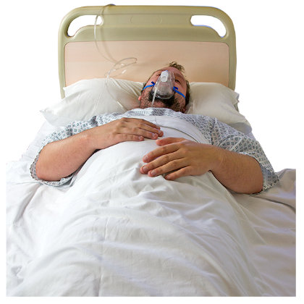
Sometimes you might not be able to give consent – for example if you are:

- not conscious or cannot be woken up

- needing medical treatment quickly.

When this happens someone else might make the decision for you.

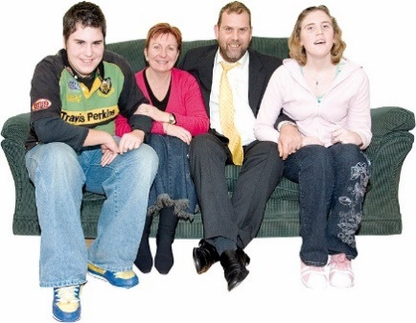
The person who makes decisions for you may be:
- a doctor
- your guardian who has been given the role of making decisions for you
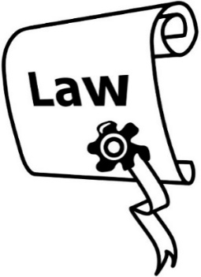
- a family member
- your Enduring Power of Attorney.

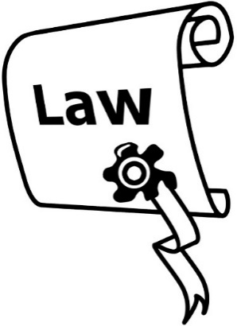
An Enduring Power of Attorney is a legal document.

It says someone else can make decisions for you if you cannot.
Costs



Sometimes it costs money to use community healthcare.

Some services are subsidised.

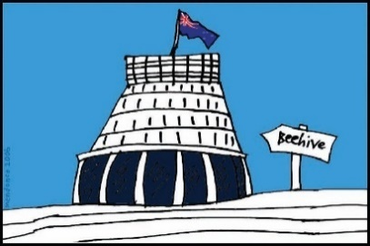
Subsidised means:
- the government will pay some of the costs
- you have to pay the rest of the costs.

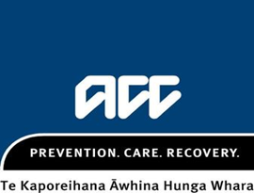
If you have had an accident the Accident Compensation Corporation may pay the cost.

The Accident Compensation Corporation is also called ACC.


To find out more information contact ACC by:

- phone on:
0800 101 996
You do not have to pay for this call.


- email at:
claims@acc.co.nz

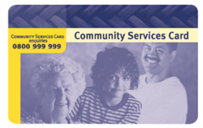
If you have a Community Services Card this may mean some costs are lower.


To find out more information about this card contact the Community Services Card team at Work and Income by:
- phone on:
0800 999 999
You do not have to pay for this call.

- email at:
- csc_enquiries@msd.govt.nz

Support needs

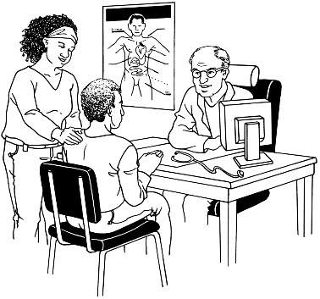
Sometimes people need support when they use services.

Anyone can have a person to support them.

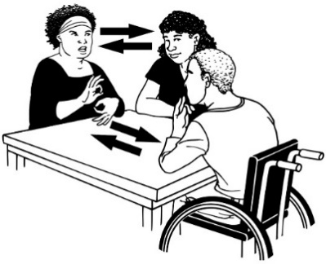
Some of the kinds of support you can have is:

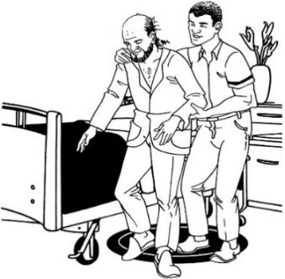
- an interpreter if you are Deaf

- someone to support you to move around if you find it hard to get around

- someone to support you with

- understanding information

- making decisions.

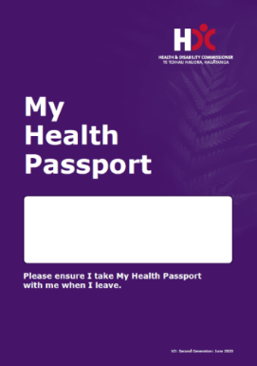
You may want to use a My Health Passport when you have appointments.

My Health Passport is a document that has information about:
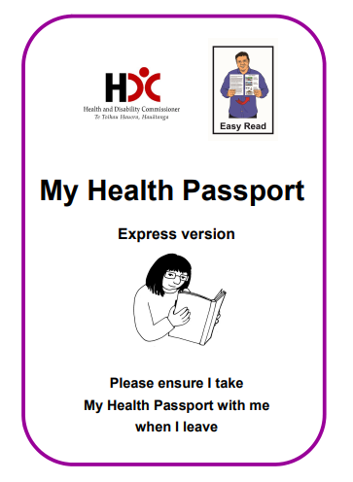
- your support needs
- contact details for your family.

There is also an Easy Read version of the My Health Passport.


You can get a My Health Passport from the Health and Disability Commissioner.


You can find out how to contact the Health and Disability Commissioner on page 48 of this booklet.

COVID-19


COVID-19 is a virus that can make some people very sick.

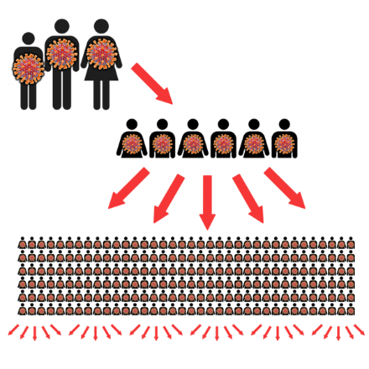
We have had to change things to make stop COVID-19 spreading.

This means there are changes to some services.

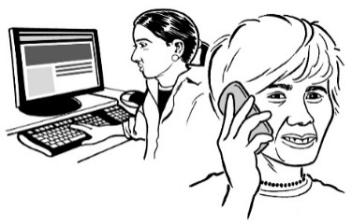
These changes may happen a lot.

Services should tell you when things change.


Some community health services may:

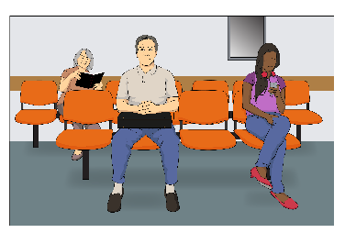
- be stopped

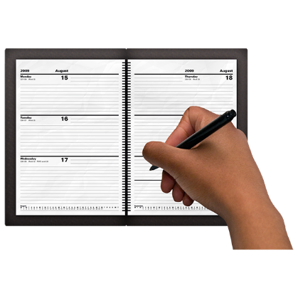
- need people to stand or sit further apart from each other

- need you to book an appointment first
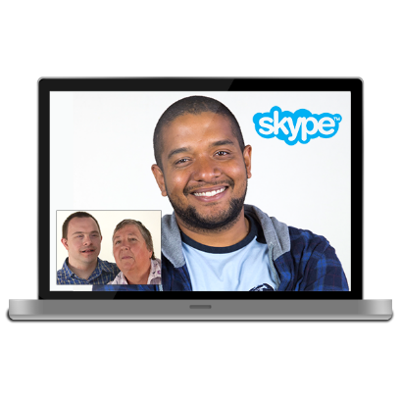
- use technology so that you do not have to meet in person.


You should tell the service if you have any signs of COVID-19 before you see them.


If you are waiting for a COVID-19 test result then you should isolate at home.

For more Easy Read information about COVID-19 changes you should go to this website:
https://covid19.govt.nz

General practice

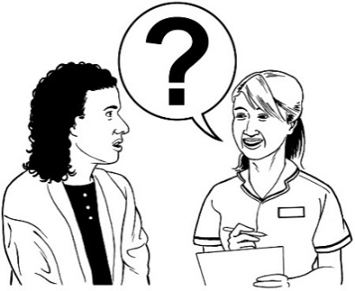
A general practice is a place where you go when you need:

- health advice
- treatment.

Doctors who work in general practice are called GPs.


A number of different healthcare professionals can work in a general practice.

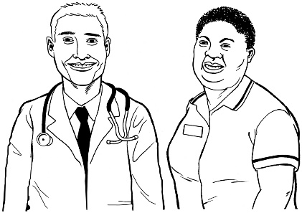
A healthcare professional is a person who has training so they can give you health advice and treatment.

Healthcare professionals are people like a:

- doctor
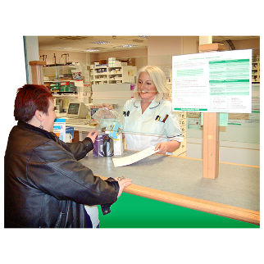
- nurse

- pharmacist.

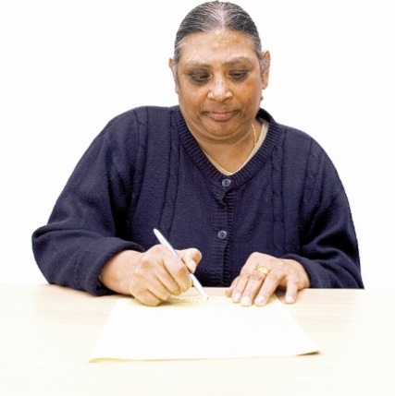
Before you can see a healthcare professional you may need to:
- sign up with a general practice in your local area
- make an appointment.

An appointment is when you meet with a healthcare professional to:
- talk about any problems you think you may have
- get their advice.


An appointment is sometimes called a consultation.


Appointments can be:
- in person

- by phone

- or through a video call.


At your appointment the healthcare professional may ask you questions and then decide:
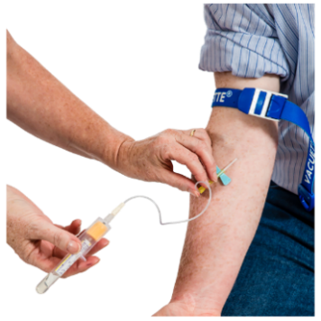
- how to treat you
- to send you for tests like blood tests or X-rays
- to send you to someone else for treatment
- to give you a prescription for medicine.

A prescription is something you can take to the pharmacist to get medicine.


The healthcare professional may also write a referral to a specialist.


A doctor writes a referral when they decide you need to be seen by another healthcare professional.

That healthcare professional will contact you to make a time to see you.

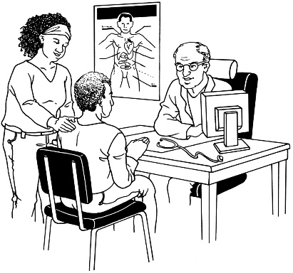
A specialist is a person who has lots of extra training in 1 kind of medicine.

Remember you may not be able to see the same person every time.
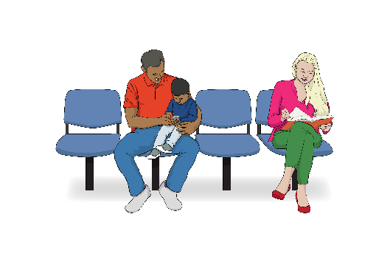

General practices can get busy which means you may have to wait before seeing someone.

Appointments

Before your appointment you should think about:


- what you want to talk about
- what do you want to happen

- what do you need from the healthcare professional you are seeing.

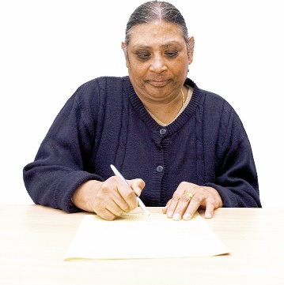
You may want to write down and take with you some information like:


- illnesses in your family like heart problems or diabetes

- the things you are feeling you have like headaches or vomiting.

You should feel like:
- you can talk with the healthcare professional
- you are listened to.

Remember you can have someone to support you at your appointment.


It is important that you understand all the information so that you can make a decision about your treatment.

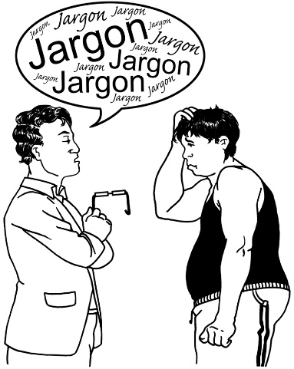
You should tell the healthcare professional if you need support to:
- talk with them
- understand information
- make decisions.
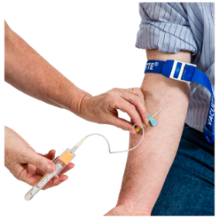
You should be told what will happen next like:

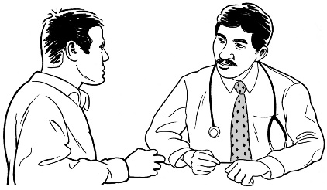
- if you need tests
- if you need a prescription for medicine

- if you are being referred to someone else
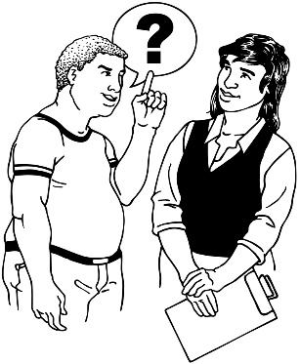
- what you should do if you feel sicker.

Remember you should talk with your healthcare professional if you have any questions.


You should check in with your healthcare professional if you are waiting for a test result or a referral.
Using technology


Health professionals sometimes use technology to talk with people so they do not have to meet in person.

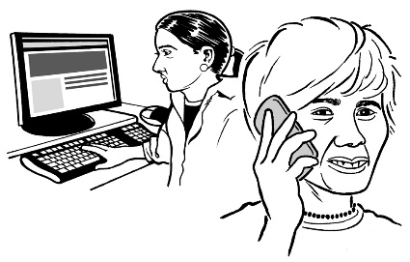
Technology means thing like:

- computers / I-pads

- internet

- emails
- mobile phones

- video calls.

You should talk to your health professional if you are worried about using technology.

Many general practices also have a patient portal.

A patient portal is a way of getting in touch with them using:

- your computer
- an app on your phone.

You can use the patient portal to:

- get a prescription

- email your general practice

- see your test results

- see all the information the general practice has about you.

Pharmacies

A pharmacy is a place where you can get medicines.

Some medicines need a prescription from your doctor.

You can also buy:

- some medicines that do not need prescriptions
- other things you need if you are sick or hurt.

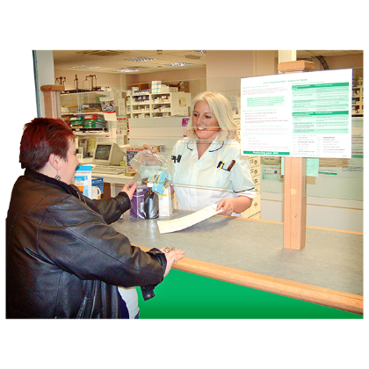
A pharmacist is someone who is trained to give you medicines.


Pharmacists can:

- support you to quit smoking
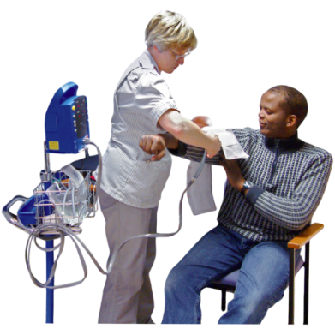
- talk to you about managing your weight

- check your blood pressure

- monitor some medications

- give you some vaccinations like for the flu

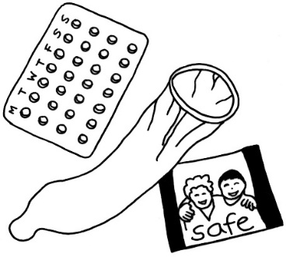
- give you contraception and emergency contraception.
Contraception is what you use to help stop you from getting pregnant.
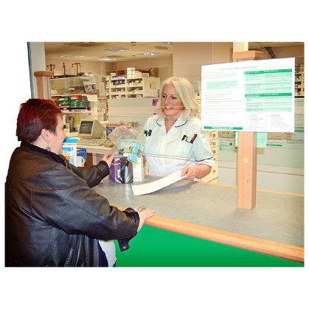
There are different types of pharmacists:

- community pharmacists who you will find in most cities and towns.

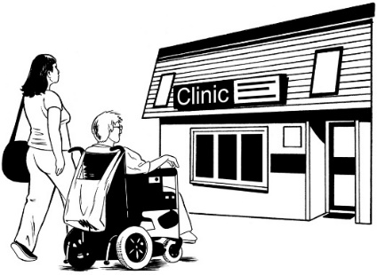
- general practice pharmacists who:

  - work in general practices with doctors and other healthcare professionals
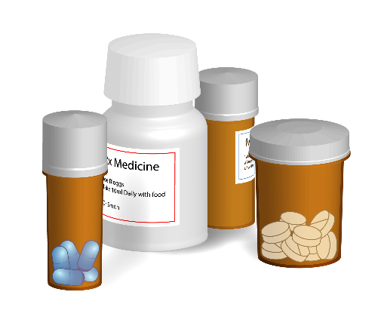
  - make sure that any medication you take is safe and works well for you.

- prescribing pharmacists who:
  - have had extra training
  - can write prescriptions for medication like doctors can.

All pharmacists should tell you:

- when you should take your medication

- how much of your medication to take

- what the side effects of your medication are

- what to do if you have a reaction to the medication.


A reaction is when something happens because of the medicine like:
- a rash
- feeling unwell.

Sometimes your medication might not look the same as the medication you have had before.

Medications can come in different packets.


Some pharmacies can deliver your medication to you.


Remember that it may cost you to get some medicines.


When you have paid for 20 new prescriptions in 1 year other prescriptions for that year may be free.

Make sure to talk to the pharmacist if you have any questions about:
- your medication
- what your medication costs.

Other services in the community

There are a lot of different services you can use in the community.

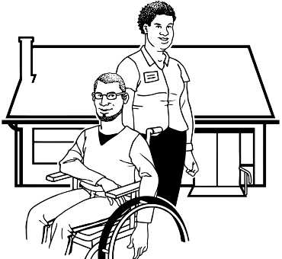
These services include:

- Home and community support services

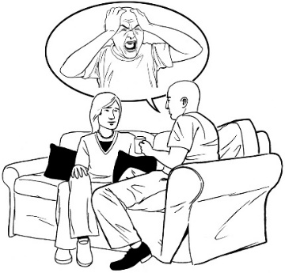
- Community mental health and addiction services

- Counsellors
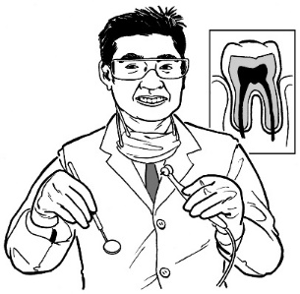
- Dentists

- Physiotherapists.

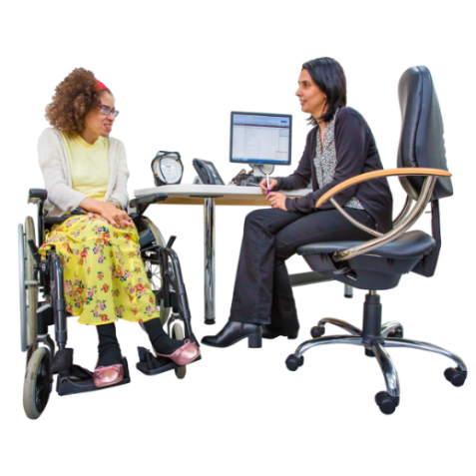
You can be referred to these services by:
- your doctor
- the hospital.

It may cost you money to use these services.

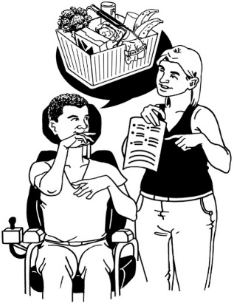
Home and community support services

Home and community support services help you to live how you want to live.

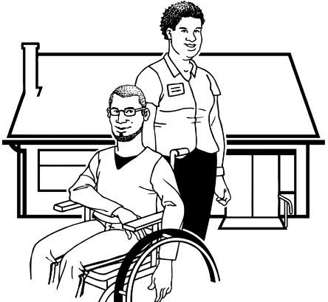
You may have a disability or other support need that means you need support to live in your home.

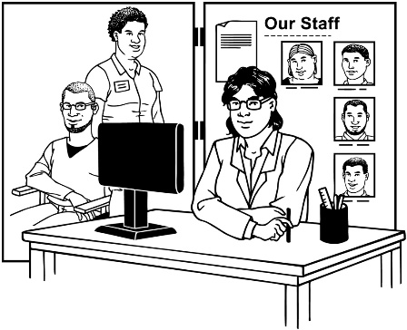
You first need to have your support needs assessed by a Needs Assessment Service Coordination Team.

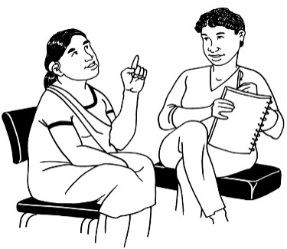
Needs Assessment Service Coordination Teams are also called NASC Teams.

You can:
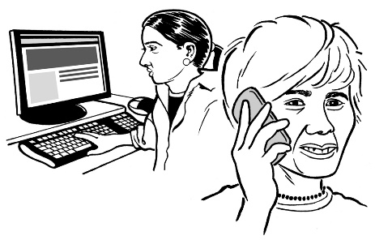
- be referred by your doctor to your local NASC Team
- contact your NASC Team yourself.


You can find out more about NASC Teams at this Ministry of Health website:

https://www.health.govt.nz/your-health/services-and-support/disability-services/getting-support-disability/needs-assessment-and-service-coordination-services
The NASC Team will talk with you about the support you need.

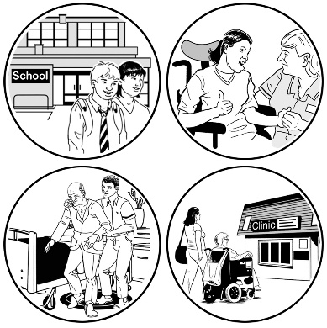
A service provider will talk with you and make a plan for your support.

Remember it may take some time to put in place a plan to help you.
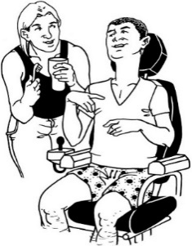
Support can be with:

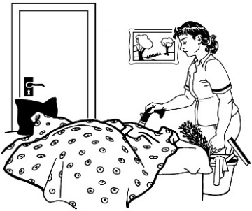
- making meals
- washing and drying clothes

- house cleaning
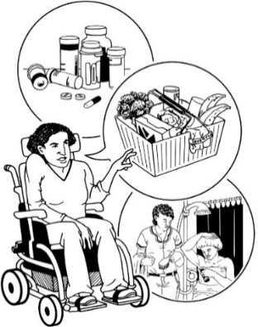
- using the bathroom
- taking medication

- getting to appointments.


If you have questions about your support you should talk to the service provider.
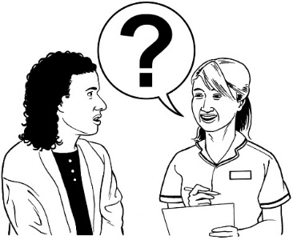
Nurses can sometimes also support you in your home so you do not have to stay in hospital.

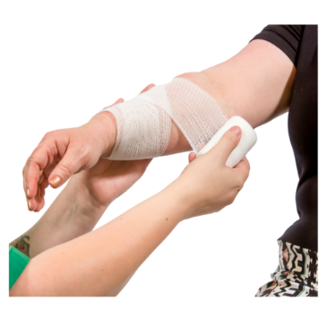
Nurses can:
- support you with wound care

- make it easier for you to live with a disease or illness
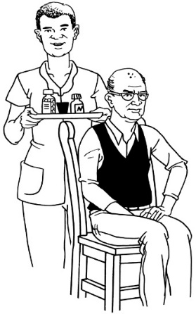
- support you to feel better if you are hurt

- give support with medication.

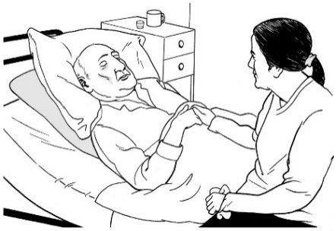
Some nurses can give you extra help if:
- you are dying
and
- you want to stay in your home.
Community mental health and addiction services


Mental health and addiction services are there to support you when you feel
- unwell
- worried.

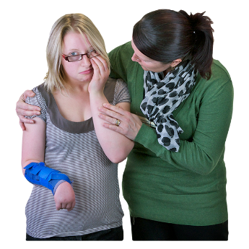

Mental health is about how you feel.


The feelings you have can change:

- how you think about things

- the things you do.

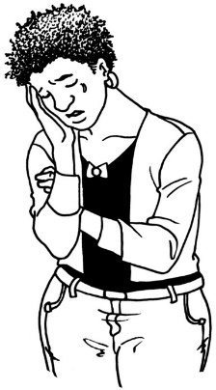
Having a mental illness means having conditions like:

- depression


- anxiety

- bipolar disorder

- schizophrenia


- post traumatic stress disorder

- eating disorders.

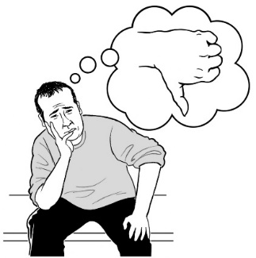
There are many other conditions.

These are just some of them.

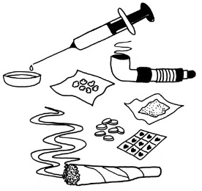
Addiction means not being able to stop yourself from doing things like:


- using drugs

- drinking alcohol

- gambling money – like:

  - betting on the horse racing

  - going to a casino.

There are many other things that people can be addicted to.

These are just some of them.

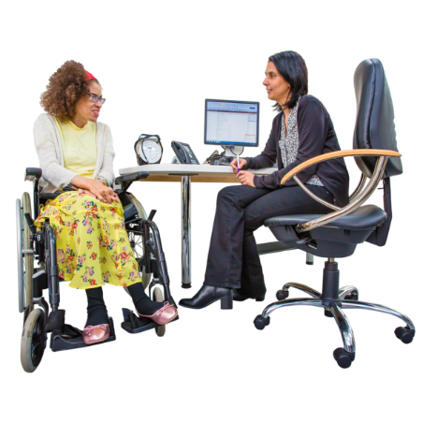
Most people are referred to mental health and addiction services by:
- their doctor
- the hospital.


It may take a long time before you can see someone.


If it is an emergency you can call your local hospital for their:
- psychiatric emergency service
- mental health crisis assessment team.


If you are feeling worried about your mental health you can also talk to someone from:

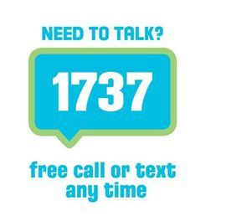
Need to Talk?

Phone or text: 1737

It will not cost you any money to call or text this number.

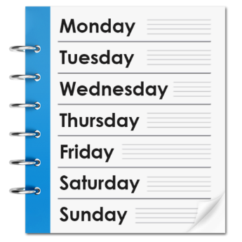

Need to Talk is open:

- everyday

- all day and all night

If you are feeling worried about your mental health you can also talk to someone from:

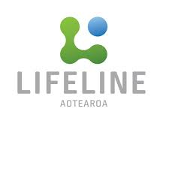
Lifeline Aotearoa


Phone: 0800 LIFELINE (0800 543 354)

Text: HELP to 4357 and someone will call you back.

It will not cost you any money to call or text this number.

Lifeline Aotearoa is open:

- everyday

- all day and all night

If you are feeling worried about your mental health you can also talk to someone from:


Samaritans Aotearoa New Zealand

Phone: 0800 72 66 66

It will not cost you any money to call or text this number.

Samaritans is open:

- everyday

- all day and all night

What to do…

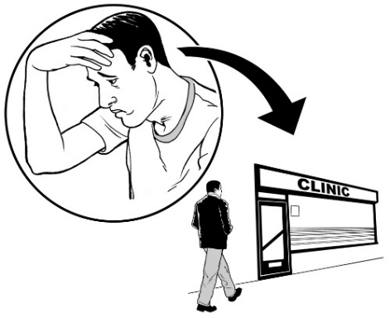
What to do if you are feeling worried about an appointment

It is okay to be worried about your appointment.


You should
- tell someone how you feel
- ask for support.

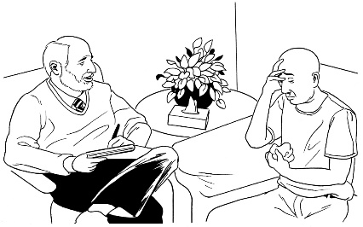
Some general practices will have people you can talk to about what is worrying you.
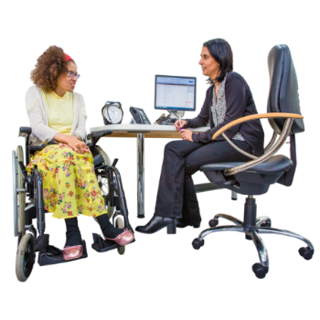

You doctor might refer you to a mental health service.
What to do if you have to wait to see someone


Sometimes you might have to wait a while:
- to see someone for an appointment
- at your appointment.


If you think you have been waiting a long time at your appointment you can tell someone.

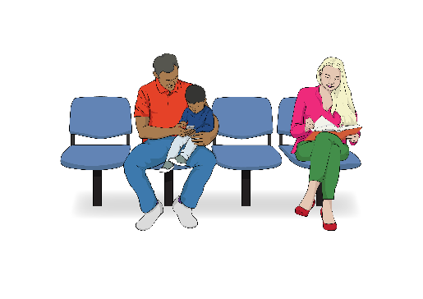
They may be able to:
- tell you how much longer you need to wait
- book a new appointment for you.

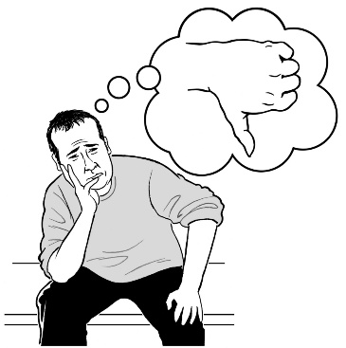
What to do if you are unhappy with a service

Sometimes you may be unhappy with how people treated you.

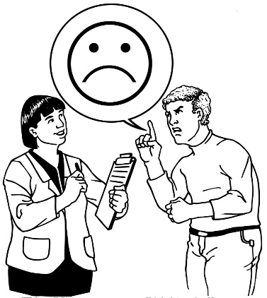
You should tell the service provider how you feel so they can help to make it better for you.

You can ask for help to talk with them.


If you do not want to talk with your service provider you can talk to:
- the Health and Disability Commissioner

- the Nationwide Health and Disability Advocacy Service.


Health and Disability Commissioner

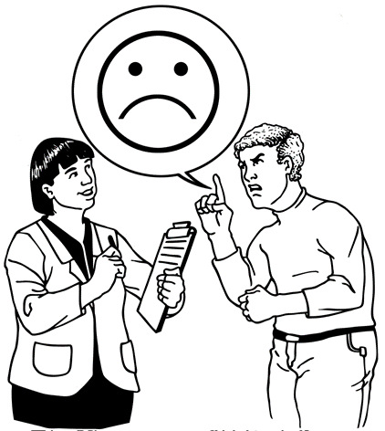
The Health and Disability Commissioner looks at complaints people make when they are unhappy with a health or disability service.


Website:

https://www.hdc.org.nz

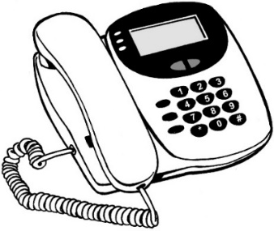
Phone:

0800 11 22 33


Email:

hdc@hdc.org.nz

Nationwide Health and Disability Advocacy Service

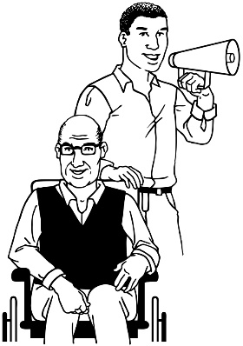
The Nationwide Health and Disability Advocacy Service can talk to you if you are unhappy with a health or disability service.

Website:

https://advocacy.org.nz

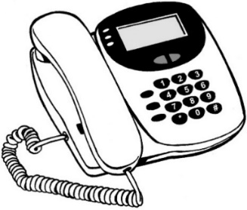
Phone:

0800 555 050


Email:

advocacy@advocacy.org.nz

Te reo Māori words

You may hear some of these words used in your appointments.

Co-morbidity | Mate tiwhatiwha
Cancer | Mate pukupuku
Diagnosis | Whakataunga
Dizziness | Ninihi
Fever | Kirika
Gout | Porohau
Hernia growth | Whatirama, whaturama
Inflammation of mucous membranes | Marupo
Patient | Turoro
Prognosis | Waitohunga
Perspiration | Kakawa
Referral | Tukunga

Some more te reo Māori words you may hear in your appointments:

Swelling | Pupuhi
Swollen | Matakoma
Tumour | Puku
A wrinkle | Pori

Information about your rights

You can contact:

The Nationwide Health & Disability Advocacy Service

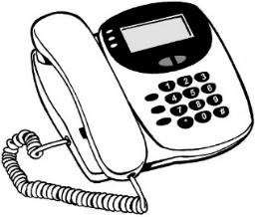
Phone:
0800 555 050

It does not cost any money to call this number.


Email:
advocacy@advocacy.org.nz


Website:
www.advocacy.org.nz
You can also contact:

The Health and Disability
Commissioner


Phone:
0800 11 22 33

It does not cost any money to call this number.

Email:
hdc@hdc.org.nz

Website:
www.hdc.org.nz

This booklet was made by the
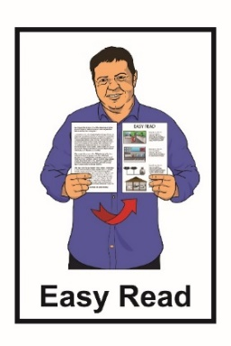
Health and Disability Commissioner and has been translated into Easy Read with advice from the Make It Easy service of People First New Zealand Inc. Ngā Tāngata Tuatahi.


The ideas in this document are not the ideas of People First New Zealand Ngā Tāngata Tuatahi.


Make It Easy uses images from:

- Changepeople.org

- Photosymbols.com


- Sam Corliss


All images used in this Easy Read document are subject to copyright rules and cannot be used without permission.

