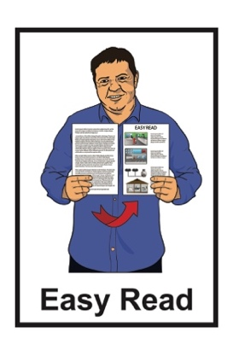
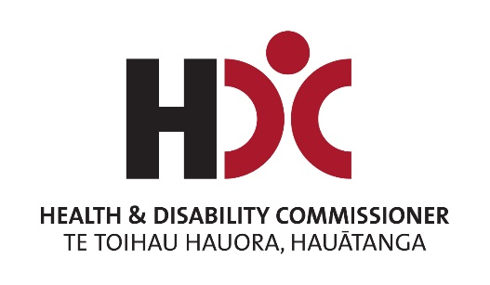

Summary of a report on
Residential Disability Services
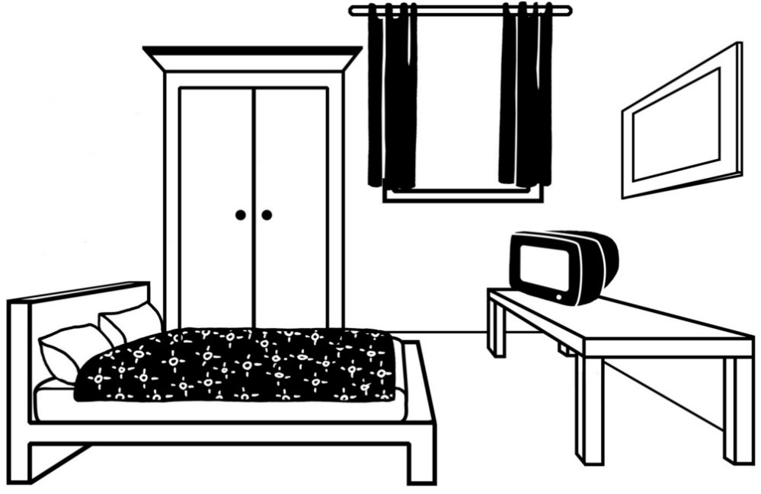

Published: September 2024

Before you start


This information may upset some people when they are reading it.

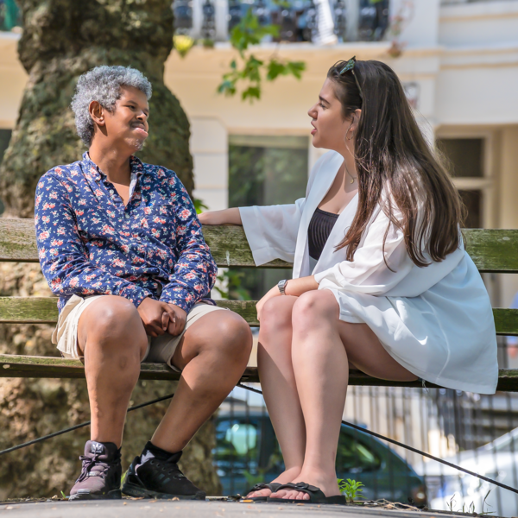
If you are upset after reading this document you can talk to your:
whānau / family
friends.

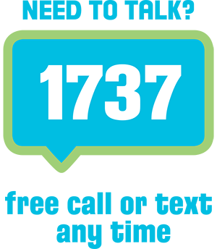
You can also contact Need to Talk by:
calling 1737

texting 1737


It does not cost any money to call / text 1737.

What is in here

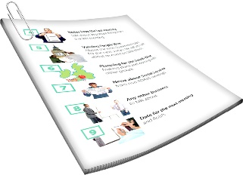
Page number:

About this document 3
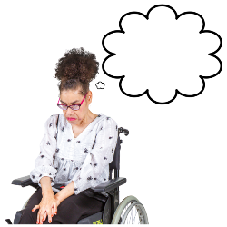

What disability support is like now 6
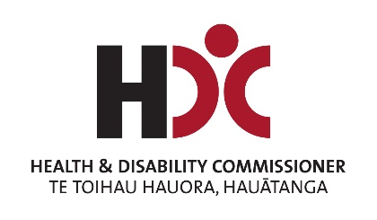

What HDC found out 10
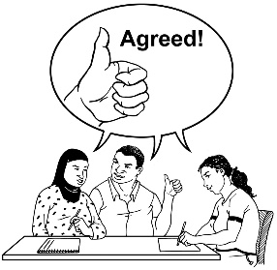

Recommendations made by HDC 18


More information 33

About this document

This document is by the Health and Disability Commissioner.

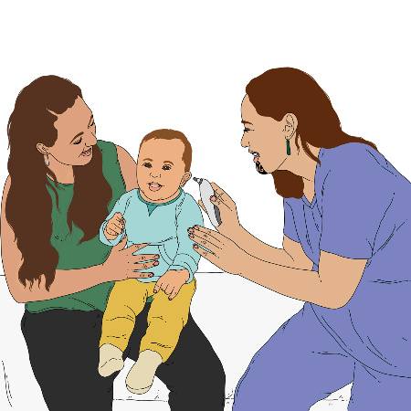
The Health and Disability Commissioner looks after the rights of people using:
- health services
- disability services.
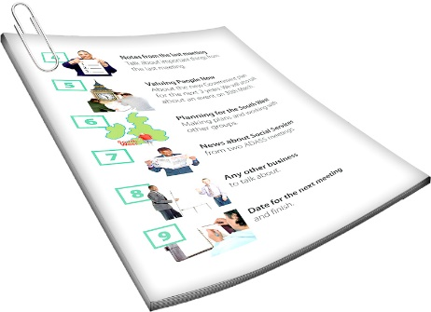

In this document the Health and Disability Commissioner will be called HDC.
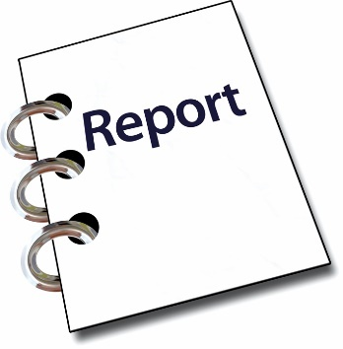

This is a summary of a report about residential disability services.

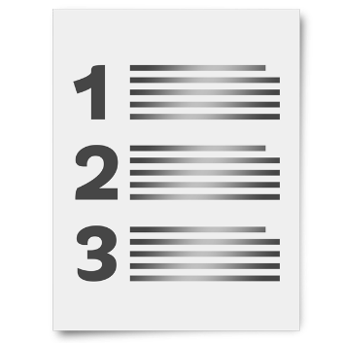
A summary is:
- shorter than the main document
- tells you the main ideas.

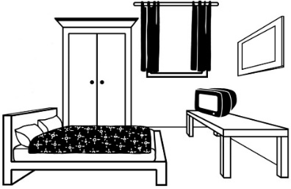
Residential disability services are when disabled people:
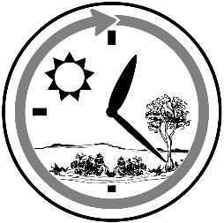
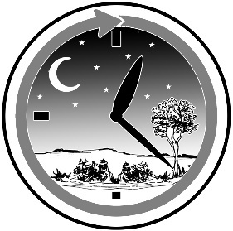
live in a home / flat in the community
get support all through the day and night.


You can read the full report at:

tinyurl.com/HDCResidentialDisability
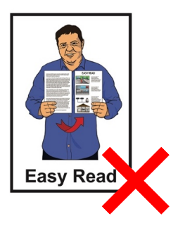

The full report is not in Easy Read.

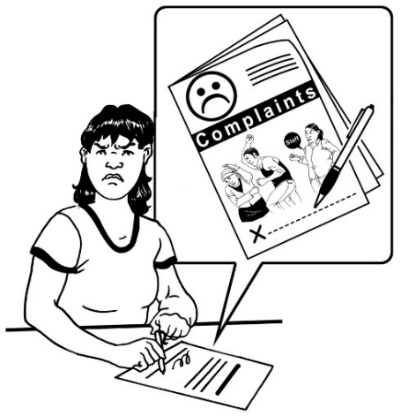
In this report HDC is only looking at complaints made to HDC that were:
about residential disability support
and
made in the past 5 years.

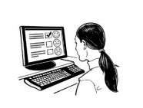
A complaint is when you tell someone that:
something is wrong
it needs to be sorted out.

What disability support is like now
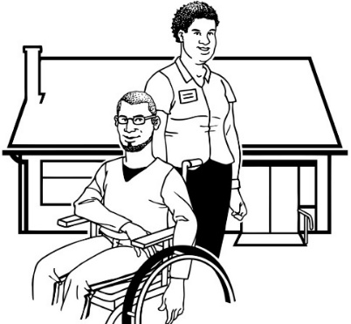

Things can be difficult for disability support in Aotearoa New Zealand.

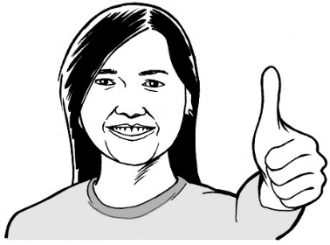
HDC thinks that:
most people working in disability support are doing a good job

there are some problems.


Many groups of people are worried about things like:
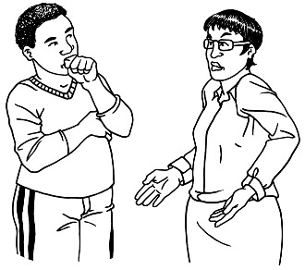
not enough people working in disability support
not being able to get disability support.

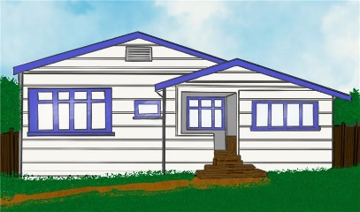
Disabled people need a place to live that:

is safe
is warm
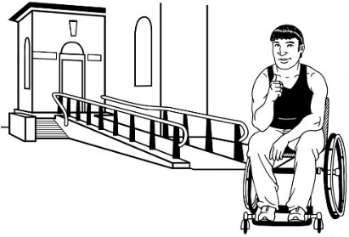
does not cost too much money
they know they can stay in
is accessible.
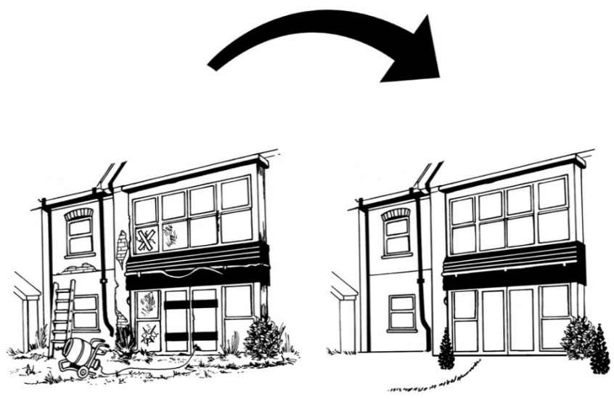

Some disabled people do not:
have good places to live
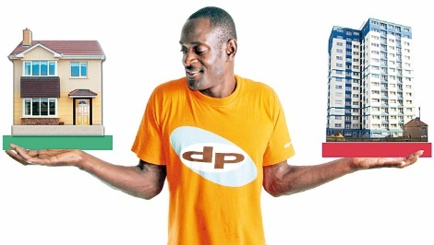
get to choose where they live.


Many groups of people are also worried about things like:

support services having closed
some people getting different or less support because of where they live

if there is enough money for disability support

if enough is being done to keep disabled people safe.


All these problems can mean that some people may not be getting the right support to:
be part of their communities
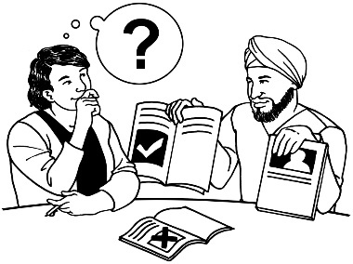
feel good about themselves
be able to make decisions about their lives.
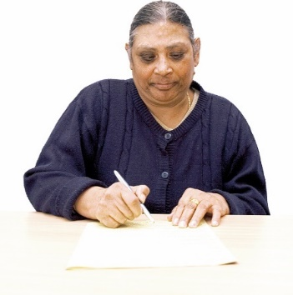
We know it can be hard to make a complaint to HDC about residential disability support.

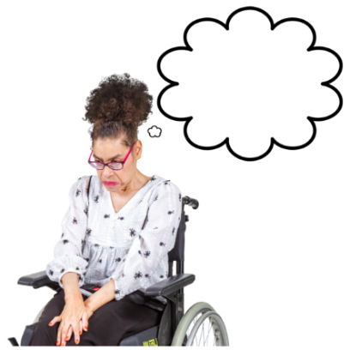
Some people:
do not want to make complaints through HDC
feel worried about making a complaint.

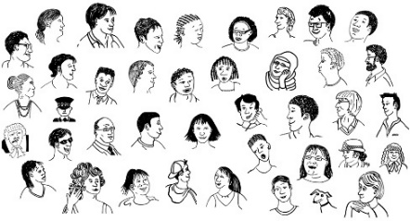
HDC thinks there are more people who are unhappy than those who tell HDC.

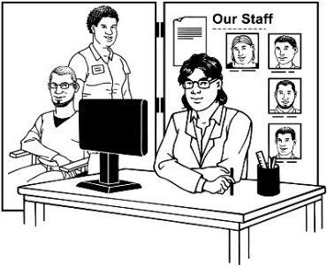
People may complain to:
their residential support service

the Human Rights Commission

the Ombudsman
organisations that pay for support like:
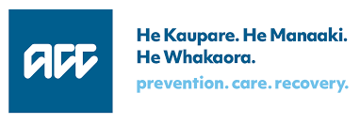

- Ministry of Disabled People - Whaikaha

- ACC
- Health NZ Te Whatu Ora.

In this Easy Read the Ministry of Disabled People – Whaikaha will be called Whaikaha.
This report is only about the complaints made to HDC.

What HDC found out


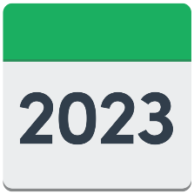
HDC looked at 5 years of complaints about residential services.


HDC found that some people were not getting good support.

Some ways support was not good included:

there were problems with safety
some people were not getting the right medicine
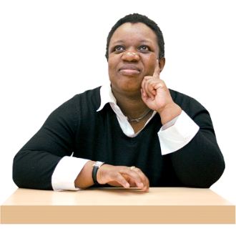
- some support staff were not getting enough support from their managers / the people in charge
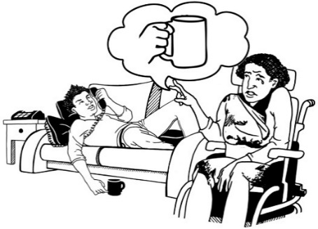
some people were getting support that did not meet their needs
HDC also found that:
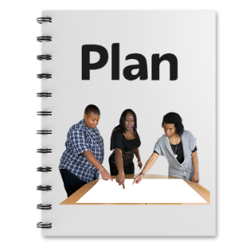
support plans for some people were not being followed
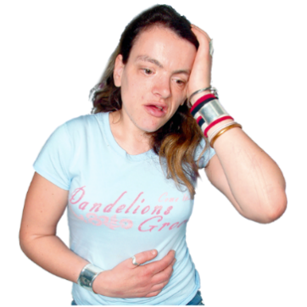
some support staff were not supporting people properly:
- with health conditions they already had
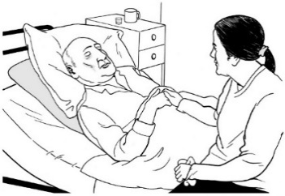
- when they got sick
- when they were getting sicker.
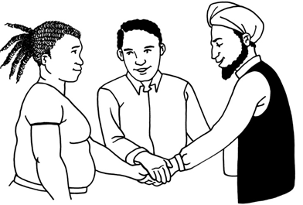
some residential disability support services were not good at working with other services like health services
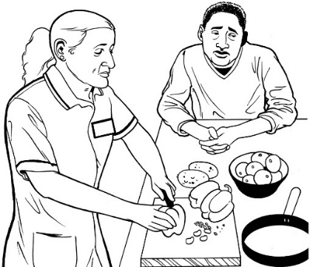
some people were not getting support from staff with the right skills
staff used restraint / force on some people.
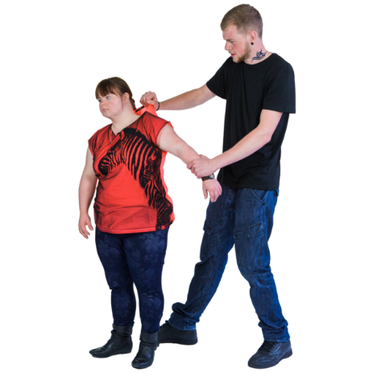
Restraint is when someone is stopped from moving in ways like:

being tied down
being given medicine
another person using their hands on them.

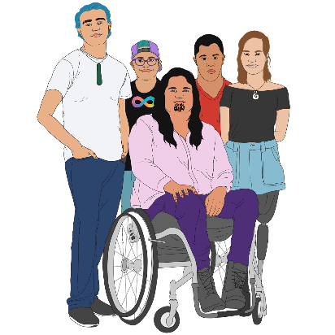
HDC also found that some tāngata whaikaha Māori / disabled Māori were not getting disability support that upheld their mana.

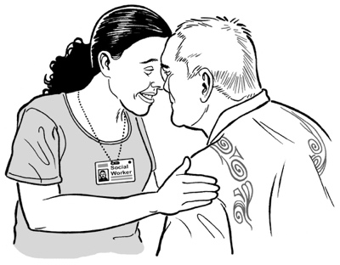
Having mana:

- means someone has a strong sense of confidence / knowledge about them
- might affect how other people see / think about them.

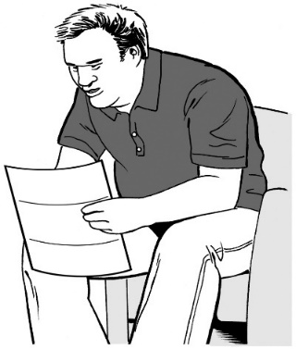
Some disabled people and their families were unhappy with communication from residential disability services.

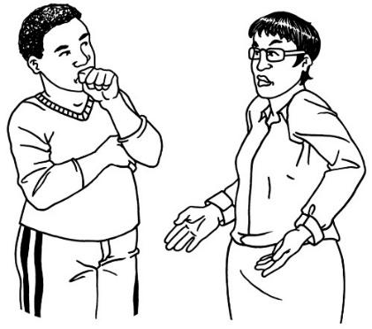
This included:
not being talked to respectfully
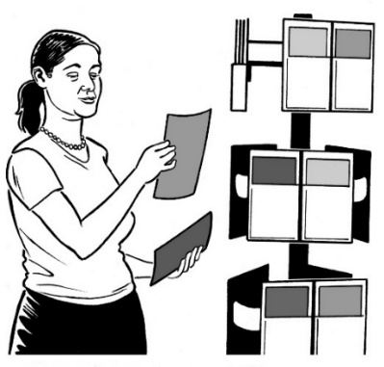
being talked to in a way that did not protect their mana
not being given good information about how much support they should be getting
not being told:
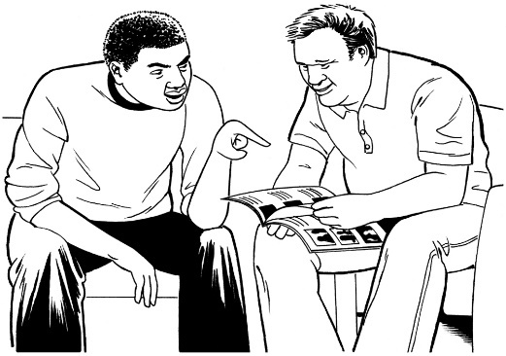
- about changes to support
- that support was going to stop.

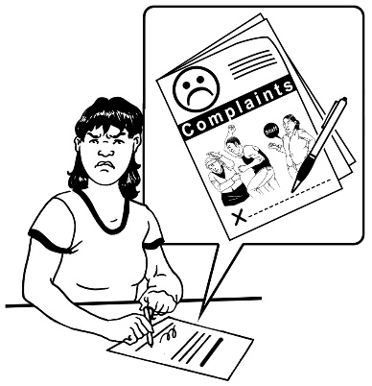
Some people had bad experiences when they made a complaint.


HDC thinks some of the reasons for the problems we found are:
there are not enough people working in disability support
some people are getting less support because of where they live
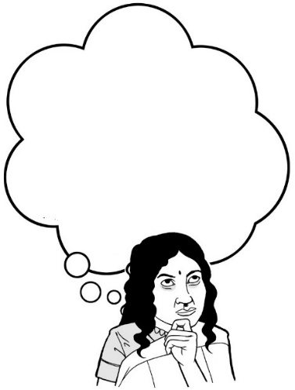
not enough is being done to make sure disabled people feel safe
we do not always know if people are getting good disability support.

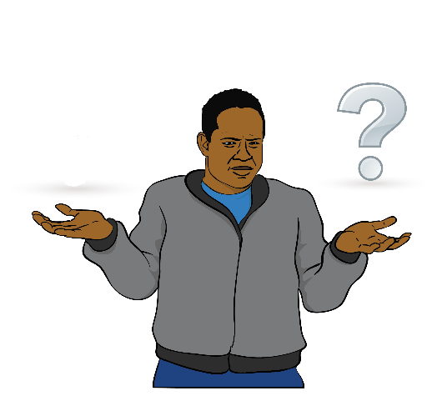
HDC thinks another reason for the problems is that people are confused about what is happening with:
disability support
Enabling Good Lives.


Enabling Good Lives is a different way of thinking about disability support.
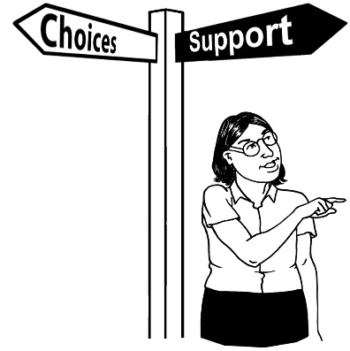

Enabling Good Lives is about having:
- choice and control in your life
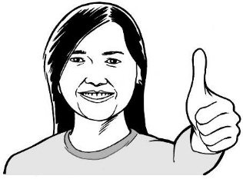
- the support you need and want
- a good life.

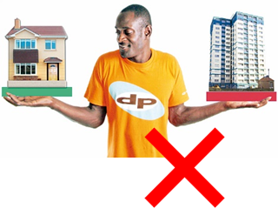
HDC thinks another reason for the problems is that people do not always have good choices about:
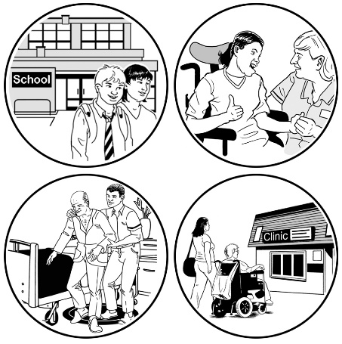
where they live
what support they get.

Recommendations made by HDC
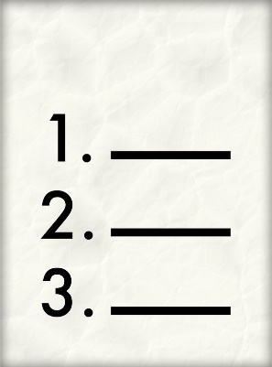

Recommendations are things someone says should happen.

Recommendations to Whaikaha Ministry of Disabled People

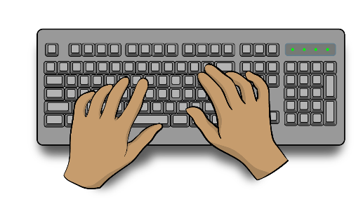
In 2023 Whaikaha asked Rachael Schmidt-McCleave to write a report.

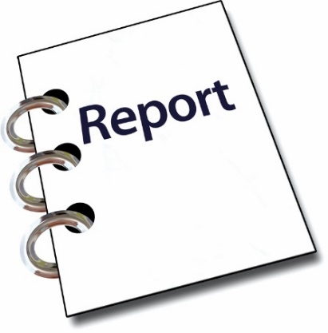
The report was about how a large disability support service dealt with complaints.

We call the report the
Schmidt-McCleave report.

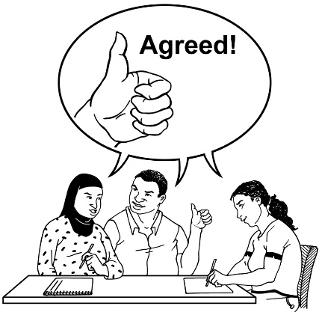
HDC agrees with the recommendations in the Schmidt-McCleave report.

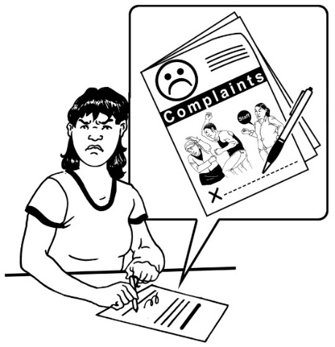
A recommendation HDC thinks is important is that it needs to be easier for disabled people and their whānau / families to:
- say what they think about their support
- complain.

HDC thinks there needs to be work done to make this easier by:
- HDC
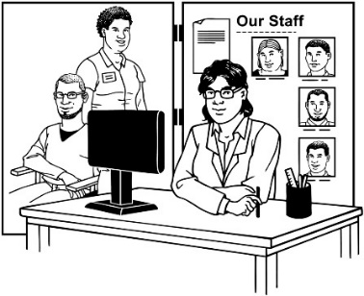
- Whaikaha
- all service providers.

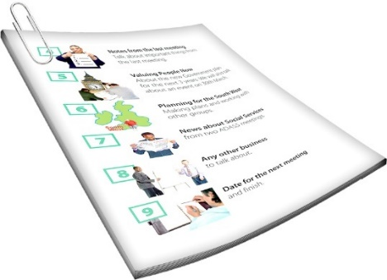
HDC thinks Whaikaha need to make clear information about what people can expect from disability support providers.

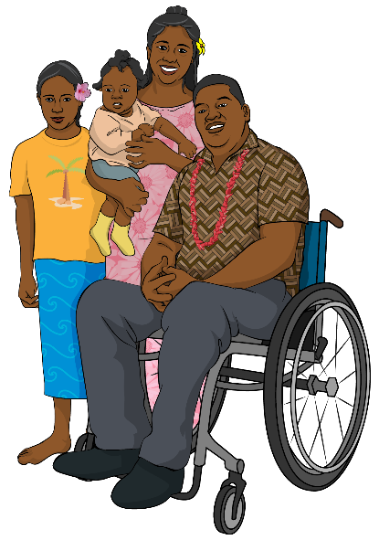
They need to give this information to:
- disabled people
- their whānau / families.

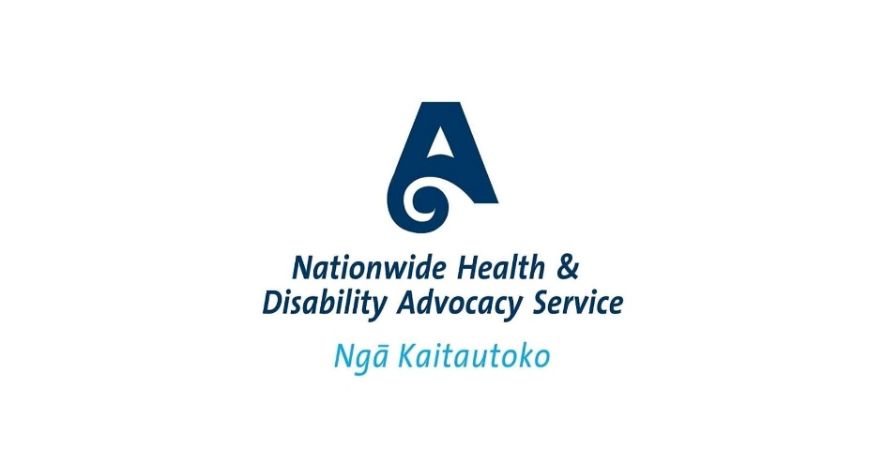
HDC also thinks Nationwide Health and Disability Advocacy Service should give more support to people who live in residential disability services.


It could support them more to speak up.

HDC will be checking in to see how Whaikaha is working on the recommendations.
HDC has looked at the complaints we get about residential disability services.

Because of this HDC has some more recommendations.


HDC recommends that Whaikaha make a quality framework for all disability support.

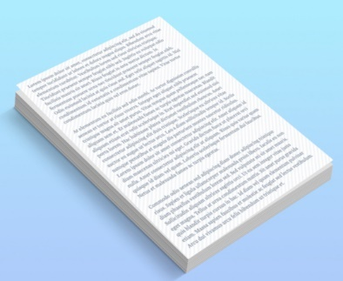
Quality frameworks mean:
- people agree about what good support is

- disabled people feel happy and safe about their support
- someone checks that everyone is getting good support in all parts of the country.
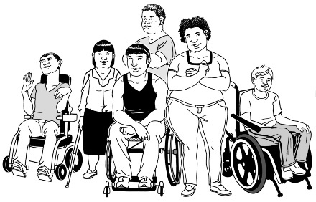
The quality framework should be made together with:
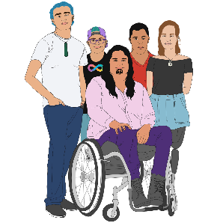
disabled people
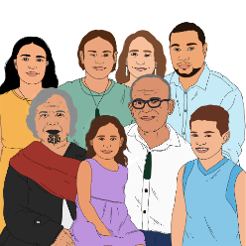
tāngata whaikaha / Māori disabled people
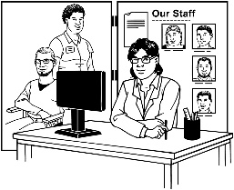
whānau / families
disability service providers
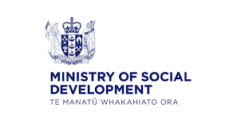
funders like:
- Ministry of Social Development
- ACC
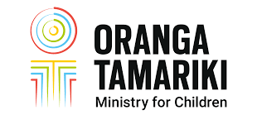
- Oranga Tamariki.


Funders are organisations that pay for services.

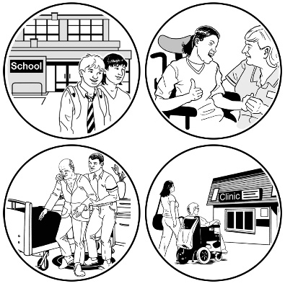
A quality framework would mean:
people would know more about what good support would look like

the disability community would know more about how support providers are doing
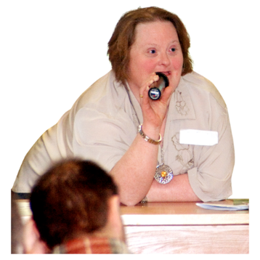
it would be easier for disabled people and their families to speak up when support is not working well.


HDC thinks a quality framework should include some rules for how service providers should respond to complaints from:
disabled people
whānau / families.

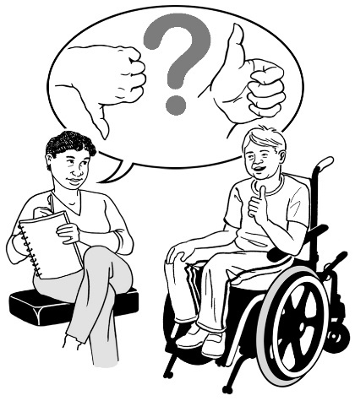
HDC also thinks the quality framework should say that service providers should ask people how things are going.


They could do this at different times so they know if things change.

For example they could ask people how things are going 1 time every month.


This would mean the providers:
would have important information about how good their service is
could tell funders like Whaikaha or ACC how things are going.

HDC also thinks different organisations could agree to the same quality framework as Whaikaha like:
Ministry of Social Development
ACC
Health New Zealand - Te Whatu Ora
Oranga Tamariki.


This would mean everyone would get the same good quality disability support.

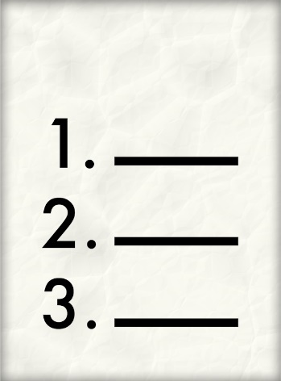
HDC has some more things it would like Whaikaha to do to make support better.

Whaikaha should:
keep working on making sure there are enough support workers
support making disability services that are led by tāngata whaikaha Māori / Māori disabled people
tell the disability community more about how they are going with making Enabling Good Lives system transformation happen in the whole country.

System transformation means changing disability services to work
in a way that fits the Enabling Good Lives ideas.


HDC supports programmes that give disabled people more choice like:
My Home My Choice
Choice in Community Living.

These programmes are only in some parts of the country.

HDC thinks Choice in Community Living should be in all parts of New Zealand.


Independent review of disability support services

In May 2024 the Government announced a review.

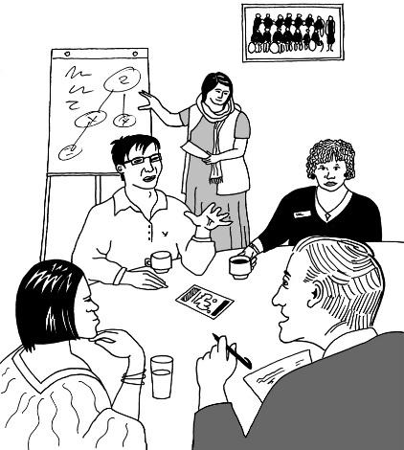
A review is when someone looks at:
how things are going
what needs to be done differently.

The review was of the disability support services that Whaikaha Ministry of Disabled People looks after.
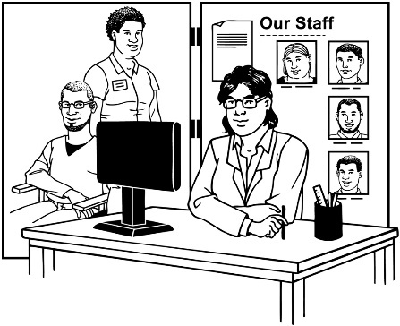

The review was about all the disability services not just residential services.
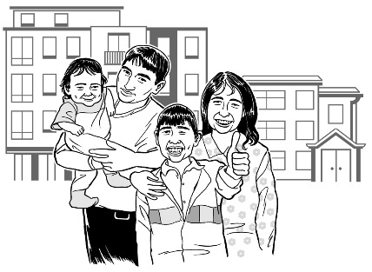
HDC thinks the review is a good chance to keep working on giving disabled people good choices about:
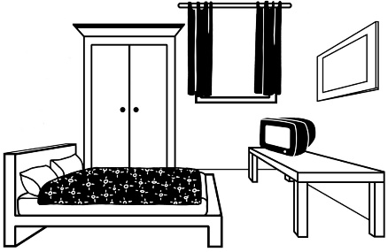
living in the community
having good residential services.

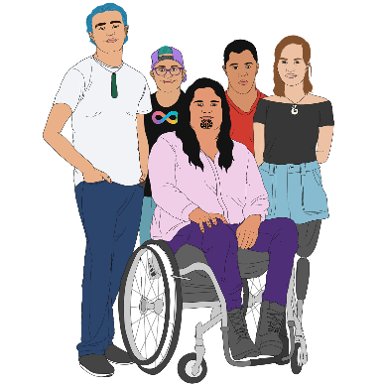
HDC thinks it is a problem the review panel has no:
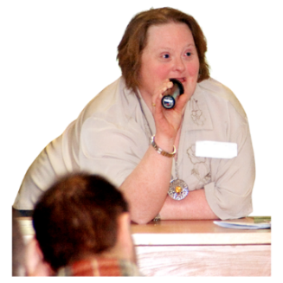
tāngata whaikaha Māori / Māori disabled people
disability community leaders
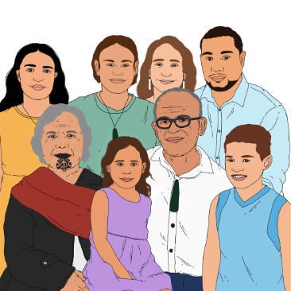
whānau / families.

The review panel is the group of people doing the review.

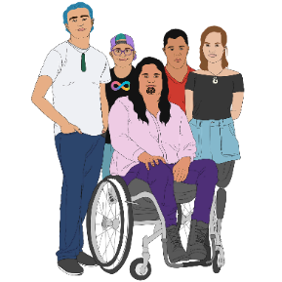
HDC thinks it would be good if the review panel included:
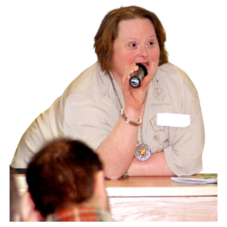
tāngata whaikaha Māori / Māori disabled people
disability community leaders
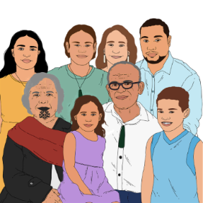
whānau / families.

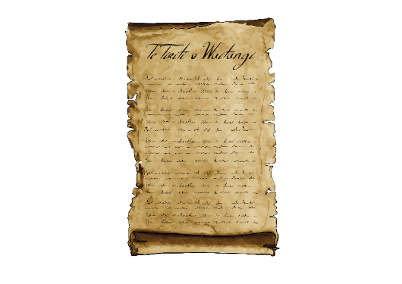
HDC also thinks it would be good if the review panel made recommendations for a good support system for all disabled people using ideas from:
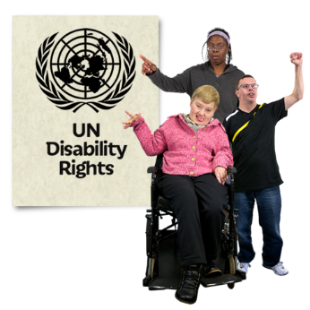
Te Tiriti o Waitangi
the United Nations Convention on the Rights of Persons with Disabilities
Enabling Good Lives.

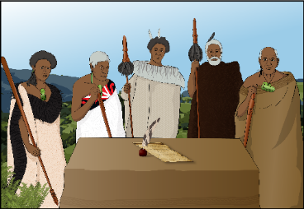
Te Tiriti o Waitangi / Treaty of Waitangi is an important agreement between Māori and the British Crown.

The United Nations Convention on the Rights of Persons with Disabilities is a law lots of countries have agreed to.

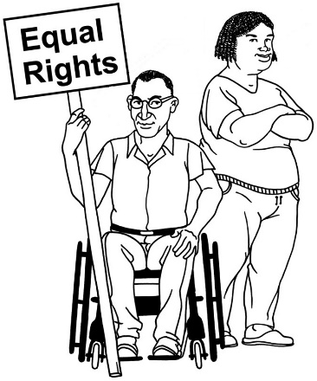
The United Nations Convention on the Rights of Persons with Disabilities is also called the UNCRPD.

It says what governments must do to make sure disabled people get the same rights as everybody else.


HDC also thinks it would be good if the review panel:
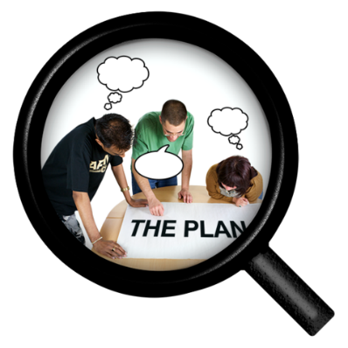
looked at how good disability supports are
looked at recommendations from other reviews
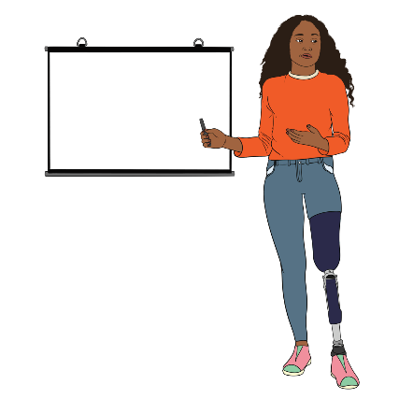
made a long term plan for people who work in disability
made sure that the plan included training for residential support staff
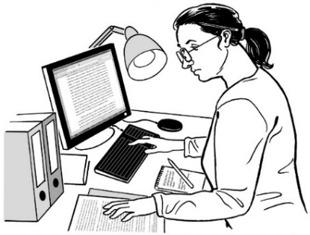
- considered doing a review of the disability sector similar to another review that is happening called the Aged Care Funding and Service Models Review.

More information

You can find information about making a complaint on the HDC website at:

https://tinyurl.com/HDCcomplaint

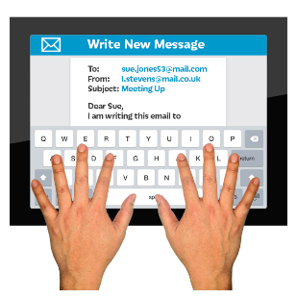
You can contact HDC by:

email at:
hdc@hdc.org.nz
phone on:
0800 11 22 33

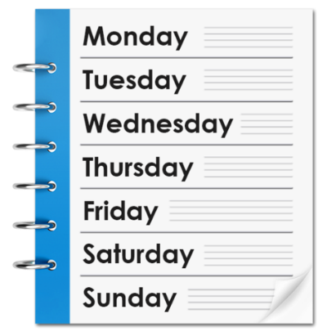
There are people to answer the phone:
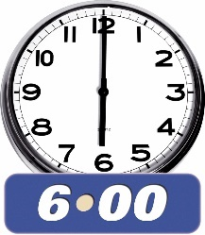
Monday to Friday
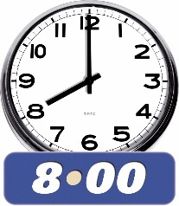
between 8:30 am and 5 pm.


If you find it hard to use the phone the New Zealand Relay service is for people who are:


- Deaf / hard of hearing

- deafblind

- speech impaired / find it hard to talk.


You can find out more about the New Zealand Relay service at:

www.nzrelay.co.nz

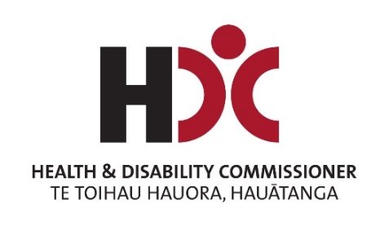
This information has been written by Health and Disability Commission / HDC. These are only the thoughts of HDC.

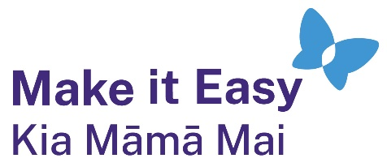
It has been translated into Easy Read by the Make it Easy Kia Māmā Mai service of People First New Zealand Ngā Tāngata Tuatahi.
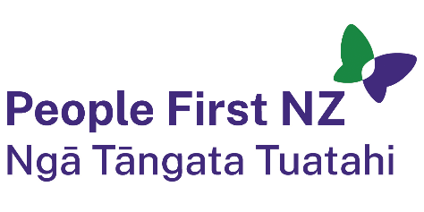
The ideas in this document are not the ideas of People First New Zealand Ngā Tāngata Tuatahi.
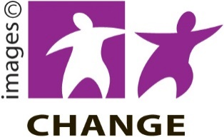
Make it Easy uses images from:
- Changepeople.org


            - Photosymbols.com


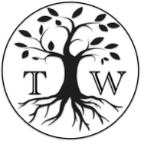
- SGC Image Works
- Huriana Kopeke-Te Aho
- T. Wood.

All images used in this Easy Read document are subject to copyright rules and cannot be used without permission.

