

When you use a health or disability service

You have rights

All people in New Zealand have these rights



What are my rights?

In New Zealand, when you use a health or disability service you have rights.

This book:

- tells you about your rights
- tells you how to make a complaint if you are not happy with a service you receive.

- To be treated with respect
- To be treated fairly
- To dignity and independence
- To receive good care and support that suits your needs
- To be told things in a way you understand
- To be told everything you need to know about your care and support
- To make choices about your care and support
- To have support
- To decide if you want to be part of training, teaching or research
- To make a complaint
1. You have the right to be treated with respect.

This means:

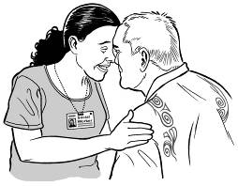
- You should be treated well


- You should be listened to


- Your beliefs and ideas should be respected

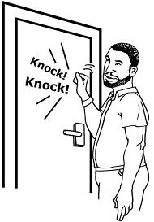
- Your privacy should be respected.

2. You have the right to be treated fairly.

This means:

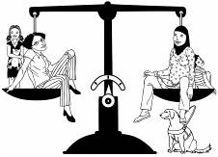
- You should be treated the same as others

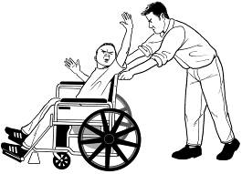
- You should not be abused or taken advantage of when receiving care and support

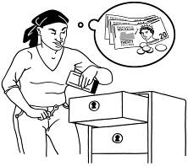
- No-one should use your things or take your money without asking you first

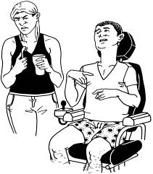
- You should not be made to feel you have to do things you don’t want to do.

3. You have the right to dignity and independence.

This means:


- You should be treated in a way that values you as a person


- You should be supported to do as much as you can for yourself.

4. You have the right to receive good care and support that suits your needs.

This means:


- All the care and support you receive should be right for you
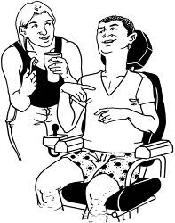
- You should be provided with good care and support

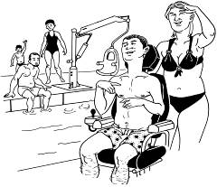
- You should receive care and support that is safe for you and helps you live a good life

- People should work together to help you.

5. You have the right to be told things in a way you understand.

This means:

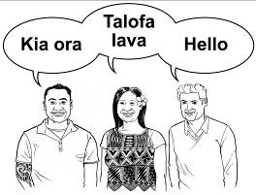
- You should be spoken to in a way you understand


- People should check that you have understood

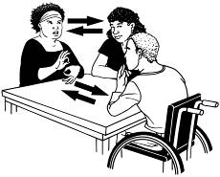
- People should use different ways to explain things to you - for example;
  - use pictures
  - write things down
  - use sign language
  - get help from someone who understands you

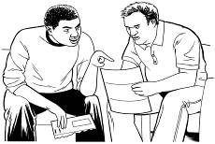
- You should be able to talk freely, ask questions and be told the truth.

6. You have the right to be told everything you need to know about your care and support.

This means:

You should be told:
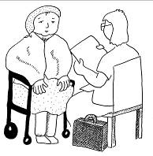
- What is happening to you

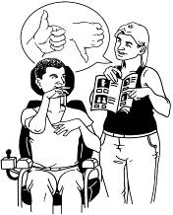
- What choices you can make, and the effect of your choices


- When you can expect to receive services


- Results of any tests or treatment


- How much it will cost you.

7. You have the right to make choices about your care and support.

This means:

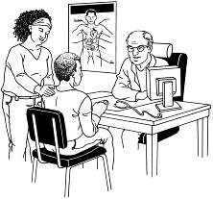
- You should be supported to make your own choices


- Sometimes other people may help you make your choices

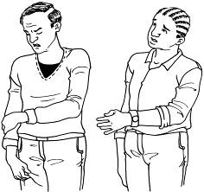
- You can say ‘no’ to receiving care and support

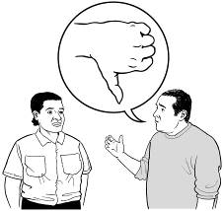
- You may be stopped from making choices that are dangerous or may hurt others.

8. You have the right to have support.

This means:

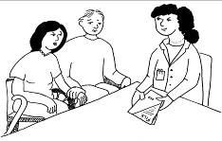
- You can have someone with you when you receive care and support

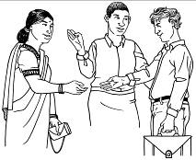
- You can choose who will support you when you receive care and support.

9. You have the right to decide if you want to be part of training, teaching or research.

This means:

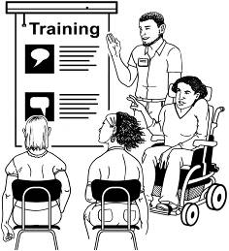
- If you are asked to be part of training or research, it should be explained to you so you can decide if you want to take part


- If you decide to take part in training, teaching or research you should be treated the same as everyone else.

10. You have the right to make a complaint.

This means:

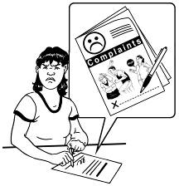
- You can complain if you are not happy with the care and support you receive

- People should listen to your concerns, worries or complaints

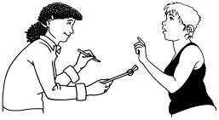
- People should tell you what they will do about your complaint and by when


- If they do not help you with your complaint, there are other people you can contact.

More about making a complaint


Who can I ask?

If you are not happy with the services and support you receive, you can:

- Talk to the person you are not happy with

- Ask your family member or a friend to help you make a complaint

- Call 0800 55 50 50 and ask for a Health and Disability Advocate to help you

- Call 0800 11 22 33 to make a complaint with the Health and Disability Commissioner.


Why should I make a complaint?

If you make a complaint:

- People should tell you what they did and why, and they may say ‘sorry’ if they were wrong

- Things can be changed so that the wrong things that happened to you will not happen to others

- It will help people who support you to learn and do a better job.
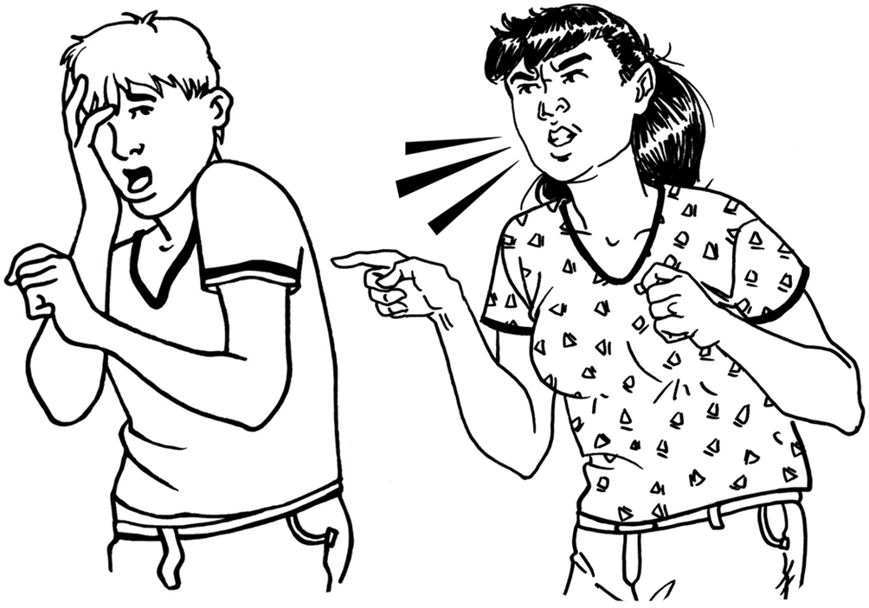
Will I be in trouble if I
make a complaint?

- You will not be in trouble if you make a complaint because it is your right to make a complaint

- You should not be treated differently if you make a complaint

- If someone treats you differently or tells you off for making a complaint, you can ring 0800 55 50 50 and someone will help you.

Health and Disability Commissioner
Te Toihau Hauora, Hauātanga

Freephone: 0800 11 22 33
Fax: 09 373 1061
Email: hdc@hdc.org.nz
Website: www.hdc.org.nz

Health and Disability Advocacy
Ngā Kaitautoko

Freephone: 0800 55 50 50
Fax: 0800 27 87 76
Email: advocacy@hdc.org.nz

