**Presentation Transcript with images and image captions:**

This document is a written transcript of the audio voiceover linked to the powerpoint presentation.

Included in this document are the images used on each slide with an image caption for viewers with a vision impairment.

1. **Slide one: Know your rights when using a health or disability service**



Kia ora everyone and welcome to this presentation from the Office of the Health and Disability Commissioner.

Image 1: Black and red letters of HDC. The logo for the Health and Disability Commissioner. This logo is on the top right hand corner of each slide.

This presentation is for people to learn about the role of the Health and Disability Commissioner and to learn about your rights when you use a health or disability service.

Image 2: Dark blue A. The logo for the Nationwide Health and Disability Advocacy Service

So let’s get started with the next slide.

Image 3: Two stick figures, one purple and one white, leaning away from each other. This is the logo for Change images. This presentation uses change images.

1. **Slide Two: What this presentation will talk about**

The second slide lists the topics I am going to talk about today.

First I will talk about the role of the Health and Disability Commissioner.

I will give an example of complaints about disability services that the Commissioner has looked at.

Then I will talk about each of the rights found in the Code of Rights.

Lastly I will talk about what you can do if you are unhappy with a health or disability service and how the Nationwide Health and Disability Advocacy Service can help you.

1. **Slide three: What does the Health and Disability Commissioner do?**

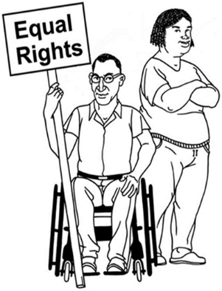The third slide talks about what the Health and Disability Commissioner does.

The Health and Disability Commissioner was a role that was created by law in 1994.

Image 1: A black and white picture of two people side by side. One is sitting in a wheelchair holding a sign with the words 'equal rights'. The second is standing with crossed arms.

The law also created the Code of Health and Disability Services Consumers’ Rights (we call this the Code).

This Code lists the ten rights that people have when they are using a health or disability service.

The Health and Disability Commissioner is independent and aims to protect and promote people’s health and disability rights.

Part of the Commissioners’ job is to make sure that if people complain then they are listened to.

The Commissioner also wants to make sure that complaints are resolved quickly.

While the Commissioner doesn’t take sides in a complaint.

They will look at a complaint, ask for more information and if something has happened then the Commissioner will decide what people need to do to make services better for everyone.

The Commissioner can also ask the service provider to make some changes.

For example, they may ask that the provider apologises or that staff have more training.

1. **Slide four: The Code of Health and Disability Services Consumers’ Rights “The Code”**

The fourth slide lists the ten rights in the Code. Service providers have a responsibility to uphold these rights when people use their services.

These rights apply for everyone every time that they use a health or disability service.

The ten rights are about: respect, fair treatment, dignity and independence, proper standards, effective communication, information, decision making, support, teaching and research and the tenth right is the right to complain.

After the complaint example which we will look at next, then we will look at the Code to see what is meant by each right.

1. **Slide five: Complaint example**

The fifth slide is the complaint example I am going to talk about today.

It is about a woman who was living in a disability home. She became upset and began to throw objects and herself around the room.

Her support plan listed things that staff could do to help calm her down.

This time the staff did not follow this plan. Instead they physically moved her out of the room.

They also did not fill out the form telling others what had happened afterwards and they did not tell the woman’s guardian about it for some time.

Because of this, the Commissioner investigated and decided that the service provider did not uphold the Code of Rights.

The Commissioner asked the service provider to change the way they reported on issues that had happened in the home and to give more training to their staff.

Now lets look at each right in the Code of rights and talk about what they mean.

1. **Slide six: Respect**

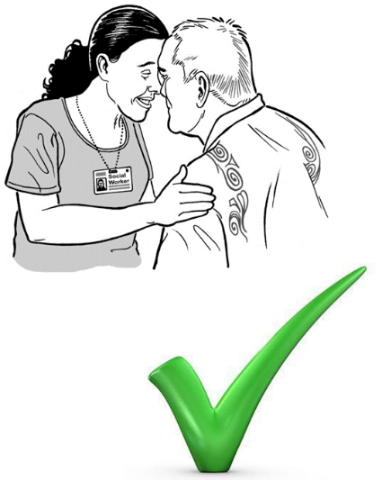

Slide six talks about the first right that we finding the Code of Rights. This right is the right to respect.

Respect can mean different things to people but it generally means that people should listen to you and you should be treated kindly.

Image A black and white image of a woman and a man greeting each other with a hongi (pressing noses together). Underneath the image is a green tick mark.

You should also have your personal privacy respected.

For example, people should knock on your bedroom door and ask you if it is ok to enter before coming in.

Service providers should take into account your culture, beliefs and values.

For example, if you ask people to take off their shoes before they enter your house people should respect this.

1. **Slide seven: Fair treatment**

Slide seven talks about the second right in the Code of 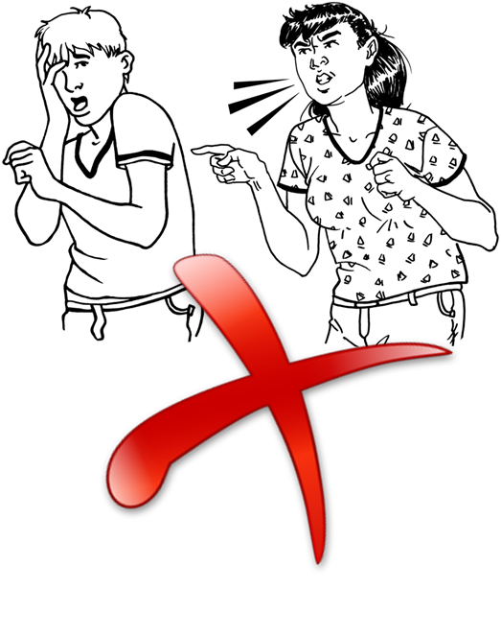Rights. This is the right to fair treatment.

Image 1: A black and white image of a woman yelling and pointing at a man. Underneath there is a red cross mark.

Fair treatment means that you have a right to be treated fairly and to be free from discrimination, harassment and exploitation.

This means that no-one should take advantage of you.

For example, people shouldn’t threaten you, swear at you or force you to do something that you don’t want to do.

1. **Slide eight: Dignity and independence**

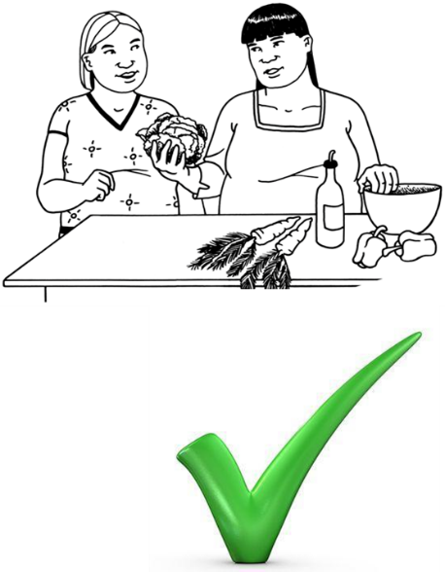Slide eight talks about the third right which is the right to dignity and independence.

Image 1: Black and white image of two women standing at a table with vegetables in front of them. Underneath is a green tick mark.

This can mean different things to different people.

It can mean things like being treated in a way that values you as a person.

It also means that you should be supported to do as much as you can for yourself.

For example, if you need support for cooking then the person supporting you should work with you and encourage you to do as much of the cooking that you can for yourself.

1. **Slide nine: Proper standards**

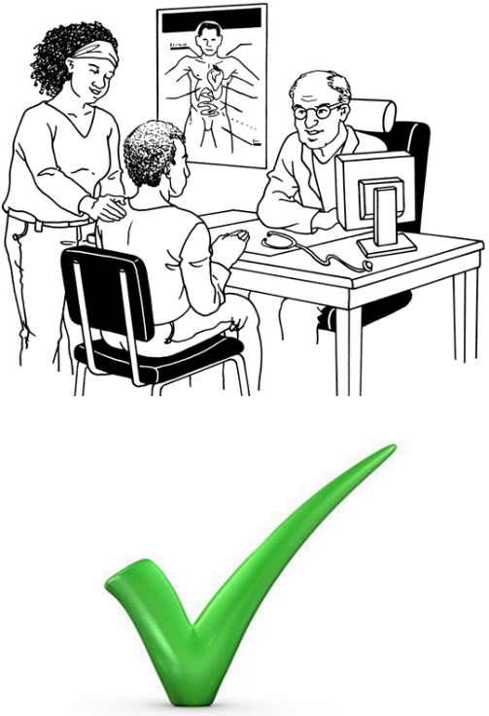Slide nine talks about the fourth right in the Code. The fourth right is the right to have services that are of a proper standard.

This means that the services are done well.

It also means that services should help you to live a good life and they should try not to hurt you.

It means that the staff are trained well and are able to do the job you need them to do.

Image 1: Black and white image of a patient sitting across from a doctor at his desk and a support person standing next to the patient. Underneath the image there is a green tick mark.

This means that services are right for your specific needs.

It also means that all of the people involved in your care and support should work together to help you.

For example, you might be using different services at the same time. Like a GP, a hospital specialist or an occupational therapist so they might need to communicate with each other to make sure all of your needs are met.

1. **Slide ten: Good Communication**

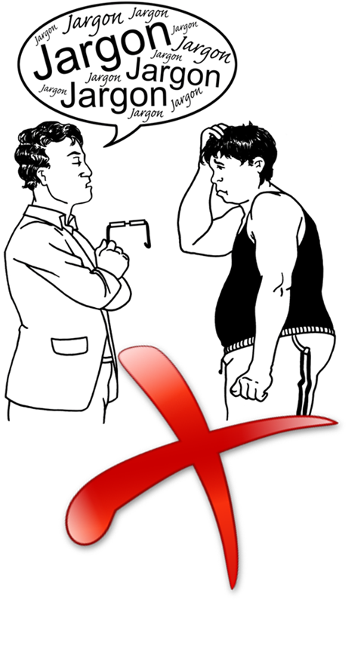Slide ten talks about the fifth right. This is a right to good communication.

Image 1: A black and white image of two people facing each other. One is scratching their head looking confused. The other has a speech bubble with the word Jargon repeated inside of it. Underneath the image there is a red cross mark.

This means that people should tell you information in a way that you can understand.

People should be open, honest and effective when they communicate with you.

You should feel comfortable to say if you do not understand something and you should be able to ask questions and to feel like you are being listened to.

Good communication also means that the person communicating with you should check and make sure that you understand what you are being told.

An example of good communication would be when the service provider is talking with you they are using words that you can understand.

1. **Slide eleven: Information**

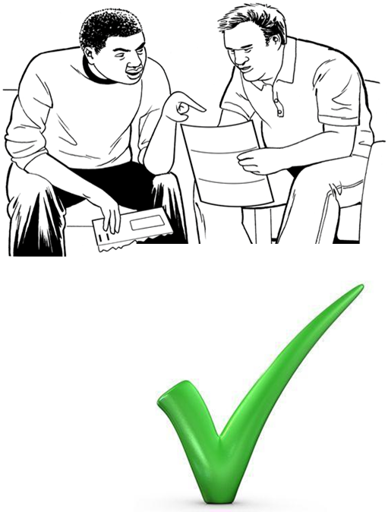

Image 1: Black and white image of two men sitting next to each other, looking at a document and one man is explaining the document to the other. Underneath the image there is a green tick mark.

Slide eleven talks about the sixth right. This is the right to information.

This means that you have the right to be told everything you need to know about your care or treatment.

Part of this means that people should be honest with you about your situation and give you accurate answers to any questions you have about your care or treatment.

You have the right to know about what is happening or is likely to happen and when you can expect to receive services.

For example, if you have a support worker who comes to your house you have a right to know who is coming and when they will be there.

1. **Slide twelve: Decision making**

Slide twelve talks about the seventh right. This is the right to make decisions.

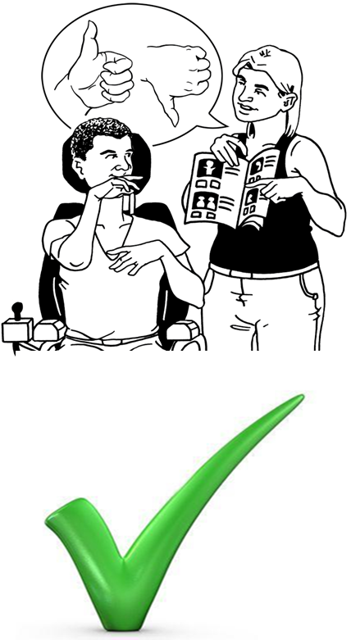This means that you have a right to make choices about your care and support.

For example, you can choose what help you want from your support worker and when you want to be supported.

You can also have support to make decisions.

This means that when you don’t have enough information or knowledge to make the decision on your own, someone can help you.

Image 1: A black and white image of a woman standing and holding a book open to a person sitting in a wheelchair. There is a speech bubble with the thumbs up and thumbs down symbols. The person in the wheelchair uses a hand gesture to answer the question. Underneath the image there is a green tick mark.

You may have people who you trust, or who are specially trained, to communicate with you and help you make these choices.

Also if you can’t make a decision then there are rules about who can make these decisions for you.

1. **Slide thirteen: Support**

Slide thirteen talks about the eighth right. This is the right to have support.

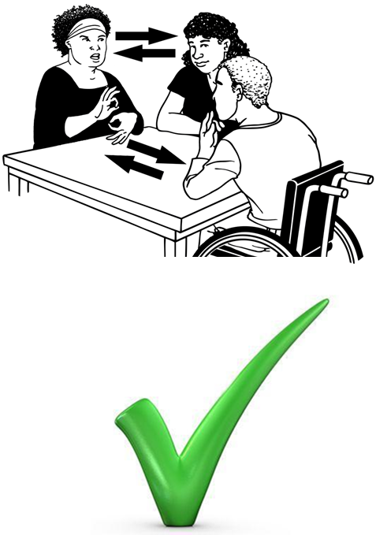This means that when you are receiving a health or disability service you have the right to have one or more support people with you.

Image 1: A black and white image of a wheelchair user sitting at a table with two women. One woman is a sign language interpreter. Underneath the image there is a green tick mark.

You may want to have someone with you who you feel comfortable with.

This could be a friend or whanau member, who knows you well.

It could be someone who is good at communicating if you do not feel confident about language, or if you are nervous or upset.

But there may be times when you are not able to have this person with you.

They may not be able to be with you if having them there will be unsafe for you or for someone else.

And if having a support person present is going to impact on someone else's privacy, then they may be asked to leave for a short time.

An example of a situation where your support person may not be allowed to be with you might be if you are having surgery and they have to move you to the operating theatre.

Your support person may not be able to come with you into theatre.

1. **Slide fourteen: Decide about teaching or research**

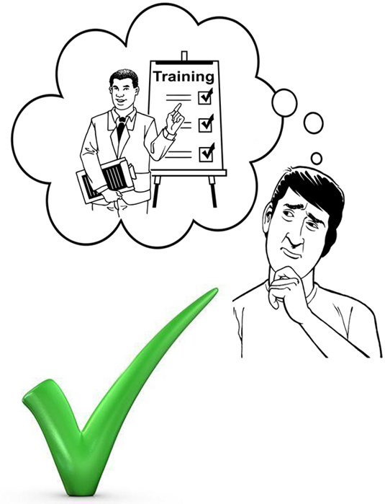Slide fourteen talks about the ninth right. This is the right to decide about teaching and research.

Image 1: A black and white image of a man with a thought bubble near his head. In the thought bubble is a man with a board with the word 'training' on it and tick marks. Underneath the image is a green tick mark.

This means that you can choose if you want to be a part of any research that the service provider is doing or if you want to be a part of teaching and training for new staff.

For example, when at the hospital you may be asked if it is OK for student doctors and nurses to be there when you are talking to the nurse or doctor.

The service provider should ask you if you are happy to have someone who is learning about the job to be there when you are using the service. You can say no to this.

If you do say yes you can also change your mind at any time.

It is important to remember that all of the rights in the Code still apply when you are a part of training or research.

1. **Slide fifteen: Complain**

The fifteenth slide talks about the tenth right. This is the right to complain.

Image 1: A black and white image of a woman with a frown on her face. She is filling out a complaints form. Underneath the image is a green tick mark.

This means that if you are unhappy with a health or disability service you can speak up about it and hopefully things can be changed.

Complaints are important for service providers so that they can learn how to do things better for people.

When you make a complaint you should feel that you have been listened to and that they are taking your complaint seriously.

You should be told what will happen with your complaint – and by when.

It is important to remember that even if you make a complaint you still have a right to access these services.

You should not be treated worse because you made a complaint.

There are many different ways that you can make a complaint.

For example, you can complain directly to the person who provided the service or someone else in that service.

You can complain to an advocate from the Nationwide Health and Disability Advocacy Service or you can complain to the Health and Disability Commissioner.

Sometimes when you are unhappy with a health or disability service it is not always that easy to make a complaint on your own.

The Nationwide Health and Disability Advocacy Service can help you with this.

So the next slide will talk about what you can do if you are unhappy with a health or disability service.

1. **Slide sixteen: What you can do if you are unhappy with a service you receive?**

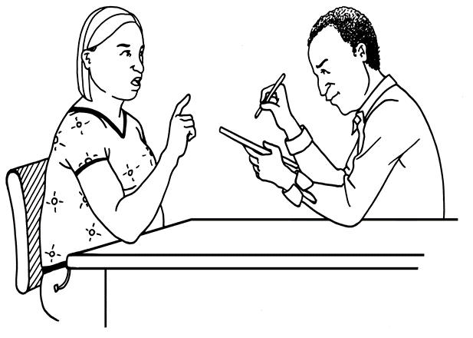Slide sixteen talks about what you can do if you are unhappy with a service you receive. If you are unhappy with a health or disability service you receive you have a few options.

Image 1: A black and white image of a woman talking to a man. The are both sitting at a table. The man is writing down notes.

If you are unhappy about how you were treated or if feel that something has gone wrong it is important to tell someone.

It is important to talk about it with someone you trust.

This could be your whānau, friends or someone else you feel comfortable with.

If you can, talk to the people who provided the service – if you are not happy with what they say you can also talk to an Advocate or to the Health and Disability Commissioner.

The next slide talks about the Nationwide Health and Disability Advocacy Service and how they can help you.

1. **Slide seventeen: The Nationwide Health and Disability Advocacy Service.**

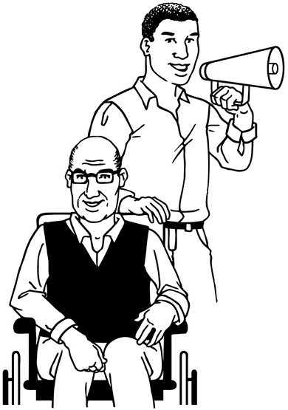Slide seventeen talks about the Nationwide Health and Disability Advocacy Service.

The Nationwide Health and Disability Advocacy Service has Advocates all over New Zealand.

Advocates are there to help people who are unhappy with a health or disability service they are receiving.

It will not cost you any money to talk with them.

Image 1: A black and white image of a man sitting in a wheelchair. Standing behind him is a second man who is holding a mega-phone.

Advocates and there to help you. They are independent from the service provider and from the Health and Disability Commissioner.

Advocates help people with making sure that their rights are respected.

They help people to resolve complaints about a health or disability service.

They can help you if things were not explained to you in a way that you can understand or if you don’t feel like you have been listened to.

Advocates can help you to understand what it is that you are unhappy about.

They can help you to work out what it would take to resolve things for you.

They will discuss your options and then can give you practical support, like helping you to write a letter or going with you to a meeting with the provider.

Advocates can provide information about other services that may be useful, including helping you to take your complaint to the Health and Disability Commissioner.

1. **Slide eighteen: How to contact us.**

Slide eighteen lists the ways you can contact us.

Thank you for watching this slideshow presentation. I hope you found the information and examples useful.

If you would like to contact the Health and Disability Commissioner you can call us on 0800112233 or you can email us at [hdc@hdc.org.nz](mailto:hdc@hdc.org.nz).

Image 1: Black and red letters of HDC. The logo for the Health and Disability Commissioner.

****If you would like to contact the Nationwide Health and Disability Advocacy Service you can call them on 0800555050 or email them at [advocacy@hdc.org.nz](mailto:advocacy@hdc.org.nz).

Image 2: Dark blue A. The logo for the Nationwide Health and Disability Advocacy Service.

Image 3: Two stick figures, one purple and one white, leaning away from each other. This is the logo for change images. This presentation uses change images.